Cybermarvels have good media balance!

What you can expect to learn
This week we will learn - what media balance is, how you can make good choices about what to watch, read or listen to and how you can get the whole family involved.

Instructions
The activities below can be completed in any order and you can do all or some of them during the week. At the end of each day, fill in your journal with what you learnt that day and how you will use this learning in the future. You will then be able to use this to create:
- a poster (PDF/word)
- a script for a play (PDF/word)
- an MP4 video
- an MP3 audio
- a website (Google site or similar)
- or write a fictional story to showcase your learning for the whole month (PDF/word).

You can access help for video, audio recording and to write a journal or a story.

Once your teacher has reviewed your work, they can select and submit them to the judge’s panel as an entry to the Be Cybermarvellous Challenge 2021 and the best productions will be published on our website.

Week 3: 18 Oct - 22 Oct
Things you need:
- Tablet/ laptop/ PC
- Internet access
- Headphone (optional)
- Paper and pencils/colour pencils
- Marker pen
- Scissors
MONDAY - My media balance- lesson 1 (adapted from Common Sense Education)
Media is all the ways that large groups of people get and share information (TV, books, the internet, newspapers, phones, etc.)

We all make choices every day about the media we watch and use. These choices include what we watch, listen to, read, or even create online. But not all media choices are the same. In fact, different choices can make us feel very differently.

Read Matthew’s and Mina’s media choices below and then answer these questions:

- How would these media choices make you feel?
- Why do you think it would affect you that way?
- How do the different parts of the example -- What? When? How Much? -- affect how you feel?

Matthew
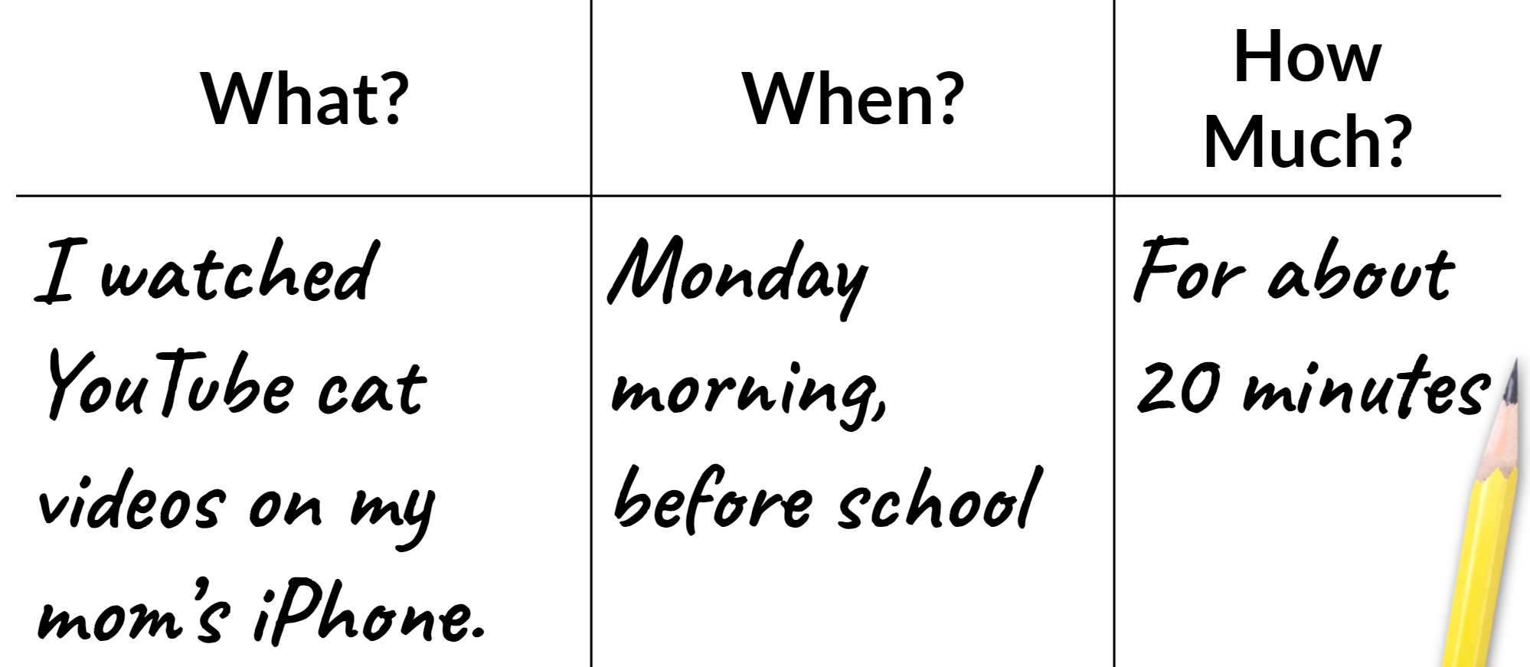
Mina
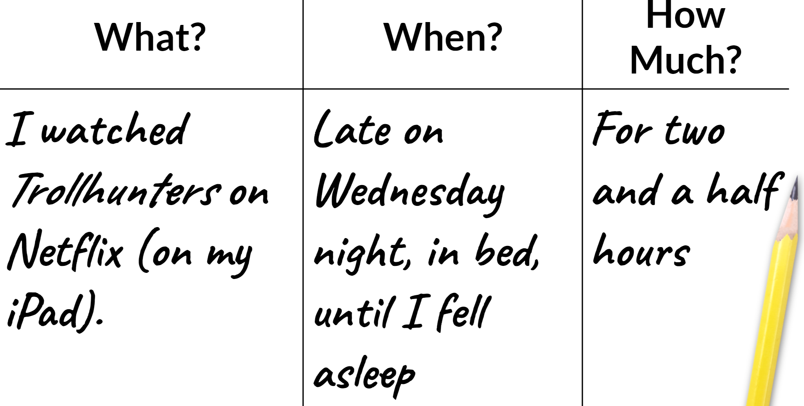
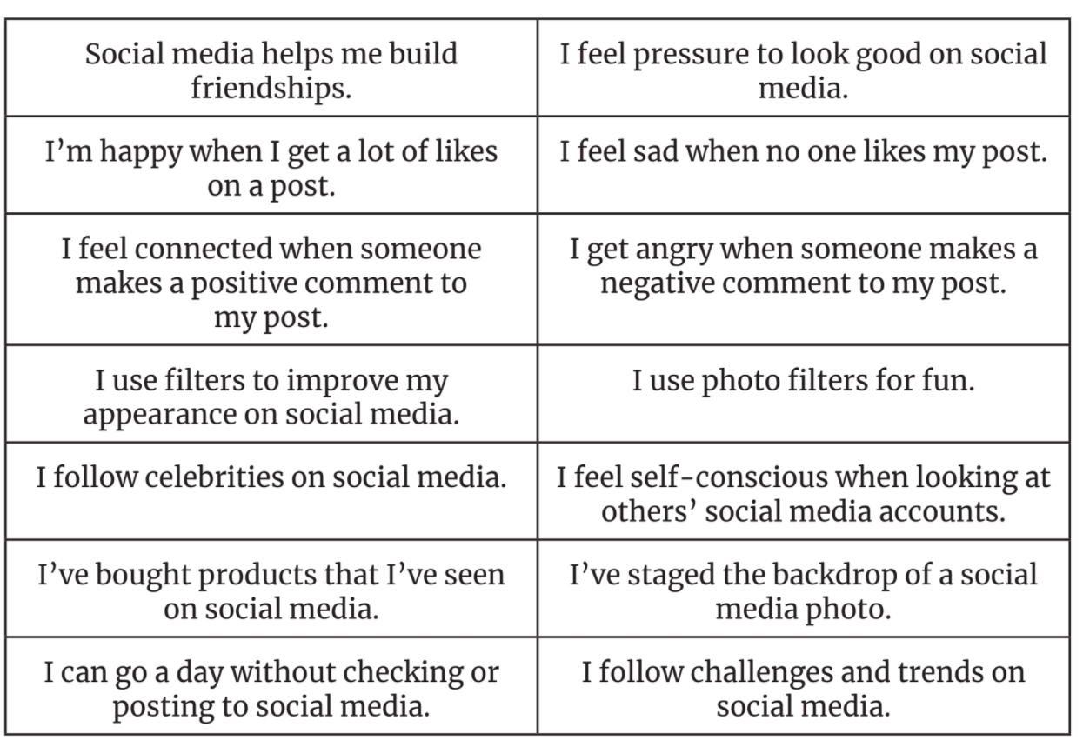
TUESDAY- My media balance - lesson 2 (adapted from Common Sense Education)
Watch this video - https://www.youtube.com/watch?v=USlHaqNfwK4&t=1s

Answer the questions below:

- How are some media choices healthier or less healthy than others?
- What is "media balance"? How might it be different for different people?
- Use the tracker below to record your media use last week.

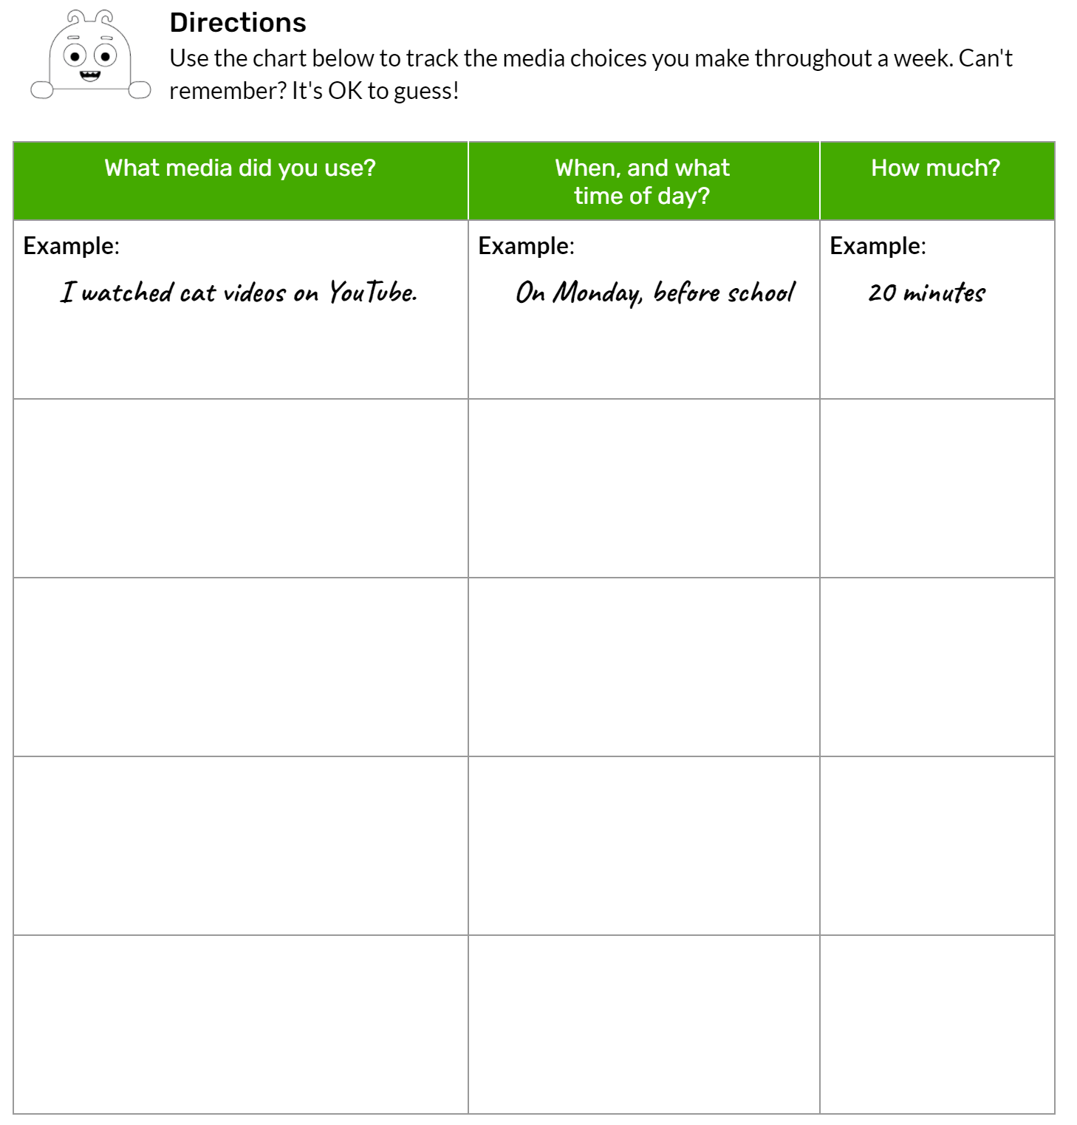

WEDNESDAY - My media balance - Lesson 3 (adapted from Common Sense Education)
Review all the media choices from your media choice tracker. Use what you wrote to answer the five questions below.
What was the healthiest media choice you made last week? Copy the What? When? How Much? for that choice below.
- Why was that your most healthy media choice?
- What was the least healthy media choice you made last week? Complete the ‘What? When? How Much?’ for that choice.
- Why was that your least healthy media choice?
- What is one healthy media choice you plan to make next week?

THURSDAY - My media balance - Lesson 4 (adapted from Common Sense Education)

You now have a fair understanding of media balance. Let’s take a quiz!

QUESTION - Select one answer from the list below.
Which three questions should you ask yourself when making healthy media choices?
- Where? Why? How?
- What? When? How much?
- How are you? How far? How much?

QUESTION 2 - Select one answer from the list below.
Healthy media choices are:
- Always the same for every person.
- Usually different for every person
- Never really much fun.

QUESTION 3 - Select one answer from the list below.
Last night, Mia's mom gave her permission to watch her favourite YouTube channel, and she stayed up late watching videos. When she got to school today, she fell asleep during art class (her favourite subject). Did Mia make a healthy media choice?
- No. Her choice to stay up late caused her to miss doing something she likes.
- No. She didn't watch as many YouTube videos as she wanted to.
- Yes. She was able to talk to her friends about the videos she watched last night.
- Yes. She really needed the nap.
QUESTION 4 - Select one answer from the list below.
Imagine you are Mia's friend. What advice would you give her to help her have media balance?

- Do not watch any videos. It is not a good choice.
- Watch fewer videos so she can get a full night's sleep.
- Watch the same number of videos. YouTube is more important than art class.

QUESTION 5 - Select one answer from the list below.
How confident do you feel about making healthy media choices for yourself?

- I feel very confident.
- I feel somewhat confident.
- I do not feel confident.

FRIDAY - Family media balance (adapted from Common Sense Education)

It's important to stay aware of how our on-screen and offscreen activities fit into our lives. Do a media balance check-up on your family.

Get one or more family members together to help. Read the setup before doing the activity together!

Setup
Read aloud: We balance the food we eat to stay healthy. We also need to balance our media use. Media includes the shows and videos we watch, the video games and apps we play, and the music we listen to. Let's answer questions to see if our media use is balanced. Then we can decide if we want to make some changes.

Activity
- Do digital devices (phones, tablets, TV) ever keep us from getting enough sleep?
- Do we use them while we eat?
- Do we do activities together without devices?
- Do we ever use them together?
- Does our digital device use cause fights? If so, what are the fights about?
- When we use our devices, how is it fun? What do we learn?
- Is there anything we want to change about how we use our devices? If so, what?
- Does the way your family uses media feel balanced and healthy? Give a thumbs up or thumbs down. Does your family agree? If you want to make changes, what are they? Think of changes that work for the whole family since you're all on the same team!

