Cybermarvels are respectful online!

What you can expect to learn
This week we will learn - what a digital footprint is, what you need to be careful before you post anything online and how you can do this using an online game, some activities and some writing tasks.

Instructions
The activities below can be completed in any order and you can do all or some of them during the week. At the end of each day, fill in your journal with what you learnt that day and how you will use this learning in the future. You will then be able to use this to create:
- a poster (PDF/word)
- a script for a play (PDF/word)
- an MP4 video
- an MP3 audio
- a website (Google site or similar)
- or write a fictional story to showcase your learning for the whole month (PDF/word).

You can access help for video, audio recording and to write a journal or a story.

Once your teacher has reviewed your work, they can select and submit them to the judge’s panel as an entry to the Be Cybermarvellous Challenge 2021 and the best productions will be published on our website.

Week 2: 11 Oct - 15 Oct
Things you need:
- Tablet/ laptop/ PC
- Internet access
- Headphone (optional)
- Paper and pencils/colour pencils
- Scissors

MONDAY - Be Internet Awesome

Play Google’s Interland game –
https://beinternetawesome.withgoogle.com/en_us/interland
Learn to not fall for fake, share with care, secure your secrets and be kind.

Talk about five things you learnt after playing the game. Read the pledge and sign and date it. Get a parent to co-sign -https://storage.googleapis.com/gweb-interland.appspot.com/en-us/hub/pdfs/Google_BeInternetAwesome_Pledge.pdf
TUESDAY - Digital footprints. (adapted from Cyber Aces)

A digital footprint is a trail of data you create when using the internet, including websites visited, emails sent, information submitted, and social media activity.

The size of someone’s shoe can help you guess how tall the wearer is, or how the style of a shoe may give you an idea about how old the wearer is. Some of the inferences may not be true, but most probably are. Look at the pictures of shoes below.

- What do you think about the people who would wear them? Write in each box:
  - How tall you think they are?
  - What are their interests?
  - How active they are on a scale of 1 to 5 ( 1 being least active and 5 being most active).
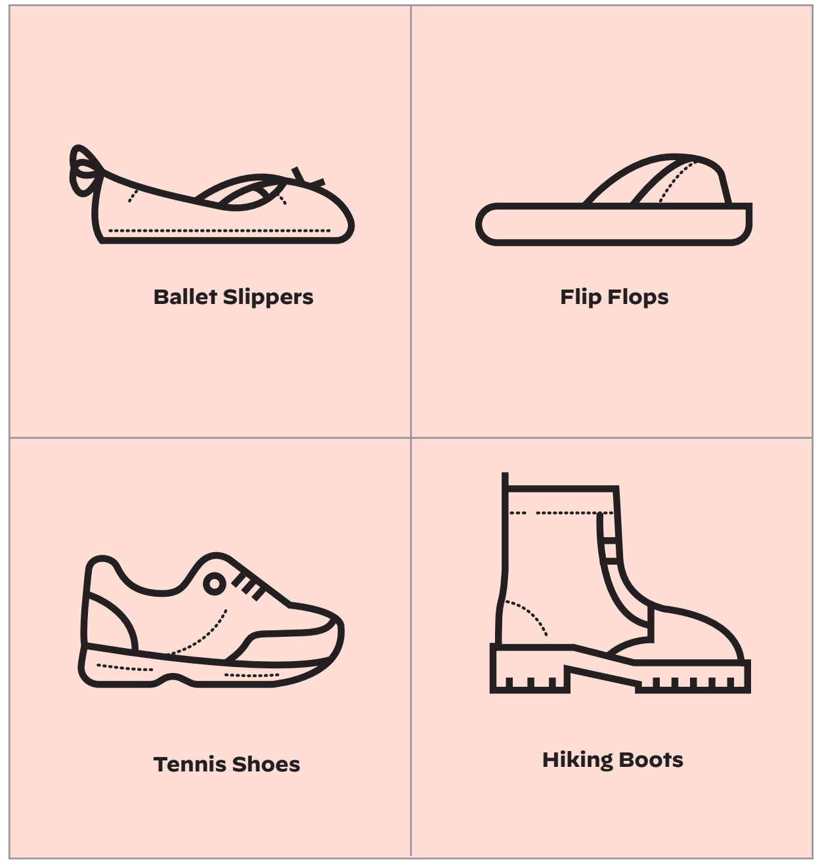
Just like these shoes can tell us something about the owner, similarly your online profile and habits tell a lot about you.

WEDNESDAY - Footprint hunt (adapted from Cyber Aces)
Read the profiles of four different people below.
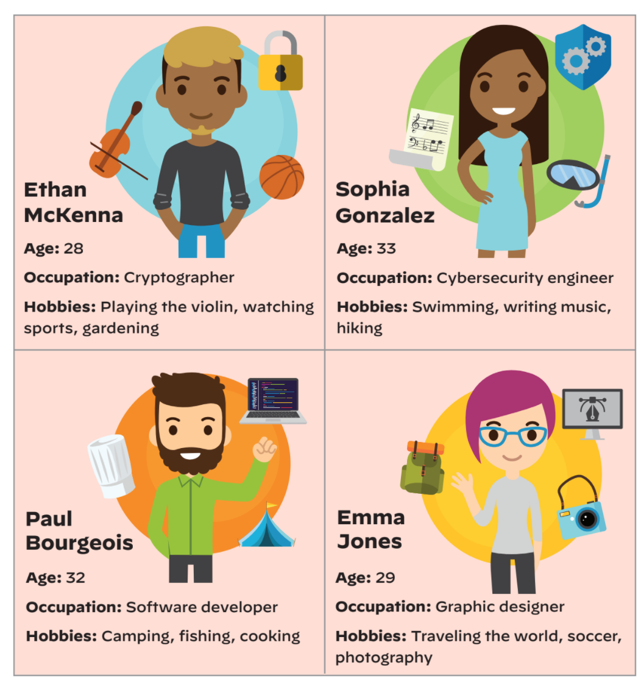
Match these profiles to one of the four digital footprints below:
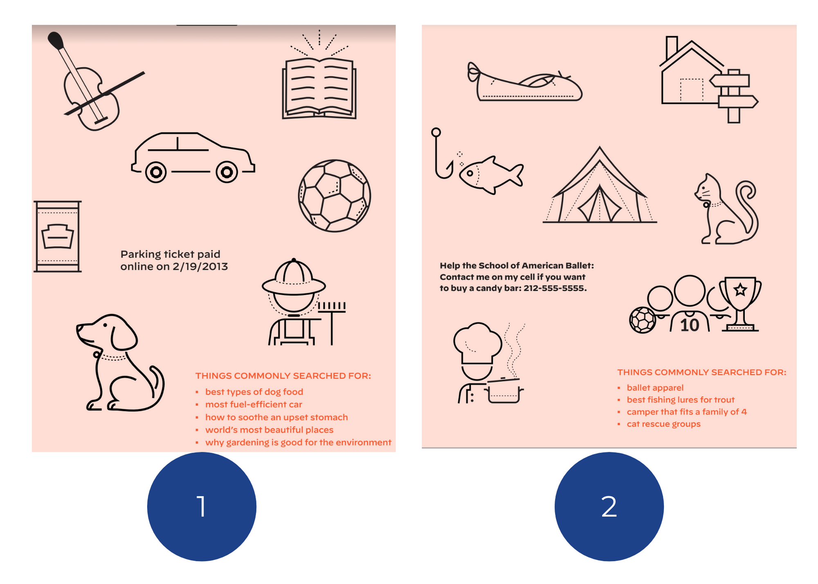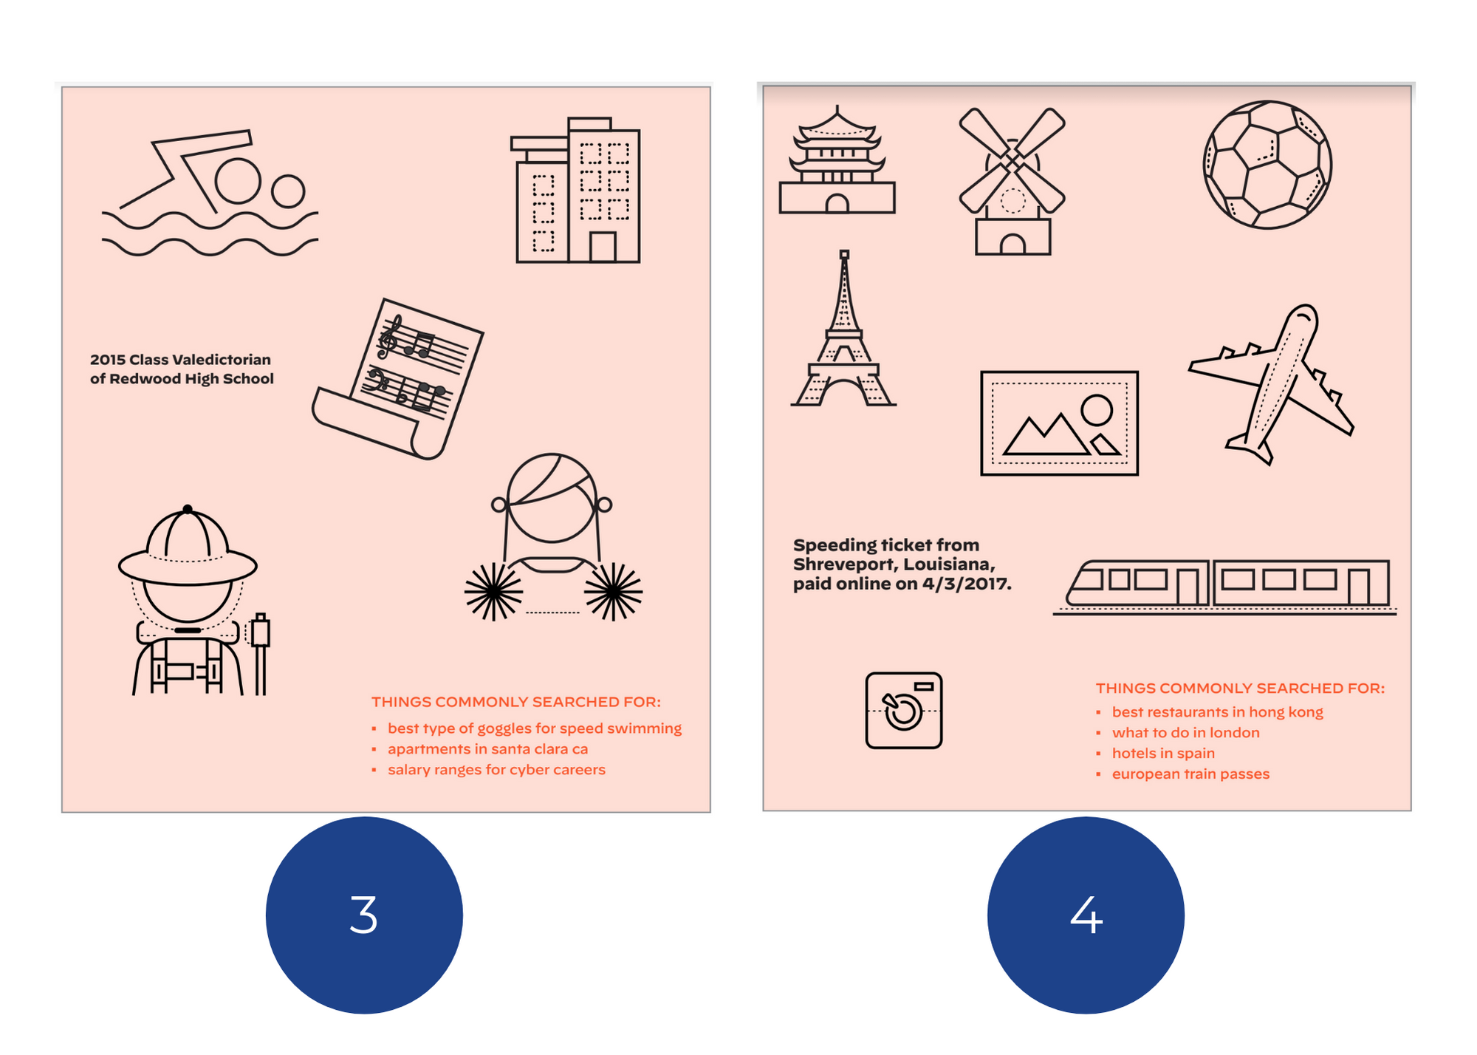

Answer the questions below:
- How did you decide who owned which digital footprint?
- Were you surprised by any particular information in some footprints?
- Talk about whether you think these footprints are permanent or temporary?

THURSDAY - My Footprint (adapted from Cyber Aces)

Take a paper and pencil. Place your foot on the paper and trace its outline and cut it out.

Create your own footprint inside your foot drawing to represent what you want others to know about you. On one side, write or draw things that represent who you are right now. On the back write down things you’re good at and things you like to do.

Remember not to share personal information like your name or your friends’ names.
On the back side, write or draw what you hope people will be able to search the internet for about you in the future.

FRIDAY - Your digital footprint (adapted from eSafety Commissioner)

Visit eSafety’s website - https://www.esafety.gov.au/educators/classroom-resources/be-deadly-online/your-digital-footprint

- Watch the clip- digital footprint
- Watch the video Be Deadly Online “Dumb Stuff”
- What happens when Ryan posts a video of him and his mates clowning around doing dumb stuff?
- What would be one advice you would give Ryan?

