Cybermarvels have strong passwords!

What you can expect to learn
This week we will learn - what a password is, why it needs to be strong and how you can do this using an online game, a physical activity and some writing tasks.

Instructions
The activities below can be completed in any order and you can do all or some of them during the week. At the end of each day, fill in your journal with what you learnt that day and how you will use this learning in the future. You will then be able to use this to create:
- a poster (PDF/word)
- a script for a play (PDF/word)
- an MP4 video
- an MP3 audio
- a website (Google site or similar)
- or write a fictional story to showcase your learning for the whole month (PDF/word).

You can access help for video, audio recording and to write a journal or a story.

Once your teacher has reviewed your work, they can select and submit them to the judge’s panel as an entry to the Be Cybermarvellous Challenge and the best productions will be published on our website.

Week 1: 4 Oct - 8 Oct
Things you need:
- Tablet/ laptop/ PC
- Internet access
- Headphone (optional)
- Paper and pencils/colour pencils
- Ribbon
- Marker pen
- Scissors

MONDAY - How strong is your password? (adapted from Common Sense Education)

A password is a secret string of letters, symbols, and numbers that you can use to restrict who can access something digital. Play the digital passport game- https://www.digitalpassport.org/gate.html

Answer the following questions:
- What is something in your life that you take steps to protect?
- How do you protect it?
- When you use devices, like a phone or computer, how do you limit who can access something that you want to protect, and why would you limit access? (some examples are password-protection, device-lock, fingerprint scanner, not letting others use the device).

TUESDAY - Uh-Oh! If ... Then ... (adapted from Common Sense Education)

Read the two scenarios and talk about/write down what could happen if a password were stolen.

- Scenario 1 - Amy forgets her phone on the bus. IF someone found it and figured out their password to unlock it, THEN what could happen?

- Scenario 2 - Justin writes his email address in his notebook and leaves it open while he goes to the bathroom. IF someone saw Justin’s email address and figured out his email password, THEN what could happen?

- Scenario 3 - Paul goes over to their friend Asia's house to play an online video game. After he leaves, their gaming profile is still saved. Asia's little brother, Ben, turns on the game and sees it. IF Ben figured out Paul’s password, THEN what could happen?

- Scenario 4 - Sarah’s cousin uses the computer at the library to go on social media. IF he forgets to log out of his account, THEN what could happen?

- Scenario 5 - Baxter’s grandpa uses an app to share pictures with his family. IF someone figured out his password to the app, THEN what could happen?

Answer the question below:
- Why do you think it is important to have strong passwords?
WEDNESDAY - I have the strongest password.

A passphrase is a mix of sentences, upper- and lower-case letters, numbers and special characters.

Watch this video - https://drive.google.com/file/d/16WtKPQ19JPe7L4w3fKHKiBd9Bpcus_D0/view
(provided by Phriendly Phishing)

- Now create a strong passphrase. Think about something only you know and then mix it up to make it a strong passphrase.
- Test the strength of your passphrase with the password monster- https://www.passwordmonster.com/. Challenge yourself to make a passphrase that will take over 500 years to crack!
- Use DinoPass to help if your get stuck- https://www.dinopass.com/
- Talk to your parents about who in your family should know your passphrase and if you should use personal information in your passphrase.
- Password tips to remember - fill in the blanks using these words -

parents, password, eight, special characters, private

- Start with a memorable ______________________.

- Only you _________________ should know your password.

- Never use any __________________ identity information in your password.

- Create passwords with at least _____________ characters.

- Use letters, numbers, and ___________________ in your password.

THURSDAY - Password hacker!

Play this game in an open space.

- Take a few small strips of ribbon and give one to each family member.
- Get them to write a secret password on their ribbon with a marker.
- Each person will then hang the ribbon as a tail on them.
- Take turns to run and try to grab the ribbon from your family members.
- The first person to get all in 5 mins wins. There may be two winners: the last person standing with a password and the person who collects the most passwords!
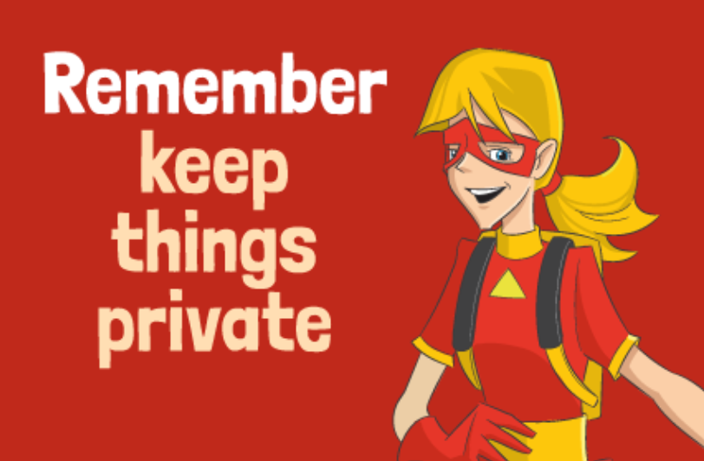
Image from Scootle- QLD DET
FRIDAY - My digital journey (log in to Scootle using your school internet login)
- Go to scootle.edu.au.
- Click on your state education logo.
- Search for S8751 or Your Digital Journey.
- Play the games, watch videos and complete the activities in all four sections:

  - digital citizenship
  - personal and private
  - chatting online
  - cyberbullying.

