Nationally Consistent Collection of Data on students with disability (NCCD)
Data Entry Tips for using ERN
- Prior to Validation (before 5 July)
Refer to the ERN – Disability Adjustment User Guide for detailed instructions on NCCD data entry in ERN. Below are quick tips for the ERN data entry process prior to validation.

How can I access prior year data?
Prior year NCCD data submissions for your school can be downloaded at any time from the Online Data Collection Website (datacollections.det.nsw.edu.au). After logging in, click Current Collections > Historical Data.

How do I complete the “DDA Disability” column?
For students to be included in the NCCD, the school team needs to determine that a student meets the broad definition of disability under the Disability Discrimination Act 1992 (DDA). They must be able to answer “yes” to the question in ERN, “Does the student have a disability under the DDA?”. This applies to all four levels of adjustment. Therefore, a “no” response in the “DDA Disability” column will exclude students from the NCCD.
Students with disability, as defined under the DDA and the Disability Standards for Education 2005, are in all school settings, including regular schools, special schools, and specialist support classes located in regular schools. They include:
- students who may not have a formal disability diagnosis but have impairment that requires an adjustment or can be supported through quality differentiated teaching
- students who have formally diagnosed disability by a health or allied health practitioner
- students with intellectual, physical, sensory and social/emotional disability as well as students with difficulties in learning or behaviour due to disability
- students who are gifted and talented and who are impacted by disability.
Having a disability confirmation or a clinical disability diagnosis is not a condition or requirement to be included in the NCCD, although many students will have one or both. Students with a disability confirmation who are receiving targeted, specialist support (Integration Funding Support or placement in a support class) are only a subset of the students who may be included in the NCCD. For this reason, it is important that schools have processes in place to identify whether the student who is receiving an adjustment meets the DDA definition of disability and the school’s obligations under the Standards.

How do I complete the “NCCD info provided to parents” column?
A “no” response in this column will exclude students from the NCCD. While consent arrangements are no longer applicable, parents and students must have information about the NCCD made available to them. This may be done through the school newsletter or the school website with links to relevant fact sheets.
Refer to the Australian Government Department of Education and Training website (education.gov.au/what-nationally-consistent-collection-data-school-students-disability) for example fact sheets and information notices.

How do I select QDTP in ERN?
To select Quality Differentiated Teaching Practice (QDTP) as the level of adjustment in the ERN – Disability Adjustments data entry screen, select “no” to the first question “Is the student provided with an adjustment?”. This means that support is provided within quality differentiated teaching practice.
This will automatically select QDTP as the level of adjustment (see below):
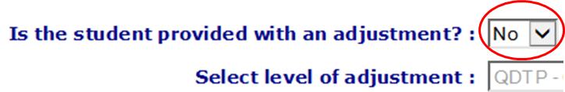

How can I check that ERN records are complete?
Use the “Status” column on the far right of the ERN – Disability Adjustments table to check that all records have been completed as intended (see below). Click the arrow on the “Status” column to group records by status type.
Only “complete included” records will be included in the NCCD. If the column says “incomplete record” or “complete excluded”, the student will not be included in the NCCD. This is because column(s) have been left blank or have a “no” response. Review the data on these records to ensure that this is the intended response.
Note that the “Ongoing adjustment” column is always blanked out at the start of each school year for all records.

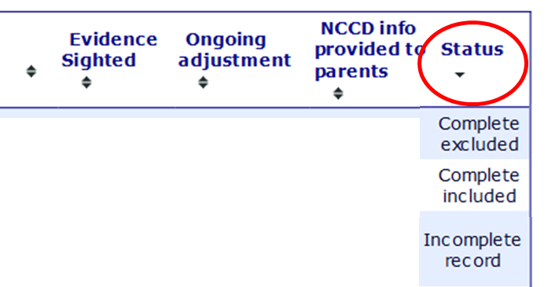

What to do after data is in entered into ERN?
The NSW Department of Education Statistics Unit will take a snapshot of data in ERN – Disability Adjustments on validation date (19 July 2019). This snapshot will be posted on the Online Data Collection Website (datacollections.det.nsw.edu.au) on 22 July 2019.
During the validation phase, schools will have two weeks to review the data in the Online Data Collection Website and make any changes in ERN as required before the census date (2 August 2019, 5pm). Schools will “sign off” in the Online Data Collection Website before census date to signal to the Statistics Unit that the validation phase has been completed.
It is important to note that there is no link between ERN and the Online Data Collection Website. Changes made in ERN are not automatically updated.
Changes made to ERN data between the validation phase and census date will not be reflected on the Online Data Collection Website until the 5pm on the census date itself.
Refer to the Tips for the Validation Stage and Tips for the Census Stage for more information on the next stages of the NCCD.
For more information contact
NCCD Helpdesk
9244 5178 or 9244 5587
nccd@det.nsw.edu.au
education.nsw.gov.au/teaching-and-learning/disability-learning-and-support/personalised-support-for-learning/national-disability-data-collection

