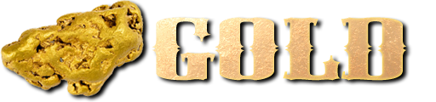

**Country of origin table: Australia’s population in 1851 and 1861**

|  |  |  |
| --- | --- | --- |
| Place of birth | 1851 | 1861 |
| England | 172,241 | 2,530,638 |
| Australia | 154,347 | 322,903 |
| Ireland | 89,865 | 141,989 |
| Scotland | 52,377 | 78,923 |
| Wales | 2,326 | 7,433 |
| Other British colonies | 6,934 | 11,499 |
| China | 4,147 | 37,720 |
| Germany | 9,200 | 15,885 |
| United States of America | 3,699 | 3,621 |
| France | 1,480 | 1,940 |
| Other foreign countries | 1,945 | 10,126 |
| Unspecified | 1,901 | 5,405 |
| **Total** | **500,462** | **3,168,082** |