V:\2009_122_Connected_Learning_in_Distance_Education\Production\02_master\lo\13286\graphics\aim_three.png

When Governor Hotham arrived in Victoria in June 1854 he discovered a colony that was in crisis. Many diggers wanted the gold license abolished immediately. However, the Governor realised that the colony needed money for public works and a tax on gold was a means of raising that revenue.

Watch the [video clip](https://aso.gov.au/titles/documentaries/riot-or-revolution/clip1/) (Flash required) and answer the questions.

1. How did the government raise revenue before the gold rush?

2. What did the diggers at the Bendigo goldfields ask Governor Hotham to do?

3. What was Hotham’s main concern about the miners’ request?

4. What did Hotham say he would try to do?

5. What had the previous Governor La Trobe done, when protests against the mining tax grew?

6. Why was the government having so many difficulties running the goldfields?

7. Why was Hotham concerned about the miners avoiding the license?

8. What was Hotham’s main issue?

9. What did Governor Hotham mean when he said:

‘Obedience must be rendered or government is at an end.’?

10. What unwelcome change did Hotham make after his tour of the goldfields? What was the result?

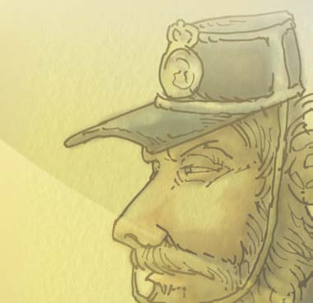Why were the miners resentful of men like the one in the image?