[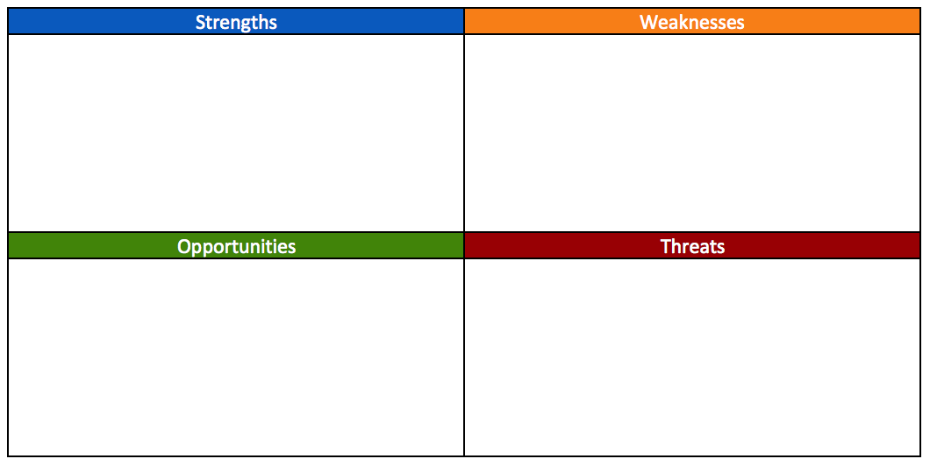](https://www.google.com/url?sa=i&url=https%3A%2F%2Fwww.aha.io%2Froadmapping%2Fguide%2Ftemplates%2Fswot-analysis&psig=AOvVaw1Ys3_aircIvIgCXVVf1htJ&ust=1582605496179000&source=images&cd=vfe&ved=0CAIQjRxqFwoTCLjR14Wv6ecCFQAAAAAdAAAAABAD)

When we talk about inclusion, who are we talking about in our school setting?



**Our school context**