My identity

Unit overview
Students explore their own identity in an artwork. They seek inspiration in self-portraits by Australian painters who include symbols of their identity. Students combine drawing, painting, collage and printing in a mixed media artwork, discovering how artworks can be built up through layering images.

Subject matter
People, objects.

Forms
Drawing, painting, printmaking.

Duration
3 to 4 weeks.

Resources
Enter art
- Portrait in the mirror, Margaret Olley, image no.13
Beyond the frame
- Self Portrait, Kieran Hall, image no.13
Other
- screen for printing
- screen printing inks or paint
- squeegee
- litho paper
- newspaper
- scissors
- crayons
- acrylic paint or Edicol dyes
- brushes
- glue
- small personal objects

Outcomes and indicators

Making
VAS 3.1 – investigates subject matter in an attempt to represent likenesses of things in the world.
- Explores the convention of self-portraiture as a means of showing identity.
VAS 3.2 – makes artworks for different audiences assembling materials in a variety of ways.
- Experiments with layering in printing and collage.

Appreciating
VAS 3.3 – acknowledges that audiences respond in different ways to artworks and that there are different opinions about the value of artworks.
- Talks about the meaning of artworks recognising how self-portraits can be interpreted in different ways.
VAS 3.4 – communicates about the ways in which subject matter is represented in artworks.
- Discusses the artist’s intentions in regard to his or her representation of self.
Outcomes and other elements of the syllabus used in this document are copyright.
Creative Arts K-6 Syllabus © NSW Education Standards Authority (NESA) for and on behalf of the Crown in right of the State of New South Wales, 2006

Learning experience 1

Appreciating artworks
- Compare Portrait in the mirror by Margaret Olley and Self Portrait by Kieran Hall.
- Identify similarities and differences in subject matter, composition, media and techniques. In these self-portraits, both artists have placed themselves with objects that are significant to them.
- Identify these objects in the artworks.
- What do they tell us about each artist’s life and interests?
- What has each artist done that is unusual or imaginative in these self-portraits?
- What types of colours has each artist used?
Note – consider warm, cool, bright and primary colours.
- How have the artists created likeness or reality?
Note – in discussing likeness, students consider tone, size, solidness, roundness, modelling, scale, proportion and detail.
- How has each artist arranged objects and used space?
- Which portrait do you prefer and why?
Note – discuss grouping or spreading of objects, open space and focal points.

Making self-portrait drawings
- At home, look in a mirror to study facial features and draw a self-portrait in pencil.

Learning experience 2

Making mixed media artworks about self
- Create a mixed media composition about self-incorporating printing, painting, drawing and collage.
- Collect small personal objects that reveal something about school life, culture or lifestyle such as a report card, sports ribbons or medallions. These objects can be photocopied.
Note – colour the photocopies of objects with diluted paint or Edicol dyes.

Making screen prints – background and shapes
- Refer to Hall’s painting. Design a composition that employs space in a similar way.
- Create two large horizontal areas of colour which provide the background for the composition. Where these areas meet, have them overlap by 2-4cms. The overlap area will provide a table or bench surface on which to place objects.
Note – sketch an outline of the structure of the works on the board indicating the two large areas of colour to be printed and include the overlap area.
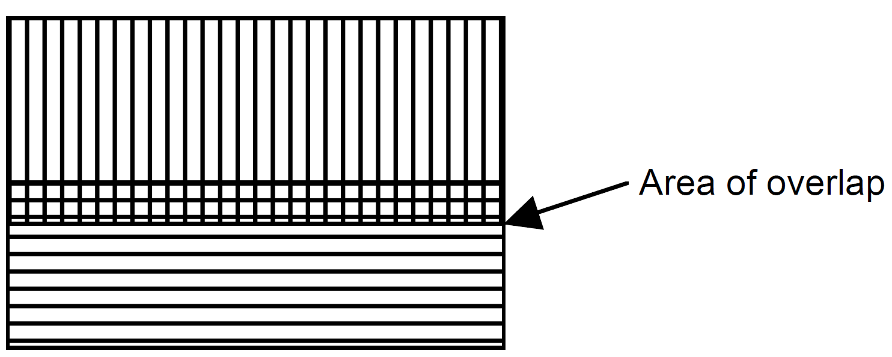
- Cut separate stencils for each large colour area.
- Print the areas of colour employing overlapping.
- Allow the work to dry between printing each colour.
Note – demonstrate cutting the stencils (allow for overlap) and using the squeegee to print.

Making drawings
- Make line drawings of personal objects (these may be sketches or continuous line drawings) as seen from the side from eye level.
Note – the drawings might be in pencil, crayon or felt pen.

Making self-portrait paintings
- Make a small painting from the drawn self-portrait.
- Cut out a shaped frame from coloured paper squares.
Note – if larger self-portraits are painted, these can be photocopied and reduced, then coloured with diluted paint.

Making collages about self
- Position the painted portrait, drawings, and drawings, or photocopies of drawings of personal objects on the printed background. Try various arrangements before fixing the images to the artwork.

Appreciating – reflecting
- Write an account of the screen-printing process (procedure).

