Online and device based gambling
Suggested duration: 60 minutes
This is one activity in a sequence designed to challenge students to develop a stronger understanding of gambling and the ways in which it presents risks for young people across all socio-cultural groups. This activity aims to explore how gambling has evolved and changed with the adoption of online gambling and smart phone apps. It empowers students to recognise that gambling is not a game and being good at gaming does not mean you will be good at gambling. These resources were developed in collaboration with the NSW Office of Liquor, Gaming and Racing.
The activity sequence includes four lessons.
- Some truths about gambling
- Sports betting and advertising
- Online and smart phone gambling
- Gambling – seeking help

Course outcomes
3.2 Analyse the positive and negative implications of technology and digital media on self-concept, independence, relationships and health behaviours.
3.1 Evaluate how contextual factors influence attitudes, values and behaviours.
5.1 Critically analyse situations, attitudes and behaviours that influence independence, health, safety and wellbeing in different contexts.
5.2 Recognise and respond appropriately to situations which may be limiting or harmful to self and others.
7.2 Demonstrate the capacity to seek help for self and others.

What do we want students to know, understand or be able to do?
- Demonstrate an understanding of the real-world consequences of online and mobile based gambling.
- Challenge the notion that those who are successful at gaming will have success in gambling.
- Encourage others to remember that gambling is not a game and promote positive health behaviours in relation to technology use.
- Recognise that gambling and online gaming addiction can be a serious condition, which can impact on our relationships with others.
- Identify the differences between gambling, both online and in person, and gambling problems or addiction.
- Conflicts and communication issues can often occur as a result of people’s gambling behaviours.
- Develop skills to take control of their own gambling or gambling behaviours and respond appropriately to others.
- Recognise that many young people may struggle with parents or caregivers who have gambling addictions.
- Identify sources of help and support for those with family or friends affected by gambling addiction.
- Develop skills in saying no to gambling in risky situations or at costs young people are not comfortable with.
- Develop an understand of the way in which technology has changed gambling in terms of ease of use and accessibility for young people.
- Discuss consequences of access to apps and online sites for gambling which all young people could have access to.
- Develop skills in safe use of technology and recognising the true risks involved in gambling online, including use of mobile gambling applications.

Suggested content
Learning context | Content
Independence  Focus: Building self-concept and independence | Personal values and beliefs  - influences on values and beliefs, e.g. technology, social and cultural norms, media, family, relationships  - influence of values, attitudes and beliefs on decisions and actions in various contexts  Digital competencies  - online safety, e.g. digital footprint, scams, security, bullying and harassment  - positive and negative influences of technology, e.g. online communities, connecting with others, gaming, body image
Drugs and alcohol  Focus: Making safe and responsible choices | Responsible behaviour  - gambling responsibly
Relationships  Focus: Developing and maintaining respectful relationships | Applying relationship skills in differing contexts  - refusal skills in different contexts and situations

Teaching notes

Online and smart device gambling
Within the last decade the face of gambling has changed extensively. The physical barrier of not being able to legally enter licensed premises, access a TAB or find a bookmaker right before an event is no longer a reality. Young people now have access to gambling 24 hours a day, 7 days a week, online and through mobile devices including phones and tablets.
Online gambling is the fastest growing form of gambling. It does not have the inbuilt mechanisms or regulations that clubs, casinos and venues have to ensure that young people are not gambling before the legal age of 18.
Gambling apps are making it more socially acceptable to engage in gambling, in particular sports betting, which was explored in lesson two. There has also been the emergence of online games and applications which engage people in ‘simulated’ gambling activities in which people win credits rather than money. Research indicates that many of these activities may make it easier for young people to transition into gambling for real money when they have the capacity and resources. In app purchases also mean that games with credits can be transited into games for real monetary amounts. Exposure to simulated games has increased with the rise of video games which recreate casino style games to allow young people to place “bets” for large amounts of money.
More information on online and smart phone betting can be accessed via the Victorian Responsible Gambling Foundation at kidbet.com.au/research-resources.

Creating a safe and supportive learning environment
There are a number of strategies that can be used to create a supportive learning environment which enables students to feel safe to learn and ask questions. They include:
- making students aware at the beginning of Life Ready sessions that disclosing personal information that indicates they may be at risk of harm will be reported to the school principal in all instances. This includes personal disclosures related to instances of abuse, drug use, neglect or sexual activity under the legal age of consent.
- being aware that some parts of Life Ready can be confronting and sensitive for some students.
- enabling students to withdraw if they find issues personally confronting to protect them from making harmful disclosures. Equally, it is important to be prepared for issues that arise as a result of a student making a public disclosure in the classroom.
More information on creating a safe and supportive learning environment can be found on the Life Ready website.

Evaluating resources before use
Preview and evaluate all strategies, resources and teaching and learning approaches in full before use with students to determine suitability for student learning needs, stage of development and local school context. Consider the age, maturity, cultural background, sexuality, gender, sex, health and other characteristics of students in your care. Apply professional judgements to all strategies, teaching and learning approaches and resources including audiovisual materials (e.g. videos, media clips and YouTube), interactive web-based content (e.g. games, quizzes and websites) and texts.
Use the resource review flowchart to decide about the suitability of teaching and learning resources.
Materials should be reviewed in full and endorsed by the school principal before use in NSW government schools.

Communication with parents and caregivers
Some aspects of Life Ready may be viewed as sensitive or controversial, such as learning about abuse, child protection, drugs, respectful relationships, sexual health, sexuality and violence. Inform parents and carers, prior to the occasion, of the specific details of the Life Ready program, so that parents and caregivers have time to exercise their rights of withdrawing their child from a particular session. In this regard, a parents or caregiver’s wish must be respected.
Establishing how parents and caregivers will be informed about programs and involved in consultation is a school-based decision. Where parents and caregivers indicate they wish to withdraw their child from a program it is useful to negotiate which parts of the Life Ready program they are concerned about. A sample information letter is available on the Life Ready website.

Learning experiences

Activity one – The changing face of gambling (15 minutes)
Students use a Venn diagram to make a list of:
- the ways people engaged in betting or gambling 20 years ago
- the ways people can engage in betting and gambling today
Remind students that betting and gambling can include:
- online gambling games
- sports betting
- apps for gambling, gaming or sports betting
- games that use credits like a casino
- casino style video games
- poker machines
- casino table based games
- venue specific gambling activities, e.g. 2 up on ANZAC day, Bingo/ KENO
- lotto, lotteries, Scratchies
As a whole group, discuss the similarities and differences between gambling methods across the decades.
Ask students to propose reasons for the similarities and differences.
- What has resulted in the changes? (e.g. technology, internet, increase in mobile devices, marketing and promotion of easily accessible methods of gambling, boom in sporting events, increased media coverage of some sporting events)
- What makes some methods sustainable and long term? (e.g. tradition, sporting culture (Melbourne Cup), popularity of sports and events, promotion and marketing, venue reliance on methods such as poker machines, increased venues and casinos, online versions of traditional methods increase interest such as casino games).
- How have the changes in gambling and betting impacted the way young people engage with gambling?
- What are the concerns and issues for young people?
- Are parents, teachers and society in general aware of these issues?

Activity two – Sucked in (10 minutes)
This activity encourages students to explore the ways in which some young people can be “sucked in” to a regular habit of gambling by social media, gaming and advertisements.

Students work in pairs with the Sucked in worksheet to explore the ways that young people can be drawn into gambling behaviours. Record the strengths, skills and strategies young people can call on to avoid high-risk gambling habits and promote responsible behaviours.
After completing the Sucked in worksheet, invite students to share their suggestions with the whole group.

Activity three – Gambling and gaming (15 minutes)
Students are given access to “Gaming grooms teens for gambling” an article written by Jason Dowling published in the Sydney Morning Herald on May 19th 2013.
After reading the article as a group or on their own, ask students to respond to the following:
- explain the growing theory that there may be a possible connection between gaming and gambling.
- from the article, what are the implications and concerns about the inability to lose while using free gaming or poker machine replicating apps? What false belief might young people using these apps develop?
- discuss why males may use these gambling style apps more than females?
- outline the ways in which apps in the article have attracted young people to gambling?
Use a strategy that encourages students to work in pairs or small groups to openly discuss their position on a series of statements. To encourage multiple perspectives and viewpoints assign perspectives to students, including young, old, male, female, different occupations, parents/ carers, and grandparents. Example strategies include:
Stay and stray — Students stand in groups of three spread within the space of the room. Number students 1, 2 and 3 in each group. Students are allocated 20 seconds only to make their case on the statement before the next person (person 2, then person 3) states their case. Students must actively listen to other students in their group and are not permitted to interrupt. After all students have had a chance to speak ask person 1 to rotate clockwise to another group, person 2 stays and person 3 rotates anticlockwise to another group. Repeat the process with a new statement.
Parallel lines — Students stand in two parallel lines facing each other. Students are allocated 20 seconds only to make their case on the statement before swapping roles and their partner making their case. Students must actively listen to other students and are not permitted to interrupt. After both students have had a chance to speak ask person 1 to move to the left or remain where they are (depending on numbers) and person 2 to move to the right to a new partner. Repeat the process with a new statement.
Fish bowl — Create a circle of 10-12 chairs (“the fishbowl”) and enough room around the circle for remaining students to observe what is happening in the “fishbowl.” Typically six to twelve chairs allows for a range of perspectives while still allowing each student an opportunity to speak. Half the class sit in the fishbowl for 5-10 minutes and then call “switch,” at which point the listeners enter the fishbowl and the speakers become the audience. Another common fishbowl format is the “tap” system, where students on the outside of the fishbowl gently tap a student on the inside, indicating that they should switch roles. Before beginning the fishbowl, review guidelines for demonstrating respect and having a respectful conversation with both speakers and observers, including no interruptions, respectful language used and speaking times.
Statements
- Most young people see gambling as a game.
- Gaming apps do not entice young people to try gambling or betting.
- The legal age for gambling should be raised to 21 years.
- Advertising and campaigns always challenge people to think about their gambling habits.

Activity four – Owning your own gambling (20 minutes)
In this activity young people reflect on how they could monitor gambling and gaming behaviours. Students should consider both the positive and negative experiences and outcomes associated with gambling. This includes both the social and emotional benefits of enjoyable gambling experiences in occasional settings and the consequences of high-risk gambling behaviours.
In pairs, student discuss:
- are all forms of gambling highly risky and problematic?
- what might influence an individual’s ability to assess risk and notice signs of high risk or problematic gambling? Is it always possible to tell?
- what can individuals, families, communities, organisations, services and governments do to ensure that gambling habits don’t become a problem?
In pairs or small groups students review the scenarios and answer the questions.

Scenario 1
Alex enjoys playing the pokies at the local Leagues Club with friends after football matches. Alex usually puts $3 into the machine and doesn’t struggle to stop when the money is gone. Alex has had a few wins, but also understands the high likelihood of losing.
Questions:
- does Alex have a gambling problem?
- could Alex’s behaviour develop into a problem? How?

Scenario 2
Aki loves to watch NRL and backs the Bulldogs every week. Aki plays in a tipping competition with some friends from both school and work. It was $75 to register with the person with the highest point winning the pool of money at the end of the season. The boss tells other employees Aki has a strong chance of winning which encourages Aki to enter even if the cost is higher than expected.
Questions:
- does Aki have a gambling problem?
- could Aki’s behaviour develop into a problem? How?

Scenario 3
Sam loves sport and follows lots of different events, leagues and matches. Sam watches both local and international matches and has backed a few winners. Sam bets through an online betting app shared by his brother. Sam usually only bets what he can afford to lose and believes he has never lost much.
Questions:
- does Sam have a gambling problem?
- could Sam’s behaviour develop into a problem? How?

Scenario 4
Casey games online every night and on the weekends. Casey needs a new challenge and has heard about a new game through social media. Others at school have been playing and telling Casey how good it is. A credit card is needed to join the game. Casey considers using a parent’s card, although this would not be allowed.
Questions:
- does Casey have a gambling problem?
- could Casey’s behaviour develop into a problem? How?
Discuss the scenarios as a whole group.
As a group, identify a number of strategies that could be used to maintain responsible gambling habits and prevent sports, gaming or social habits turning into a gambling problem. Suggestions may include:
- use an online filter like Gamblock and Betfilter to keep gambling games from popping up.
- go into TABs for betting rather than using apps or online sites to limit your time frames for gambling.
- don’t gamble alone, this is when you’re more likely to keep going past the point of having fun and enjoying yourself.
- avoid online or app based games that draw you into higher and higher stakes or habits.
- ask others to keep you accountable.
- don’t take more money to night’s out than you can afford to spend.
- don’t play or gamble under the influence of drugs or alcohol as it reduces ability to make clear decisions.

Teacher notes – Gambling
As young people are particularly vulnerable to the normalisation of gambling through exposure to sports betting advertising, gambling products, gambling in the home and the increase in the availability and accessibility of gambling, education is an important part of awareness raising.
It is illegal for anyone under the age of 18 to gamble, including Lotto, Scratchies and online gambling.

Young people and gambling
Many people in NSW and across Australia gamble by playing poker machines, betting on sporting events, buying lottery tickets or playing casino games. For most people gambling is an occasional social activity that causes no harm. For others gambling can become a problem and have a negative impact on their social, emotional, mental and financial health.
In 2009, 70% of Australians engaged in some form of gambling and spent over $19 billion on gambling, around $12 billion of which was spent playing the poker machines. Some people who engage in this type of gambling can have serious gambling problems and at present over 500,000 Australians are at risk of, or are, problem gamblers. The Australian Government estimates that only 15% of those affected by gambling problems seek help, and the actions of one problem gambler affects the lives of between 5 and 10 other people. Problem gamblers lose around $21,000 each year which reflects a large portion of the average Australian salary (http://www.problemgambling.gov.au/facts/).
For young people gambling is often presumed to be a small risk due to low access to licensed venues in which gambling takes place. However, this belief does not take into account the ways in which gambling has changed over the last decade and fails to recognise the influence of gambling advertisement on young people. According to the Victorian Responsible Gambling Association, the latest research shows that simulated gambling on social media, video games, smartphone applications and online betting are key issues for young people under 18. The NSW Office of Liquor, Gaming & Racing (OLGR) further suggest that the proliferation of online and mobile channels and the normalisation of gambling through advertising within sport have changed the way young people are exposed to and impacted by gambling.
Recent studies indicate that 77% of young people between the ages of 10 and 24 years of age engaged in gambling over a 12-month period (Australian Council for Educational Research Ltd, 2011). This indicates a far higher proportion of young people engaging in gambling than many other forms of risk taking including alcohol use, smoking and illegal drug use. Further studies indicated that between 3-5% of these young people would be classed as problem gamblers and as many as 19% were considered “at risk” (Australian Council for Educational Research Ltd, 2011). Not surprisingly, many problem gamblers first developed gambling habits while still in their teenage years and have continued to engage in risky levels of gambling well into their adult life.
Most under-age gamblers are introduced to gambling by a family member, and having a parent who gambles or friends who are involved in gambling may further increase the risk of problem gambling among young people (Australian Clearing House for Youth Studies, 2013). Not only would young people ‘likely benefit from school-based intervention and prevention programs aimed at changing idiosyncratic belief systems and superstitious beliefs connected to gambling behaviours’ (Taylor et al., 2014), but it is important that parents, carers, community leaders and educators have an understanding of the current gambling environment to enable them to minimise young people’s exposure to harm.
The proliferation of online and mobile gambling channels and the normalisation of gambling through advertising within sport have changed the way young people are exposed to and impacted by gambling. For young people who follow sport, gambling promotion is a normal part of lived experience. Ground signage, team uniforms, gambling statistics quoted by commentators and scheduled advertising all add to the ubiquity of the message on both television and radio.
A study by Ebiquity noted that in 2012, there were 528 individual online betting advertisements on free-to-air television, shown more than 20,000 times, primarily during family viewing time, with airings on pay-television estimated as many times higher.

Sucked in – Worksheet

How can young people be drawn into gambling?
Working with a partner, complete the following image by listing 3 methods to show how you think young people could be drawn into regular habits of gambling.
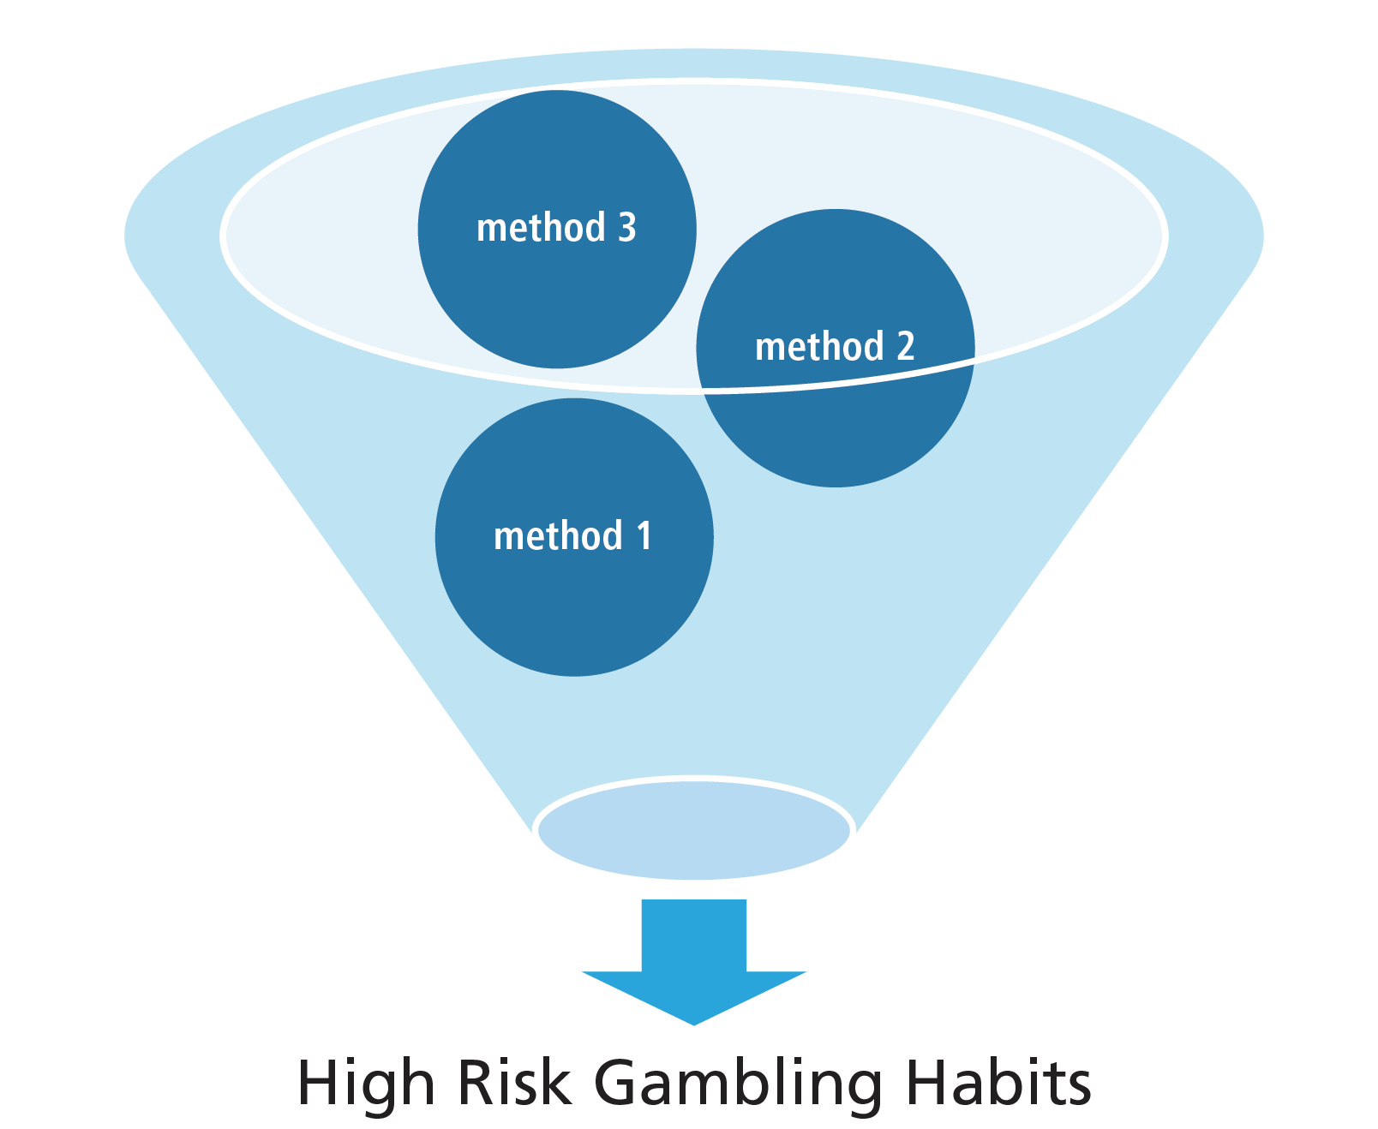
What can be done to encourage responsible behaviours when young people choose to engage in gambling and betting and avoid young people from being sucked into high-risk gambling habits? Consider the strengths, skills and strategies young people can call on to avoid high-risk gambling habits.

Gaming grooms teens for gambling - Article
Jason Dowling, Published: May 19, 2013 — 3:00AM, Sydney Morning Herald
Teenage fans of video games that simulate gambling are more likely to convert their habits to real losses, according to new research. A study of the gaming habits of 13 to 17-year-olds by the University of Adelaide found more than a quarter of teens have played gambling-style video games, while nearly one in 10 have played gambling games on social media, and about one in 20 had played them on mobile phones.
A smaller number, about 2 per cent, said they had tried to gamble with real money on the internet. Dr Daniel King from the university’s school of psychology led the research and said young people who engaged in the non-financial gambling online were three times more likely to report also gambling with money — “you see this association between the two’’. About 40 per cent of teenagers who played online or digital gambling games reported a future intention to gamble with money, he said.
Dr King will be in Melbourne next week to speak at a summit addressing the impact of video games on young people and, in particular, the infiltration of gambling into video games and apps. He said one of the problems with non-financial gambling games was they could give young people the wrong impression about gambling.
He said he downloaded three poker machine apps that did not require real money to play. “I tried to lose money and it’s impossible. That is one of the concerns about these types of games — they misrepresent the odds of gambling.’’
Many free gambling games have appeal for a youth audience and include advertisements for real gambling sites, and there are often no barriers to entry, Dr King said. “There’s no age verification, there is no data coming out [from the] industry on whether young people are using these apps.’’
The research found males were twice as likely to play gambling games than females. In March, Communications Minister Stephen Conroy said the government would not be licensing online tournament poker or online “in play’’ sports betting before “a nationally consistent approach to harm minimisation and consumer protection’’ was agreed on.
He said a review into Australia’s Interactive Gambling Act released this year “identified concerns in relation to casino-style gambling simulations being accessed through a variety of platforms, including social media, and the potential risk that this may pose to children’’.
Next week’s summit in Melbourne is being organised by Manningham YMCA Youth Services as part of Gambling Awareness Week. The youth service last year conducted a study of available research into the impact of video games on young people. It found 94 per cent of six to 15-year-olds play video games and between 3 per cent and 15 per cent could be characterised as addicted.
Study author and manager of Manningham YMCA Youth Service Steven Dupon said excessive use of video games had been linked to mental health issues, in particular depression and anxiety. Out of the report the service launched a project that aims to provide parents and young people with information about video games, increase social interaction between gamers, increase safety in online gaming by creating a safe server that is regulated and monitored, and create opportunities for young game developers to increase their skills.
Mr Dupon stressed they were not anti-gaming; instead, they wanted to minimise any harmful effects of gaming on young people.
This story was found at: www.smh.com.au/national/gaming-grooms-teens-for-gambling

