Teaching strategies used in Vocal Ease MORE (Module 1)
Vocal Ease More

Commonly used music education strategies
- This section includes the most commonly used teaching strategies in Vocal Ease MORE. These are commonly used in most music education lessons. This list is not exclusive to this resource and it is also not exhaustive. There are many other strategies that can be used, these are just suggestions.

Key to icons

Concepts of Music
Duration
Pitch
Dynamics
Tone colour
Structure

Learning experiences
Performing
Organising sound/composition
Listen

Strategies used
Teaching and learning strategy | What it teaches | How to use | Sample piece in Vocal Ease MORE | Learning Experience | Musical Concept
Beat keeping | How to maintain the beat and the difference between beat and rhythm. | Body percussion  Instruments  Stick passing games  Clapping games  Bounce a ball  Pass the beat around a circle with a clap or an object. | All
Movement | Add movement as a way of reinforcing all musical concepts | Step the beat  Change movement to reflect the differences of phrases, instruments or timbre, sections or structure, pitch, rhythms, styles, dynamics  Use scarves, elastics, ribbon sticks, representative objects. | All
Call and response | For teaching new materials of any kind.  Improvisation | Clap, sing, say or play a new phrase or section of a song for students to echo or respond to  Clap or play a new rhythm or melody. Students respond with the same or improvised answer or response. | All
Rhythmic accompaniment | Using rhythm to accompany a piece and add interest. Using an ostinato. | Use speech, sentences or words  Ostinatos using words of the song or sentences or phrases  Instruments  Environmental percussion such as tables or chairs. | Rubbish Rap  Issunboshi  When the Clouds/A Wonderous Place  Where the Creatures Roam
Rhythmic improvisation | Creating own rhythm patterns whilst maintaining a steady beat. | Call and response  Create own rhythms as a combined group or in pairs  Taking turns to create own rhythms always with a pulse underneath  Create rhythmic patterns to a set number of beats  Use stick notation cards and mix up the cards to create different rhythms  Use symbols to notate and read  Box ‘conversations’. | Rubbish Rap  Issunboshi  When the Clouds/A Wonderous Place  Where the Creatures Roam
Melodic contour | Following the changes in pitch. | Use scarves, balls, parachutes, elastics to move up and down as a group or individually to follow the changes in pitch provided by the melody  Use hands to map the contour  Use a pen on a smartboard to replicate a melody or to create a melody  Follow a ‘conductor’ finger to create a melody. | Issunboshi  When the Clouds/A Wonderous Place
Melodic accompaniment | Exploring ways of adding harmony. | Partner songs  Rounds  Drones  Melodic ostinatos  Chords  12 bar blues. | Issunboshi  When the Clouds/A Wonderous Place  Where the Creatures Roam  Boogie Woogie Woogie Woogie Boogie
Melodic improvisation | Creating own melodies to suit the music.  Using the pentatonic scale – your new best friend!  12 bar blues | Start with a limited range of pitch such as one note or two and experiment with changing rhythms with each note or in combination  Major pentatonic scale - 1, 2, 3, 5, 6  C Major - C, D, E, G, A  E minor - E, G, A, B, D  Notes within a chord as indicated on the music  12 bar blues – follow the notes of the chord.  In C Major - C, C, C, C, F, F, C, C, G, F, C, C. | Issunboshi  When the Clouds/A Wonderous Place  Where the Creatures Roam  Boogie Woogie Woogie Woogie Boogie
Composing and organising sound through a soundscape | Learning different ways of experimenting with sound to create or arrange a composition. | Using a visual image for inspiration of composition  Use a text to inspire  Technology such as looping or layering apps  Topics or themes  Environmental issues. | Rubbish Rap  Where the Creatures Roam
Graphic notation | Creating and reading graphic notation which can lead into traditional notation. | Following a symbol or stick notation score. | Rubbish Rap

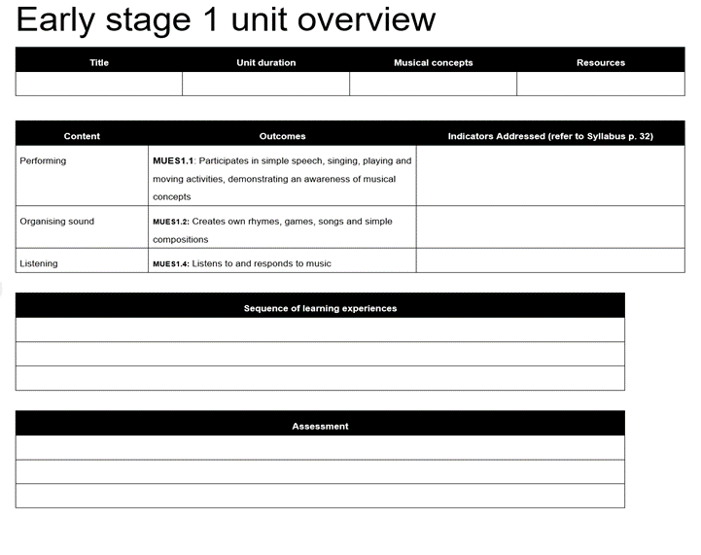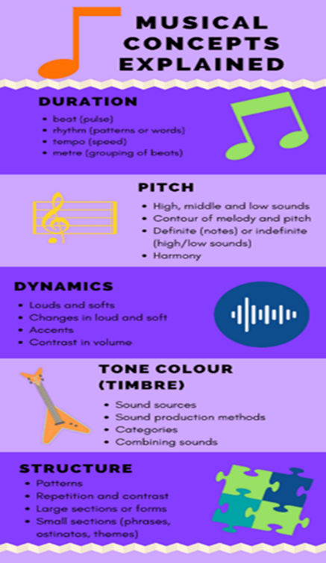

Melodic best friends

E minor pentatonic scale
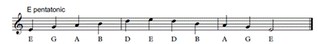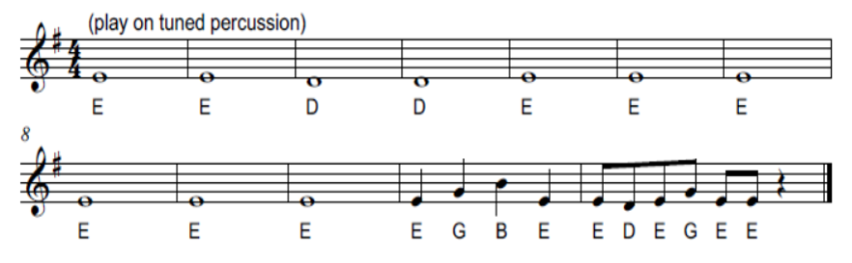

C pentatonic scale
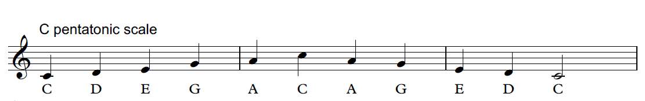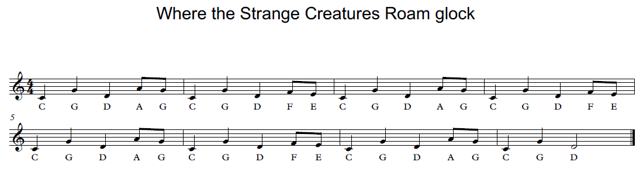

C 12 bar blues
Bar | 1 | 2 | 3 | 4 | 5 | 6 | 7 | 8 | 9 | 10 | 11 | 12
Chord | I | I | I | I | IV | IV | I | I | V | IV | I | I
Note | C | C | C | C | F | F | C | C | G | F | C | C

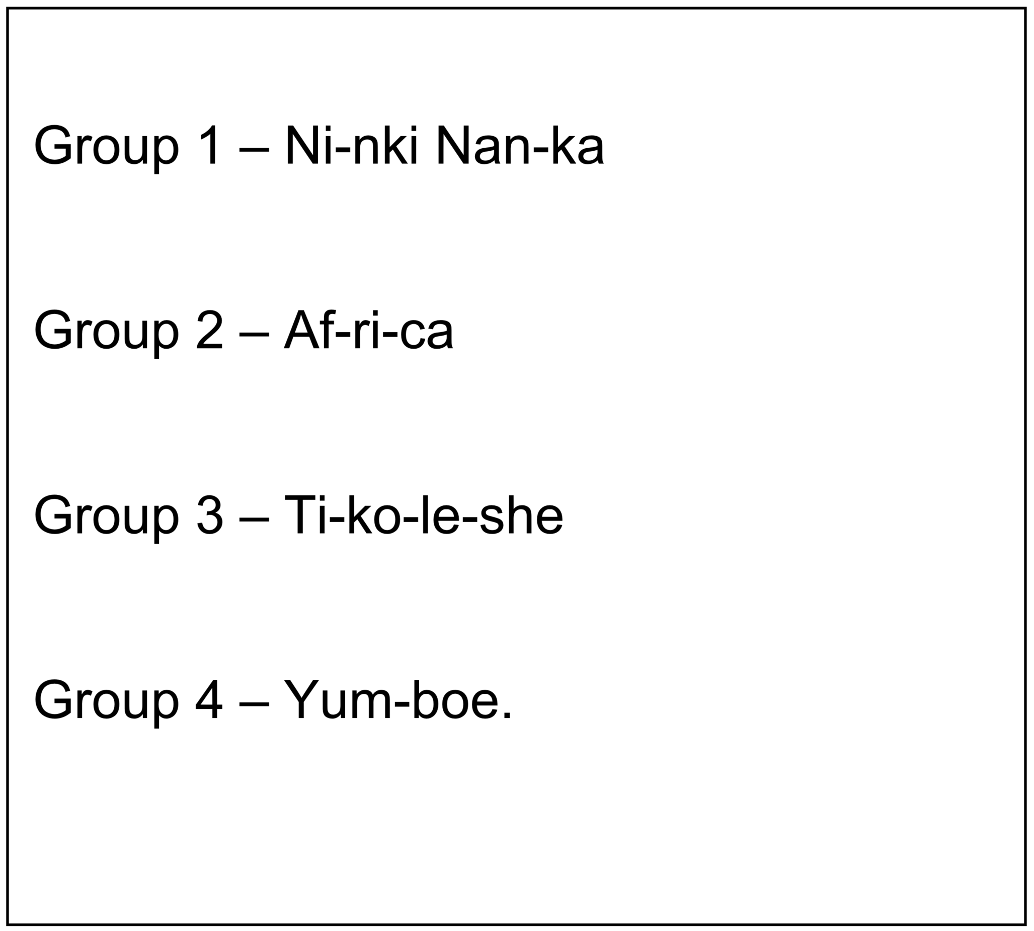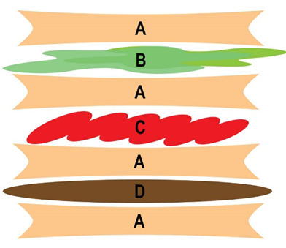

Hold control/command and select the image to open the PDF.
