Personalised Learning and Support Signposting Tool

Frequently Asked Questions

The PLASST (Personalised Learning and Support Signposting Tool) is a web based tool developed by the Department of Education to assist teachers to identify or ‘signpost’ the educational needs and strengths
of students.

1. How do teachers use the PLASST?
To use the PLASST teachers use their professional judgement to answer a number of questions online about a student’s needs and capabilities in the classroom. The data from these is analysed and a PLASST profile report is produced for the teacher about that student.
The student profile report presents each student’s relative needs and strengths under six domains: Cognitive; Attentiveness to Learning; Communication; Social Skills; Social Adjustment; and Personal Independence.
The information in each student profile report is based on responses to the question set at a particular point in time, by a particular teacher or teachers.
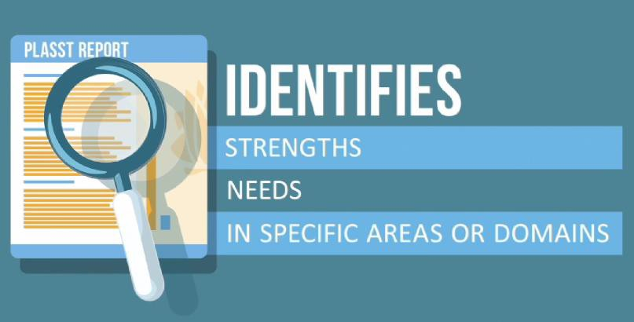

2. What is the purpose of PLASST?
To help teachers inform planning to meet a student’s learning and support needs.

3. Who can use the PLASST?
Teachers and principals employed in NSW public schools.
The school PLASST administrator will enable school access. The administrator is either the principal or someone who the principal has delegated authority to facilitate teacher access.

4. How is the PLASST accessed?
The PLASST is accessed by logging onto the DEC insight staff portal. Click onto the My Applications tab and scroll down to ‘P’ then click onto PLASST. This will take you to the secure PLASST website.
Instructions and guidance about using the tool are detailed on the left hand side of the PLASST dashboard.
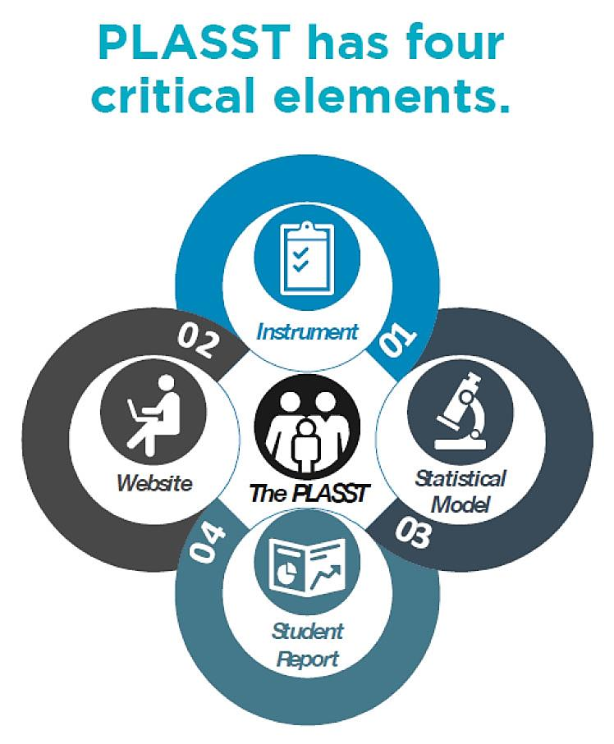

5. Which students would benefit from a PLASST
Any student whom a teacher believes may have additional learning and support needs. This includes students:
- in regular classes, and students in support classes in regular and special schools
- experiencing difficulties in learning or behaviour whatever the cause
- with intellectual, physical, sensory or social/emotional disabilities.

6. When is the best time to complete a student profile report for a student?
A report can be completed at any time of the year. Teachers will need to have some knowledge about the student’s abilities as the online question relies on a teacher’s professional judgment about the student’s needs and capabilities in the classroom.
The question set details the information a teacher will need to know about the student to complete a report.

7. Is it compulsory?
No. It is the teacher’s decision to use the PLASST for a student or not.

8. How will using the PLASST benefit students and teachers?
Teachers and schools use a range of information and tools to assess and understand the learning needs of their students. The PLASST is one of these tools which assists in identifying the individual needs of a student. The PLASST focuses on ways in which the student is unique.
Where a PLASST student profile report has identified areas of specific need, teachers could use this information to:
- collaborate with other teachers and school teams to personalise support for a student
- generate discussions with the student and their parents/carers as part of the consultation
- regarding the student’s learning needs and possible learning adjustments
- inform the planning of professional learning activities to support a student or group of student’s particular learning and support needs.

9. How long does it take to complete a PLASST report for a student?
15 – 20 minutes. Once teachers are familiar with the question and online processes it is often quicker.
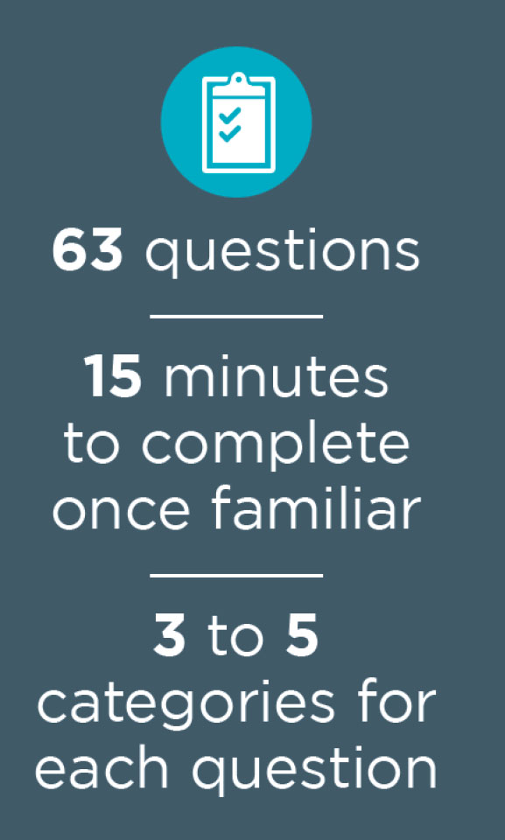

10. Are the results in the PLASST student profile report norm referenced?
No. The student profile report describes a student’s ‘relative strengths’ and ‘additional relative needs’ in their current context at a point in time, based on a teacher’s professional knowledge of that student.
The data is analysed through a statistical model which sits behind the website. The scores for each domain are calculated using a Rasch model. These methods are widely used in educational and behavioural measurement studies.
The results are not norm referenced and the student profile report is not designed to compare and rank students with other students.

11. Who has access to the PLASST reports?
The only people that can access the student profile report are the person that created the student profile and any Principal-level users at the school.

12. Can I share the student profile report with the student's parents/carers?
PLASST was developed to support teachers to identify the educational needs and strengths of students and to provide a structure to facilitate discussion between parents/carers and teachers.
Like all information schools collect about a student the profile report should be managed carefully and confidentially. The profile report is one measure of information about a student’s ability. Teachers along with their principals and school leadership teams should decide about whether or not sharing a student profile report with parents/carers is helpful.

13. Can the PLASST be used as part of a student's personalised learning and support plan?
Yes. A student’s individual profile report is one measure of information about a student’s ability and could be used to develop specific teaching strategies to support a student’s successful learning.
Information detailed in the report could contribute to the development a student’s personalised learning and support plan.
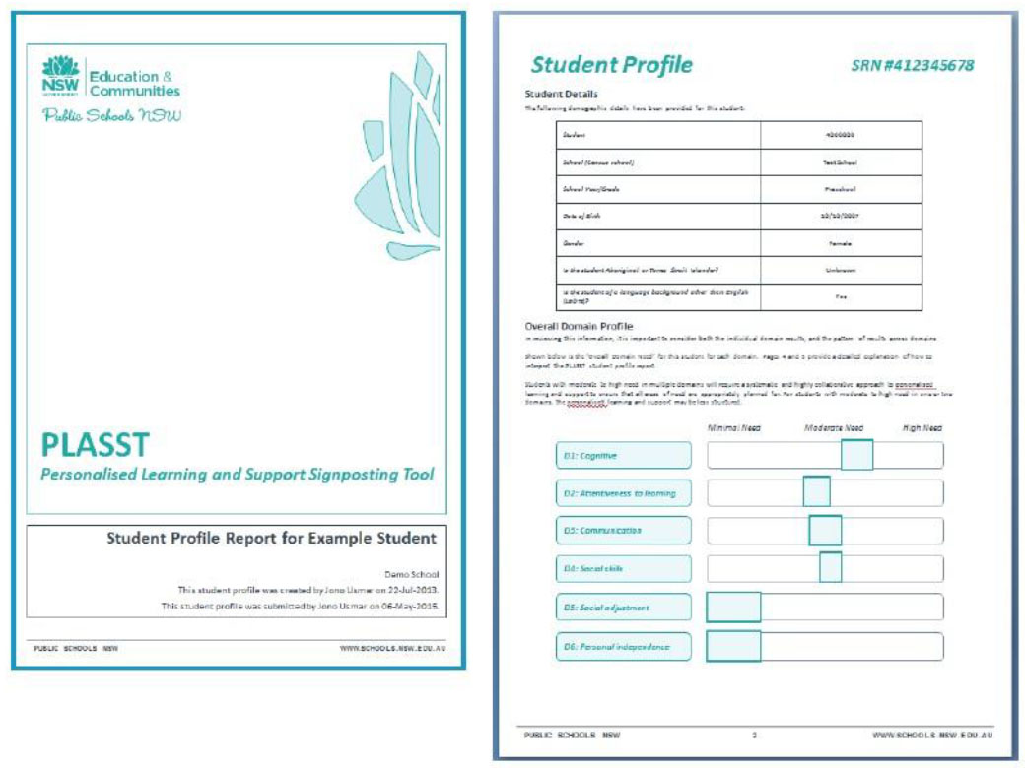

14. How was the PLASST developed?
PLASST was developed by the Department of Education. The trial of PLASST was conducted by PricewaterhouseCoopers (PwC) and was run in more than 500 NSW public schools. The trial collected more than 25,000 student profiles by more than 6,000 teachers.
High levels of participation in the trial contributed to the development and refinement of the tool.
The questions in the PLASST have been designed to measure a student’s educational need in their current classroom/school context. The questions cluster into six groups known as domains.
The scores for each domain are calculated using a Rasch model. These methods are widely used in educational and behavioural measurement studies.

15. Does the PLASST affect a school's funding?
No

16. How does the PLASST relate to the Nationally Consistent Collection of Data on school students with disability (NCCD)?
The PLASST and national disability data collection (NCCD) are two separate activities.
The PLASST is a teaching resource developed by the Department to assist teachers in NSW public schools in profiling the educational needs and strengths of their students.
The Nationally Consistent Collection of Data on students with disability (NCCD) is a mandatory annual activity in all
Australian schools from 2015, using a nationally agreed model provided by the Australian Government.
The NCCD will provide national data on Australian students with disability and the level of adjustments they are being provided based on available evidences of personalised learning and support in the school.
A PLASST student profile may contribute to a school’s evidence of assessed individual student need required for a student to be included in the national disability data collection (NCCD). More information about the NCCD and its implementation in NSW public schools can be accessed from Department’s intranet at https://detwww.det.nsw.edu.au/disability-national-data

For more information
PLASST Website: https://detwww.det.nsw.edu.au/plasst
Email:
plasstsupport@det.nsw.edu.au
© 2016 NSW Department of Education, Disability Learning and Support

