

Dear Languages Teachers

Welcome to the **Secondary Languages** Adobe Connect meeting room. <https://connect.schools.nsw.edu.au/secondarylanguages/>

Adobe Connect is a web conferencing platform which allows users to participate in collaborative environments via any computer with an internet connection. There is further information about mobile and tablet connectivity.

Adobe Connect meetings will be advertised on the **News** page of the **Languages NSW** site.

**Equipment**

**Prior to the event**

1. Your computer will need to have **functioning speakers or headphones**. You will only need a microphone to speak if you are given microphone rights in a session.
2. Complete a **Connection Test** on the computer you will be using by clicking on <http://admin.adobeconnect.com/common/help/en/support/meeting_test.htm>

Follow the onscreen instructions. This may take a few minutes.

1. You may see a pop-up window to allow the Adobe Connect Add-in to work. Click ‘yes’.

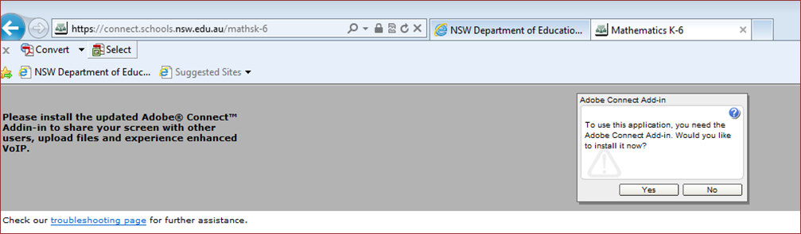

**How to login on the day**

1. Click on this link <https://connect.schools.nsw.edu.au/secondarylanguages/>

or type the address into your URL bar.

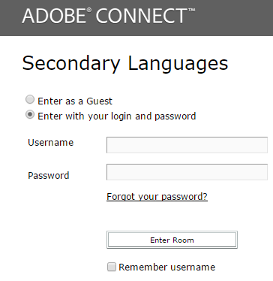

1. Login to the room 5-10 minutes before the scheduled meeting time.
2. Login using the following details:

**Username: detusername@detnsw (e.g. firstname.lastname@detnsw)**

**Password: Your DoE portal password**

Troubleshooting: If it won’t log you in (invalid password/ error message), delete all information in the Login section and then type your details from scratch.

Note: You only write **detnsw** address after the @, not your whole email.

1. Click ‘Enter room’.
2. You will now be taken to the meeting room. There will be music playing when you successfully enter the room. If not, please check your computer’s volume/audio settings. On the top menu bar, the speaker icon should be green. You can also troubleshoot by selecting ‘Meeting’ from then top menu, then ‘Audio Setup Wizard’, then following the steps.
3. There may be a poll question for you to complete. We will ask you to add your school name into the chat box. This will also allow you time to resolve any issues if you are new to Adobe Connect. **We will not be able to provide you with support once the meeting starts.**
4. While you wait for the presentation to begin, please take the time to familiarise yourself with the layout, complete any poll questions and write your school name in the chat pod. If you are participating as a group (i.e. not on individual computers), add how many participants there are from your school in brackets.  
   e.g. Chester Hill HS (2)

The chat pod looks like this:

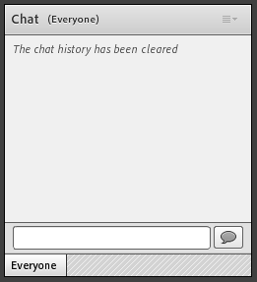

You can type in the chat pod by typing in the white bar, then clicking the speech bubble or hitting Enter on your keyboard.

A large number of participants may be accessing this presentation. If the connection drops out or freezes, close the window and try logging back in.

**Participating in breakout rooms**

Automatically be given when put in random rooms.

This gives ……

**Adobe Connect via mobile and iPhone**

1. Download Adobe Connect via Google Play or iTunes. Look for the following icon.

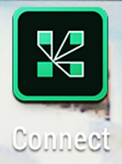

1. Type in the **Languages NSW** meeting address: <https://connect.schools.nsw.edu.au/secondarylanguages>

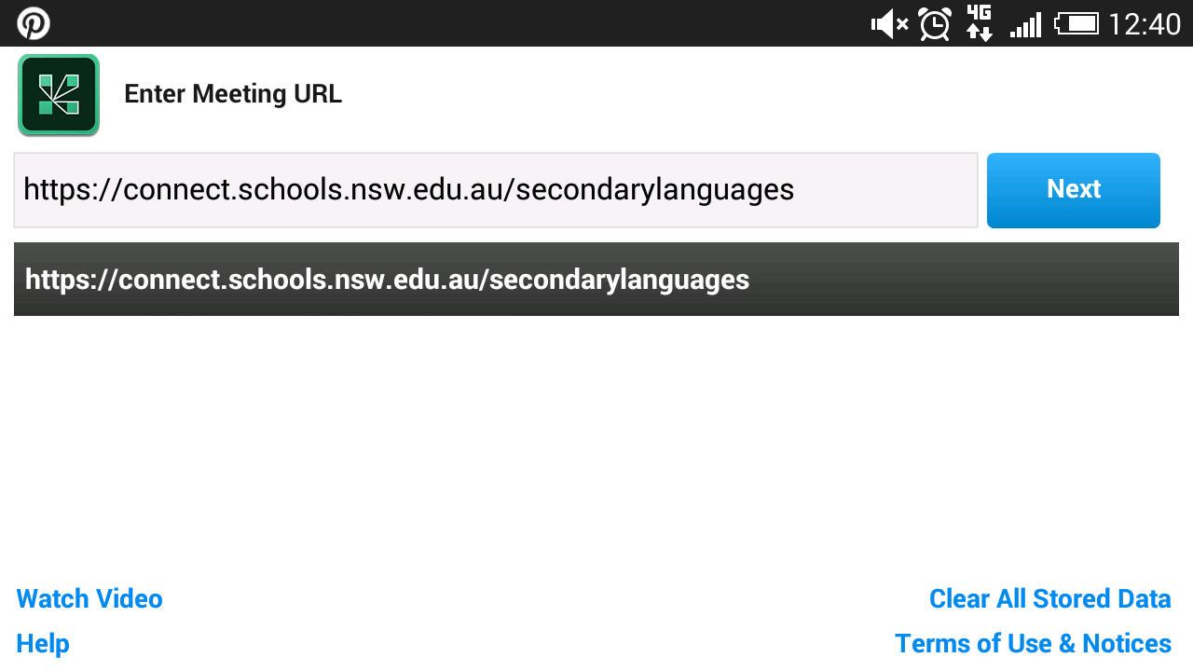

1. Sign in with your @detnsw login and password and click ‘Enter’.

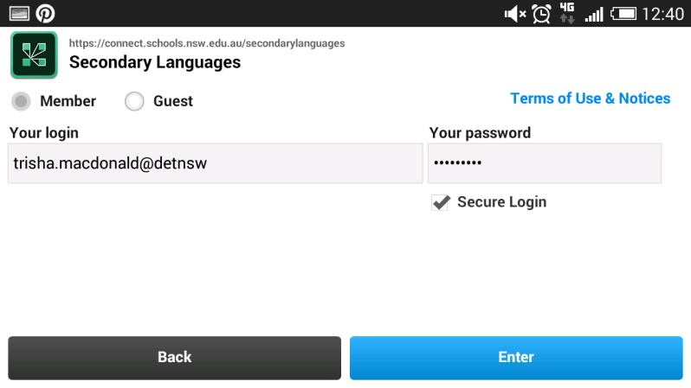

If you continue to have trouble or cannot attend the live sessions, they will be recorded for later viewing. Email [janelle.byrne@det.nsw.edu.au](mailto:janelle.byrne@det.nsw.edu.au) for the link.

We look forward to seeing you in the Secondary Languages meeting room.

Kind regards,  
The Languages and Culture team