Acknowledging controllable factors and empathy
Duration: 60 minutes

Purpose of the task
Having external and environmental resources that can be drawn upon during challenging and changing situations are a vital component of learning to be resilient. Having these resources increases our personal confidence in being able to go through life’s ups and downs. In addition, empathy (understanding other people’s feelings / emotions / experiences) assists resilience through developing strong and supportive relationships and is particularly helpful when people are experiencing tough times.

Teacher further learning:
- Controllable factors, Centre for confidence

Course outcomes
1.1 Assess personal strengths and skills to achieve positive outcomes in a range of challenging and changing situations.
1.2 Critically evaluate services and resources to identify sources of reliable information and support.
1.3 Build positive thinking, self-belief and a sense of empowerment to take action to promote meaningful futures for self and others.
4.1 Demonstrate capacity to build resilience and adapt to manage current and future challenges.

What do we want students to know, understand or be able to do?
- Recognise the controllable factors for resilience and how they impact on our optimism and outlook.
- Reflect on their own levels of empathy and evaluate how they demonstrate empathy for others in different situations.

Required resources and materials for preparation
Student activities are set around:
- whole group and small group
- individual activities
- offline
Equipment required:
- butchers paper (7sheets)
- pens/textas
- Controllable factors for resilience information sheet

Suggested content
Learning context | Content
Mental health and wellbeing  Focus: Developing self-efficacy and mental fitness | Building resilience  - acknowledging controllable factors  - seeking, accessing and accepting help and support  - empathising
Mental health and wellbeing  Focus: Support for self and others | Skills and strategies for managing change and challenges  - perspective taking  Connecting and reaching out  - networks of online and offline support  - recognising when help is needed  - asking for and accepting help for self and others  - accessing services  - supporting others
Independence  Focus: Building self-concepts and independence | Personal values and beliefs  - influence of values, attitudes and beliefs on decisions and actions in various contexts  - self-concepts  Self-management  - managing change and initiating contingency plans  - responsibility for self and actions

Teaching notes

Creating a safe and supportive learning environment
There are a number of strategies that can be used to create a supportive learning environment which enables students to feel safe to learn and ask questions. They include:
- making students aware at the beginning of Life Ready sessions that disclosing personal information that indicates they may be at risk of harm will be reported to the school principal in all instances. This includes personal disclosures related to instances of abuse, drug use, neglect or sexual activity under the legal age of consent.
- being aware that some parts of Life Ready can be confronting and sensitive for some students.
- enabling students to withdraw if they find issues personally confronting to protect them from making harmful disclosures. Equally, it is important to be prepared for issues that arise as a result of a student making a public disclosure in the classroom.
More information on creating a safe and supportive learning environment can be found on the Life Ready website.

Evaluating resources before use
Preview and evaluate all strategies, resources and teaching and learning approaches in full before use with students to determine suitability for student learning needs, stage of development and local school context. Consider the age, maturity, cultural background, sexuality, gender, sex, health and other characteristics of students in your care. Apply professional judgements to all strategies, teaching and learning approaches and resources including audio visual materials (e.g. videos, media clips and YouTube), interactive web-based content (e.g. games, quizzes and websites) and texts.
Use the resource review flowchart to decide about the suitability of teaching and learning resources.
Materials should be reviewed in full and endorsed by the school principal before use in NSW government schools.

Communication with parents and caregivers
Some aspects of Life Ready may be viewed as sensitive or controversial, such as learning about abuse, child protection, drugs, respectful relationships, sexual health, sexuality and violence. Inform parents and carers, prior to the occasion, of the specific details of the Life Ready program, so that parents and caregivers have time to exercise their rights of withdrawing their child from a particular session. In this regard, a parents or caregiver’s wish must be respected.
Establishing how parents and caregivers will be informed about programs and involved in consultation is a school-based decision. Where parents and caregivers indicate they wish to withdraw their child from a program it is useful to negotiate which parts of the Life Ready program they are concerned about. A sample information letter is available on the Life Ready website.

Learning experiences

Acknowledging controllable factors
Teacher background information:
For further information about each factor, access the Centre for Confidence
Explain to students there are varying controllable factors which influence resilience.

Graffiti walk
- Create seven graffiti sheets (e.g. seven pieces of butchers paper around the room or seven online spaces, each with one of the seven controllable factors for resilience recorded on of the space)
- Controllable factors:
  - Impulse Control
  - Emotional Awareness and Self-regulation
  - Optimism
  - Flexible and Accurate thinking
  - Empathy
  - Connecting and Reaching Out
  - Self-Efficacy
- Students work in small groups. Allocate two minutes for each group to work with each controllable factor graffiti sheet. In two minutes, groups discuss and record as much as they know about each factor, including examples of when they or someone they know has displayed or used each factor.
- Once each group has completed all seven graffiti sheets, each group decides upon the three most interesting pieces of information recorded on the last sheet they wrote on.
- Groups present their information to the class.

Pair discussion
- Students work with the Controllable factors for resilience information sheet.
- Students highlight which factors for resilience they are strongest at and record reasons why.
- Students circle the factors they need to work on and how they plan to practice it.
- Invite students to form pairs and share their answers.
- Where students are comfortable with their partner and know their partner well, ask each student to use a different coloured pen to indicate on their partner’s sheet each resilience factor(s) they believe their partner uses the most. Provide examples of the partner’s actions where possible.
- Invite students to form small groups of 4-6 to discuss/share their responses where appropriate.

Focused activities – two controllable factors for resilience

Optimism
- As a group, discuss students understanding of optimism. Record and display responses from students on a visible space online or offline.
Note: Explain to students that being optimistic is all about being hopeful and positive of the future. When working on boosting our optimism, we don’t have to pretend we are happy and hopeful all the time, but we do need to make a conscious effort to work on being more hopeful and optimistic.
Focusing on the positive things during each day is a great way to boost our optimistic thoughts and increase our resilience.
- Individually, students record three positive things that have happened in their previous week and explain why they happened, why they are positive and/or how they can make them happen again.
Note: Explain to students how surrounding ourselves with positive and optimistic people ignites positivity and boosts optimism.
- Individually, students record the people in their lives that help boost their optimism.
- Students form pairs to brainstorm and record characteristics of people who are less likely to boost your optimism.
- Discuss as a whole group to identify common characteristics across the group.
- Ask students:
  - what about these characteristics impacts on an individual’s or group’s optimism?
  - how could a young person reduce the impact of these characteristics on their optimism?
  - what could a young person do in the next few days to spend more time with the people who boost their optimism?
  - to what extent does media impact on our ability to be optimistic?
  - in pairs, ask students to brainstorm and record media (TV, movies, games, web sites, apps, and other forms of media) that they believe impact both positively and negatively on their sense of optimism and positive thoughts. The following prompts will trigger ideas for students:
On TV I watch
After watching_____________ I feel
I like to read/ play
After reading/ playing ___________ I feel
I find out about what is happening in the news by
After reading/watching/listening to the news I feel
- Individually, ask students to reflect on two things they could switch to boost positivity and optimism?
- Extension activity — Research 3 Apps (Android and/or iOS) suitable for young people aged 14-17 that aim to boost optimism. Evaluate the effectiveness of each app in terms of boosting optimism and building the skills of young people to think positively.

Connecting and reaching out
Note: Remind the group that connecting and reaching out is about taking risks and connecting with others. Connecting with others boosts our resilience as we draw upon their knowledge and skills and we extend our understanding of others and how they get through tough times and everyday life.
- In small groups students discuss their thoughts on the following questions:
  - what does it mean to belong to a community or a group?
  - in what ways do newcomers boost and enrich our community?
  - what are some barriers to newcomers in our community/group?
  - what do newcomers need and want from a community? (e.g. health, housing, shopping, sports clubs, friends)
  - what things do we do to actively connect new people to a community/group?
  - list examples of groups/communities you belong to or which are in the community you live in/ attend school.
- Invite students to report back to the whole group.

Empathy

Group discussion
- Individually, students record on a post-it note (online or offline) their ideas and thoughts of empathy.
- Display the post it notes for other students to explore and discuss as a whole group.
- If students are dominating discussions or students are reluctant to volunteer an answer, use the Fairness Jar strategy.
Teacher tip: fairness jar activity
To encourage open group discussion and invite all students to have an equal chance of sharing their opinion through this brainstorm, use the paddle pop stick strategy. Record students’ names on a paddle pop stick each and place in a jar. Through the discussion remove a student’s name from the jar and invite them to share their idea.

Circle chat: are you empathetic
- Individually, students silently reflect on and think about the following questions — Are you empathetic?
- Questions: Are you empathetic?
  - Do you think about how others feel?
  - Do you listen well to others by making eye contact and not interrupting?
  - Do you try to understand different people’s opinions/points of view?
  - Are you conscious to not make a habit of making fun of people, as you understand what it would feel like to be in their shoes?
  - Do you listen to others in an attempt to understand what they are going through?
  - Do you understand that people may have a different reaction to situations and may not react like you do?
- Use a Circle chat to invite students to share their responses with members of the group.
Circle chat:
Students’ stand in two concentric circles, facing a partner. Teacher reads out the empathetic statements one by one and students take turns to share their responses with their partner. Students should explain their answers by giving examples.
After 45 seconds, the teacher calls out “switch” and the outside circle moves one step to their right to meet their next partner. Continue sharing until each student has spoken with at least 6 different students/all 6 questions are discussed.

Student pair discussion: practicing empathy
- Students work in groups of 3 and label themselves student A, student B and student C.
- Students complete the following activity beginning with student A as the speaker, student B as the empathetic listener and student C as the observer.
  - Describe an embarrassing story, moment or a situation where they were scared or sad.
or
  - Choose a fictional character to describe a situation where they have gone through an embarrassing moment/where the character was sad or scared.
Note: Newly released movies or cartoons are a good starting point to prompt ideas for students. When running this activity search for the latest movie releases for providing prompts for characters/ movie scenes for students
- Students swap roles and repeat activity until all students have adopted each role.
- Draw a Y chart to facilitate a whole group discussion. As a whole group, discuss the following questions:
  - what did empathy look like/sound like/feel like in your discussion? When would people use empathy the most?
  - how could a young person practice more empathy?

Controllable factors that contribute to resilience
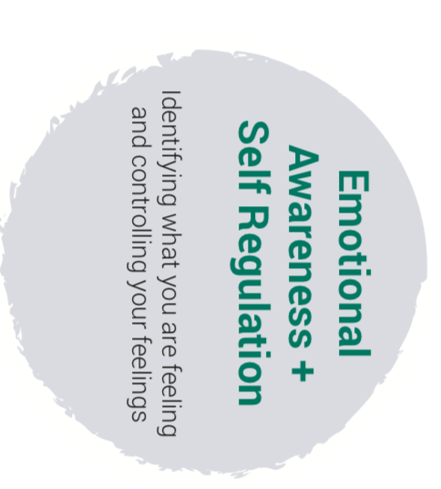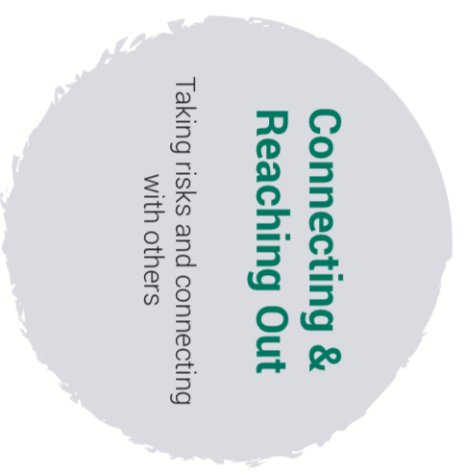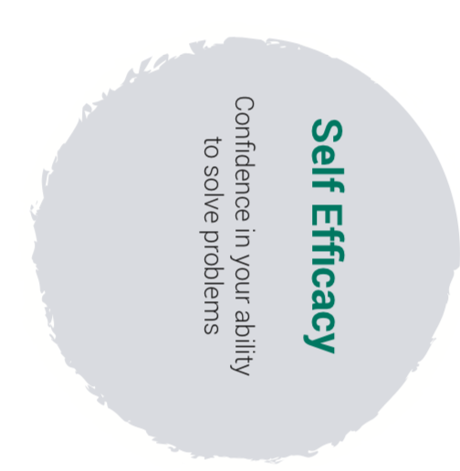

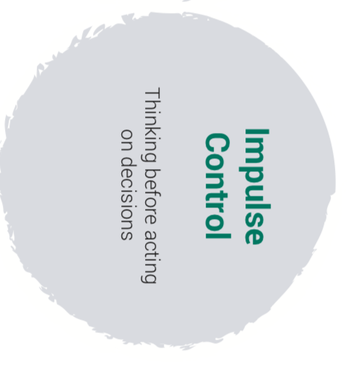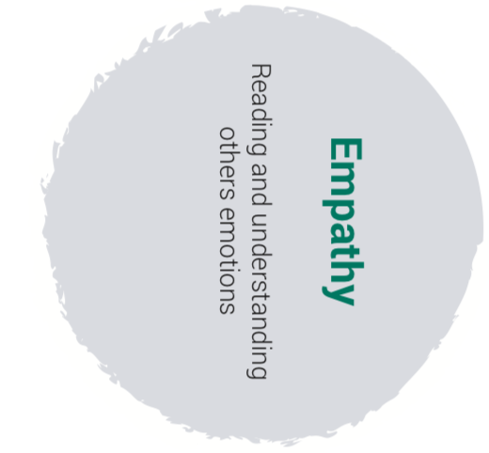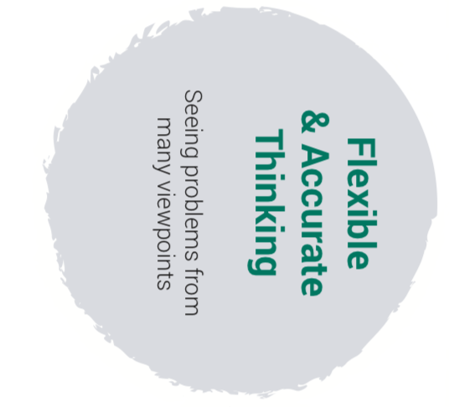
Information based on the work of Dr Karen Reivich and Andrew Shatté (The Resilience Factor, 2002)

