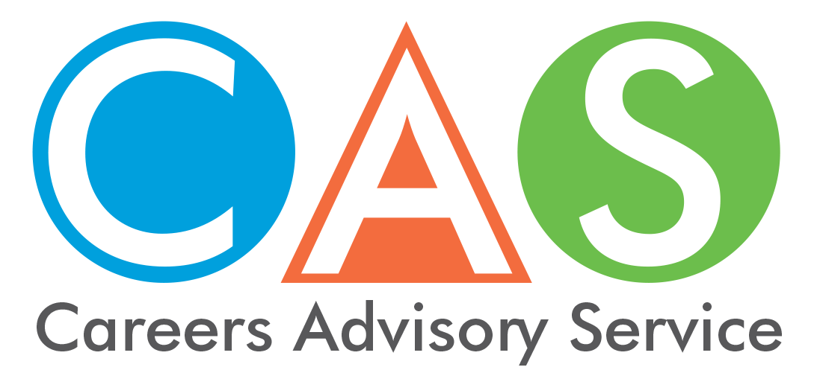

3. Key dates and information from University Admission Centre (UAC)

2018/19 Key Dates for UAC applications
The key dates and information for UAC applications with offer rounds is located on the UAC website.

Changed for 2019 admissions through UAC
You can now apply online for the Educational Access Schemes through UAC, when you have submitted your undergraduate application. For further details please see the Educational Access Schemes Applications - Steps to Completing Your EAS Application -UAC website.
If you are unable to complete your Educational Access Schemes application online, you can still download a hardcopy application form. Your application and documents can be sent by post or delivered in person to UAC. Please see Contact UAC for these details. UAC will then scan and upload your EAS application and documents for assessment at UAC.

UAC Offers
UAC advises students of their offers on behalf of the participating institutions. There are a number of offer rounds throughout the year. The key dates and information for UAC applications with offer rounds is located on the UAC website.
The most important offer rounds for Year 12 students are December Round 2 (Thursday 20 December 2018) and January Round 1 (Friday 11 January 2019), after the ATARs are released. Although some Year 12 students receive early offers before the December Round 2, these are usually for early entry schemes such as Schools Recommendation Schemes, ADFA courses and distance education courses.
The key dates and information on the UAC website shows the dates by which you need to apply, provide documents and change your preferences to be guaranteed consideration in each offer round. Update your application using Selecting and changing course preferences.

Deferment
Deferment means that a student has received an offer to enrol in a course but they have been given permission by the institution to delay the start of their course for a fixed period, usually six months to a year. All deferments are granted subject to the course being offered the following semester or following year. See UAC website.

For more information contact

UAC phone:
For general information before release of HSC results.
Phone between 8.30am and 4.30pm Monday to Friday (Sydney time) by calling 1300 275 822
from mobiles (02) 9752 0200
from overseas +61 2 9752 0200.

UAC website:
www.uac.edu.au (includes online email enquiry service.)
ATAR Enquiry Centre
Contact after the release of the ATARs.
Days and hours of operation are:
14th December (8.30am - 6pm)
Monday 17th to Wednesday 19th December (8.30am - 4.30pm)
1300 MY ATAR (1300 692 827)
or from mobiles: (02) 9119 5012
or overseas: +61 2 9119 5012

UAC app:
Download MyUAC from the App Store or Google Play

© 2018 NSW Department of Education

