

Differentiated learning

# Activity booklet

# Contents

Activity 1: Differentiation in my teaching practice 3

Activity 2: The learner - Know my students and how they learn 4

Activity 3A: Identifying student data to inform practice 5

Activity 3B: Interrogating sample student data 5

Best Start/PLAN example 5

SMART example 6

Activity 4: Linking Quality Teaching model and differentiation elements 8

Quality teaching element 8

Comment 8

Activity 5: Unit of learning modification plan 9

Differentiation strategies – Primary/Secondary template 10

Course deliverable 12

# Activity 1: Differentiation in my teaching practice

This activity is a personal reflection on your current knowledge and understanding of differentiation.   
Complete this task to help you reflect on how you encorporate differentiation into your practice.

| Differentiation in my classroom | Rating | Example of teaching practice |
| --- | --- | --- |
| Learning in my classroom focuses on high quality professional practice | □ Strength  □ Development* |  |
| Learning in my classroom focuses on learning of significance | □ Strength  □ Development |  |
| I set high expectations for student learning, providing support through explicit scaffolding where required | □ Strength  □ Development |  |
| I try to differentiate learning based on the individual needs of my students | □ Strength  □ Development |  |
| My program is differentiated to align syllabus outcomes, instruction and assessment practices to meet individual student need | □ Strength  □ Development |  |
| I make evidence-based modifications to content, process, product and learning environment to meet the needs of individual students | □ Strength  □ Development |  |
| I use a range of appropriate resources to support learning and teaching | □ Strength  □ Development |  |
| I incorporate flexible classroom routines | □ Strength  □ Development |  |
| I use formative assessment (assessment *for* learning) to improve learning and achievement | □ Strength  □ Development |  |
| I engage in evaluation and reflection on my teaching practice and my students’ learning | □ Strength  □ Development |  |

*This activity could inform the process of developing goals in your [Performance and Development Plan](https://detwww.det.nsw.edu.au/lists/directoratesaz/humanresources/schoolteachers/performmanage/index.htm).

# Activity 2: The learner - Know my students and how they learn

Below are some factors that influence student learning. These align to Standard 1 of the *Australian Professional Standards for Teachers*. Each will impact on different students in different ways. Rate each factor according to its importance for learning for the cohort you teach/your school context.

| Factors that influence student learning | Rating | Explanation of rating |
| --- | --- | --- |
| Students’ prior learning experiences e.g. family mobility, progression of learning | □ High  □ Medium  □ Low |  |
| Teacher use of evidence-based research e.g. local, state, international | □ High  □ Medium  □ Low |  |
| Emotional characteristics  e.g. history of trauma | □ High  □ Medium  □ Low |  |
| History of interventions  e.g. Reading Recovery, withdrawal, extension group, diagnosis and outside provider groups | □ High  □ Medium  □ Low |  |
| Linguistic background  e.g. EAL/D, literacy in first language | □ High  □ Medium  □ Low |  |
| Social characteristics  e.g. position in family, peer groups | □ High  □ Medium  □ Low |  |
| Cultural context  e.g. Aboriginal and Torres Strait Islander background | □ High  □ Medium  □ Low |  |
| Learning environment  e.g. playground, classroom, grouping, school culture | □ High  □ Medium  □ Low |  |
| Physical characteristics  e.g. learning aids, gender | □ High  □ Medium  □ Low |  |
| Socioeconomic and community context | □ High  □ Medium  □ Low |  |

# Activity 3A: Identifying student data to inform practice

Refer to the information in Activity 2 to complete this table. Identify all forms of student data available to you.

| **Student data e.g. SmartData, PLAN, Welfare, Learning and Support interventions such as Reading Recovery, PLASST, Literacy and Numeracy Continuums, such as L3, CMIT, TOWN** | **Who is responsible for this data?** | **How can you access this data?** |
| --- | --- | --- |
|  |  |  |
|  |  |  |
|  |  |  |
|  |  |  |
|  |  |  |
|  |  |  |

# Activity 3B: Interrogating sample student data

Choose an example below and analyse the data provided to identify students’ needs

## Best Start/PLAN example

On the next page is a typical excerpt from a class report generated from Planning Literacy and Numeracy (PLAN) data. This report indicates the demonstrated level of student achievement in literacy. These levels represent the apsects of the NSW Literacy Continuum.

Interrogate the data and consider:

* obvious learning needs of individual students in this group
* ways to group these students in order to differentiate the learning needs of students in Vocabulary knowledge
* whole group structure which could allow you to address the needs of all students in Reading texts
* anomalies in these results - What are they, and why are they interesting? Do they need to be addressed in teaching and learning programs?
* particular students who may need differentiated instruction.

In group situations, discuss with a colleague some of the observations you can make about these students from the data in this table.

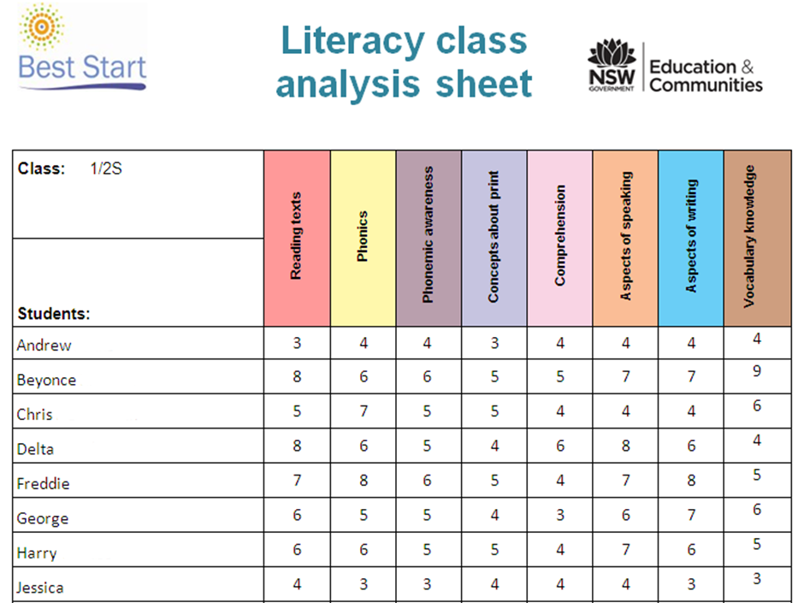

## SMART example

See the next page for a typical excerpt from a Numeracy report for a cohort, generated from NAPLAN SMART data.

Interrogate the data and consider:

* questions in which the percentage of students from the school answering correctly is significantly   
  below state
* questions in which the percentage of students from the school selecting particular incorrect answers is significantly above state
* further interrogation or analysis that may be useful for you to make informed decisions about differentiation for these students in your KLA.

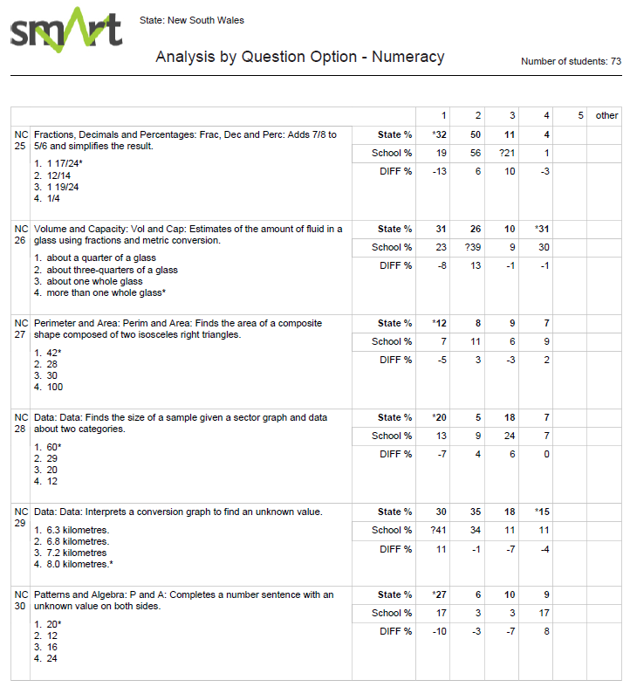

# Activity 4: Linking Quality Teaching model and differentiation elements

In your group, discuss how the Quality Teaching model relates to Tomlinson’s four elements of differentiation. Use this table to capture your thinking, giving your reasons in the Comment section. Quality Teaching elements may be used more than once.

**NSW Quality Teaching model**

**Intellectual Quality**

Deep knowledge

Deep understanding

Problematic knowledge

Higher-order thinking

Metalanguage

Substantive communication

**Quality Learning Environment**

Explicit quality criteria

Engagement

High expectations

Social support

Students’ self-regulation

Student direction

**Significance**

Background knowledge

Cultural knowledge

Knowledge integration

Inclusivity

Connectedness

Narrative

| Quality teaching element | Comment |
| --- | --- |
| **Content** | |
|  |  |
|  |  |
|  |  |
|  |  |
|  |  |
|  |  |
| **Product** | |
|  |  |
|  |  |
|  |  |
|  |  |
|  |  |
|  |  |
|  |  |
| **Process** | |
|  |  |
|  |  |
|  |  |
|  |  |
|  |  |
|  |  |
|  |  |
| **Learning environment** | |
|  |  |
|  |  |
|  |  |
|  |  |
|  |  |
|  |  |
|  |  |

# Activity 5: Unit of learning modification plan

Plan for the modification of your unit of learning. Identify opportunities where differentiation of content, process, product and learning environment could be incorporated. Use the proforma *Differentiation strategies – Primary/secondary template* (p10-11) to plan.

Choose strategies from the *Differentiation in practice* tab which you could use as you plan for modifications.

Consider the questions below when differentiating your unit of learning:

* How will you build upon what you already know in a manner suited to individuals and larger groups?
* How will you ensure deep student understanding and embed a process to facilitate greater understanding of the ideas or concepts?
* What can be done to adjust the complexity, pace and variety?
* Is there an option for student choice or design?

# Differentiation strategies – Primary/Secondary template

| Lesson component | Description |
| --- | --- |
| **Differentiation element(s)** | **Content, Process, Product** or **Learning environment** (select one or more) |
| **Stage** |  |
| **Subject** |  |
| **Outcomes** | **A student:** |
| **Content statement** | **Students learn to:** |
| **Purpose of lesson** |  |
| **Strategies** | **Core strategies**  Students will:  **Differentiation strategies** |
| **Resources** | List resources such as internet links, book titles etc. |

# Differentiation strategies – Primary/Secondary template

| Lesson component | Description |
| --- | --- |
| **Differentiation element(s)** | **Content, Process, Product** or **Learning environment** (select one or more) |
| **Stage** |  |
| **Subject** |  |
| **Outcomes** | **A student:** |
| **Content statement** | **Students learn to:** |
| **Purpose of lesson** |  |
| **Strategies** | **Core strategies**  Students will:    **Differentiation strategies** |
| **Resources** | List resources such as internet links, book titles etc. |

# Course deliverable

Deliverable iconThe deliverable for this course gives you the opportunity to demonstrate your knowledge of the four elements of differentiation - content, process, product and learning environment.

You will submit a differentiated unit of learning. This may be a new unit on a topic you are planning to teach, or you may modify a unit you have already developed.

The unit will include:

1. **Evidence** **gathered** about your students. Refer to the *Know your students* tab.
2. **Analysis of the data** to determine the needs of the students. This will include consideration of the following questions:

* *What are some of the significant needs of my students that are clear from the data?*
* *What are some of the needs of my students that I already know about?*
* *How can I group my students to effectively address these needs?*

1. **Ideas** to make sure your students are able to access the content and develop their skills. Refer to the *Differentiation in practice* tab - *Toolbox* mini-tab and *Differentiation K-10* mini-tab*,* *Primary and Secondary differentiation strategies* samples.
2. **Completion of the** *Differentiation strategies – Primary/Secondary template*. This is where you outline the various strategies you intend to use as you differentiate your unit of learning.
3. **Presentation of your unit of learning.** Modifications for differentiation will be embedded. You must provide evidence about:
   * the processes and practices you employed to differentiate (Process and Content)
   * how the product was differentiated (Product)
   * the modifications you made to the learning environment (Learning environment).

To finish, submit the deliverable to your principal or supervisor for verification and accreditation.

|  |  |
| --- | --- |
|  |  |