# Activity 4: Collaborative task using Office 365 – OneDrive

**Instructions for:**

* **Presenter - sharing with participants(before session)**
* **Participants - opening and editing (during session)**

## Presenter – Before session

1. Save [Activity 4: Linking Quality Teaching model with differentiation elements](Act_4QTandElements.docx) to your computer.
2. Access Microsoft Office 365 through your DEC staff portal page. If not already installed, look under ‘My learning tools’ and select Microsoft Office 365>add to My Essentials. The icon will then be displayed in your Essentials area.  
   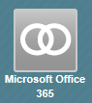
3. Select OneDrive.  
   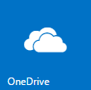
4. Select upload. Find the document on your computer and upload it. It will then appear in the Documents list.  
   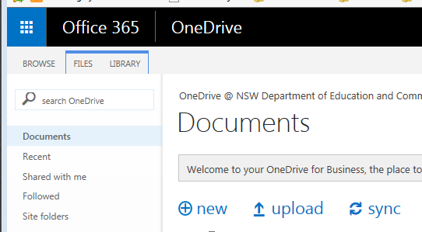
5. Open the document, then select the SHARE button. Enter names or email addresses of participants in the ‘Invite people’ field. Add a message if you want to. Under SHOW OPTIONS ensure the ‘Send an email invitation’ box is ticked. Select the Share button. Participants will receive an email with the document name hyperlinked.  
     
   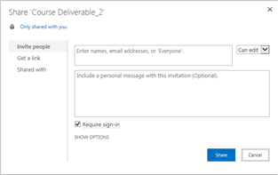
6. Participants go to EDIT DOCUMENT and select ‘Edit in Word’. For more information see [Simultaneously edit a document with other authors](https://support.office.com/en-US/Article/Simultaneously-edit-a-document-with-other-authors-2a6059e7-9fe9-4e66-8ecd-f3d5372c27f4). The edited document will stay in your OneDrive. Save and download it to your own computer if you wish.

## Participants – During session

Participants can access the document in one of two ways:

* Open the email containing the document. Select the hyperlinked document name to open it.   
  OR
* Follow the steps below to access the document from OneDrive.

1. Go to your staff portal homepage and select Microsoft Office 365.  
   
2. Select OneDrive.  
   
3. From the left-hand menu select ‘Shared with me’ to see a list of documents you can either view or edit.
4. Open the document. Go to EDIT DOCUMENT and select ‘Edit in Word’. *You may be asked to allow and sign in to portal again.*
5. When the document has opened, select Enable Editing to make changes. Save the edited document. As you save, updates from other authors are refreshed automatically.   
   The edited document will stay in your OneDrive. Save and download it to your own computer if you wish.  
   For more information see [Simultaneously edit a document with other authors](https://support.office.com/en-US/Article/Simultaneously-edit-a-document-with-other-authors-2a6059e7-9fe9-4e66-8ecd-f3d5372c27f4) (https://support.office.com/en-US/Article/Simultaneously-edit-a-document-with-other-authors-2a6059e7-9fe9-4e66-8ecd-f3d5372c27f4).