# Activity 4: Collaborative task using Google Drive

**Instructions for:**

* **Presenter - sharing with participants (before session)**
* **Participants - opening and editing (during session)**

## Presenter – Before session

1. Save [Activity 4: Linking Quality Teaching model with differentiation elements](Act_4QTandElements.docx) to your computer.
2. Using Google Chrome as your browser, access Google Apps through the DEC staff portal page. If not already installed, go to ‘My learning tools’ and select Google Apps>Add to My Essentials. The icon is now displayed in your Essentials area. Choose it to open.  
   
3. Select ‘Drive’ under Collaborate & Present.
4. Select the Upload arrow and choose ‘Files…’  
   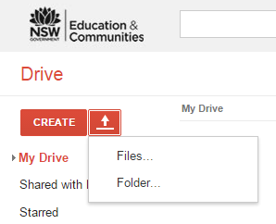
5. Find the document on your computer and open it. The document is now listed under ‘My Drive’. Open it from the list.
6. To share the document, either select the Share button (top right) or select Share in the ‘Upload complete’ mini-screen.  
   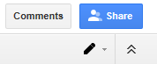  
   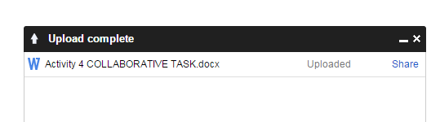
7. Enter the names or email addresses of participants. Add a note if you wish. Ensure ‘Can edit’ is selected from the drop-down menu. Select ‘Send’. Participants will receive an email with the document name hyperlinked.   
   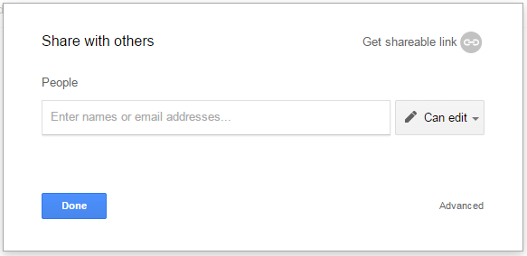
8. To enable editing, participants must access the ‘Open’ menu and ‘Open with Google Docs’. For existing Google Apps users, the document will automatically open for editing in their Drive.  
   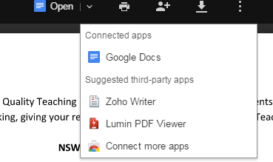

## Participants – During session

1. Open the email containing the document and either select the hyperlinked document name to open it or select Open in Docs.
2. *Existing Google Apps users:* the document will automatically open for editing in your Drive.  
   *New Google Apps users:* to enable editing, access the ‘Open’ menu and ‘Open with Google Docs’.  
   
3. Edit the document in your group. Changes are automatically saved in Drive.
4. Select ‘Share’ button to send your edited version to others. Enter names in the ‘Share with others’ field and select Send. Recipients will receive an email containing a link to the document.  
   
5. See the File drop-down menu for other options.