

Stage 6 English Content Endorsed Course English Studies
Unit of Work

Module: English in Sport: Playing the game

Indicative hours: 20 hours.
Rubric from English Studies Syllabus

Through the study of the module, Playing the Game – English in sport, students will develop understanding of and practical competence in the language used in recreational and professional sport at a local, national and international level. Students explore how language is used by a range of people such as coaches, players, journalists, sports writers, and makers of films and documentaries. Students consider how language in sport is used to enthuse and motivate; report and analyse team and individual performance; create and sustain interest in sporting stories and issues, as well as to persuade the public and individuals to particular points of view. This may involve writing personal recounts about sporting experiences; writing about the experiences of others involved in sport in relation to fitness, motivation, success, failure and enjoyment.

Students will also have the opportunity to experience, engage with and critique literary texts that illustrate, through imaginative use of language, how sport can spark enduring stories about important issues, legendary feats, ambition, success and failure, relationships, controversy, motivation and fitness. Texts may include longer works such as novels, biographies, autobiographies, plays and films. Through the study of a range of literary texts in both written and electronic forms, students will broaden their understanding of the importance of language in the presentation and promotion of sport to the wider community, and how individual and collective commitment to sport as a profession or as recreation is created and sustained. In addition, by engaging with these texts, students will extend their own skills in comprehending and responding to texts, and their own abilities to use language expressively and imaginatively.

Key concepts

* Students will explore how language is used and manipulated by various people in the sporting community to achieve a particular purpose.
* Students will be required to plan, draft, write and edit accurately and appropriately expressed reports, biographies, letters to the editor and motivational speeches to demonstrate their understanding of how the language and structure of texts is shaped to suit purpose, audience and context.

Assessment

The assessment task for this unit of work will be a portfolio that students will be building for the duration of the unit. The portfolio requires students to write and present a motivational coach’s speech, a biography of a sports person and a letter to the editor regarding a sports issue or sports person. Students will be working towards this assessment task throughout the unit.

Syllabus outcomes

The assessment task will directly address outcomes P1.1, P1.2, P1.3, P3.1 and P3.2, or H1.1, H1.2, H1.3 and H3.1 if the unit is to be undertaken in the HSC year.

Several Preliminary and HSC outcomes will be addressed through a range of activities included in this unit.

Rationale for approach used in this teaching program

This unit has been designed to make students aware of the different types of individuals and groups that use language and to understand how language can be manipulated for a variety of different purposes.

Students will be writing about sport through various different texts types including biographies, speeches, letters, reports and recounts. To gain an understanding of the types of language used in these texts types students will engage with and critique a number of literary texts, including extracts from The story of Tom Brennan, Andrew Johns: the two of me and Australian story: man for all seasons.

The activities in this unit have been designed to ensure high levels of engagement for a particular cohort of students. Aspects of NRL and AFL are the focus of teaching and learning activities. However, teachers may wish to focus their unit on a different sport or a variety of sports, depending on students’ interests.

Week 1&2: Introductory activities
Syllabus outcomes | Quality Teaching | Learning and teaching activities | Evidence of learning
P1.4, P4.2  H1.2 | Background knowledge  Engagement  Connectedness  Significance  Inclusivity  Problematic knowledge | What is Sport?  - Brainstorm sports students play. What are their favourite sports? Ask them to justify why.  - In class or small groups, make a survey about what sport means to people. Students survey teachers and classes. Write a report on the result.  - Students create a visual representation of the importance of sport to their community. | Visual representations and class discussions.
P1.1, P1.2, P1.3  H1.1, H1.2, H1.3 | Engagement  Higher order thinking  Narrative | Sport in texts  - Read excerpts from The Story of Tom Brennan and complete comprehension activity.  - Smart board lesson on the major themes, values and ideas that exist within the excerpt. | Student responses to comprehension activities and observations of students’ interactions during smart board activities.
P4.1, P3.2, P1.4  H4.1 | Deep Understanding  Deep knowledge  Engagement | Dream team  - Students set up a ‘Dream Team’ for a sport of their choosing. They must come up with a team name, uniform and logo that is to be presented on a poster. Students must also write a report justifying their choices. Students give a presentation to the class. | Students use language appropriate to purpose, audience and context in the report and the presentation.

Week 3: Motivational speech
Syllabus outcomes | Quality Teaching | Learning and teaching activities | Evidence of learning
P1.3, P2.1, P3.1, P3.2  H1.3, H2.1, H3.1, H3.2 | Substantive communication  Background knowledge  Deep knowledge  Deep understanding | Speeches  - Brainstorm the concept of motivation and the qualities that make a good coach.  - Work through the speeches in resources and answer the attached questions.  Listening task  - Listen to Any given Sunday as a group and discuss how the language is used to motivate listeners.  - Complete listening task activities. | Lesson. observation  Answers to listening task activities.
P1.3, P2.1, P3.1, P3.2  H1.3, H2.1, H3.1, H3.2 | Deep understanding  Higher order thinking | Portfolio  - Students write and present a motivational speech directed at their ‘dream team’. The speech must be between 2-3 minutes long and have correct structure and appropriate motivational language. To start this, students will be given a scaffold to draft their speech.  - Students will present their speeches and will complete the peer evaluation speech on two of their classmates’ speeches.  - Students will be required to hand in a portfolio at the end of the unit of work which should include a hard copy of their motivational speech. | The speeches effectively demonstrate motivation techniques.

Week 4: Sports biography

Syllabus outcomes | Quality Teaching | Learning and teaching activities | Evidence of learning
P1.1  H1.1 | Background knowledge  Metalanguage | Biography  - Students study biography text type – see Resource . They will examine structure as well as the language forms and features. | Observations throughout lesson.  Lesson observations
P1.1, P1.2, P1.3  H1.2, H1.3 | Deep knowledge  Engagement | Biography of a sports person  - Students use the internet to find biographies of sports men and women in whom they are interested.  - Students read/view the Andrew Johns biography, the Darren Lockyer sample and scaffold in Resource. | Student response and discussion
P1.4  H1.4 | Deep understanding  Explicit quality criteria | Students write their own biographies  - Students write a biography for inclusion in their portfolio. Students select a member from their ‘Dream Team’ and spend one lesson researching and then write a biography of their life. Students can use the scaffold provided in Resource 4. | Will be assessed in the portfolio.

Week 5: Letter to editor

Syllabus outcomes | Quality Teaching | Learning and teaching activities | Evidence of learning
P4.1,  H4.1 | Deep knowledge  Problematic knowledge  Background knowledge | Issues in sport  - Students research an issue in sport using current newspapers, news and current affairs programs.  - Students write a letter to the editor about a player or issue in sport.  - Students identify one issue in sport to respond to for their portfolio. Students explore different solutions and perspectives on the issue. | Observations throughout lesson.
P1.1, P1.2,  H1.1, H1.2, | Metalanguage  Substantive communication  Background knowledge | Writing letters  - Look at letter to the editor from a current newspaper.  - Students make annotations regarding the structure and language used in the second letter to the editor. (Could use the smart board for this exercise).  - Select an issue in sport. Use the smart board to brainstorm and collaboratively write a letter to the editor. | Students contributions to the group work.
P1.1, P1.4, P3.1  H1.1, H1.4, H3.1 | Deep understanding  Higher order thinking  Student direction  High expectation | Students write their own letters to the editor  - Using an issue previously chosen, students brainstorm the type of concerns they would wish to discuss in their letters.  - Students use a scaffold of a letter to the editor to help them to write their letters.  - Teacher checks draft before students write final copies. | Students produce letter for portfolio.

Resource 1

J.C Brennan, The story of Tom Brennan
Pages 13-26 (Chapter 2)

Comprehension

Students read chapter 2 of The Story of Tom Brennan.
Answer the following questions using full sentences.

- How do we know Tom did not enjoy the football game? (Page 13)
- What were the only things Tom felt like doing? (Page 13)
- Why did he call his room the cave? (Page 13)
- What picture gave Tom the ‘spooks’? Describe it. (Page 14)
- What did Tom love about footy? (Page 15)
- What type of language/words and phrases show that Tom is not happy? (Page 17)
- What is the population of the town? (Page 17)
- What is Peter McGregor’s nickname? (Page 17)
- Find five example of colloquial language. (Page 18)
- What does sudden death mean in football terms? (Page 19)
- What advice does the Dad give to the team? (Page 19)
- What was the final score? (Page 20)
- How do we know Tom was re-telling his memory of the game? (Page 21)
- How many players were on the north and south sides? (Page 24)
- What did people say to Tom after the game? (Page 26)

Resource 2

Motivational speeches

Read the speeches by Princess Diana Abraham Lincoln, answering the questions that follow each speech.





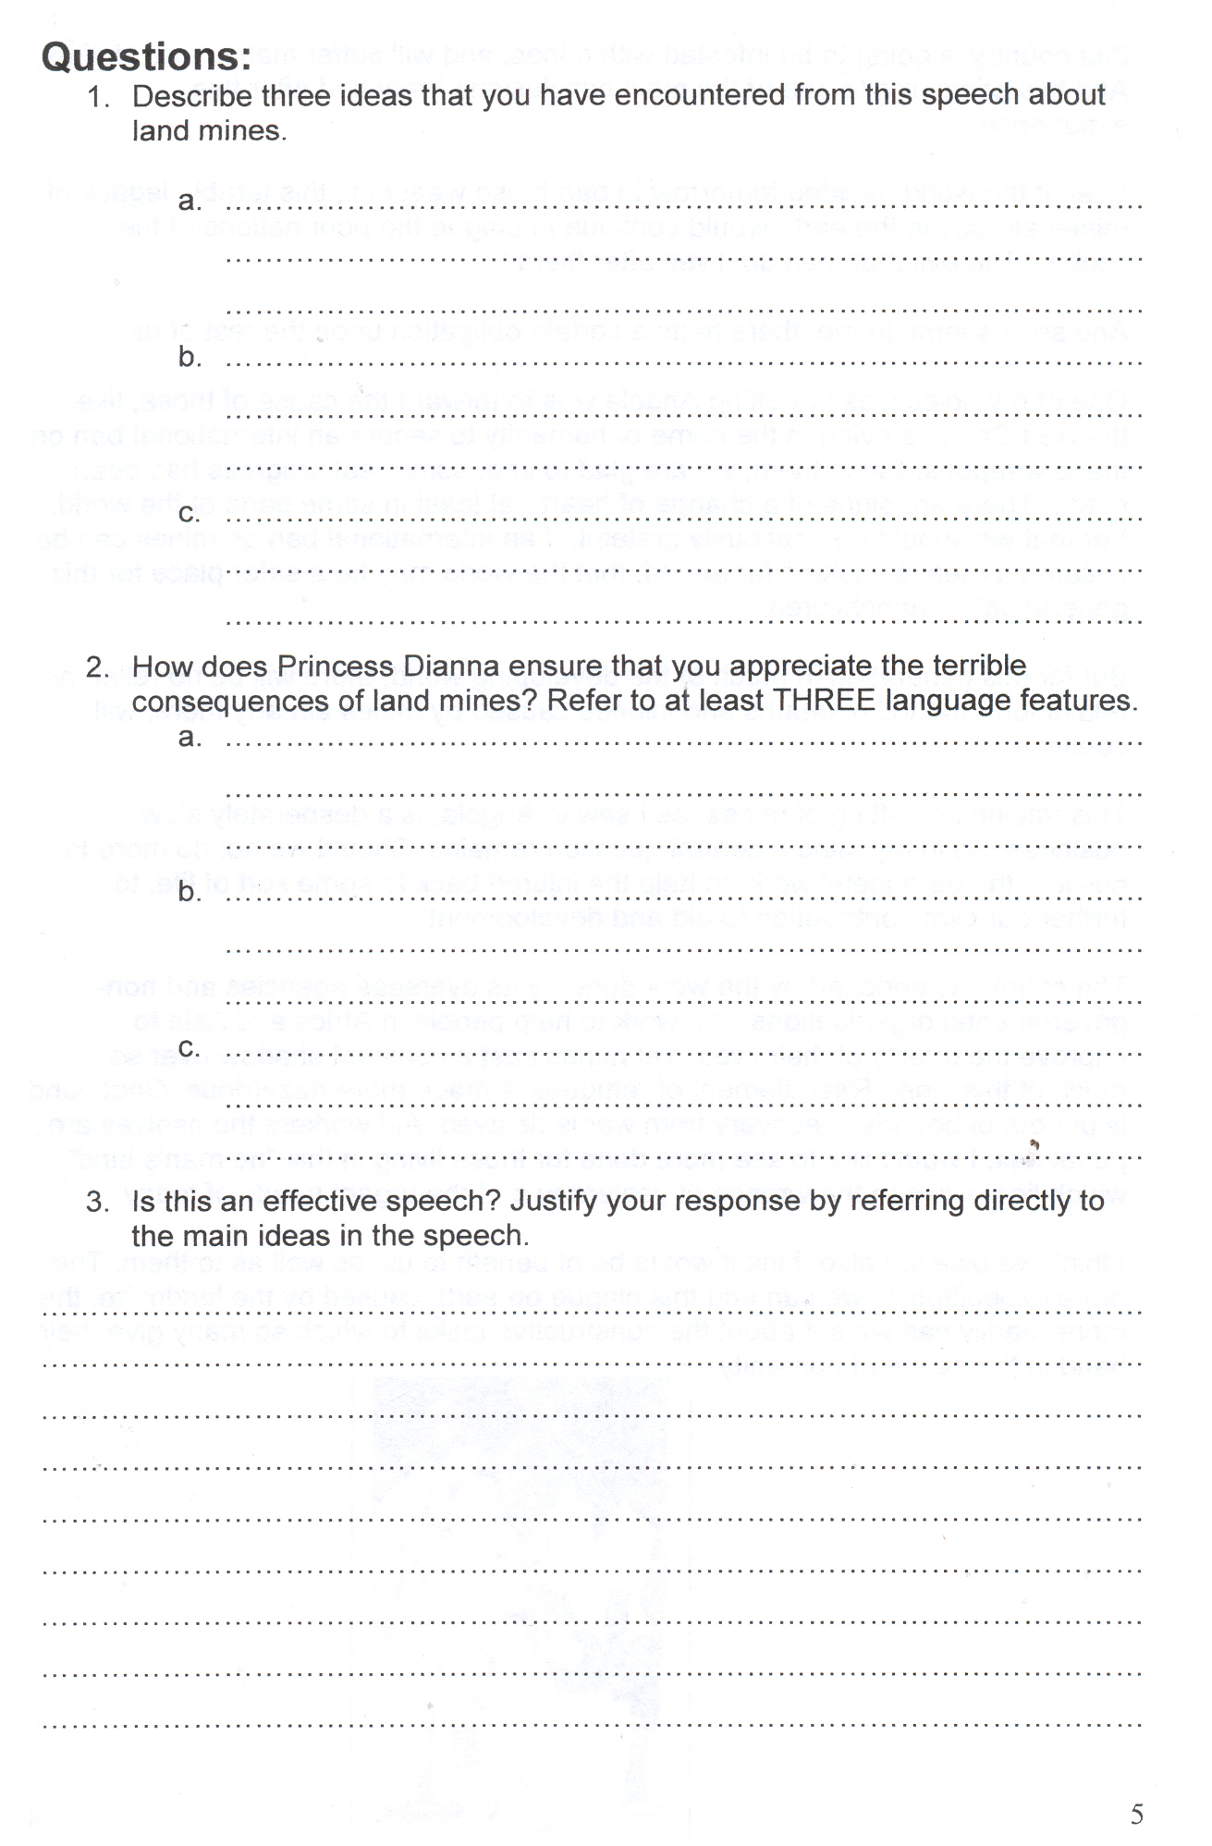
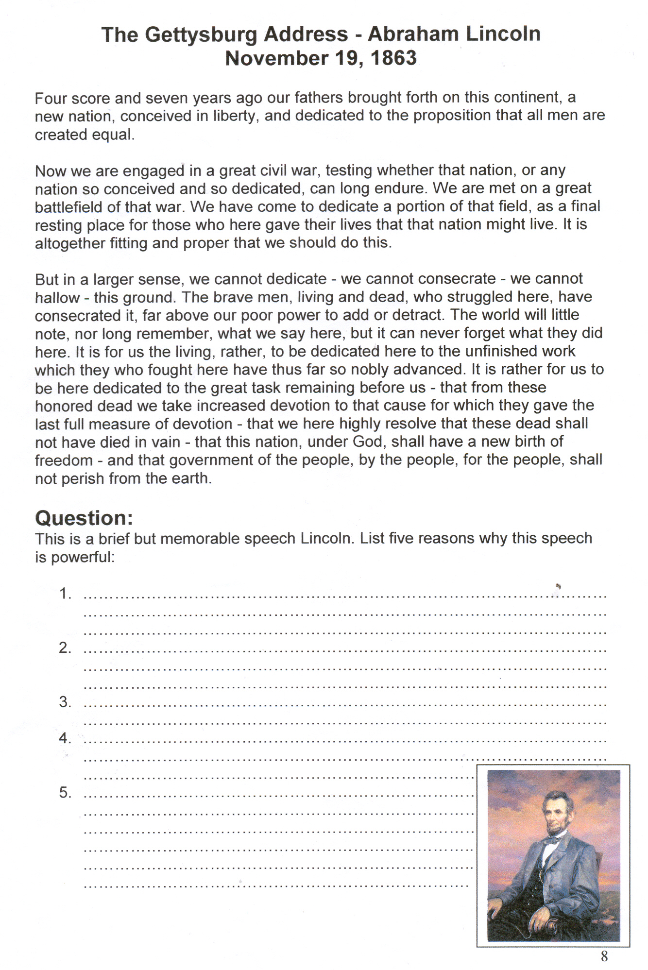

Resource 3

Search You Tube for Al Pacino, Any given Sunday.
Listen/view and discuss as a group.

- This is a motivational speech. Describe the tone and pace of the speech at the beginning.
____________________________________________________________________________________________________________________________________________________________________________________________________________________________________________________________________________________________________________________________________________________________________________________________________________________________________________________________________________________________________________________________________________________________

- Pacino tells stories about his life. What are some of these?
______________________________________________________________________________________________________________________________________________________________________________________________________________________________________________________________________________________________________________________________________________________________________________________________________________________________________________________________________________________________________________________________________________________________________________________________________________________________________________________

- Why does Pacino start raising his voice and how do the players react to this change?
________________________________________________________________________________________________________________________________________________________________________________________________________________________________________________________________________________________________________________________________________________________________________

- Why do you think Pacino wants the players to look into the eyes of a team mate?
________________________________________________________________________________________________________________________________________________________________________________________________________________________________________________________________________________________________________________________________________________________________________

- How does the speech end?
____________________________________________________________________________________________________________________________________________________________________________________________________________________________________________________________________________________________________________________________________________________________________________________________________________________________________________________________________________________________________________________________________________________________

- Do you think this speech is motivational? Explain your answer.
______________________________________________________________________________________________________________________________________________________________________________________________________________________________________________________________________________________________________________________________________________________________________________________________________________________________________________________________________________________________________________________________________________________________________________________________________________________________________________________

- Create a mind-map of all the language features you would like to include in your motivational speech.

Resource 4

How to write a biography
A biography is simply the story of a life. Biographies can be just a few sentences long, or they can fill an entire book - or two.
- Very short biographies tell the basic facts and overall importance of someone's life.
- Longer biographies include that basic information of course, with a lot more detail, but they also tell a good story.
Biographies analyse and interpret the events in a person's life. They try to find connections, explain the meaning of unexpected actions or mysteries, and make arguments about the significance of the person's accomplishments or life activities. Biographies are usually about famous, or infamous, people, but a biography of an ordinary person can tell us a lot about a particular time and place. Biographies are often about historical figures, but they can also be about people still living. Many biographies are written in chronological order, i.e. events in order of time. Some group time periods around a major theme (such as "early adversity" or "ambition and achievement"). Still others focus on specific topics or accomplishments.

To write a biography you should:
- Select a person you are interested in.
- Find out the basic facts of the person's life.
- Think about what else you would like to know about the person, and what parts of the life you want to write most about. Some questions you might want to think about include:
  - What makes this person special or interesting?
  - What kind of effect did he or she have on the world? On other people?
  - What are the adjectives you would most use to describe the person?
  - What examples from their life illustrate those qualities?
  - What events shaped or changed this person's life?
  - Did he or she overcome obstacles? Take risks? Get lucky?
  - Would the world be better or worse if this person hadn't lived? How and why?
Do additional research at your library or on the Internet to find information that helps you answer these questions and tell an interesting story.

Resource 5

Sports biography research scaffold

Name:
Nickname:
Born (where):
Birthdate:
Weight:
Height:
Debut:
Career:

Family:

Sporting awards/achievements:

Other awards/achievements:

Resource 6
My Profile: Darren Lockyer

Nickname: Locky
Born: Brisbane, Qld, 24th Mar 1977
Junior Club: Roma Cities
Weight: 84kg
Height: 178cm
First Grade Debut: v Eels Round 13, 1995
Biography: Darren Lockyer was born in Brisbane, Queensland, and is an Australian professional rugby league player and current captain of the Brisbane Broncos, Australian Kangaroos sides and the Queensland Maroons. Widely considered one of the finest players in the modern game, Lockyer has played more games and scored more points for the Brisbane Broncos than any other player in the club's history.
Lockyer currently plays in the five-eighth position, having moved there from his previous position of fullback in 2004. Upon switching positions, Lockyer endured heavy criticism, but responded in 2006 with arguably his finest ever season, becoming the first person since Allan Langer (a former teammate) to captain winning teams in the National Rugby League premiership, the State of Origin series, and the Tri-Nations series all in the same year. Lockyer also became only the second player to have won the golden boot award twice.
Other achievements:
Club Rookie of the Year 1995
Member of the 1997 Super League World Club Challenge winning Broncos side (Broncos defeated Hunter Mariners 36-12).
Member of the 3rd Broncos Premiership Winning Team in 1997 (Broncos defeated Sharks 26-8, Lockyer scored 5 goals; 10 points).
Most points in one season: 272 in 1998
Member of the 4th Broncos Premiership Winning Team in 1998 (Broncos defeated Bulldogs 38-12, Lockyer scored 5 goals; 10 points).
Member of the 5th Broncos Premiership Winning Team in 2000 (Broncos defeated Roosters 14-6)
Clive Churchill Medal Winner 2000
Club Player of the Year 2002,2003
Captain 2005-present
Dally M. Medal Five-Eighth of the Year 2006
Dally M. Medal Representitive Player of the Year 2006
Highest Ever Brisbane Point-Scorer with 1,220 Club Points (as of End of 2007 Season)
Club Best Back Award 2001,2002,2003,2006
Member of the 6th Broncos Premiership Winning Team in 2006 and also Captain (Broncos defeated Storm 15-8, Lockyer scored 2 goals and 1 field goal).
Highest capped Broncos player
Dally M. Medal Five-Eighth of the Year 2007
From: http://www.sportingpulse.com/mysport.cgi?a=BLOG_VIEWENTRY&blogID=132801

Resource 7
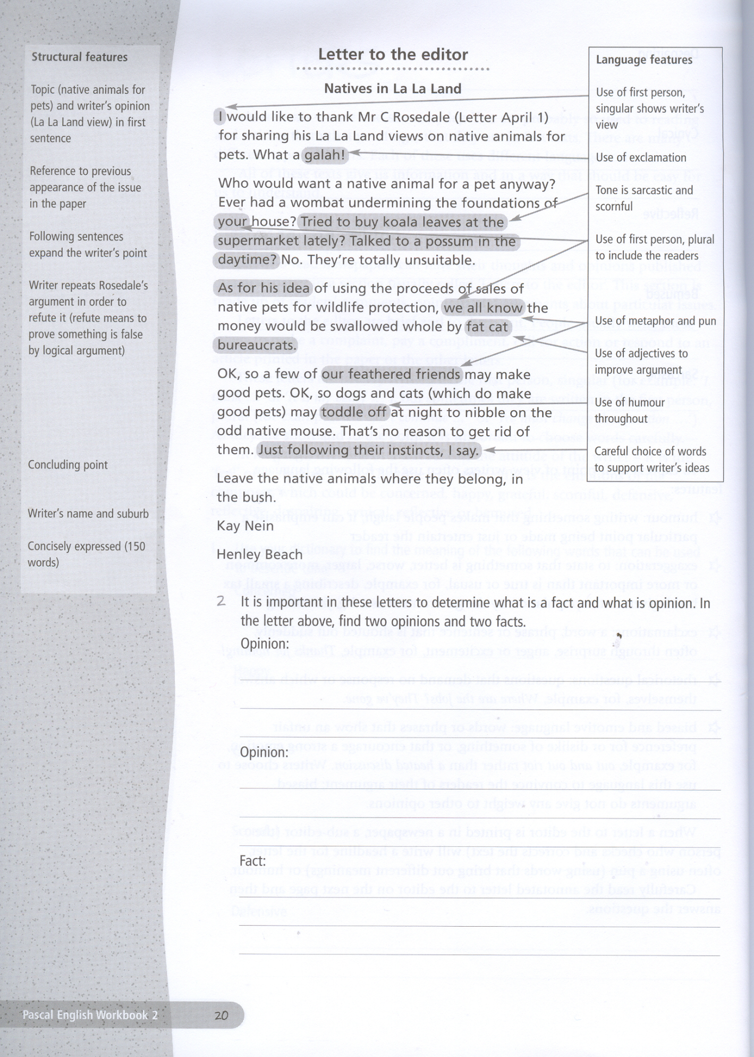
Resource 8
Letter to the editor scaffold
Author’s details:

(date)
Dear Editor
1st paragraph refers to the news item you are writing about, you state your opinion on the topic.

2nd paragraph is an explanation of your viewpoint.

3rd paragraph is used to suggest a solution or make a recommendation.

Complementary close

Author, signature and suburb

Suggestions for language:
- first person
- informal language
- emotive words
- rhetorical questions

Assessment task
English Skills
Playing the game: English in sport
Preliminary/HSC

Task description
You will submit a writing portfolio that you will be working on during the course of the unit. The portfolio should include three pieces of writing.

- Imagine that you are the coach of a sporting team which is about to play in a grand final. Compose a motivational speech using language devices appropriate for this purpose.

- Choose one player from your ‘dream team’ and compose a one page biography outlining the life and career of the person. The biography must use language and structure appropriate to a biography.

- After researching a variety of issues in sport, select an issue and write a letter to the editor of a sport magazine for young people.

Outcomes addressed
P1.1 has experience of extended and short texts in a range of forms to gain knowledge, understanding and appreciation of how English is used to convey meaning.
P1.2 explores the ideas and values of the texts.
P1.3 identifies how language and other techniques are used to convey meaning in extended and short texts in a range of forms.
P3.1 recognises a range of audiences and the appropriate text forms, vocabulary, style and tone when writing and speaking for those purposes.

Criteria for assessment
- Demonstrates understanding of how language is used in the sporting community for a variety of purposes: to excite, persuade, shape perceptions, motivate and inform.
- Builds response on well selected research
- Organise, develop and express ideas skilfully using language appropriate to audience, purpose and form.

Value of task for school assessment
XX%

MARKING GUIDELINES
Criteria | Marks
- Demonstrates a perceptive understanding of how language is used in the sporting community for a variety of purposes  - Builds responses on well-developed research  - Organises, develops and expresses ideas skilfully, using language appropriate to audience, purpose and form. | 9 10
- Demonstrates a competent understanding of how language is used in the sporting community for a variety of purposes  - Builds responses on sound research  - Organises, develops and expresses ideas competently, using language appropriate to audience, purpose and form. | 7 8
- Demonstrates understanding of how language is used in the sporting community for a variety of purposes  - Builds responses on adequate research  - Organises, develops and expresses ideas adequately, mostly using language appropriate to audience, purpose and form. | 5 6
- Demonstrates a limited understanding of how language is used in the sporting community for a variety of purposes  - Builds responses on limited research  - Organises, develops and expresses ideas in a limited way, sometimes using language appropriate to audience, purpose and form. | 3 4
- Demonstrates an elementary understanding of how language is used in the sporting community for a variety of purposes  - Builds responses on elementary research  - Organises, develops and expresses ideas in an elementary way. | 1 2
- Non-attempt | 0

TOTAL MARK: ________ / 10 SIGNATURE OF ASSESSOR: __________________________________________ DATE: _______________

COMMENT: ________________________________________________________________________________________________________

__________________________________________________________________________________________________________________

__________________________________________________________________________________________________________________

