Teaching notes

How to use this resource
This resource, Laptop wrap: Under universal skies, is designed to support student use of laptops in both online and offline classroom environments.
The purpose of this Laptop wrap is to engage students in an exploration of electromagnetic radiation in relation to astronomy, by listening to a young scientist who offers a clear explanation of electromagnetic radiation, calling it ‘light you can see and light you can’t see’. He also tells of his exciting observation of an exploding star. Through engagement with the tasks, students are expected to be able to identify some electromagnetic radiation used to obtain information about the universe; describe some difficulties in obtaining this information; identify an Australian scientist; and have a deeper understanding of the universe when next they look into the night sky.

Explore
Students explore the student interview with a 2008 Young Tall Poppy science award winner, Professor Bryan Gaensler, a radioastronomer who was also the 1999 Young Australian of the Year. This interview is taken from the larger resource Science Talk 2009.

Your tasks
The first task – Create an electromagnetic radiation diagram – requires students to synthesise the knowledge and understanding gained from the Professor Gaensler interview, to design a diagram in Microsoft OneNote (or another word-processing program) of electromagnetic radiation related to astronomy around a graphic of a changing wavelength. Student can search for electromagnetic radiation diagrams on the internet to check their diagrams and possibly add extra content they discover. The following is a snip of a possible diagram made on OneNote.
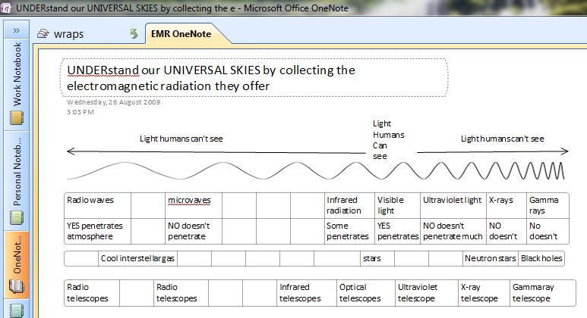

The second task – The right telescope for the job – requires students to modify their electromagnetic radiation diagram from Task 1 to include images of the various types of telescopes used to detect the full electromagnet spectrum and sample images captured by these telescopes.
Student can draw on the information in the Astronomer’s Toolbox website and Multiwavelength Astronomy Gallery for telescope types and sample images. Advanced students should also draw on other sources for telescope types and sample images.
The extension activity direct students to a Wikipedia diagram of EM spectrum Properties which includes information about the ability of different types of electromagnetic radiation to penetrate the earth’s atmosphere. Students must use this information to answer the following questions: Why are various types of telescopes placed in different geographical locations? How does the type of electromagnetic radiation that the telescope is trying to detect affect where to locate the telescope?
The third task – Searching for cosmic objects – requires students to add more information to their electromagnetic radiation diagram from Task 1 and Task 2. Students use the information in Professor Bryan Gaensler’s interview Kinds of info from EMR to match various cosmic objects, such as black holes, neutron stars, stars and cool interstellar gas to the types of telescopes used to detect them. Students also need to evaluate the pros and cons of the various telescopes. All of this information could be included in the OneNote diagram as voice-over annotations, or it could be recorded as a separate podcast or in a presentation. For clarity students might also wish to include sample images of the cosmic objects their diagram refers to.

Quality Teaching Framework
This resource provides opportunities to incorporate the following elements of Quality Teaching Framework in NSW public schools by:
- giving students an opportunity to discover the nature and practice of science (deep knowledge, deep understanding, connectedness, metalanguage, knowledge integration)
- highlighting the dynamic nature of research in astronomy (problematic knowledge, higher-order thinking).

