Online Learning Courses: Information for principals and schools

Specialised professional learning courses supporting teachers and schools to meet the needs of students with disability

Courses:
- are evidence based and regularly updated
- support participants to learn about assessment, making adjustments, SMART goals, intervention strategies and personalising learning and support
- use a blended learning model of tutor support during tutor led sessions and self-paced learning online
- use a web-based format that accommodates adult learning and includes interactive activities.

20 hours NESA accreditation
- Understanding & supporting behaviour
- Understanding autism spectrum disorder
- Dyslexia & significant reading difficulties
- Speech, language & communication needs
- Understanding hearing loss
- Dyspraxia & motor coordination difficulties

40 hours NESA accreditation
- Understanding personalised learning & support
- Supporting student wellbeing & mental health

20 hours Elective PD
- Understanding Attention Deficit / Hyperactivity Disorder

Learning cohorts
The courses can run as school-based cohorts or as open courses in a community of schools or principal network.

Tutors:
- lead a cohort of up to 12 participants
- facilitate 3 + tutor sessions for 20-hour courses or 4 + tutor sessions for the 40-hour courses
- guide participants through all aspects of the course and the website
- maintain course quality and integrity
- manage their events on MyPL
- support participants to complete all course requirements.

Finding a tutor
- There are trained tutors across the Department in local schools and delivery support teams.
- Local coordinators should be contacted for assistance in matching with a tutor.

Cost
- Any charges for courses are determined by the local delivery support team.
- Parramatta office funds tutor training.

Go to:
aus.oltinternational.net / NSW DoE
Watch short videos that explain the course delivery model, individual course benefits and features.

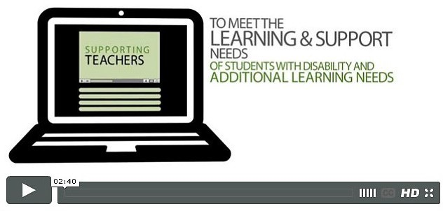
For further information email:
disabilitylearning@det.nsw.edu.au

