Information Gap Activity

Instructions
In pairs, each student will be given a handout with four diagrams and four empty boxes. Students should not show their handout to their partner. They must take it in turns to describe their diagram to the partner to help them draw it exactly. In doing this, they must take into account the orientation of the triangle (For example, the right angle is at the top left corner) and guide their partners to label all the information in their handout.

Student 1
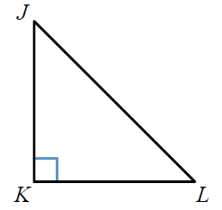 |  | 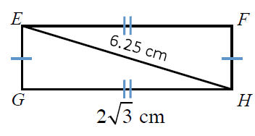
 | 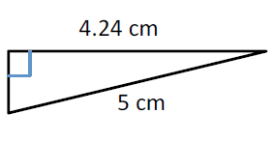
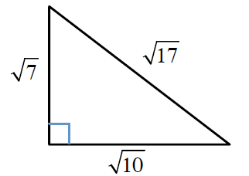

Student 2
 | 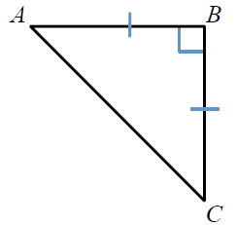
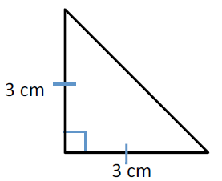 |  | 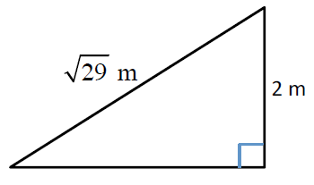
 | 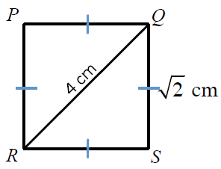

Solution

