Pastures from Space

Teacher notes

Introduction to Precision Agriculture

What is Precision Agriculture?
The term ‘precision agriculture’ is described by the CSIRO as:
“…seek(ing) to exert more control over a production system by recognising variation and managing different areas of land differently, according to a range of economic and environmental goals. To do this, the tools of Precision Agriculture are used to collect large amounts of data on crop or animal performance and the attributes of individual production areas (for example, fields, paddocks and blocks) at a high spatial resolution.
A number of enabling technologies are critical to Precision Agriculture. These include the global positioning system (GPS), geographical information systems (GIS), Variable-Rate Technology (VRT), soil sensors and yield monitors which, with GPS, enable georeferenced records of yield to be collected ‘on-the-go’ during harvest. Remote and proximal crop canopy sensing is also often invaluable whilst digital elevation models are often key to understanding the variation in both crops and soils. With these technologies, growers are better able to observe, understand and manage the variability in their production systems by tailoring inputs to desired outputs.”¹
Precision Agriculture is a process:
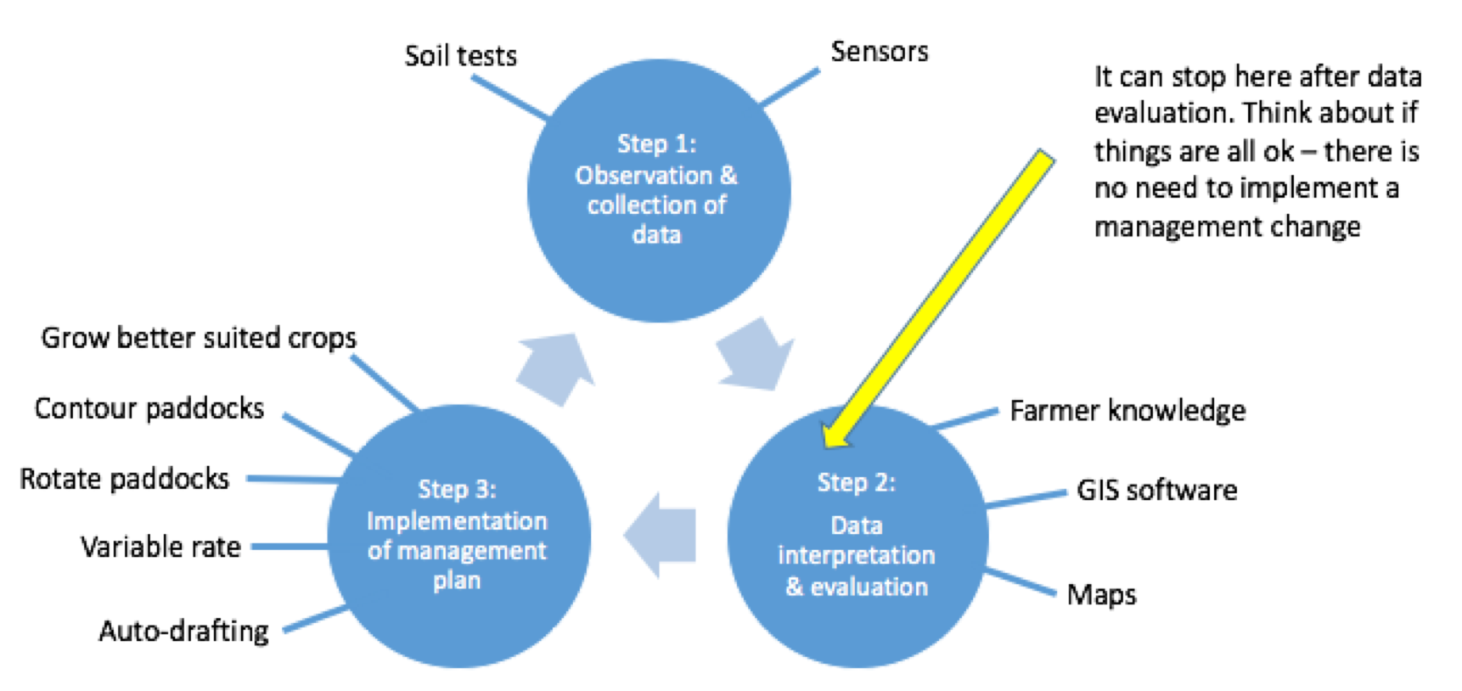
¹CSIRO (2017) Precision Agriculture. Retrieved from https://www.csiro.au/en/Research/AF/Areas/Sustainable-farming/Precision-agriculture.

The Future of Farming
The Future of Farming & Agriculture video (May 2017), although produced in the USA, gives an excellent overview of current and emerging technologies in the agricultural industry. (http://www.youtube.com/watch?v=Qmla9NLFBvU&fref=gc)

Why is it important?
- Social
  - Access to greater amounts, and more accurate data about land capability, animal and plant performance which can be used to make informed decisions in a timely manner.
  - Individual monitoring of animals allowing farmers to quickly identify and address health issues.
  - Increased understanding of agriculture by the industry and greater community when presented in a straightforward manner.
- Environmental
  - More efficient use of inputs, such as seed, fertiliser and pesticides.
  - Improved soil condition by identifying areas constrained by soil type, quality, and so on, and choose agricultural activity based on land capability.
  - Targeted herbicide use improving weed management.
  - Reduce overgrazing and associated land degradation.
- Economic
  - Reduced inputs costs through the application of variable rate fertiliser, pesticide, herbicide, and so on.
  - The possibility of improved yields through targeted application of inputs.
  - Increase efficiency, for example, improved pasture utilisation.
  - Higher profits through reduced inputs, improved yields.

Useful precision agriculture resources
- Precision Agriculture case studies (http://www.precisionagriculture.com.au/case-studies.php)
- Applying Precision Agriculture (GRDC) (https://grdc.com.au/__data/assets/pdf_file/0027/39852/applyingpa-pdf.pdf.pdf)
- PA in Practice II (https://grdc.com.au/__data/assets/pdf_file/0012/100740/painpracticeii-pdf.pdf.pdf)
- Precision Agriculture Laboratory (https://sydney.edu.au/agriculture/pal/about/what_is_precision_agriculture.shtml)
- Society of Precision Agriculture Australia (http://spaa.com.au/pa-publications.php)

Careers and Pathways
There are many jobs available in the area of precision agriculture (such as consultant). However, as new technologies and systems are developed and adopted on farms and in the agricultural supply chain, all careers in agriculture will involve some aspects of precision or digital agriculture.
Students wanting a career in precision agriculture will require a bachelor’s degree in agriculture or related discipline.
Many universities are now offering specific units of study in precision agriculture or are embedding information about new technologies in their existing course and practicals.
- Tasks common for Precision Agriculture professionals (http://www.une.edu.au/current-students/resources/academic-schools/school-of-environmental-and-rural-science/careers/agricultural-careers/precision-agriculture)

Agricultural career pathway resources
- Career Harvest (http://www.careerharvest.com.au)
- Primezone (http://primezone.edu.au/careers-in-ag/?id=2)
- Agrifood Careers (http://agrifoodcareers.com.au/home.php?id=1)

Pastures from Space reading
- Pastures from Space and the role of remote sensing at the farm level – PowerPoint presentation.
- Pastures from Space FAQs (https://pfs.landgate.wa.gov.au/support/frequently-asked-questions)
- A. Edirisinghe , M. J. Hill , G. E. Donald & M. Hyder. 2011. Quantitative mapping of pasture biomass using satellite imagery. International Journal of Remote Sensing 32: 2699-2724.
- Smith, R.C.G., M. Adams, S. Gittins, S. Gherardi, D. Wood, S. Maier, R. Stovold, G. Donald, S. Khohkkar and A. Allen. 2011. Near real-time Feed On Offer (FOO) from MODIS for early season grazing management of Mediterranean annual pastures. International Journal of Remote Sensing 32 (16): 4445-4460.

Learning intentions
After completing this unit of work students will have understanding of:
- what precision agriculture is
- how an actual commercially available tool can be used by farmers
- the use of technology to improve farm management decisions
- how science, technology, engineering and mathematics (STEM) can be used in agriculture
- pathways to a career in agriculture.

Success criteria
Students will do this through:
- using the Pastures from Space® Plus program to observe close to real time farm data
- using their critical thinking skills to reflect creatively how the information from Pastures from Space® Plus can be used to guide farm management decisions to improve profitability, productivity and environmental sustainability
- employ or further develop their ICT knowledge and skills
- accessing a range of online resources, such as videos and websites.

Scope and sequence
Lesson | Content | Extension | Resources | Outcomes
Introduction | - Brainstorming – identify key areas  - Pastures from Space PowerPoint | N/A | - Video overview of Pastures from Space Plus (https://www.youtube.com/watch?v=BiTKKY1OO00)  - Pastures from Space.pptx | 5.1.2, 5.4.1
Eastern Australia PGR | - Complete Pastures From Space – Student activities part 1  - Explore several locations | - Compare different geographical areas and give reasons for differences  - Climate  - Season  - Industry | - Pastures From Space – Student activities part 1 | 5.5.2, 5.4.1
High res versus low res data | - Past methods – eyeball paddock  - Explain satellite  - Wave lengths of light  - High res (Landsat 8)  - Low res (MODIS)  - Explain NDVI  - Limitations  - Cloud cover  - Forests versus grass  - Start exploring Student activities – part 2 | - Accuracy – number of pixels  - NDVI equation  - Links to biomass  - Explore different ways to collect NDVI | - Pastures From Space – Student activities part 2  - Landsat 8 satellite (https://www.geoimage.com.au/satellite/landsat-8) | 5.5.2, 5.4.1
Dry matter | - What is dry matter?  - What does it mean in terms of animal production?  - What is DSE (dry sheep equivalent)?  - Satellite data is based on this | - Explore different species  - Take photo  - Do pasture cut and drying practical exercise  - Make comparisons | - Estimating dry matter yield (http://futurebeef.com.au/wp-content/uploads/2015/12/Yield-estimation.pdf) | 5.3.3, 5.3.4, 5.5.1
PGR and FOO | - Define each  - How are they calculated?  - Use – management, sustainability, stocking rotation  - Difference between PGR and FOO  - Complete PGR and FOO activities on student activities part 2 | N/A | - Pastures From Space – Student activities part 2 | 5.3.3, 5.4.1
Compare FOO and PGR | - Compare across the farm  - Recognise high FOO and low PGR  - Explain the difference | - Compare different locations  - Compare different times of the year  - Reasons for variation | - Pastures From Space – Student activities part 1 and 2  - Commonly used grazing terms (http://mbfp.mla.com.au/Pasture-utilisation/5-Rest-periods) | 5.3.3, 5.4.1, 5.5.1
Stocking rate calculator | - Complete calculator exercises at the end of Pastures From Space – Student activities part 2 | - Benefits  - Seasonal conditions  - Set up scenarios, for example, 3 month rotation of 100 crossbred ewes – which paddock would you use? | - Pastures From Space – Student activities part 2  - Video – Pastures from Space Plus Stocking Calculator Tutorial (https://www.youtube.com/watch?v=pJepcpE-hl4) | 5.3.3, 5.3.4, 5.4.1, 5.4.2, 5.4.3, 5.5.1
Conclusion | - Summary  - Animal welfare  - Planning | N/A | N/A | 5.4.3, 5.5.1

