Pastures from Space

Student activities

Part 2 — Using Pastures from Space® Plus
You will investigate the features of the Pastures from Space® Plus website. Paddock information is available for the University of Sydney’s John Pye farm.
- Open the Pastures from Space website (http://www.pasturesfromspace.csiro.au/) and click anywhere on the top graphic to navigate to the Pastures from Space® Plus site.
- Using the menu at the top of the page, select ‘Login’ and enter the email address ‘pfs@smartfarmhub.com’ and password ‘pfshub00’.

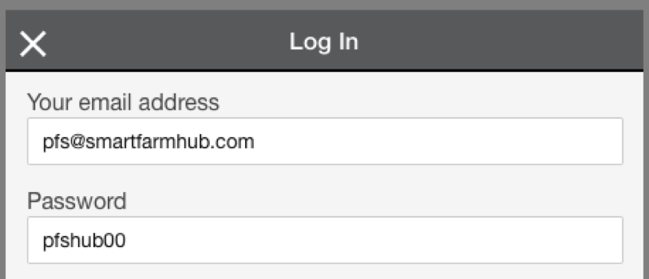

- Select the ‘John Pye’ button.
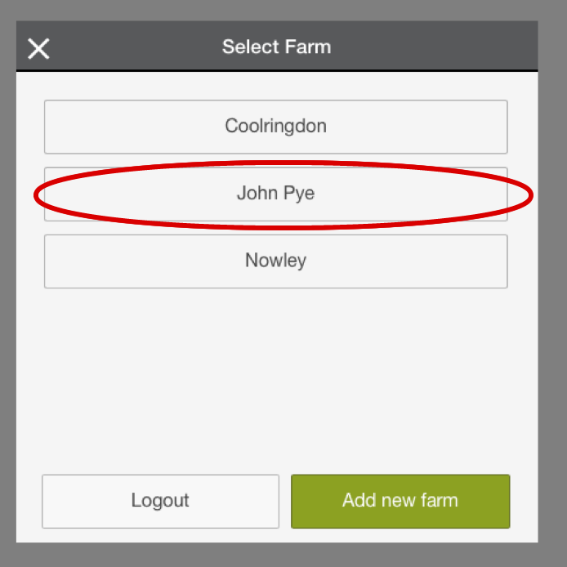
- Pastures from Space can access imagery from two different satellites. NDVI data is collected by MODIS satellites. MODIS pixels are 250m x 250m and are updated each week. Landsat 8 imagery has a resolution of 30m, such that each pixel is 30m x 30m and a new image is made available approximately every fortnight.
- Display the MODS NDVI image by selecting the icon circled. You should see the individual PGR pixels derived from MODIS.
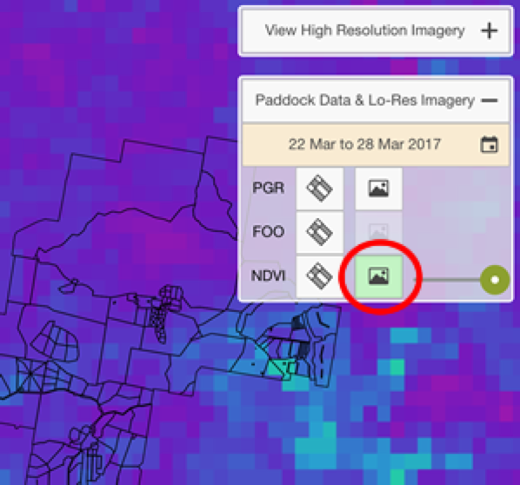
- As you can see, the MODIS pixels don’t necessarily line up within paddock boundaries – what problems might this cause?

- Now let’s compare the low resolution MODIS imagery to the high resolution Landsat 8 imagery. Select ‘View High Resolution Imagery’ and select the date 29 August 2017. You can view the imagery for FOO, NDVI and PGR.
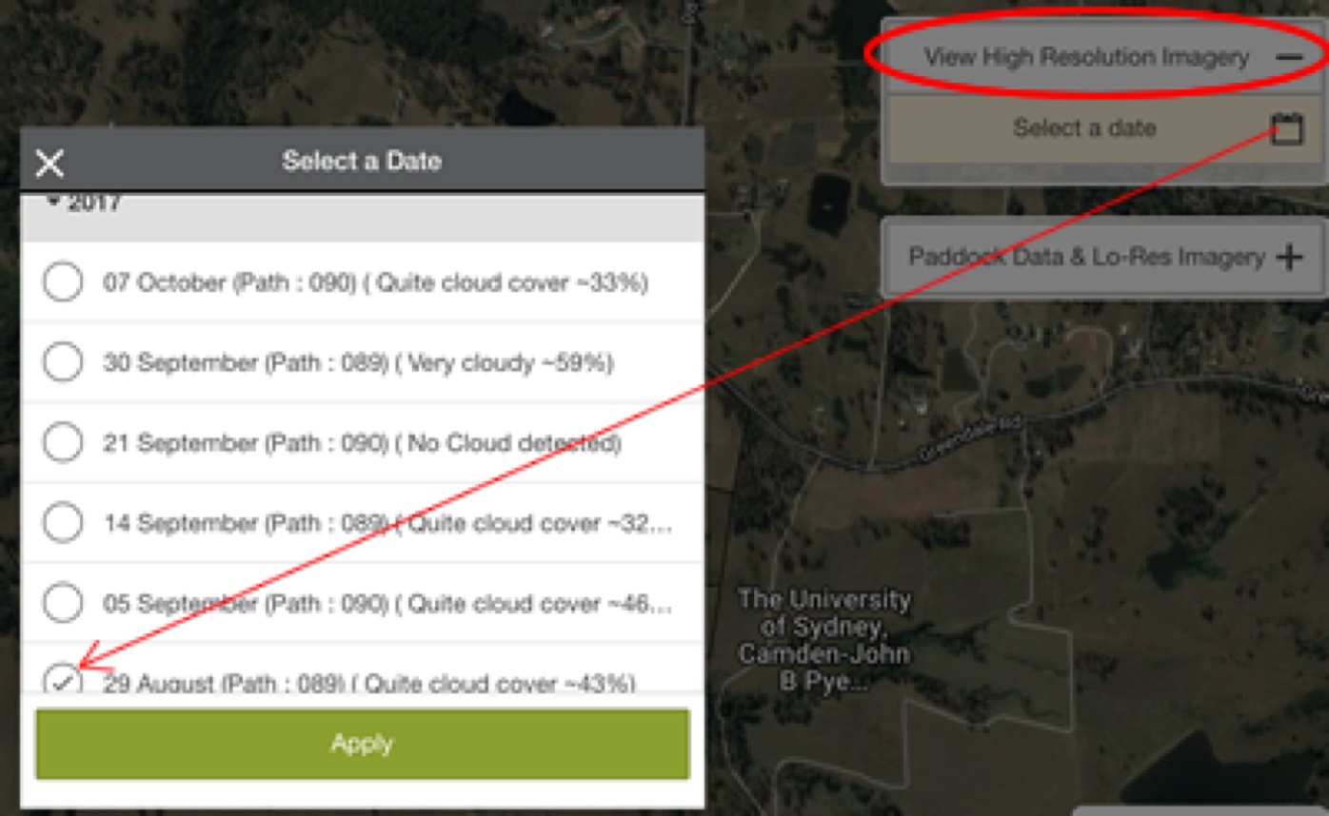
- Are areas of the image white? What does this indicate?

- What differences can you see between the MODIS and Landsat 8 image? From a farmer’s perspective, how would the Landsat 8 image assist them to make management decisions?

- Select the ‘Paddock Data & Lo-Res Imagery’ button.
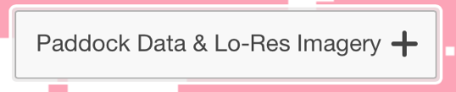
- Select the week starting 31 August 2016.
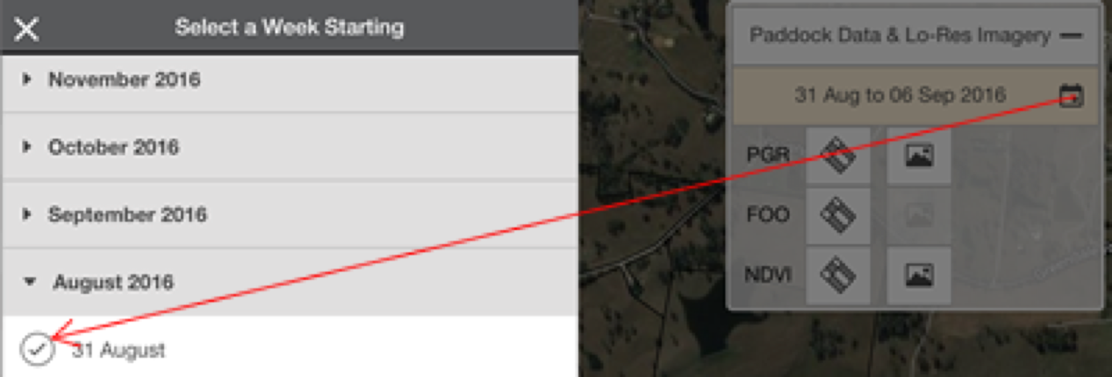
- This is the image you should see.
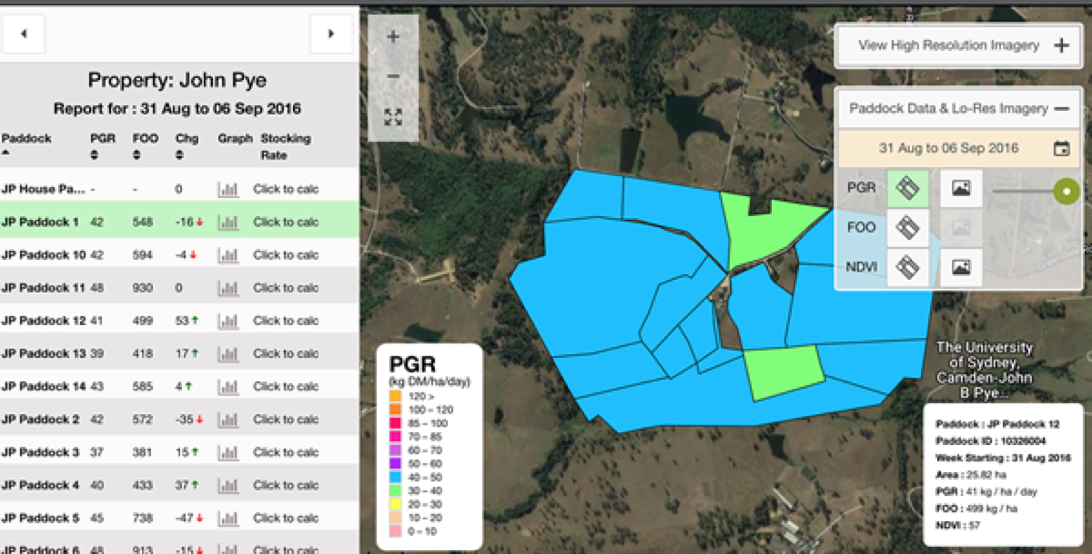
- Understanding the terminology.
- NDVI (Normalised Difference Vegetation Index) – amount of live green vegetation observed by the satellite.
- FOO (Feed On Offer) – the total amount of above-ground, attached green plant material, measured in kg DM/ha.
- DM (Dry Matter) – the proportion of plant material remaining after water has been removed. TDM is the total for the year.
- PGR (Pasture Growth Rate) – derived from both NDVI (from satellite imaging) and plant growth modelling (using climate data). PGR is measured in kg DM/ha/day (measured each week).

- Select the ‘PGR’ and ‘FOO’ buttons and compare the images for the entire property. Describe what you observe. Do the PGR and FOO maps follow the same trend? If not, why might this be the case?
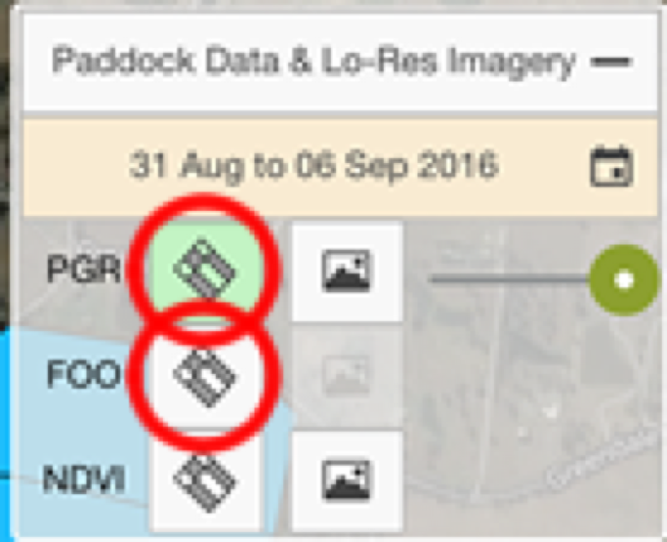

- Select ‘Paddock 3’ from the paddock list on the left. Examine the Area, PGR and FOO information in the box on the right.
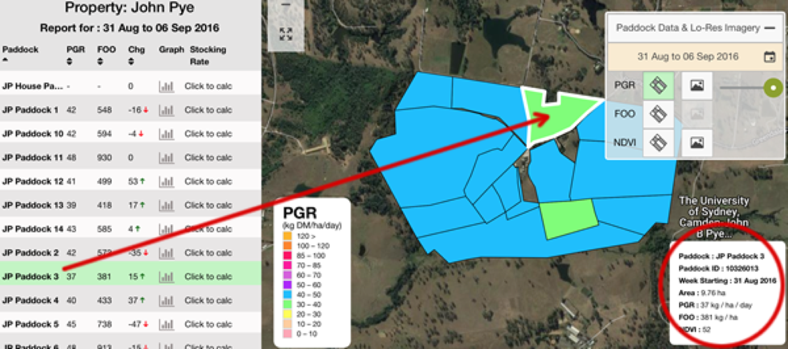
Write down the key information for Paddock 3 and Paddock 6.
Paddock 3. Area: PGR: FOO:
Paddock 6 Area: PGR: FOO:

- Select the ‘Graph’ icon for Paddock 3. This screen allows you to observe the trends in PGR, FOO, NDVI, TDM and rainfall for each paddock since 2004.
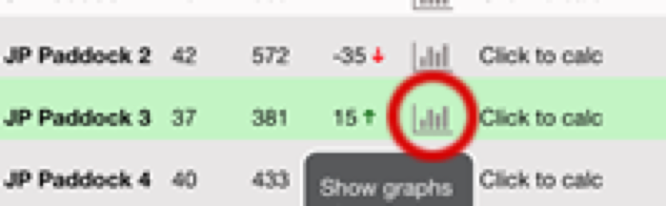
Compare data for paddock 3 for 2016 and 2011 (uncheck the average and all other years).
What are the similarities and differences for each year.
PGR:

FOO:

TDM:

- You can also select different paddocks to compare. Select the Menu List icon on the top right of the graph window. Choose ‘Select Paddock’ from this list.
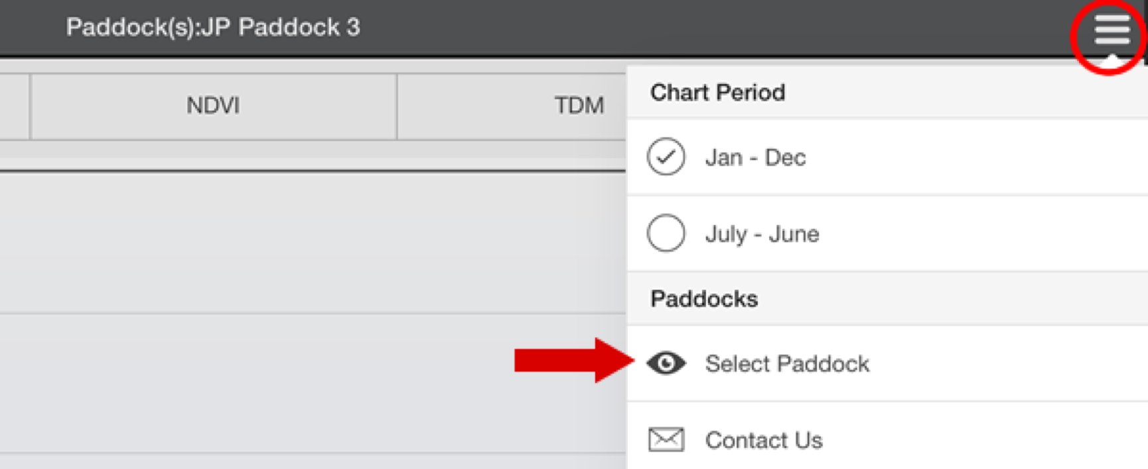
- Select any paddocks you wish to compare and click the ‘Apply’ button. Each of the selected paddocks is shown as a different colour on the graph. Hover your mouse over a coloured line to see which paddock you are looking at.
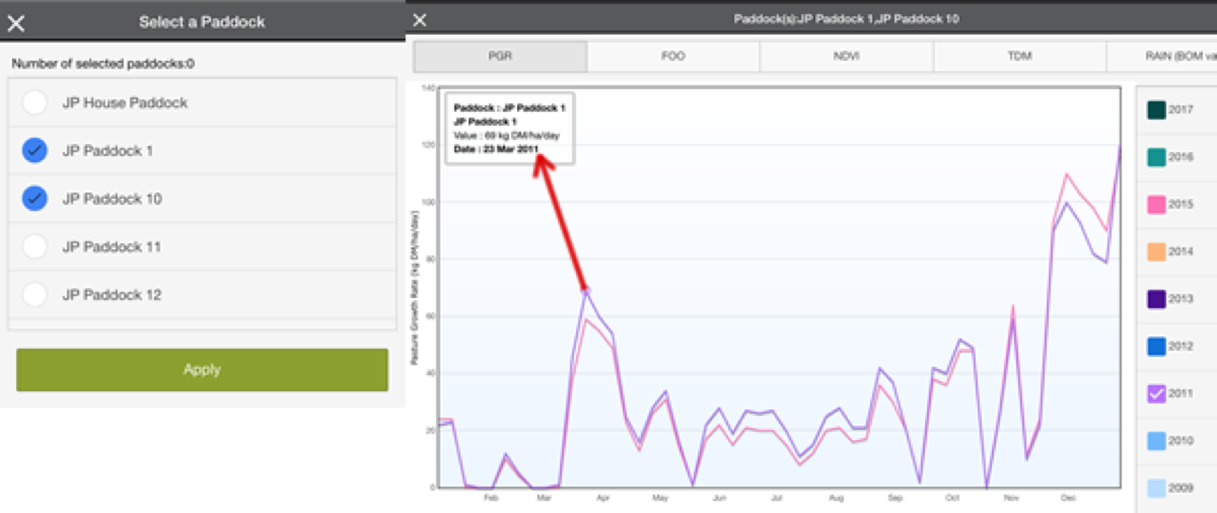
- Discuss how a farmer might use the information provided by these graphs.

- Another useful tool provided is the Stocking Rate Calculator. This allows the grazier to enter variables and calculate the number of stock that can be placed in a particular paddock for a given number of days or the number of days a paddock can support a given number of stock. Return to the map and select the ‘Click to calc’ option for a paddock. Check that you are still on the week beginning 31 Aug 2016.
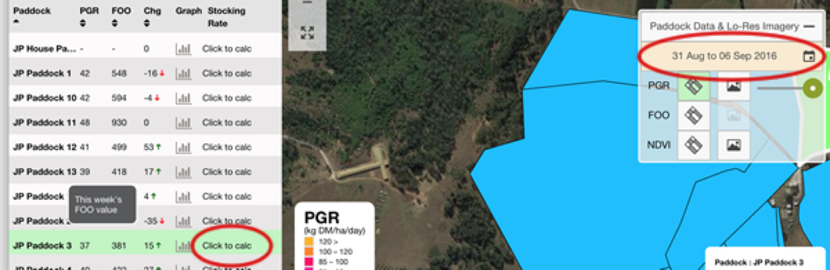
- When you enter the appropriate data and select the ‘Calculate’ button, the information you require is displayed – depending on whether you chose to calculate the number of head or number of days.
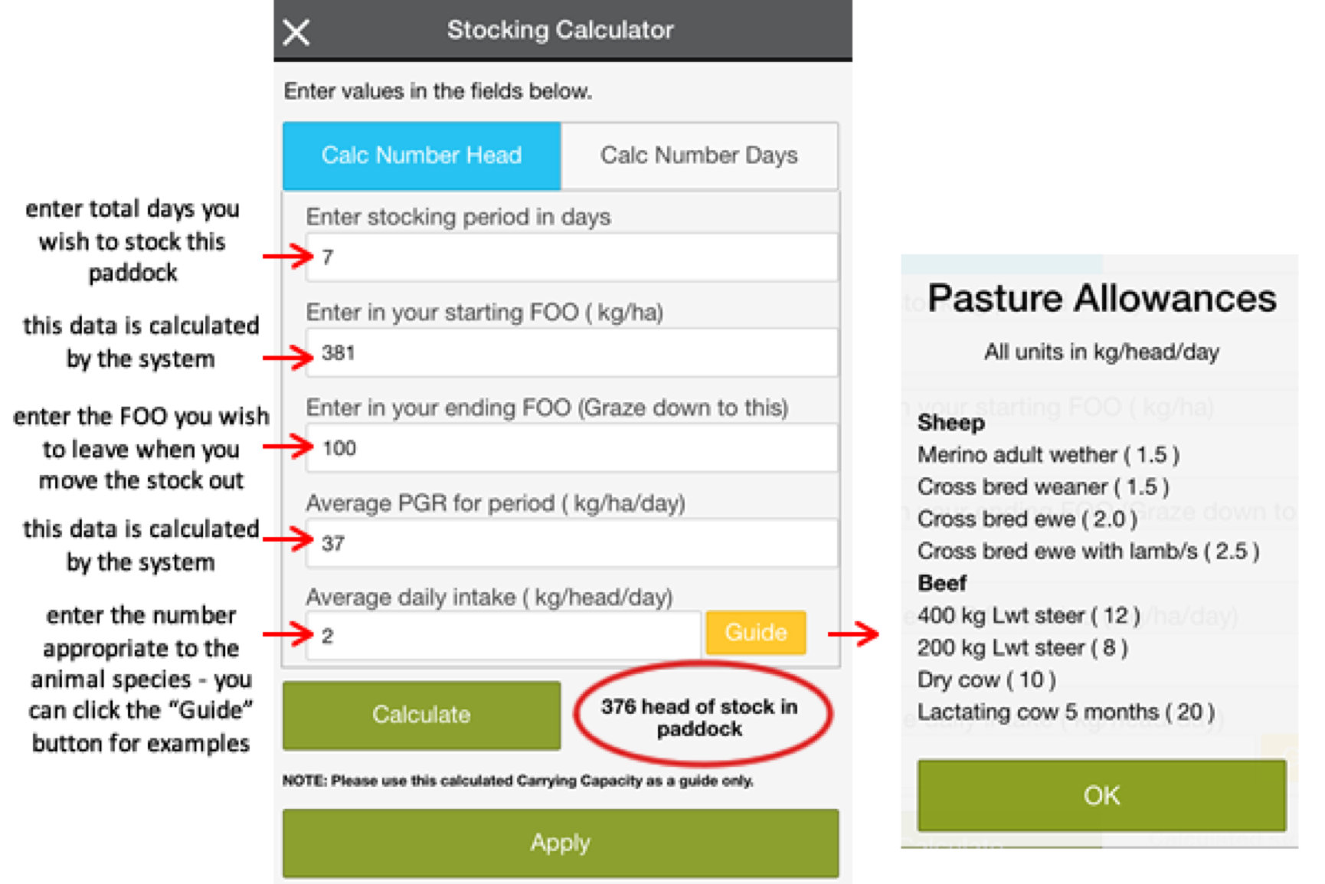

- Calculate the number of head of 400kg Lwt steers that you can place in paddock 10192008 for 10 days leaving a FOO value of 100 kg/ha. Note: you must select the ‘Calc Number Head’ option at the top of the calculator.

- Calculate the number of days you can place 100 dry cows in paddock 10192028 leaving a FOO value of 200 kg/ha. Note: you must select the ‘Calc Number Days’ option at the top of the calculator.

