Pastures from Space

Student activities

Part 1 — Pasture Growth Rates (PGR)
You will learn how to use the public access Pastures From Space web interface and understand the broad scale information that it provides. Open the Pastures from Space website (http://www.pasturesfromspace.csiro.au/).
- Select the ‘Eastern Australia PGR Data’ button as shown by the red arrow in the image below.
- You need to accept the liability statement. DO NOT complete the first-time user’s registration details. Select the ‘PGR Data Returning User’ button as shown by the red arrow to get through to the Pasture Growth Rate map.
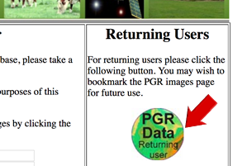
- Select the enlarge tool at the top left of the map.
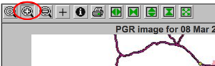
- Drag the cursor on the map to select the area around Armidale and zoom into that area. You may have to do this a couple times to get a suitable view. If you exceed the allowable zoom level you may have to try again.

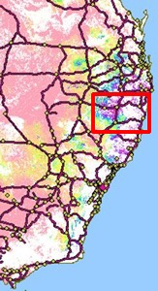
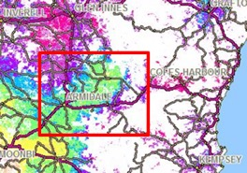

You should get to the magnification shown below.
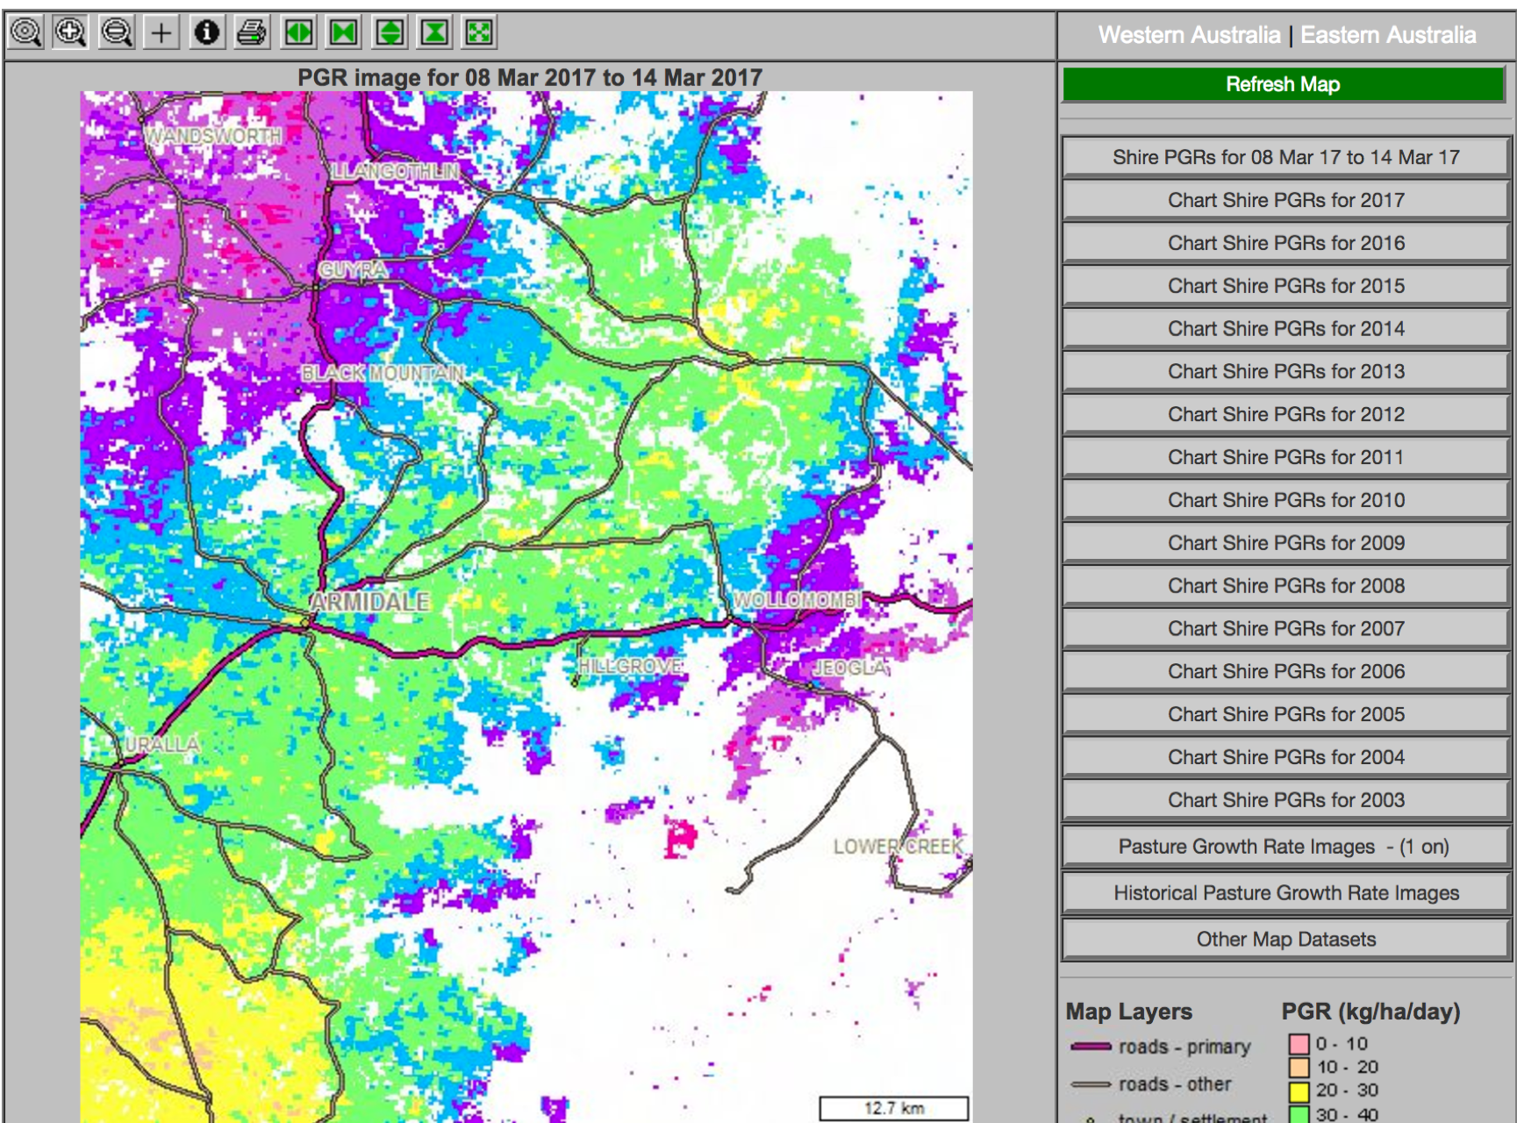

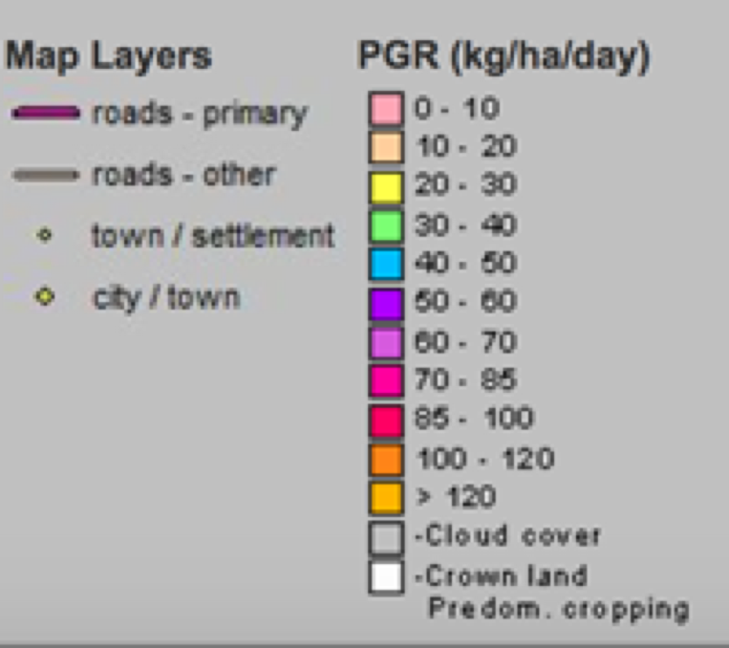
Using the map legend record the range of pasture growth (kg/ha/day) around Armidale at the moment.

- Select the ‘Pasture Growth Rate Images’ button and scroll down to the bottom of the date list and select the year ‘2011’.
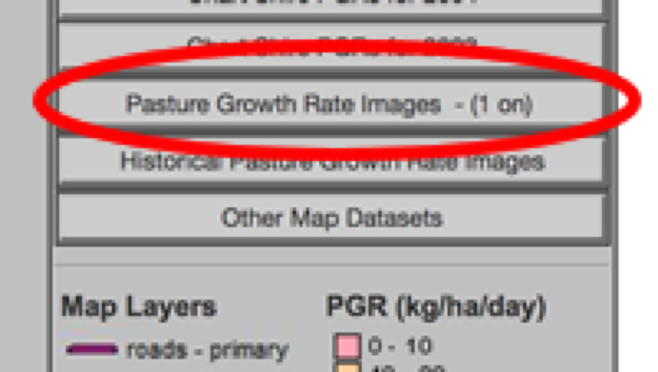
- Select the ‘Pasture Growth Rate Images’ button again.
- Select a PGR image from February 2011. Select the ‘Refresh Map’ button.

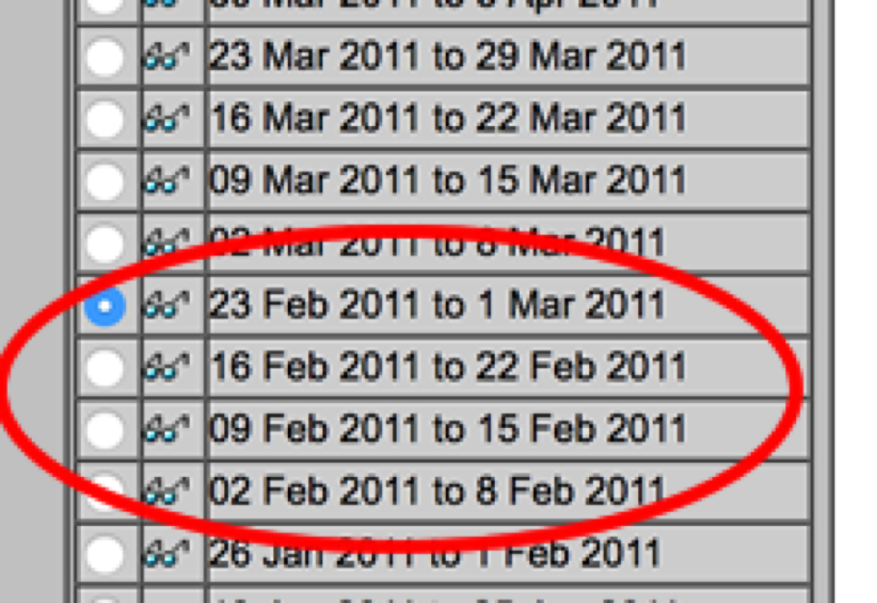
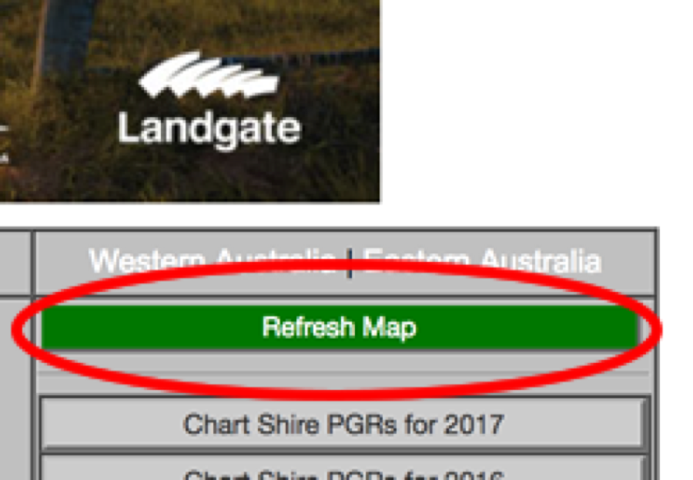

- Zoom in to the Armidale area again and record the range of pasture growth (kg/ha/day) in February 2011.

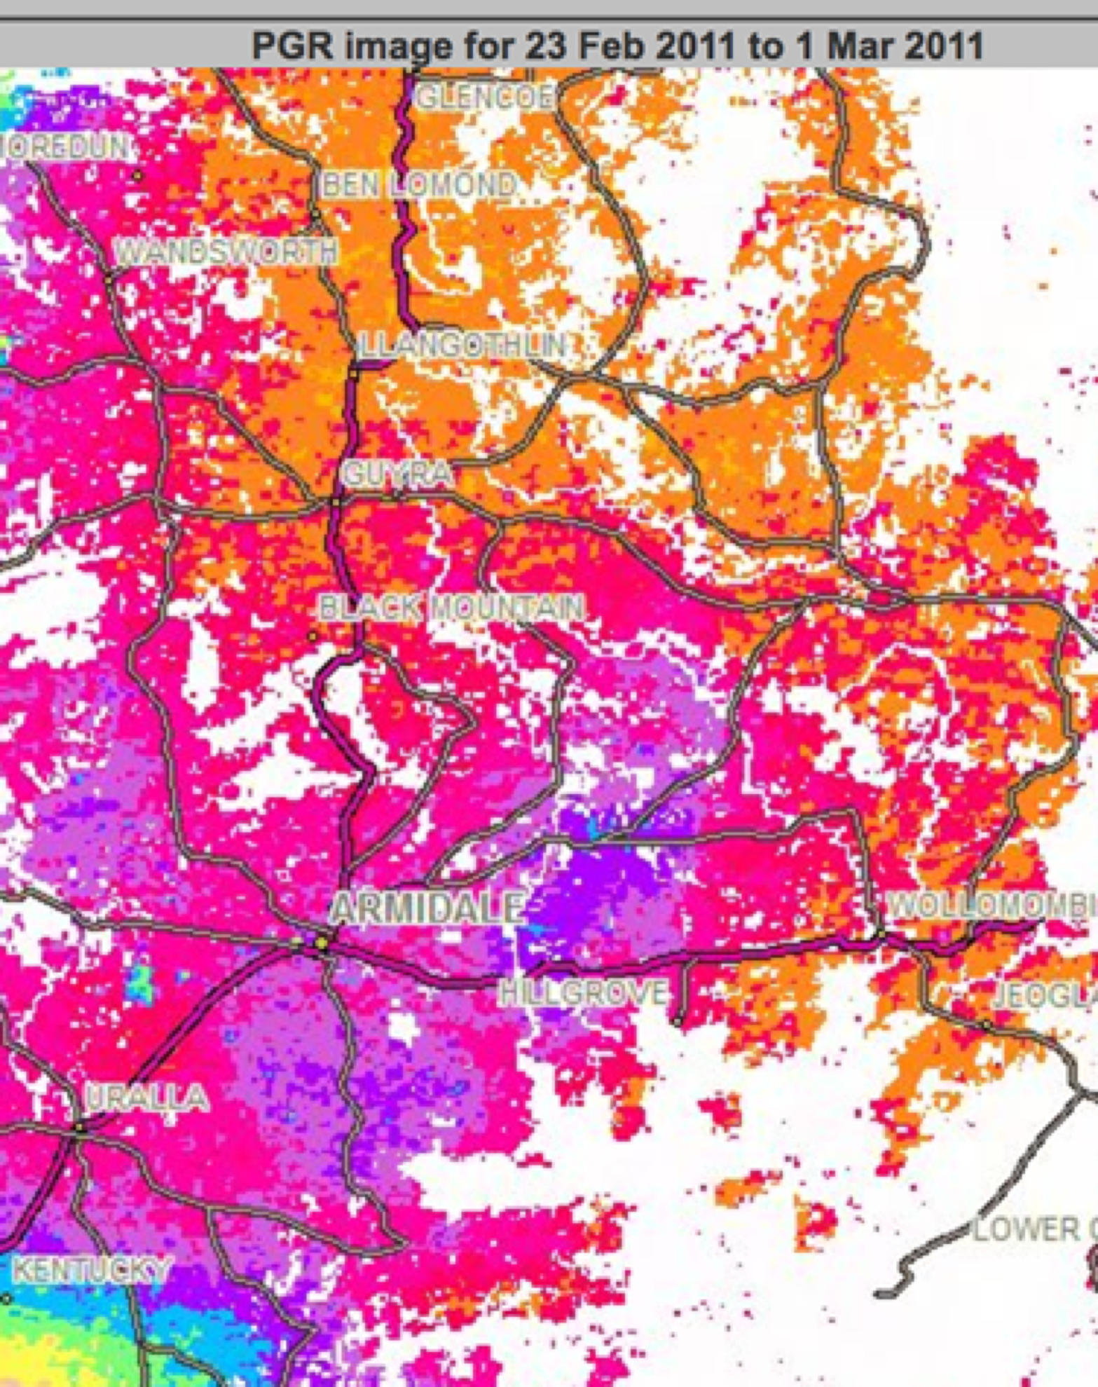
- Repeat steps 3 to 8 and select your local area. Examine the Pasture Growth Rate for a particular time period.

- Select the ‘Chart Shire PGR’s for 2011’ button. From the list select ‘Armidale Dumaresq’ and ‘Lower Eyre Peninsula’, select the ‘Graph Shires’ button.

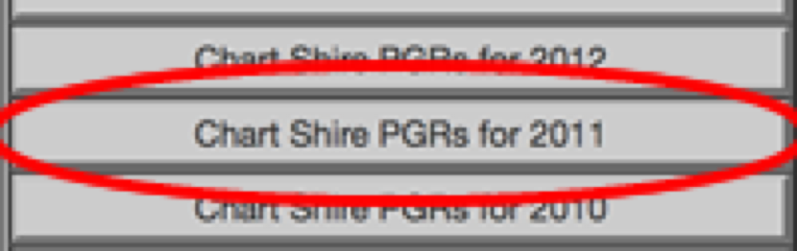
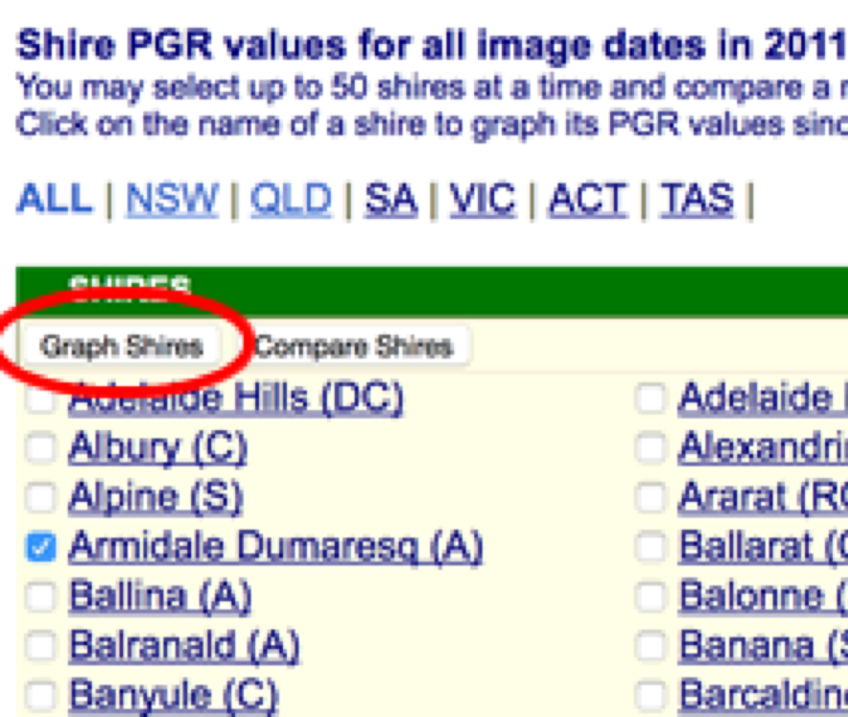

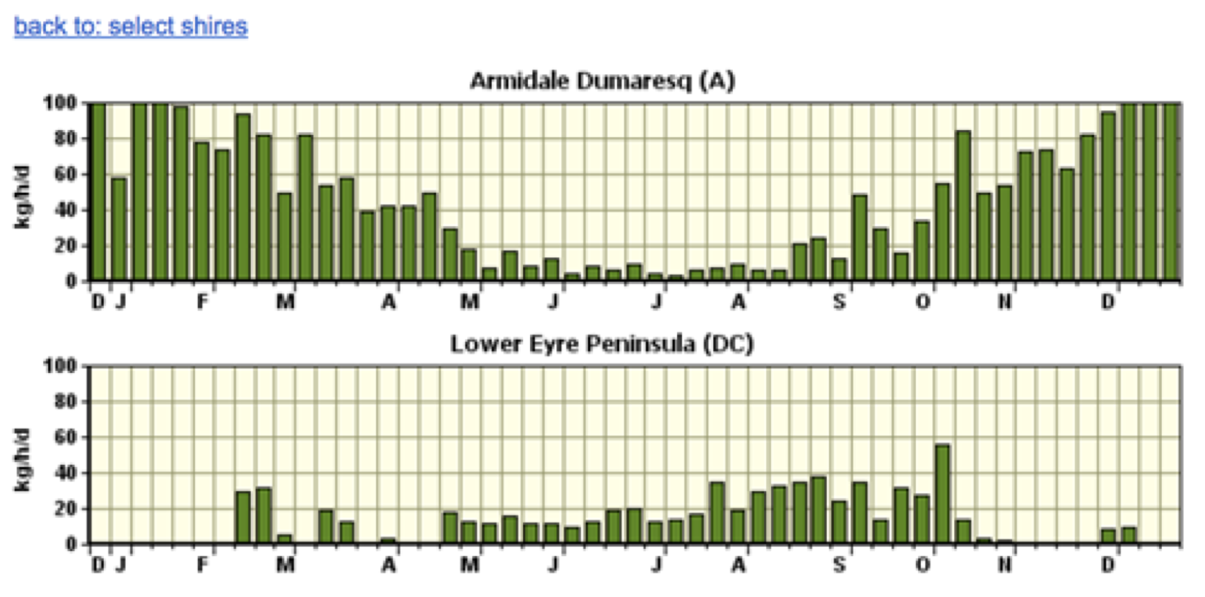
How would you describe the pasture growth profile of each area?

Suggest reasons for the different growth profiles.

Repeat step 10 and explore an area of interest to you. Describe the PGR from a recent image.

What might be some of the practical applications of this information for farmers?

