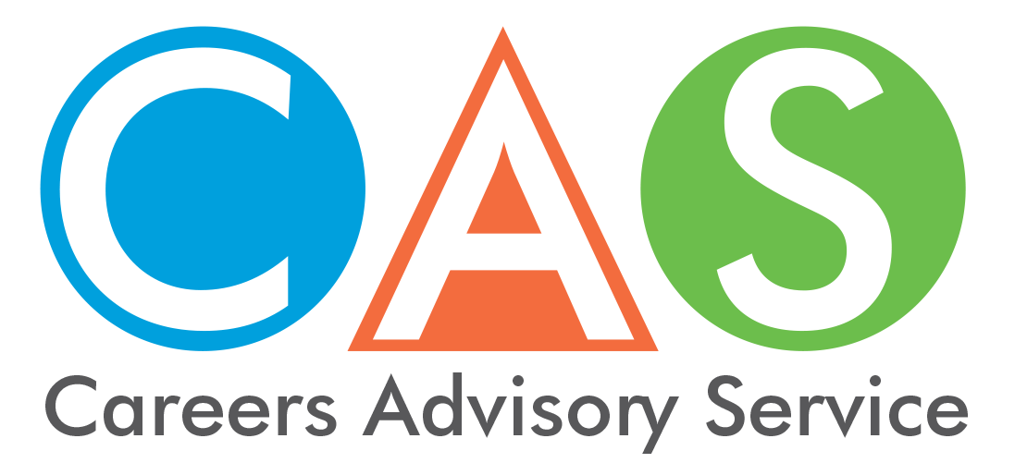

11. Rural and remote students

Transitioning from school is a major event for a young person. Some rural and remote students can find this time particularly challenging. This fact sheet has information to help you to access and remain in higher education.

Australian Government financial support
The Department of Human Services, through Centrelink, provides financial support to assist with costs while you finish school, undertake tertiary education, or undertake an Australian Apprenticeship or traineeship. See fact sheet 15 for a full list or visit the Centrelink website. Some examples include:
- Youth Allowance provides financial help for people 16 to 24 years of age who are studying full time, undertaking a full time Australian Apprenticeship, training, looking for work or sick.
- Relocation Scholarship is a yearly payment to help students move to or from a regional or remote area to study. You must get ABSTUDY or Youth Allowance and be in full time higher education.
- Student Start-up Loan supports the upfront cost of study for higher education students.

Grants and scholarships
- The Country Education Foundation (CEF) helps disadvantaged rural and regional students' access education, training and careers. See the 'Students' tab on their website for information on CEF grants, a survival guide, a scholarship guide and student support.
- NSW Department of Education offers rural teaching scholarships. Get paid while you study to become a primary or secondary teacher in a rural or remote NSW public school.
- Rural Skills Australia has compiled a list of rural scholarships around the country.
- Country Women's Association (CWA) of NSW offers a variety of Education Grants to students from NSW.
- going rural health have compiled a list of scholarships for the health services. Check out if you are eligible for any.
- Rural and Regional Enterprise Scholarships - The Commonwealth Government is offering scholarships to regional and remote students to help them access and complete tertiary STEM qualifications.

Student loans
A Commonwealth supported place (CSP) is a subsidised higher education enrolment. CSP's are available at all public universities (and some private higher education providers in national priority areas like nursing and education). A CSP means the government helps by paying part of the fees directly to the university. Students are required to pay the remainder of the fees which is known as the ‘student contribution’ amount.
The Australian Government’s Higher Education Loan Program (HELP) provides financial assistance through different HELP schemes to assist you to pay the student contribution amount and other tuition costs. The right loan for you will depend on your circumstances, eligibility and where you want to study.
VET Student Loans provide similar loans to students studying approved higher level vocational education and training (VET) courses.
The Australian Government StudyAssist website has full details about eligibility, student contributions and repayment. Note that there are citizenship eligibility requirements to be met.
Both programs are administered by the Australian Government Department of Education and Training. Debts and repayments are managed by the Australian Taxation Office (ATO).
For more details go to our CAS home page - Get the facts. Fact sheet 15 - Higher Education Loan Program (HELP) and other student loans.

University Educational Access Schemes (EAS)
Educational Access Schemes (EAS) are designed to help students who have experienced long-term educational disadvantage gain admission to tertiary study.
The University Admissions Centre (UAC) administers the Educational Access Schemes (EAS). Participating institutions (except University of Technology Sydney, which allocates places for eligible applicants) use EAS assessments to apply equity adjustments that increase an applicant's selection rank.
Equity adjustments do not change an applicant's ATAR, instead they change your selection rank for a particular course. The application of equity adjustments does not guarantee you entry to a course, as you still need to meet the published lowest selection rank.
Disadvantage codes S01C and S01R apply to certain rural schools.
NEW - Help for Students Affected by Drought
For students who are affected by drought, EAS enables them to apply and claim for disadvantages such as: excessive family responsibilities, severe family disruption and financial hardship.
Students who attend schools in regional and remote areas are automatically eligible for EAS consideration and will receive notification from UAC after they apply for study.
Also check the website of the universities that you are interested in for information on scholarships offered for students from rural or regional areas.
See also more details go to our CAS home page - Get the facts. Fact sheet 8 - Alternative university entry schemes.

© 2018 NSW Department of Education

