Circle geometry
Syllabus elements | Teaching ideas | Teaching resources
Definitions of terms related to circles. | Students need to be comfortable with the basic parts of a circle: circle, centre, radius, diameter, arc, sector, segment, chord, tangent, concyclic points, and cyclic quadrilateral.  They also need to understand the concept of “subtending”, common tangent and point of contact.  Students should be encouraged to write definitions in their own words rather than rote learning lists.  Students should be encouraged to draw diagrams from worded problems. | A fun introduction to circle geometry can be seen in Philip Glass’ Sesame Street animation  There are a large number of Geogebra ‘books’ freely available, but students are encouraged to construct their own files.
Simple angle properties of a circle. | Geogebra is extremely useful to demonstrate these properties. Students can either build their own files or the teacher can use pre-made files to demonstrate the assumptions.  Students will need to remember these assumptions, and recognise them in a variety of situations. They need to understand the concept of “converse” and recognise these situations. | Top Drawer Geometry by AAMT has some great notes regarding misconceptions, teaching ideas and resources (such as the Great Angle Chase and Dynamic Geogebra files.
Derivation of further angle, chord and tangent results. | Many of the properties of circles require students to use similarity or congruence proofs. They will need to be comfortable with many of the concepts covered in geometry. Essential prior knowledge includes:  - properties of angles on a straight line;  - vertically opposite angles;  - angles at a point;  - angles associated with parallel lines;  - geometry of plane shapes including exterior and interior angle sums, properties of special triangles and quadrilaterals;  - Pythagoras’ theorem;  - Similarity and congruence proofs  As students are expected to be able to prove these results, they should not be encouraged to rote learn them but derive them. This can be done in a number of ways but a suggested process is:  - Investigation using traditional construction techniques with students forming hypotheses  - Explore hypotheses using geogebra  - Formalise the wording of conclusions  - Practice finding numerical solutions  - Practice finding general/algebraic solutions  Once learned, students will need sufficient practice with theorem’s to enable quick recall and visualisation of theorems. | A two page pictorial summary of all the theorems  A summary booklet of the theorems  The Great Angle Chase in Top Drawer Geometry by AAMT is fantastic for a challenging review of all the theorems.  A Google Drive folder full of all the circle geometry proofs  A self-guided task for students which takes them through the definitions, assumptions and proofs
Teaching with Paper Circles | An interesting way to explore the introductory properties of the circle is to use pre-cut paper circles.  A good teaching sequence:  - Draw a chord on your circle - any chord. Encourage students to draw very different chords to their neighbour  - Using a ruler, draw two angles (in the same segment) subtended by the chord.  - Cut out one of the angles. Place it on top of the other angle - are they the same? Did it work for your neighbour too?  - Stick this in your book to show the idea.  - Take another circle. This time draw an angle at the circumference, and one at the centre. Cut out the angle at the circumference. Place it on top of the angle at the centre. What do you see? Confirm by cutting out another angle at the circumference and putting both angles.  - Stick in your book.  - How can we be sure this is always true? Now start a proof.  Properties of the chords can also be done this way:  - Showing the perpendicular bisectors of chords meet at the centre. (Easily done with folding). Note that this may not be very accurate for pre-cut circles!
Introductory Challenge | A student has a large metal circle. She needs to drill a hole in the centre. How will she find the centre?
Applications of geometric knowledge to numerical and theoretical problems requiring one or more steps of reasoning. | The difficulty of problems should progress as:  - Simple numerical  - Numerical but involving several steps  - Simple deductions with diagram supplied  - Harder deductions (with or without supplied diagram)  Students should always be encouraged to draw large (⅓ page) diagrams before attempting a problem. Introducing symbols on the diagram may simplify their working or clarify ideas for them.  Teachers are encouraged to be specific and explicit in their expectations of the set-out and reasoning to be provided by students. | Suggested abbreviations of the theorems
Common Errors | Students misapply their understanding of the product of intersection of chords to the products of the secants.  So they typically write:  instead of  A clear diagram showing the separate components to multiply, or emphasising where the similar triangle lie will help fix this. | 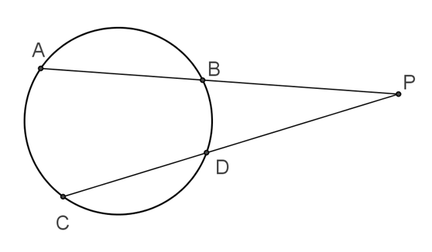
Limiting case of the product of the secants | And astute student may realise that the theorem for the tangent and the secant is a limiting case of the product of the secant intersections: | 