 Summer crop and tractor operation

Year 9 Agriculture

Teacher answer book

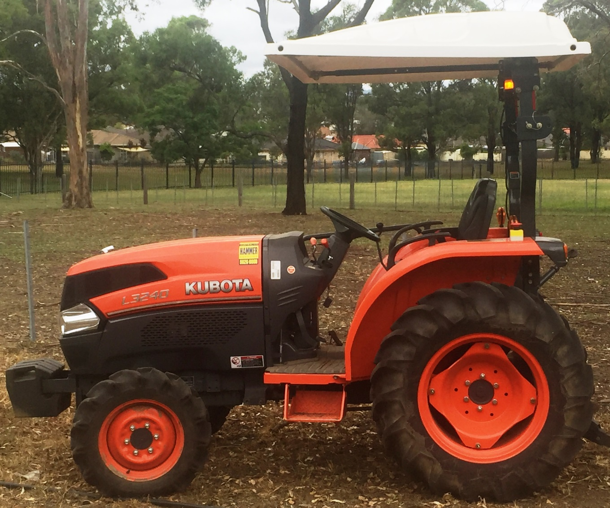

Acknowledgements

The resources for the ‘Sweet Corn’ unit of work were developed by the NSW Department of Education, Learning and Teaching Directorate for use by TAS teachers in NSW. They are developed to meet the requirements of the NESA [Agricultural Technology Years 7-10 Syllabus 2003](http://www.educationstandards.nsw.edu.au/wps/wcm/connect/44ba8fc9-9519-41ef-b2d8-3259d2f05be4/ag_tech_710_syl.pdf?MOD=AJPERES&CVID=Technology%20(Mandatory)%207-10%20Syllabus%20%C2%A9%202003%20Copyright%20Board%20of%20Studies%20NSW%20for%20and%20on%20behalf%20of%20the%20Crown%20in%20right%20of%20the%20State%20of%20New%20South%20Wales.).

The materials were developed by:

* Tony Butler, Tumut High School
* Sally Bannerman, Learning and teaching Directorate
* Dan Rytmeister, Learning and Teaching Directorate

The following people and organisations contributed to the development of the materials:

* Craig Jarrett, Mount View High School
* Don Anderson, Galston High School
* Australian Hammer Supplies
* Department of Primary Industries
* Yates Australia

The document and program are available for download from the [education website](https://education.nsw.gov.au/teaching-and-learning/curriculum/key-learning-areas/tas/s4-5/resources) (<https://education.nsw.gov.au/teaching-and-learning/curriculum/key-learning-areas/tas/s4-5/resources>).

**Notes for teachers using this document.**

This unit of work should be used in conjunction with the teaching and learning program, Equipment Safety in Schools and other advice from School Infrastructure NSW. The relevant advice can be can be found on theeducation website (<https://education.nsw.gov.au/school-infrastructure-nsw/procurements-and-contracts/compliance-contracts/equipment-safety-in-schools>)

**This resource has been developed to support NSW teachers of agriculture who wish to integrate tractor operation into a plant enterprise. It is expected that teachers will adapt this resource to their school context by varying the crop and images to suit the equipment and situation at their school.**

**Answers in this booklet appear in red and are suggested. Answers may vary depending on your school situation and equipment.**

Version 1.0

Farm Safe

**Answer the questions below. Information can be found on the** [Farm Safe website](https://farmsafe.org.au/) (https://farmsafe.org.au/).

Farm machinery is involved in approximately 40% of deaths on farms. Identify two machines responsible for many of these deaths?

Tractors and quad bikes

On average, how many deaths occur each year due to quad bikes?

10 (Ten)

**Go to the pages labelled** “[Staying safe on Australian farms](https://farmsafe.org.au/Staying-Safe-On-Australian-Farms)” (https://farmsafe.org.au/Staying-Safe-On-Australian-Farms) **and then** “[Tractor and machinery safety](https://farmsafe.org.au/Tractor-and-Machinery-Safety)” (https://farmsafe.org.au/Tractor-and-Machinery-Safety).

How many deaths involved tractors last year?

9 (Nine)

How many people were seriously injured?

8 (Eight)

What is a hazard?

Something that can cause injury or death

List seven hazards associated with using tractors on farms:

1. Tractor rollover

2. Tractor run over

3. Tractor power take offs (PTO)

4. Hydraulics

5. Ergonomics

6. Noise

7. Operator skills

What injuries were reported from using grain augers?

1. Crush injury or amputation of fingers

2. Crush injury or amputation of hands

3. Crush injury or amputation of arms

4. Crush injury or amputation of feet

**Click on the link labelled** “[Safe tractor operation](http://keo-cms.appspot.com.storage.googleapis.com/sites/farmsafe/assets/51450096-bbeb-4e85-8be6-650727eaa483.pdf)”. **Read the introduction on Page 2 and answer the following questions:**

List four responsibilities of the employer:

1. Consultation with workers to implement WHS program

2. Provision of a safe working environment

3. Organisation of safe systems of work

4. Maintenance of work areas, machinery and equipment in a safe condition

Identify one responsibility of the employee:

Must take reasonable care of the health and safety of themselves and others

List the four key processes that must be set in place to manage risk:

1. Consult with workers

2. Identify hazards

3. Assess risk

4. Control risk using the hierarchy of control approach

Identify two pieces of personal protective equipment (PPE) that should be supplied by the employer:

1. Eye protection

2. Hearing protection

List five pieces of PPE required while operating a tractor:

1. Hat/ safety vest

2. Eye protection- safety glasses

3. Ear protection-ear muffs or ear plugs

4. Long sleeve shirt and long pants/work gloves

5. Work boots

What does ROPS refer to?

Roll Over Protective Structure

Label the following statements as true or false:

* 1. People who operate smaller tractors without a cabin are at risk of injury. True
  2. Driving close to embankments is a risk of tractor roll over. True
  3. When driving a tractor with a ROPS, you need to wear a seat belt. True
  4. When you are driving a tractor, passengers are allowed to be on the tractor. False

Why are 4 wheel drive tractors less likely to backflip than 2 wheel drive tractors?

Four wheel drive tractors are less likely to backflip as they have more weight over the front axle than a 2WD and the torque is applied to both front and rear axles.

Outline three scenarios in which a person could be run over by a tractor and either injured or killed.

1. People may be run over by the rear wheel of a tractor or by an implement when they slip, trip or fall on the ground in front of a tractor

2. Standing next to a tractor in front of the rear wheel or a trailing implement may result in being run over

3. A person standing in front of a tractor may be crushed against a post, gate or building by the front of a tractor

What does PTO refer to?

Power Take Off

Outline three hazards or risks when working around the PTO.

1. Working near an inadequately guarded PTO shaft runs the risk of entanglement

2. Stepping over an operating PTO increases the risk of entanglement

3. Wearing loose clothing, clothing with drawstrings, jewellery or having long hair increases the risk of entanglement

Why is working with hydraulics a risk of injury to the operator?

The hydraulic oil is under pressure and can penetrate the skin.

What does ergonomics refer to?

The relationship of the body to the work that is being done. Ergonomics involves changing the environment to better fit the worker

Describe a typical injury that a tractor operator could suffer if they operate a machine for long periods.

The operator can have back, shoulder and other pain and injury – especially with poorly designed seats and controls.

Damage to hearing from long periods in a noisy environment.

List two types of noises that can affect a tractor operator while driving a machine.

1. Engine noise

2. Radio noise at high volume

What does WHS refer to?

Work Health and Safety

Identify four groups of people most at risk of injury on a farm.

1. Children

2. Visitors

3. Contractors

4. Older farmers

Why should farms be “emergency ready”?

Being well prepared with emergency plans and equipment will ensure that the damage to people and property is minimized when accidents happen

How can an employer ensure he or she is prepared for the following.

Needing first aid: A suitable first aid kit should be accessible to all workers on the property

Fire: Fire extinguishers should be available where fire is a hazard

Tractor operations

There are six models of tractor approved for use by students in schools. These tractors are modified to ensure students can learn tractor operation safely as part of the Agriculture curriculum.

The school tractor

Identify the tractor that is at your school. Use the tractor operator’s manual to assist.

Make:

Model:

Power:

4WD or 2WD:

Engine capacity:

Fuel type:

Hours:

Features:

Date of purchase:

Product ID number:

Engine Serial Number:

Transmission Serial Number:

Personal safety

Tractor operators must wear suitable PPE (Personal Protective Equipment) when operating a tractor.

Identify the following PPE:

| Image of PPE | Label the PPE |
| --- | --- |
| Identify this PPE | Work boots |
| Identify this PPE | Eye protection |
| Identify this PPE | Hat |
| Identify this PPE | High visibility safety vest |
| Identify this PPE | Long sleeves and pants |
| Identify this PPE | Hearing protection/ear muffs |
| Identify this PPE | Work gloves |

Safety decals

Safety decals are placed in important areas on the tractor to draw your attention to potential safety hazards. The three types of decal used are danger, warning and caution.

Danger labels identify the most serious hazards.

Task: find the following safety labels on the tractor and identify their purpose and location.

Caution

Colour Yellow

Location (Several locations can be identified by the student on the tractor)

Purpose If the caution is not taken it could result in minor or moderate injury

Warning

Colour Orange

Location (Several locations can be identified by the student on the tractor)

Purpose If the identified warning not observed it could result in death or serious injury

Danger

Colour Red

Location (Several locations can be identified by the student on the tractor)

Purpose If the identified danger is not avoided it will result in death and serious injury

Safety features

Identify and describe the purpose of the following safety features:

ROPS: Roll Over Protective Structure - Reduce injury in event of rollover

Safety Triangle: slow moving vehicle sign - reflective orange triangle bordered with red that warns road users that the vehicle displaying this sign is travelling slower than the normal speed of traffic

Audible alarms: An alarm signal that is audible - warns workers of a reversing tractor

Flashing light: visual warning - Provides visual warning to nearby workers

Guards: Covers moving parts - Protect the operator and others in the immediate area of an operational tractor from injury or death

Mounting step: Assists the operator of the tractor to safely mount and dismount - forms one of the three points of contact

Hand hold: Assists the operator of the tractor to safely mount and dismount - forms one of the three points of contact

Hydraulics

Leaking hydraulic oil can be very dangerous. The hydraulic oil can be under high pressure (200 times atmospheric pressure) and can be 170 degrees Celsius. Leaking hydraulic fluid can penetrate the skin and inject you with oil causing significant health issues.

Identify the places where there is hydraulic fluid under pressure.

Steering system, Brake system, 3 point linkage, SCV (Selective Control Valve)

What can happen if you are injected with hydraulic fluid?

Hydraulic fluid injected under the skin is extremely serious as hydraulic fluids are highly toxic. Delay in surgical treatment often leads to amputation or death due to cellular death

How can you test for leaking fluid?

Wear gloves and eye protection. Use cardboard to detect leak. Never use hand or skin.

What should you do if you have been injected with hydraulic fluid?

Ensure machine is turned off and on the ground, immediately seek medical attention

Parts of the tractor

Main parts identification checklist:

Your teacher will check off the table below as you identify each part.

| Component | Identified | Component | Identified |
| --- | --- | --- | --- |
| Radiator |  | ROPS |  |
| Engine |  | Three point linkage |  |
| Exhaust |  | Slow moving vehicle signal |  |
| Engine air cleaner |  | Draw bar |  |
| Engine oil dipstick |  | Fuel tank/filler |  |
| Tyre valves |  | Battery |  |
| Power take off (PTO) shaft |  | Oil filler cap |  |
| Greasing points |  | Three point attachment |  |

Controls identification checklist.

Your teacher will check off the table below as you identify each control.

| Controls | Identified | Controls | Identified |
| --- | --- | --- | --- |
| Steering wheel |  | Fuel gauge |  |
| Hand accelerator lever |  | Temperature gauge |  |
| Clutch |  | Ignition switch |  |
| Foot brakes |  | Horn |  |
| Gear lever |  | Choke |  |
| Range lever |  | Power take off control |  |
| 2 and 4 wheel drive lever |  | Right and left indicator lever |  |
| Light control switch |  | Hydraulic lever |  |

Student’s name –

Teacher signature – sign here

Date –

Pre start procedures

Check the following before starting the tractor:

1. Power – Check fuel level
2. Oil – Check dip stick and oil level windows
3. Water – Check coolant level in the coolant reservoir tank
4. Electrics – Test lights and check water level in the battery
5. Rubber – Check tyres have no irregularities
6. Air – Clear air filter and ensure tyres are inflated to manufacturer’s specifications.

If checks 1, 2 and 3 show low level then top up with correct fluids.

Generally inspect tractor for unfamiliar items and remove build-up of materials such as grass.

Check for 3 point linkage implement attachments.

Check shed and surrounding area for hazards.

Start up and shut down tractor.

* Mount the tractor using the foot step and grip handle. Maintain 3 points of contact at all times.
* Sit in the tractor and adjust seat to ensure controls are within reach.
* Fasten seat belt.
* Put earmuffs on.
* Check people are clear of the tractor.
* Check any attached implements are on the ground.
* Set the following controls:
  + Range lever to neutral
  + Gear lever to neutral
  + Throttle to medium level
  + Clutch depressed
* Turn the ignition on using the key and engage the starter
* Warm up engine by allowing it to idle
* Stop the engine by turning off the ignition.

Task – Identify procedures and controls

Images below show the pre-service checkpoints for the Kubota and John Deere tractors. 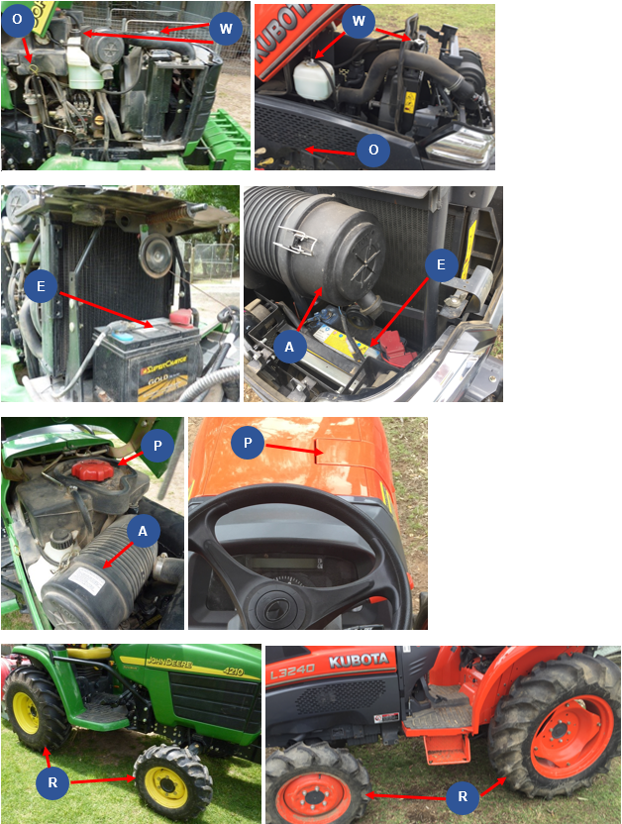

Complete the table below by identifying each of the labelled checkpoints.

| P | O | W | E | R | A |
| --- | --- | --- | --- | --- | --- |
| Fuel | Oil | Water/radiator | Electrics/battery | Rubber/tyres | Air filter |

Operation controls

Images below show the operation controls for the Kubota and John Deere tractors.

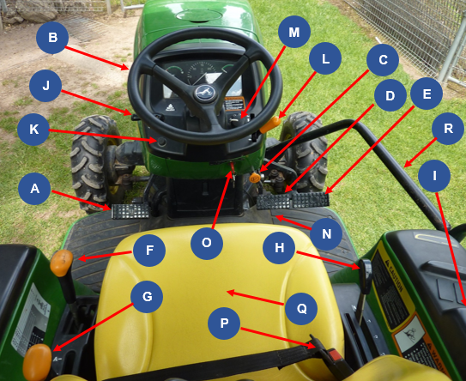 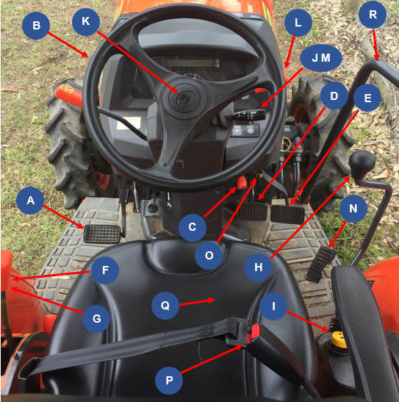

Use the images above to complete the tables by labelling each control.

| A | B | C | D | E | F |
| --- | --- | --- | --- | --- | --- |
| Clutch | Steering Wheel | Park Brake control knob | Left rear brake pedal | Right rear brake pedal | Gear lever |

| G | H | I | J | K | L |
| --- | --- | --- | --- | --- | --- |
| Range lever | Position control lever (Kubota), Rockshaft control lever (John Deere). | PTO control | Right and left indicator lever | Horn | Hand accelerator lever |

| M | N | O | P | Q | R |
| --- | --- | --- | --- | --- | --- |
| Light Control switch | Engine speed foot throttle | Ignition switch | Seat belt | Seat | Safety rail |

Floor panel controls

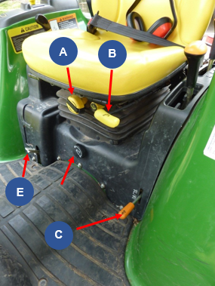 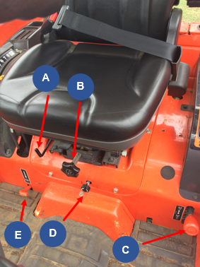

Use the images above to complete the tables by labelling each control.

| A | B | C | D | E |
| --- | --- | --- | --- | --- |
| Seat height adjustment knob | Seat adjustment lever | 2WD and 4WD lever | 3point hitch lowering speed knob (Kubota), Rockshaft Rate-of-drop control knob (John Deere) | Differential lock lever |

Light switch controls

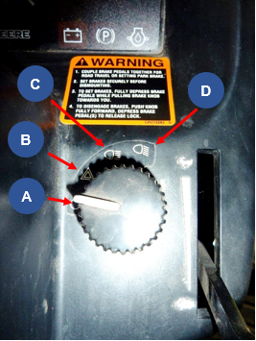 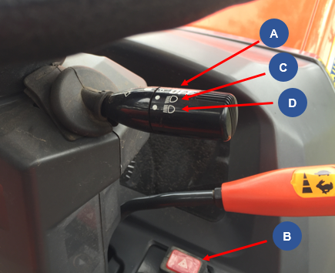

Use the images above to complete the tables by labelling each control.

| A | B | C | D |
| --- | --- | --- | --- |
| All lights off | Warning flasher lights on | Road Position: Headlights/ Taillights/ Warning Flasher lights on | Field Position:  Headlights/ Taillights & optional working lights on |

Instrument control panel

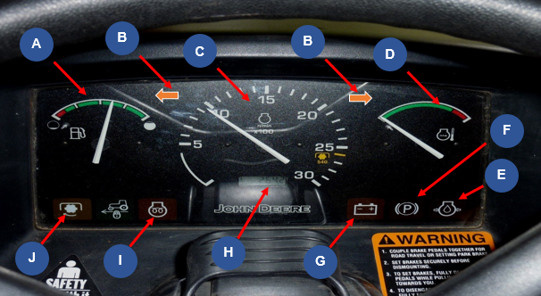

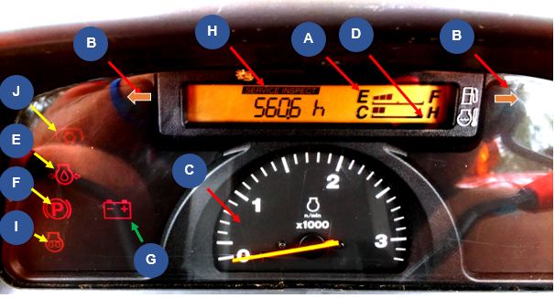

Use the images above to complete the tables by labelling each control.

| A | B | C | D | E |
| --- | --- | --- | --- | --- |
| Fuel gauge | Warning Flasher/ turn signal indicator light | Tachometer | Engine coolant temperature gauge | Engine oil pressure light |

| F | G | H | I | J |
| --- | --- | --- | --- | --- |
| Park brake light | Alternator/ battery charging light | Hour meter | Cold start indicator light | PTO engaged light |

Tractor hand signals

Identify what each signal means.

Stop

Speed up (accelerate).

Move toward me

Move away from me

Start the engine

Lower the 3 point linkage implement

Raise 3 point linkage Implement

Turn engine off

Emergency, come to me

This far to go

Slow down

Tractor operation

Your teacher will check off the table below as you complete each task.

| Task | Completed |
| --- | --- |
| Complete pre-start checks |  |
| Mount tractor safely. |  |
| Check seat position, mirror and fasten seat belt. |  |
| Ear muffs on. |  |
| Start the tractor. |  |
| Turn lights onto road position. |  |
| Ensure the area is clear of people. Survey the area for hazards. |  |
| Release handbrake. |  |
| Push the clutch down and select the gear and range. |  |
| Let the clutch pedal out slowly. |  |
| Drive the tractor along the prescribed path. |  |
| Stop the tractor by pushing the clutch pedal down and braking gently. |  |
| Put the gear and range levers in neutral and release the clutch. |  |
| Apply the park brake. |  |
| Turn lights off. |  |
| Stop the tractor. |  |
| Remove the key. |  |

Student’s name –

Teacher signature – Sign here

Date –

Tractor implements

Identifying each implement, what it is used for, the risks and the safety requirements.

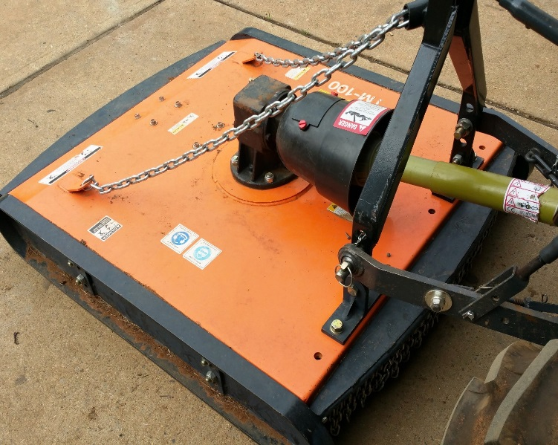

Image Courtesy of Australian Hammer Supplies: DOC18/65562

Implement name:

PTO Slasher

What this implement is used for:

For cutting long, thick grass

What are the risks associated with this implement:

PTO entanglement/amputation/death, tractor rollover, struck by projectiles, fire initiation, noise

What precautions must be taken when using this implement?

Ensure PTO is guarded/ stay clear of operating PTO implement, Check operating ground conditions/ don’t operate across contour, Slasher fitted with roller/chain skirt guarding, don’t operate on fire ban days, wear hearing and eye protection.

Which year groups are permitted to use this implement?

Year 9 – 10 can operate. Year 11 and 12 can attach and operate.

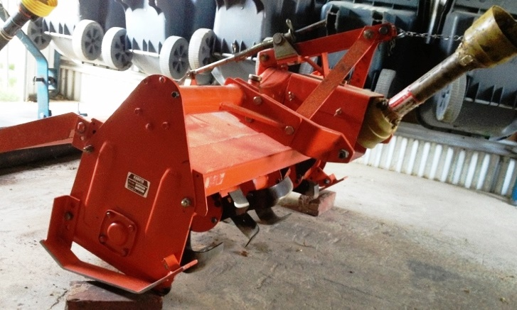

Implement name:

PTO rotary tiller/ Rotary hoe attachment

What this implement is used for:

Till the soil for seedbed preparation for gardens, lawns or landscaping

What are the risks associated with this implement:

PTO entanglement/amputation/death, tractor rollover, struck by projectiles, dashing of tractor (if hard soil or stumps/tractor may jolt forward suddenly), noise

What precautions must be taken when using this implement?

Ensure PTO is guarded/ stay clear of operating PTO implement, Check operating ground conditions/ don’t operate across contour, Slasher fitted with roller/chain skirt guarding, don’t operate on fire ban days, wear hearing and eye protection.

Which year groups are permitted to use this implement?

Year 9 – 10 can operate. Year 11 and 12 can attach and operate

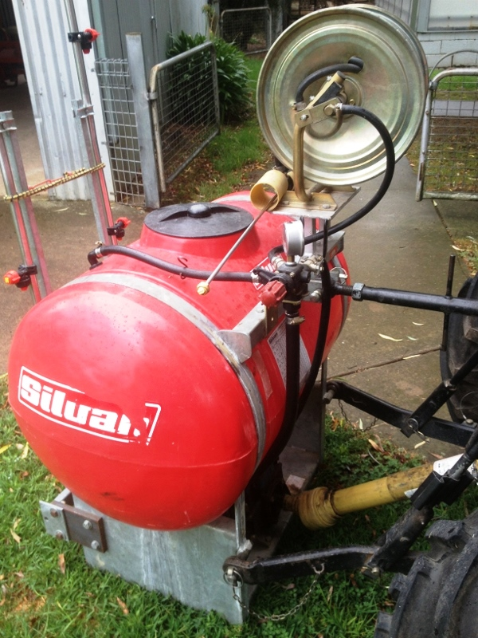

Implement name:

PTO Boom spray

What this implement is used for:

Application of farm chemicals to control various pests including weeds, insects and fungi

What are the risks associated with this implement:

PTO entanglement/amputation/death, tractor rollover, spray drift, chemical absorption, environment: effect of target species, noise.

What precautions must be taken when using this implement?

Ensure PTO is guarded/ stay clear of operating PTO implement, check operating ground conditions/ don’t operate across contour, apply chemical by using larger spray droplets and low pressure, only use in 3 to15km/hr wind speed, read the chemical label and observe procedures, use PPE required for using the chemical, Wear ear and eye protection

Which year groups are permitted to use this implement?

Year 9-10 may operate if fully trained, Year 11 and 12 can attach and operate

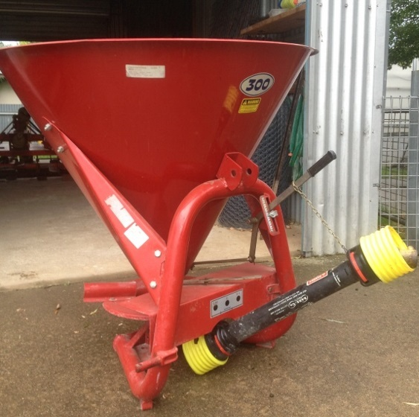

Implement name:

PTO fertiliser spreader

What this implement is used for:

Spread various granular or powered fertilisers and seeds

What are the risks associated with this implement:

PTO entanglement/amputation/death, tractor rollover, struck by fertiliser, noise

What precautions must be taken when using this implement?

Ensure PTO is guarded/ stay clear of operating PTO implement, Check operating ground conditions/ don’t operate across contour, guarding fitted, wear hearing and eye protection.

Which year groups are permitted to use this implement?

Year 11 – 12 only can attach and operate.

Working safely on and around tractors

Identify two actions required to protect people when operating tractors.

Many to choose from including: fastening seat belts, ensure ROPS fitted, training …

List two strategies needed to be implemented when driving tractors so that safety is not jeopardized or roll overs caused.

Reduce speed when turning, Avoid operating tractors near ditches, embankments or holes

What needs to be remembered about driving tractors near creek banks or irrigation ditches?

Keep tractors away from irrigation ditches and embankment edges to avoid tractor upsets

When travelling uphill on a tractor, what gear needs to be selected?

Low gear

If the slope is too steep when driving a tractor, what other alternative can be adopted?

Reverse the tractor up the slope to increase your stability or use another route

If your tractor gets stuck in a mud hole or swamp; what is the best solution to remove the tractor?

Have another tractor pull you out

What is the general reminder about passengers on tractors?

Do not permit others to be passengers

How should loads be attached to the back of the tractor?

To the draw bar or rear hitch

Where do we never hitch a load? Why?

To the tractors axle or seat/ as this will cause the tractor to upset backwards

How can an unbalanced tractor be weighted correctly?

Add front weights and balance the weight on the trailing implement

Why can tractors tip over easily?

Tractors have a high centre of gravity

How can this be overcome?

Drive down and avoid quick manoeuvres

List the four procedures that an operator needs to do before you carry out any adjustment to the tractor.

Set the brakes

Turn off the engine

Put tractor into gear

Remove the key

What needs to be turned off when working around the PTO implements?

Disengage the PTO and turn off engine

What does the operator need to know about safety guards on tractors?

Replace the PTO shield and other shields after making adjustments

When using the public road to transfer the tractor and implements from one property to another; what are three aspects of tractors that need to be checked?

Tails light and signals, safety chains, brake fluid, engine fluid is maintained, slow moving vehicle emblem

List two other checks which need to be made on tractors before using them for work.

Choose from: fuel, water levels, tyres, air filter … (POWERA)

On public roads, what signage should be displayed on tractors?

Ensure a slow moving vehicle emblem

When dismounting or mounting a tractor what safety considerations need to be remembered?

Use provided hand railing and steps to maintain 3 points of contact

What needs to be used when working with others?

Use safety hand signals

Summer crop enterprise - Research

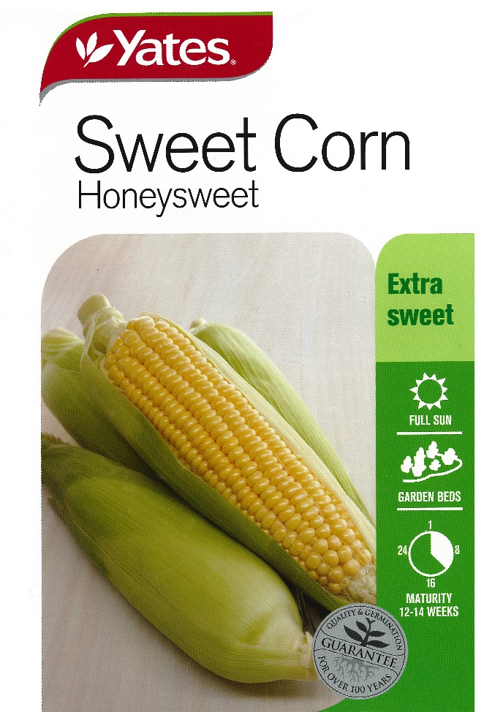 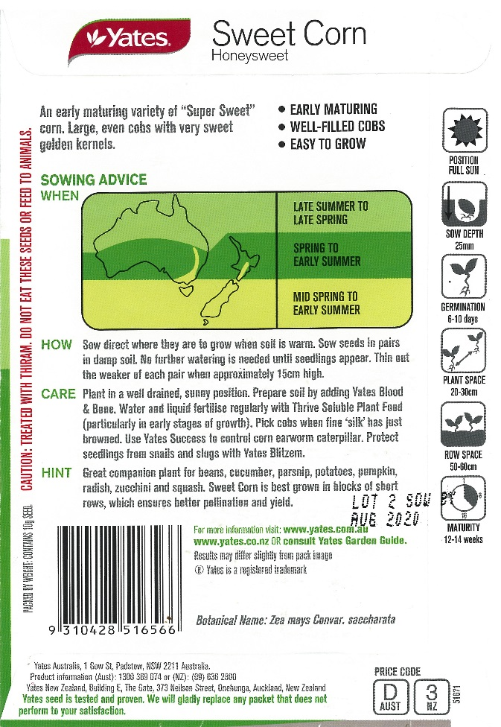

Images Courtesy of Yates: DOC18/47291

Use information from the seed packets above and the Internet to answer the following questions.

Soil preparation

How is the soil prepared for planting a sweet corn crop?

Soil pH test, Spray site, cultivate area, form rows of ‘Hills’

What machinery and implements are used in the soil preparation?

Tractor and PTO rotary tiller/rotary hoe

Fertiliser application

Name the fertilisers that can be used in sweet corn production.

Blood and bone, thrive soluble plant food

What are the nutrients supplied by these fertilisers?

Nitrogen, Phosphorus, Calcium

How is the fertiliser applied?

By hand - hand held fertiliser spreader used

When is the fertiliser applied to the paddock?

Prior to ‘hill’ formation

Planting information

At what depth should the seed be sown?

25 mm

What is the ideal distance between rows?

500-600 mm

What is the ideal distance between plants in each row?

200-300mm

Irrigation information

Identify the methods of irrigation suitable for watering the sweet corn crop.

Spray

When is the water applied?

Before sowing and after seedlings appear

Sweet corn reproductive system

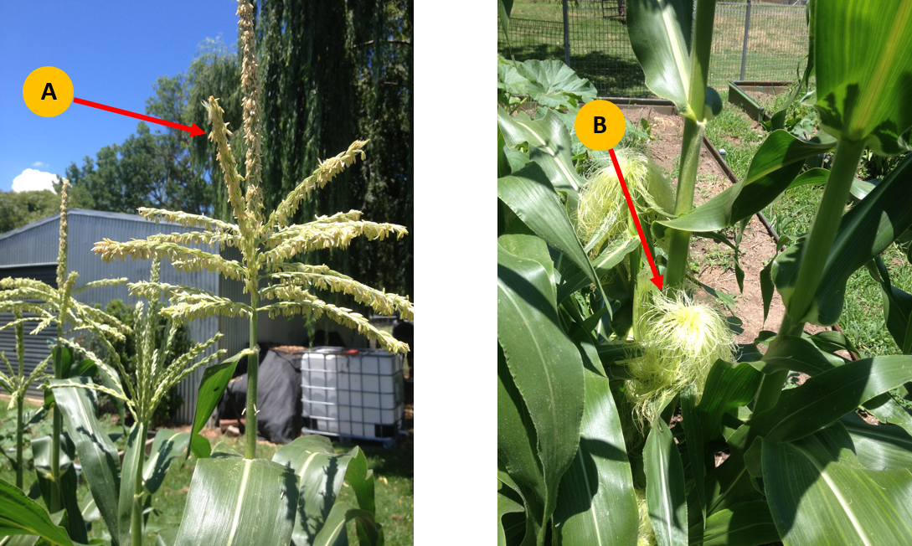

Use the image above to help complete the table below.

| Reproductive system parts | Name of part | Role or function |
| --- | --- | --- |
| Male reproductive system (Part A) | Tassel | Male reproductive part  Produce pollen |
| Female reproductive system (Part B) | Cob | Female reproductive part  Seed production |

Draw a sweet corn plant on the next page and label each of the parts listed below.

Leaf

Tassel

Husk

Silks

Pollen

Shoot System

Blade leaf

Fibrous roots

Stalk

Root system

Ear of corn

Node

Internode

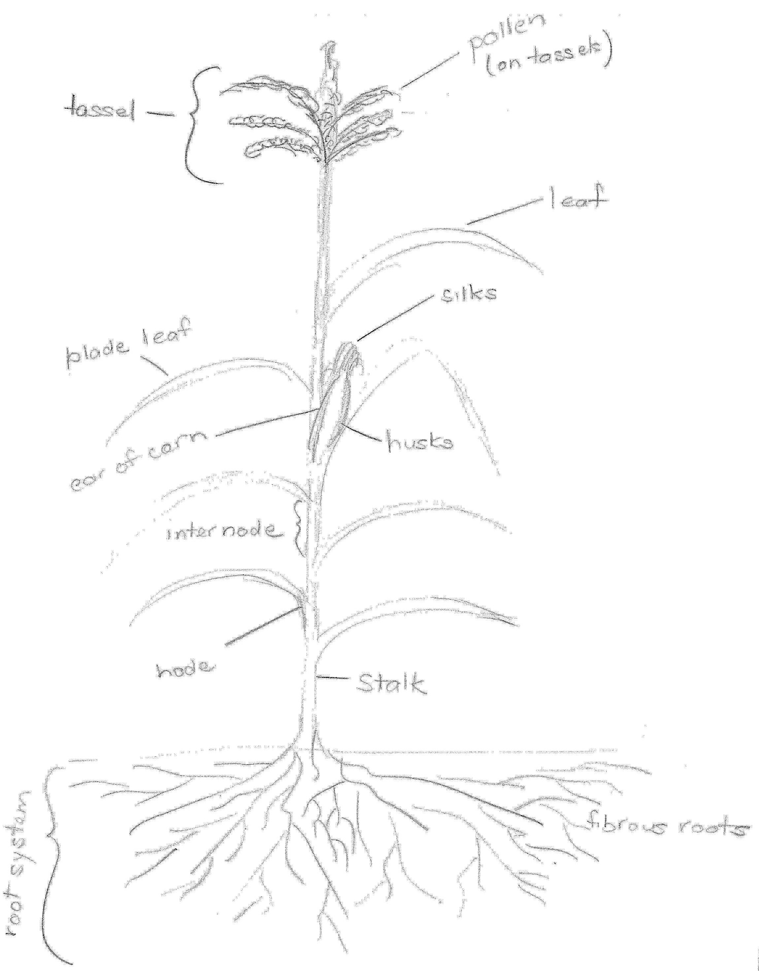

Summer crop enterprise - Practical

Purpose

* Cultivate an area provided in the agriculture farm using the tractor and rotary tiller.
* Use the machinery safely and your driving skills to complete the task
* Sweet corn has a growing period of approximately 3 months. By planting Sweet Corn in the middle of November, your crop will be ready to harvest about mid-February when you return to school in year 10 next year.

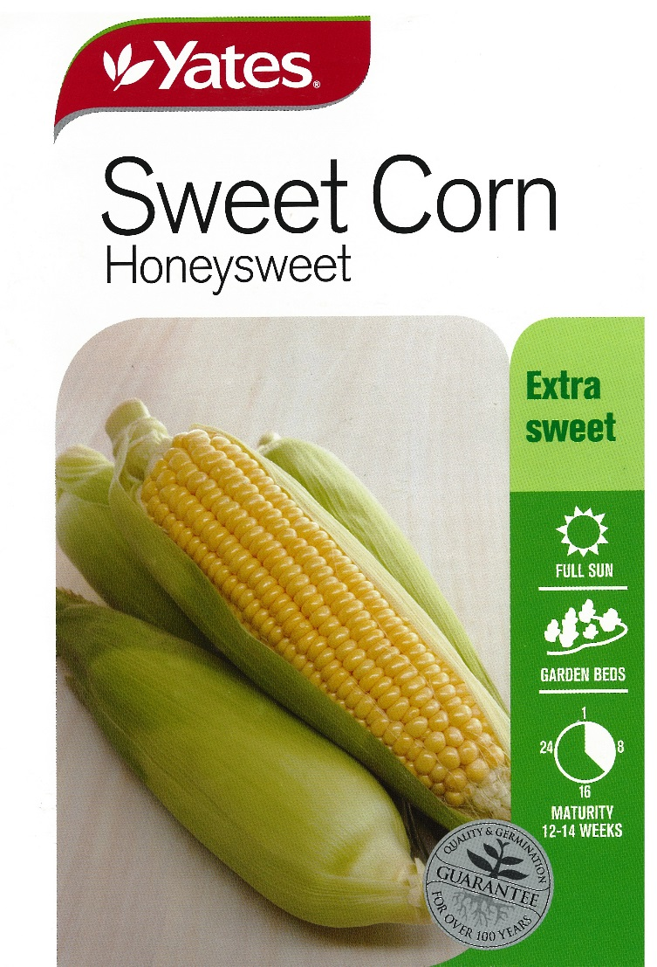 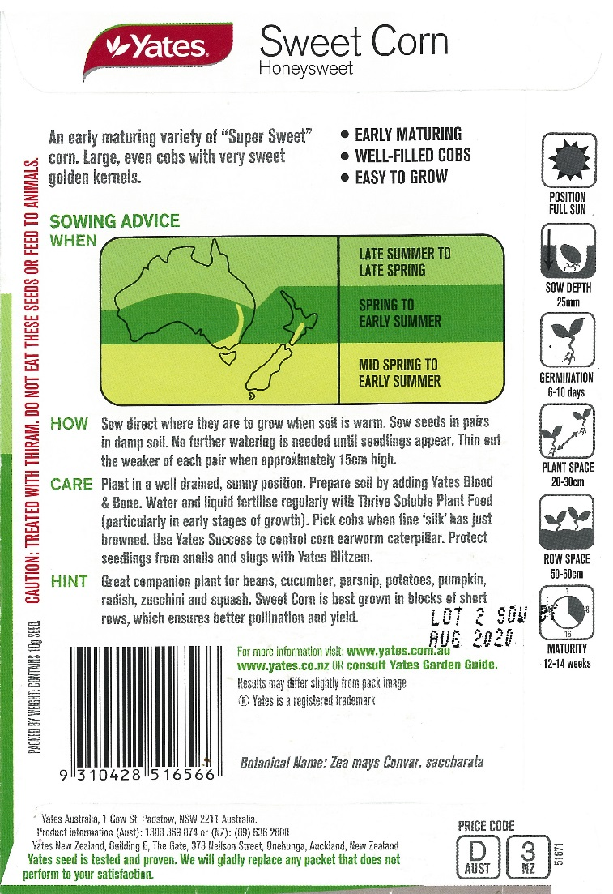

Images Courtesy of Yates: DOC18/47291

Method

Prepare Site:

* Spray the area for weeds
* Add Lime to the area before cultivating

Irrigation:

* Ensure the computerised irrigation system is programmed to water the sweet corn over the summer period

Fertilizer:

* Superphosphate
* Experiment with:
  + Blood & Bone
  + Multi Grow
  + Other
* You might trial the following:
  + one row of each fertiliser
  + combined row
  + no fertilizer
* Record the crop yield for each treatment. (Weight and number of cobs).

Once cultivated

* Use twine to mark out the rows
* Use rakes and 'D' handle spades to form the rows
* Construct rows approximately 0.8 metres apart and 0.3 metres high
* The number of ‘hills’ constructed will depend on the size of the area cultivated
* Place the fertiliser approximately 100mm below the seed placing
* Follow the directions of seed depth and seed placing within rows as per the packet
* You may place mulch or pea straw along the rows to prevent weeds and maintain the moisture
* Use an electric fence to partition the area from the remainder of the gardens and animals over the holidays

Questions

Identify the seed company:

Yates

What is the variety of sweet corn?

Gentle Giant

Describe the care that is needed to grow sweet corn successfully:

Plant in a well-drained soil in a sunny position

Prepare soil with blood and bone, pick cobs when silk turns brown

Control corn earworm caterpillar, snails and slugs

After harvest:

Were there different yields from each row?

(Comments based on cob size and number)

What could have caused any variations in yield? Consider the use of fertilisers, the position of each row in the paddock, the amount of water used, exposure to sun and any weather variations.

Soil type

Water amount/ duration

Fertiliser / nutrients availability

Pests

Weeds

Based on the results, how would you manage future sweet corn crops to maximise yield and minimise inputs?

Fertiliser amount and type

Water amount/ duration

Pests and weed control

Location of crop/ sunlight

Soil type and drainage

Variety of sweet corn

Organic matter input (compost/mulch)