Summer crop and tractor operation

Year 9 Agriculture
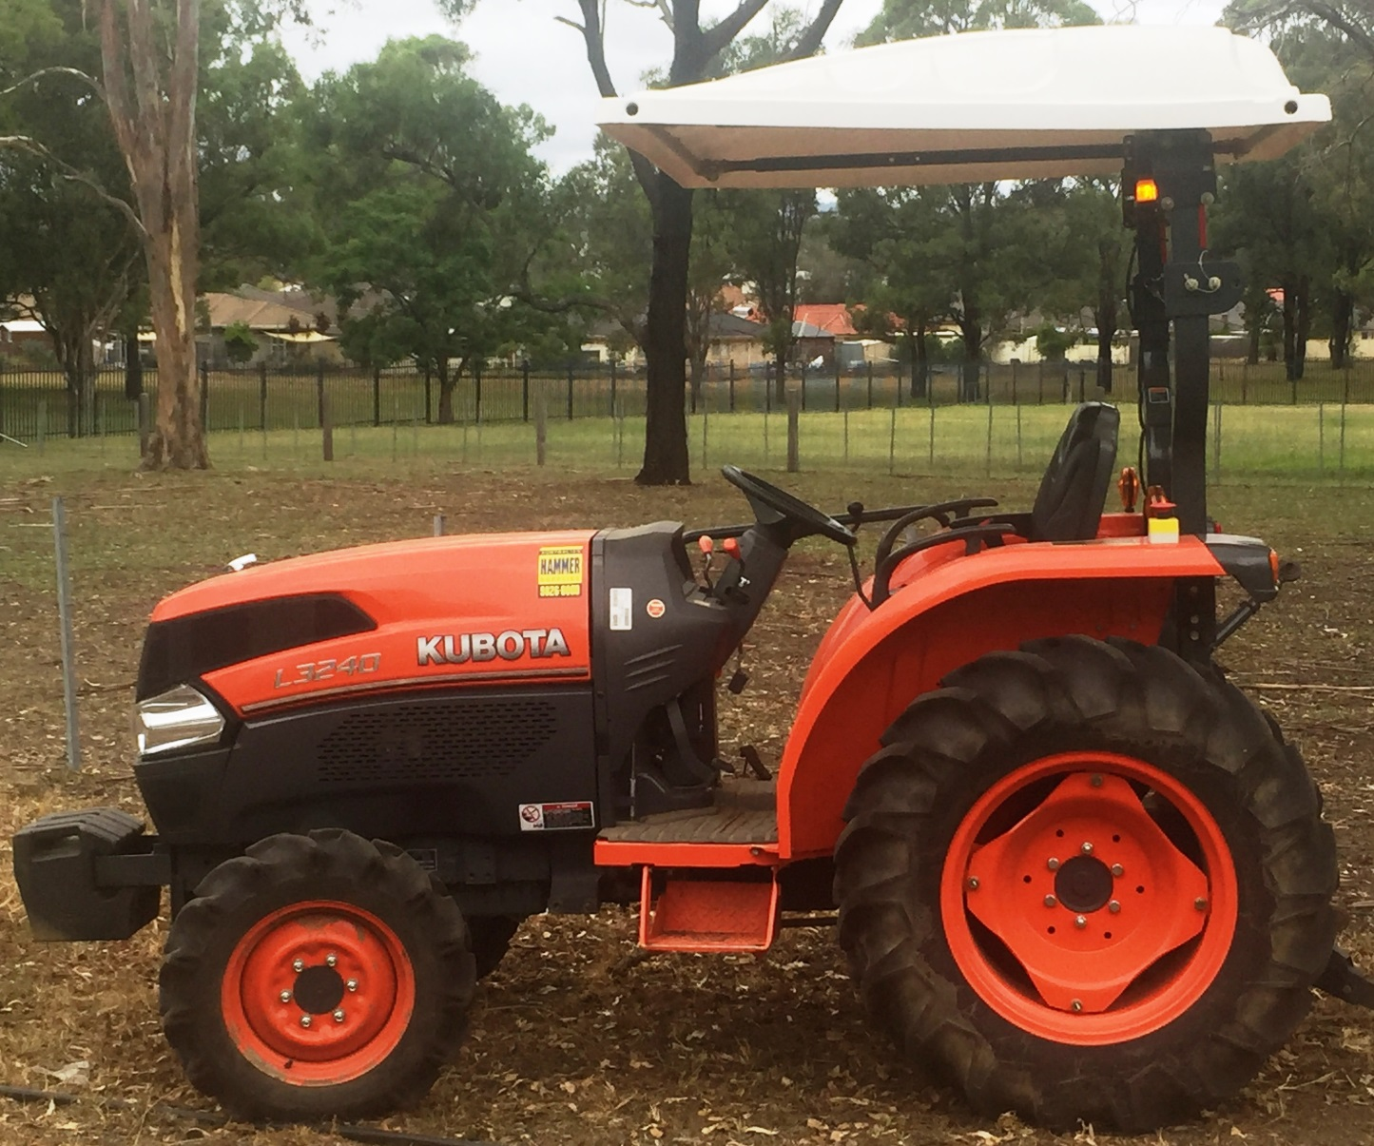

Acknowledgements
The resources for the ‘Sweet Corn’ unit of work were developed by the NSW Department of Education, Learning and Teaching Directorate for use by TAS teachers in NSW. They are developed to meet the requirements of the NESA Agricultural Technology Years 7-10 Syllabus 2003.
The materials were developed by:
- Tony Butler, Tumut High School
- Sally Bannerman, Learning and teaching Directorate
- Dan Rytmeister, Learning and Teaching Directorate
The following people and organisations contributed to the development of the materials:
- Craig Jarrett, Mount View High School
- Don Anderson, Galston High School
- Australian Hammer Supplies
- Department of Primary Industries
- Yates Australia
The document and program are available for download from the education website (https://education.nsw.gov.au/teaching-and-learning/curriculum/key-learning-areas/tas/s4-5/resources).
Version 1.0

Farm Safe
Answer the questions below. Information can be found on the Farm Safe website (https://farmsafe.org.au/).
Farm machinery is involved in approximately 40% of deaths on farms. Identify two machines responsible for many of these deaths?

On average, how many deaths occur each year due to quad bikes?

Go to the pages labelled “Staying safe on Australian farms” (https://farmsafe.org.au/Staying-Safe-On-Australian-Farms) and then “Tractor and machinery safety” (https://farmsafe.org.au/Tractor-and-Machinery-Safety).
How many deaths involved tractors last year?

How many people were seriously injured?

What is a hazard?

List seven hazards associated with using tractors on farms:
1.
2.
3.
4.
5.
6.
7.

What injuries were reported from using grain augers?
1.
2.
3.
4.
Click on the link labelled “Safe tractor operation”. Read the introduction on Page 2 and answer the following questions:
List four responsibilities of the employer:
1.
2.
3.
4.
Identify one responsibility of the employee:

List the four key processes that must be set in place to manage risk:
1.
2.
3.
4.
Identify two pieces of personal protective equipment (PPE) that should be supplied by the employer:
1.
2.
List five pieces of PPE required while operating a tractor:
1.
2.
3.
4.
5.

What does ROPS refer to?

Label the following statements as true or false:
- People who operate smaller tractors without a cabin are at risk of injury.
- Driving close to embankments is a risk of tractor roll over.
- When driving a tractor with a ROPS, you need to wear a seat belt.
- When you are driving a tractor, passengers are allowed to be on the tractor.
Why are 4 wheel drive tractors less likely to backflip than 2 wheel drive tractors?

Outline three scenarios in which a person could be run over by a tractor and either injured or killed.
1.

2.

3.

What does PTO refer to?

Outline three hazards or risks when working around the PTO.
1.

2.

3.

Why is working with hydraulics a risk of injury to the operator?

What does ergonomics refer to?

Describe a typical injury that a tractor operator could suffer if they operate a machine for long periods.

List two types of noises that can affect a tractor operator while driving a machine.
1.
2.
What does WHS refer to?

Identify four groups of people most at risk of injury on a farm.
1.
2.
3.
4.
Why should farms be “emergency ready”?

How can an employer ensure he or she is prepared for the following.
Needing first aid:

Fire:

Tractor operations
There are six models of tractor approved for use by students in schools. These tractors are modified to ensure students can learn tractor operation safely as part of the Agriculture curriculum.

The school tractor
Identify the tractor that is at your school. Use the tractor operator’s manual to assist.
Make:
Model:
Power:
4WD or 2WD:
Engine capacity:
Fuel type:
Hours:
Features:

Date of purchase:
Product ID number:
Engine Serial Number:
Transmission Serial Number:

Personal safety
Tractor operators must wear suitable PPE (Personal Protective Equipment) when operating a tractor.
Identify the following PPE:
Image of PPE | Label the PPE
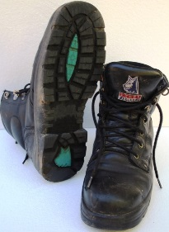
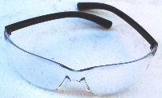
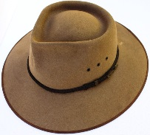
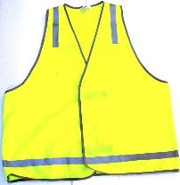
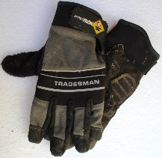

Safety decals
Safety decals are placed in important areas on the tractor to draw your attention to potential safety hazards. The three types of decal used are danger, warning and caution.
Danger labels identify the most serious hazards.
Task: find the following safety labels on the tractor and identify their purpose and location.

Caution
Colour
Location
Purpose

Warning
Colour
Location
Purpose

Danger
Colour
Location
Purpose

Safety features
Identify and describe the purpose of the following safety features:
ROPS:
Safety Triangle:

Audible alarms:

Flashing light:

Guards:

Mounting step:

Hand hold:

Hydraulics
Leaking hydraulic oil can be very dangerous. The hydraulic oil can be under high pressure (200 times atmospheric pressure) and can be 170 degrees Celsius. Leaking hydraulic fluid can penetrate the skin and inject you with oil causing significant health issues.
Identify the places where there is hydraulic fluid under pressure.

What can happen if you are injected with hydraulic fluid?

How can you test for leaking fluid?

What should you do if you have been injected with hydraulic fluid?

Parts of the tractor
Main parts identification checklist:
Your teacher will check off the table below as you identify each part.
Component | Identified | Component | Identified
Radiator |  | ROPS
Engine |  | Three point linkage
Exhaust |  | Slow moving vehicle signal
Engine air cleaner |  | Draw bar
Engine oil dipstick |  | Fuel tank/filler
Tyre valves |  | Battery
Power take off (PTO) shaft |  | Oil filler cap
Greasing points |  | Three point attachment
Controls identification checklist.
Your teacher will check off the table below as you identify each control.
Controls | Identified | Controls | Identified
Steering wheel |  | Fuel gauge
Hand accelerator lever |  | Temperature gauge
Clutch |  | Ignition switch
Foot brakes |  | Horn
Gear lever |  | Choke
Range lever |  | Power take off control
2 and 4 wheel drive lever |  | Right and left indicator lever
Light control switch |  | Hydraulic lever
Student’s name –
Teacher signature –
Date –

Pre start procedures
Check the following before starting the tractor:
- Power – Check fuel level
- Oil – Check dip stick and oil level windows
- Water – Check coolant level in the coolant reservoir tank
- Electrics – Test lights and check water level in the battery
- Rubber – Check tyres have no irregularities
- Air – Clear air filter and ensure tyres are inflated to manufacturer’s specifications.
If checks 1, 2 and 3 show low level then top up with correct fluids.
Generally inspect tractor for unfamiliar items and remove build-up of materials such as grass.
Check for 3 point linkage implement attachments.
Check shed and surrounding area for hazards.

Start up and shut down tractor.
- Mount the tractor using the foot step and grip handle. Maintain 3 points of contact at all times.
- Sit in the tractor and adjust seat to ensure controls are within reach.
- Fasten seat belt.
- Put earmuffs on.
- Check people are clear of the tractor.
- Check any attached implements are on the ground.
- Set the following controls:
  - Range lever to neutral
  - Gear lever to neutral
  - Throttle to medium level
  - Clutch depressed
- Turn the ignition on using the key and engage the starter
- Warm up engine by allowing it to idle
- Stop the engine by turning off the ignition.

Task – Identify procedures and controls
Images below show the pre-service checkpoints for the Kubota and John Deere tractors. 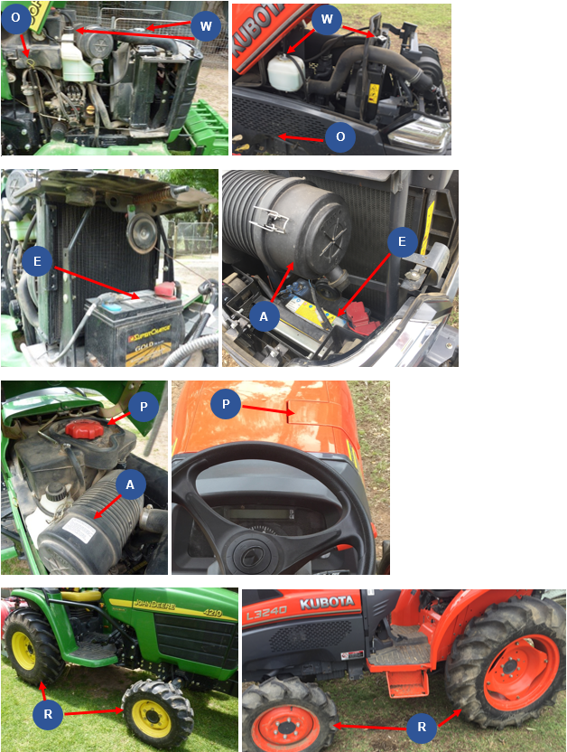
Complete the table below by identifying each of the labelled checkpoints.
P | O | W | E | R | A

Operation controls
Images below show the operation controls for the Kubota and John Deere tractors.
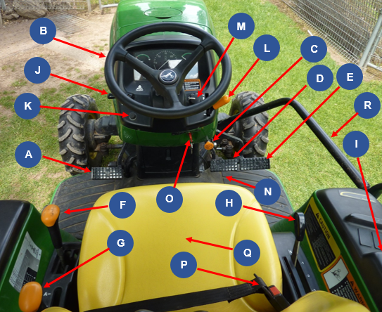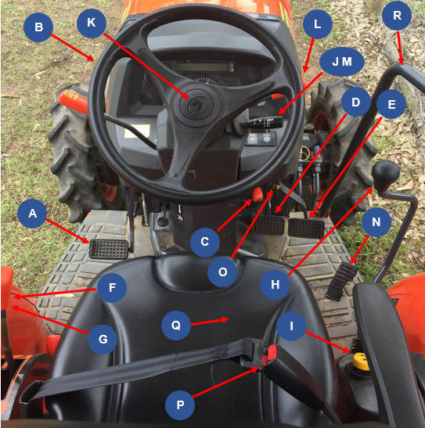
Use the images above to complete the tables by labelling each control.
A | B | C | D | E | F

G | H | I | J | K | L

M | N | O | P | Q | R

Floor panel controls
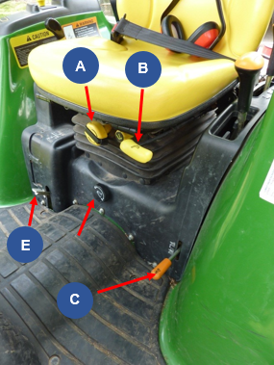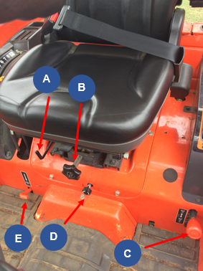
Use the images above to complete the tables by labelling each control.
A | B | C | D | E

Light switch controls
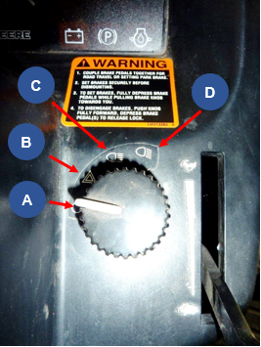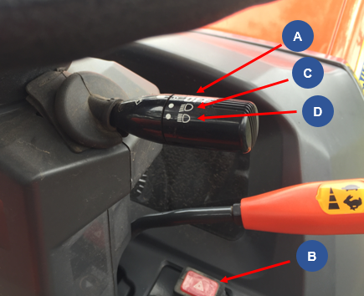
Use the images above to complete the tables by labelling each control.
A | B | C | D

Instrument control panel
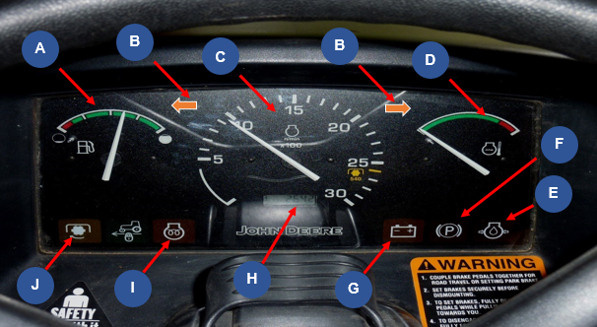
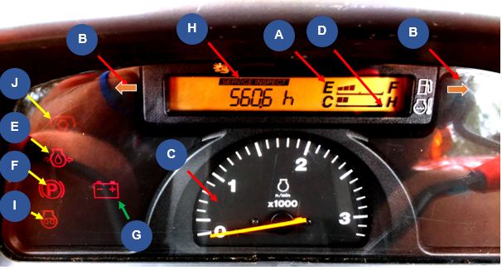
Use the images above to complete the tables by labelling each control.
A | B | C | D | E

F | G | H | I | J

Tractor hand signals
Identify what each signal means.

Tractor operation
Your teacher will check off the table below as you complete each task.
Task | Completed
Complete pre-start checks
Mount tractor safely.
Check seat position, mirror and fasten seat belt.
Ear muffs on.
Start the tractor.
Turn lights onto road position.
Ensure the area is clear of people. Survey the area for hazards.
Release handbrake.
Push the clutch down and select the gear and range.
Let the clutch pedal out slowly.
Drive the tractor along the prescribed path.
Stop the tractor by pushing the clutch pedal down and braking gently.
Put the gear and range levers in neutral and release the clutch.
Apply the park brake.
Turn lights off.
Stop the tractor.
Remove the key.
Student’s name –
Teacher signature –
Date –

Tractor implements
Identifying each implement, what it is used for, the risks and the safety requirements.
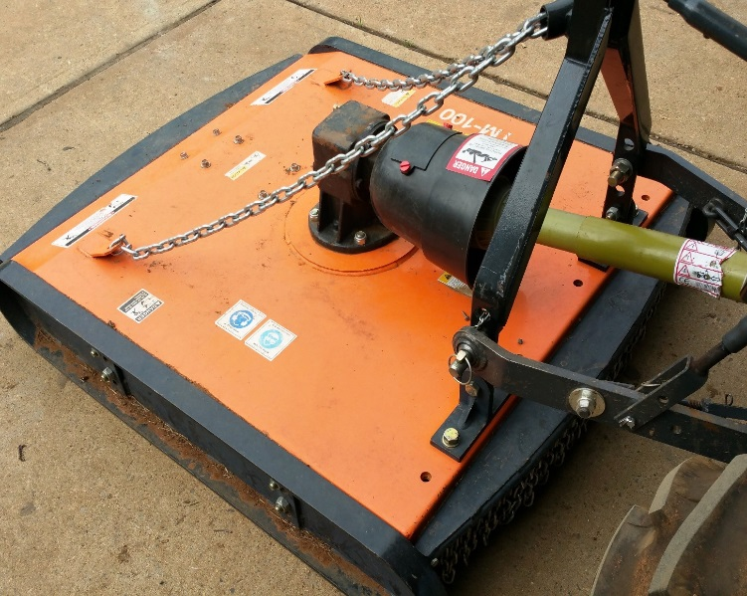
Image Courtesy of Australian Hammer Supplies: DOC18/65562
Implement name:

What this implement is used for:

What are the risks associated with this implement:

What precautions must be taken when using this implement?

Which year groups are permitted to use this implement?

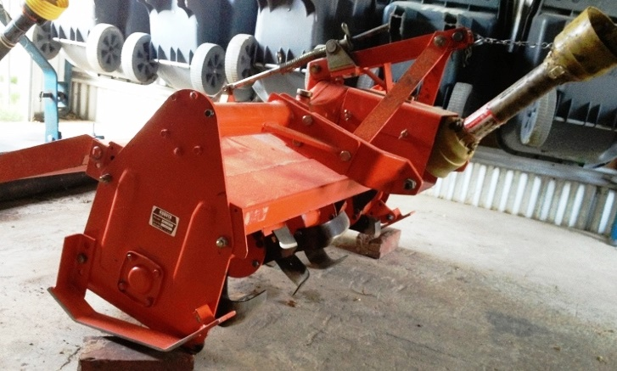
Implement name:

What this implement is used for:

What are the risks associated with this implement:

What precautions must be taken when using this implement?

Which year groups are permitted to use this implement?

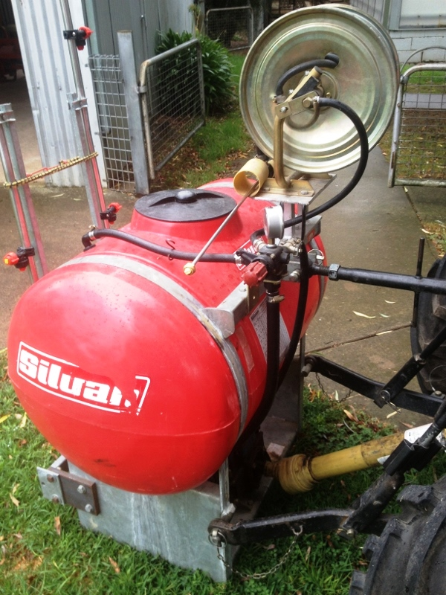
Implement name:

What this implement is used for:

What are the risks associated with this implement:

What precautions must be taken when using this implement?

Which year groups are permitted to use this implement?

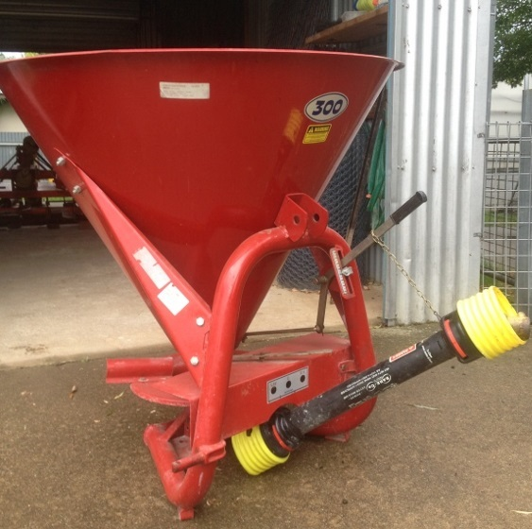
Implement name:

What this implement is used for:

What are the risks associated with this implement:

What precautions must be taken when using this implement?

Which year groups are permitted to use this implement?

Working safely on and around tractors
Identify two actions required to protect people when operating tractors.

List two strategies needed to be implemented when driving tractors so that safety is not jeopardized or roll overs caused.

What needs to be remembered about driving tractors near creek banks or irrigation ditches?

When travelling uphill on a tractor, what gear needs to be selected?

If the slope is too steep when driving a tractor, what other alternative can be adopted?

If your tractor gets stuck in a mud hole or swamp; what is the best solution to remove the tractor?

What is the general reminder about passengers on tractors?

How should loads be attached to the back of the tractor?

Where do we never hitch a load? Why?

How can an unbalanced tractor be weighted correctly?

Why can tractors tip over easily?

How can this be overcome?

List the four procedures that an operator needs to do before you carry out any adjustment to the tractor.

What needs to be turned off when working around the PTO implements?

What does the operator need to know about safety guards on tractors?

When using the public road to transfer the tractor and implements from one property to another; what are three aspects of tractors that need to be checked?

List two other checks which need to be made on tractors before using them for work.

On public roads, what signage should be displayed on tractors?

When dismounting or mounting a tractor what safety considerations need to be remembered?

What needs to be used when working with others?

Summer crop enterprise - Research
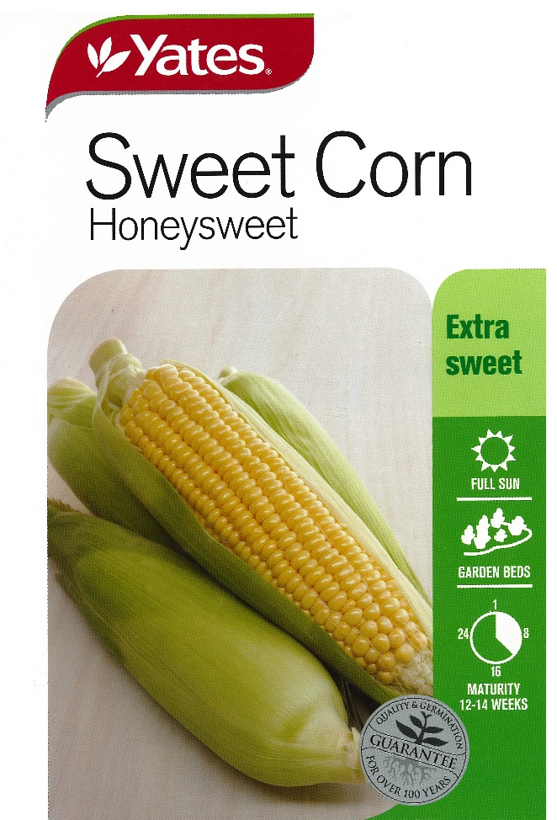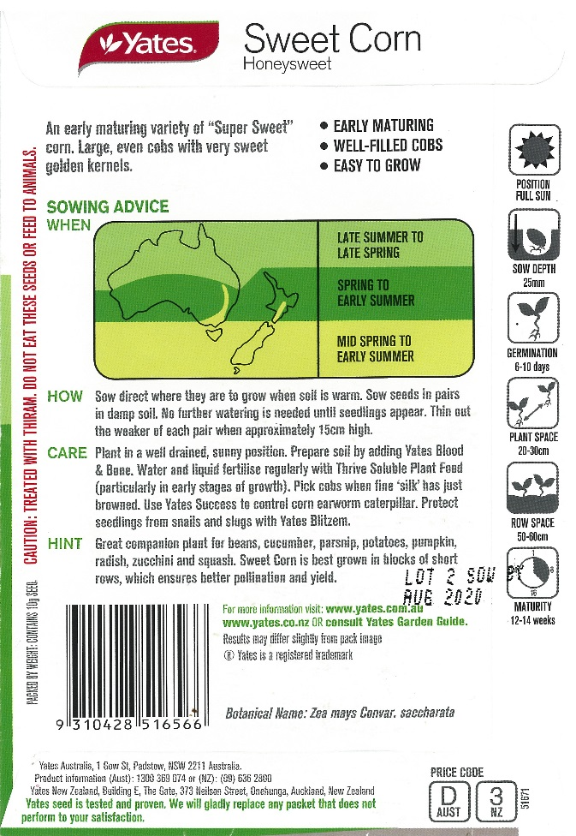
Images Courtesy of Yates: DOC18/47291
Use information from the seed packets above and the Internet to answer the following questions.

Soil preparation
How is the soil prepared for planting a sweet corn crop?

What machinery and implements are used in the soil preparation?

Fertiliser application
Name the fertilisers that can be used in sweet corn production.

What are the nutrients supplied by these fertilisers?

How is the fertiliser applied?

When is the fertiliser applied to the paddock?

Planting information
At what depth should the seed be sown?

What is the ideal distance between rows?

What is the ideal distance between plants in each row?

Irrigation information
Identify the methods of irrigation suitable for watering the sweet corn crop.

When is the water applied?

Sweet corn reproductive system
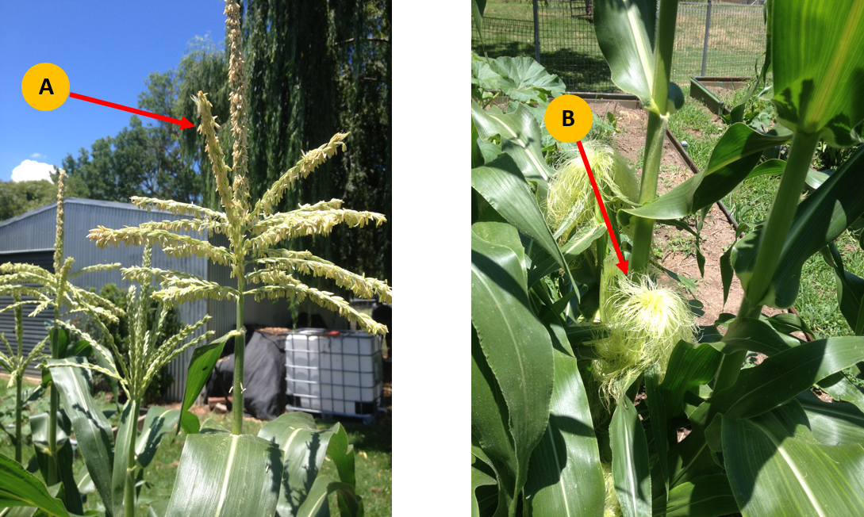

Use the image above to help complete the table below.
Reproductive system parts | Name of part | Role or function
Male reproductive system (Part A)
Female reproductive system (Part B)
Draw a sweet corn plant on the next page and label each of the parts listed below.
Leaf
Tassel
Husk
Silks
Pollen
Shoot System
Blade leaf
Fibrous roots
Stalk
Root system
Ear of corn
Node
Internode

Summer crop enterprise - Practical

Purpose
- Cultivate an area provided in the agriculture farm using the tractor and rotary tiller.
- Use the machinery safely and your driving skills to complete the task
- Sweet corn has a growing period of approximately 3 months. By planting Sweet Corn in the middle of November, your crop will be ready to harvest about mid-February when you return to school in year 10 next year.
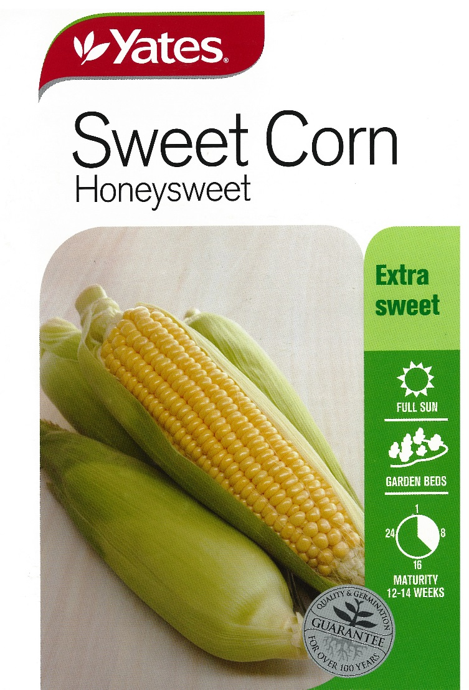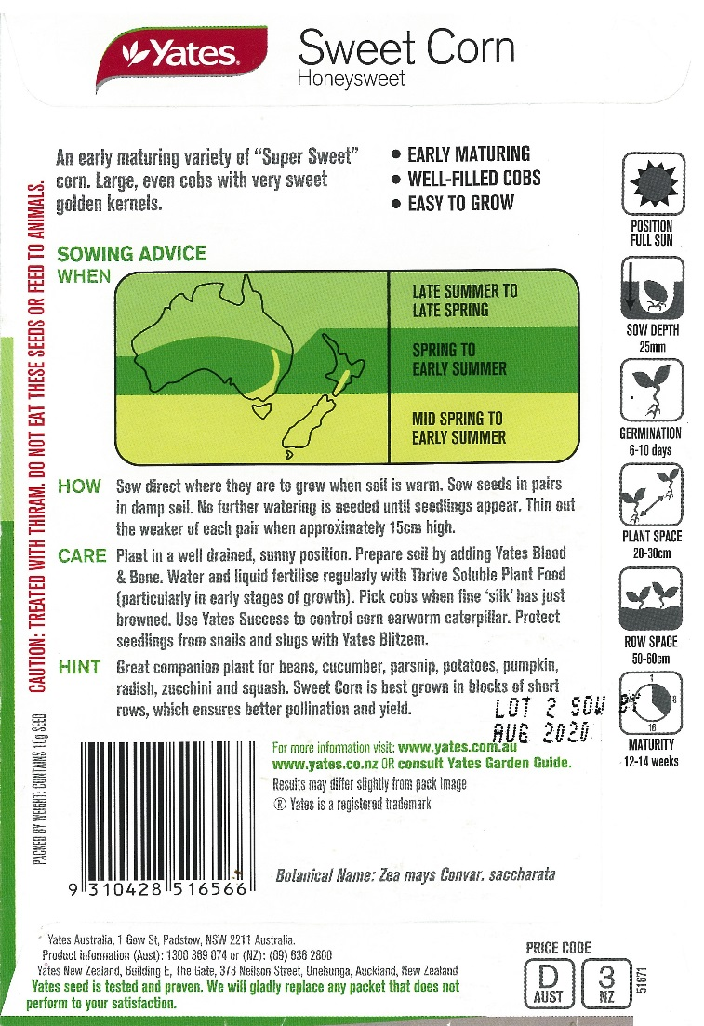
Images Courtesy of Yates: DOC18/47291

Method

Prepare Site:
- Spray the area for weeds
- Add Lime to the area before cultivating

Irrigation:
- Ensure the computerised irrigation system is programmed to water the sweet corn over the summer period

Fertilizer:
- Superphosphate
- Experiment with:
  - Blood & Bone
  - Multi Grow
  - Other
- You might trial the following:
  - one row of each fertiliser
  - combined row
  - no fertilizer
- Record the crop yield for each treatment. (Weight and number of cobs).

Once cultivated
- Use twine to mark out the rows
- Use rakes and 'D' handle spades to form the rows
- Construct rows approximately 0.8 metres apart and 0.3 metres high
- The number of ‘hills’ constructed will depend on the size of the area cultivated
- Place the fertiliser approximately 100mm below the seed placing
- Follow the directions of seed depth and seed placing within rows as per the packet
- You may place mulch or pea straw along the rows to prevent weeds and maintain the moisture
- Use an electric fence to partition the area from the remainder of the gardens and animals over the holidays

Questions
Identify the seed company:

What is the variety of sweet corn?

Describe the care that is needed to grow sweet corn successfully:

After harvest:
Were there different yields from each row?

What could have caused any variations in yield? Consider the use of fertilisers, the position of each row in the paddock, the amount of water used, exposure to sun and any weather variations.

Based on the results, how would you manage future sweet corn crops to maximise yield and minimise inputs?

