Engineered systems – context focus

**Teacher Guide**

This resource provides teachers with guidance when teaching this unit. Parts of this guide can be adapted for use as worksheets or a booklet for students.

The Engineered Systemscontextfocuses on how force, motion and energy can be used in systems, machines and structures. Students are provided with opportunities to experiment and develop prototypes to test their solutions. They learn how forces and the properties of materials affect the behaviour and performance of engineered systems, machines and structures. The knowledge of these principles and systems is applied to the design of a vehicle.

The Dragster

The vehicle has been designed to provide an easy introduction to electro-mechanical devices. It is also intended that a number of dragsters can be used to compete in a class environment. This puts the additional requirement on students to investigate the effects of gearing on speed and acceleration, and to consider these factors in their vehicle design.

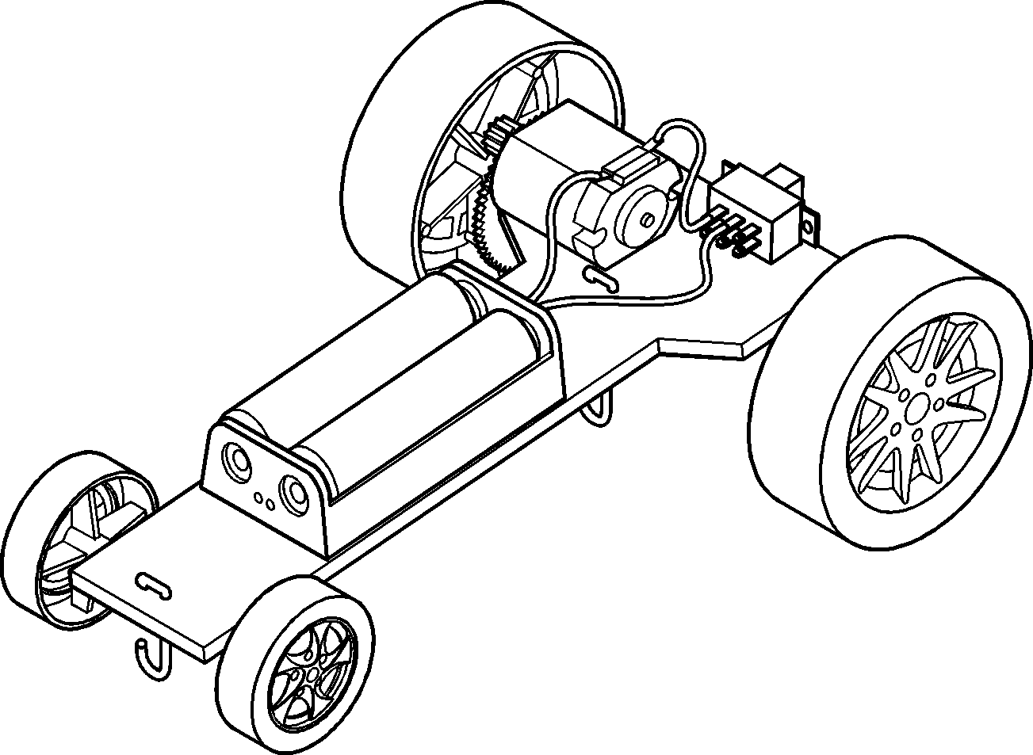

Section 1 – general and planning information

This section will detail all general and planning information that need to be considered when constructing the Dragster.

1.1 Design considerations

The major aspects of this project are the planning, design, construction, assembly and evaluation stages of the vehicle. Usage and performance (including the races) can be added.

1.2 Design brief

Each student will construct a vehicle to compete in a race against the other students in the class. Each student receives the same components and is to use these components to design and construct their vehicle. The vehicle is designed to travel along a fishing line 10mm above the surface of the racetrack.

1.3 General

The design stage is crucial. This allows the desired size and shape of the vehicle’s platform to be developed on paper. This layout affects the functionality and the ease of assembly. The design of the vehicle should be drawn full size (showing component layout and locations) in the students’ log book. The drawing should be a plan view (viewed from above) showing all the important measurements.

The following points are given as a list of things to be taken into consideration for planning:

The dragster consists of a platform on which the various components are mounted.

Note: for best functionality of the vehicle, the designer must look at the vehicle as a complete unit, and not just as separate parts.

The speed of the motor, under load, is approximately 6500 RPM.

Of the spur and pinion gears provided, only one of each type is needed. The gears provided allow for a large choice of ratios, and the student needs to select the desired gear ratio. The acceleration and speed of the vehicle is mainly determined by this selection.

Note: the higher the gear ratio, the faster the acceleration but the lower the vehicle’s top speed.

The guide line (fishing line) should be at a height of 10mm above the surface the vehicles will race along.

1.4 Design specifics

Define the shape of the dragster’s platform. This affects the weight of the platform. Before starting construction, the location of all components needs to be carefully planned and laid out.

When designing the platform, the dimensions of the supplied components (such as the axle, gears and tube, battery compartment, electric motor and switch) must be considered.

The size and shape of the vehicle platform is up to each designer. We suggest that the material for the platform should be 5mm corflute or 3 to 4mm thick plywood, and not larger than 150mm x 60mm (although the axle allows a wider platform).

The switch should be mounted on the rear end of the platform.

Weight distribution and ease of operation should be considered.

The plastic tube (supplied) is for use as an axle guide and will be attached (glued) to the platform. This axle guide tube length can be a limiting factor to the width of the vehicle. The tubes should be about 2-3 mm longer than the width of the platform to which it is glued. This will prevent the wheels rubbing against the base and slowing the vehicle down.

The steel rod must go into the wheel hole all the way. Hint: place a nail or piece of wire into the wheel hole to measure its depth. The length of the steel rod needed is worked out by taking the length of the plastic tube plus 2 times the depth of the wheel hole (i.e. for both wheels) plus 2 mm for clearance (so the wheel will not jam up against the plastic tubing).

When working out the rear axle length, remember to allow for the large (spur) gear as well.

Measurements showing where the axles will be placed are also needed, so that the rear axle large (spur) gears will also mesh with the motor’s pinion (small) gear.

Allow for 4 small holes in the platform – these are required for the two guide hooks (2 holes at the front, and 2 at the rear - these holes should be 2mm either side of the centre line. These must be in an area of the base not covered by the battery holder or motor.

Once this has been completed, construction work can begin.

1.5 Planning stage

Before commencing work, the class and each student should plan the project.

It is suggested that the intended usage of the dragster is decided, and the rules for racing are defined before starting the project as these will affect the design.

The factors that affect the vehicles speed can be researched individually or in groups e.g. the class could be split into groups of 4 and brainstorm the topic. Each student should list all the reasons that are raised within the group. Then, split the groups and move to new groups to discuss the factors raised.

Each student should draw up a plan describing:

* The sequence of work that will be necessary to complete the dragster. This could be incorporated into a timeline showing the anticipated completion dates of each section of work. The student can then use the timeline to properly manage their classroom time.
* How the dragster will function.

1.6 Record keeping

The plans should also consider what items should be recorded on an ongoing basis, throughout the life of the project. These could include:

* Creation and completion of a portfolio.
* Recording progress on a weekly or daily basis.
* Detailed information about calculations made, problems encountered, measurements taken and observations made. These will be used in the evaluation process.
* Assessment on progress and completion in relation to the planned timeline.

Section 2 - components and material required

The following components are supplied in the kit:

* 1 x battery holder – 2AA (BH2AA)
* 1 x switch – Sliding on-off (KSSWS)
* 2 x wheel – 52mm diameter – 2.4mm hole (W52C2)
* 2 x wheel – 30mm diameter – 2.4mm hole (W30C)
* 1 x electric motor 1.5-4.5V (MOT12)
* 2 x shaft – Steel – 2.5x120mm
* 2 x tube – Guide – 100mm long White
* 1 x pinion gear 10T – 1.9mm hole
* 1 x pinion gear 12T – 1.9mm hole
* 1 x pinion gear 8T – 1.9mm hole
* 1 x spur gear 50T/10T – white 2.4mm hole
* 1 x spur gear 60T/10T – white 2.4mm hole
* 2 x copper wire – 1mm x 100mm

2.1 Additional requirements

The following items are available from Scorpio Technology or a similar supplier and need to be ordered separately:

* Battery – AA, 2 required (BATTAA)
* Drill Bit – 2.3mm (DB2.3)
* Electric hook-up wire – multi-strand
* Corflute, PVC or acrylic sheet or plywood
* Fishing line (for racing)
* Self-adhesive tape – single-sided
* Self-adhesive tape – double-sided

Note: if a group of students are going to construct the dragster (i.e. as a class project), it is recommended that additional purchases of a tube each of steel rod and plastic tube and extras of all the other components (especially gears). This is to enable the replacement of any damaged or lost parts that (inevitably) occur during student work.

The following material is to be supplied by the student/designer:

* Material for the platform (PVC or acrylic sheet, plywood, corflute, etc.)

2.2 Tools required

The following tools are required:

* Assorted hand tools eg
* Soldering equipment and solder
* Hot glue gun (unless using double sided and single sided tape)
* Hairdryer or hot-air gun

Note: at various stages of construction, items need to be glued together (and sometimes removed and relocated!). Hot glue guns give good results, but extreme care needs to be exercised to avoid burning of the skin.

Note: it is useful to have a hair dryer available during construction work. Using the hair dryer on its hottest setting will allow students to heat up the hot glue to soften it, and also allow students to reposition or remove incorrectly positioned or faulty components.

Section 3- fabrication and assembly

Constructing the platform:

Select the material for the platform, not larger than 150mm x 60mm

Use the drawing produced to mark out the platform and cut it to shape.

Draw a centre line down the middle of the platform.

Mark the positions of the 4 small holes for the two guide hooks.

Drill the four 2.3mm diameter holes.

Sand the cut edges so they are smooth – the base is now ready for mounting the components.

3.1 Assembling components to the platform

3.1.1. Make and attach axle guide tubes

Cut the plastic tubes to the lengths required. Make sure that the ends of the tubes are smooth (file or sand them) to further reduce friction.

Glue the plastic tubes in place on the platform. Make sure that the tube is straight and not on an angle (or the dragster will steer to one side).

Warning, if using hot glue, follow safety procedures.

Warning: hot glue can heat up the plastic tube and cause it to bend, making the axle a tight fit. To prevent this, and keep the plastic tube straight, place the axle through the plastic tube before gluing and hold the axle down (as shown in the picture) until the glue sets.

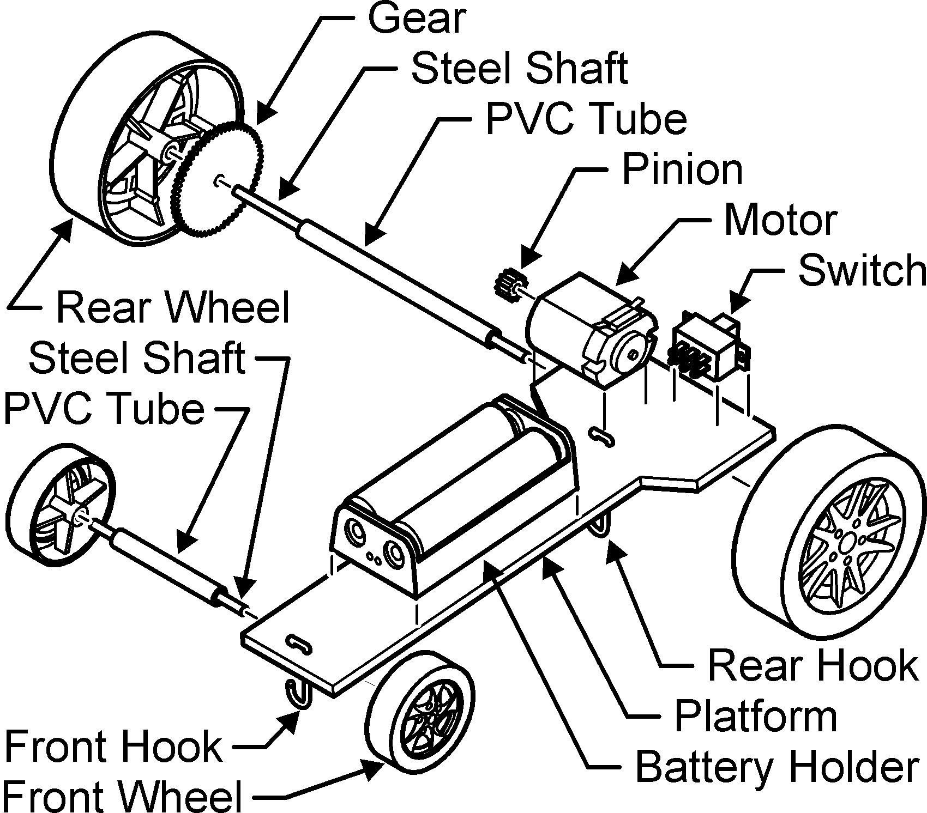

3.1.2. Make front axle (30mm wheels)

Measure and cut the steel rod to length and de-burr the ends.

Insert the steel axle into one of the (30mm) front wheels. Using a hammer, carefully tap the steel axle down into the wheel hole.

Slide the axle into the plastic tubing, place the second wheel on the end of the steel axle and carefully tap the wheel down onto the steel axle.

Note: ensure that the inside of the wheels have clearance on each side and can turn freely.

Attaching axle tube to platform.

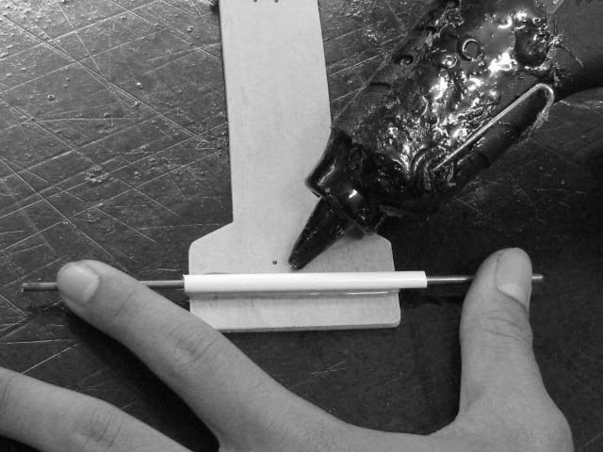

3.1.3. Make rear axle (52mm wheels)

Install the spur gear to the axle

Take the chosen spur gear (either 50 tooth or 60 tooth), and place it with the pinion (small) gear facing downward onto a firm surface.

Spur gear mounted on axle.

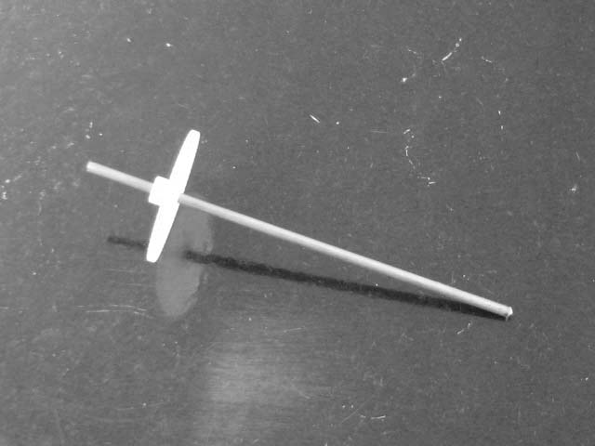

3.1.4. Install the axle to the wheel

Take the axle and place one end into the hole in the wheel.

Using a hammer tap the axle down into the wheel hole until the gear is flush with the wheel and the axle is at the end of the hole. (See picture.)

Slide the axle into the plastic tubing.

Place the second wheel onto the end of the axle and carefully tap the wheel down onto the axle, until the end of the axle is level with the end of the hole.

Note: ensure that the inside of the wheels have about 1 mm clearance between them and the plastic tubing to allow them to turn freely.

Note: if there is too large a gap, the axle can slide back and forth and prevent the motor’s pinion gear from meshing properly with the large gear.

3.1.5. Axle and gear installed to rear wheel

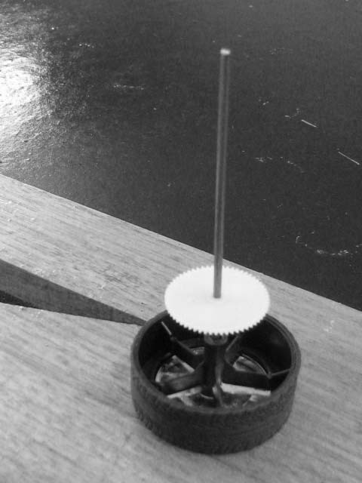

Take the selected pinion gear and place it on a firm surface.

Place the electric motor shaft into the hole and tap the opposite end of the shaft (seen slightly protruding from the rear end of the motor) with a hammer until the motor shaft is at the end of the pinion gear hole.

3.1.6. Axle and gears in position.

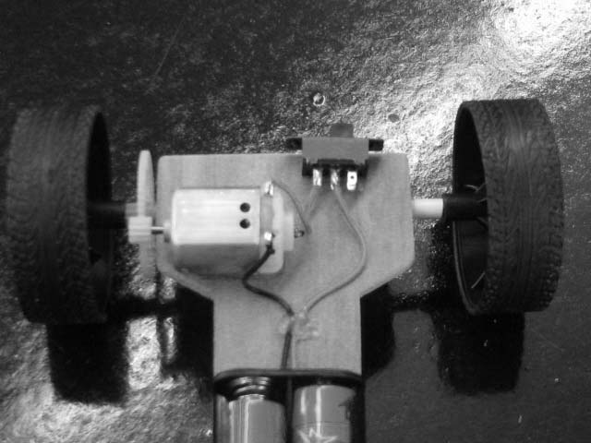

Hint: place the gear on the bench, insert the motor shaft into the pulley’s hole and gently tap the end of the shaft (where it exits the motor) with a small hammer.

Warning: don’t just push the motor down as this can push the motor armature out of its bearings and jam the motor.

Section 4 electrical assembly

Below are the details and steps involved in the electrical assembly of the Dragster.

4.1 Electrical components

4.1.1. Mounting the motor in place

Place the dragster on a flat surface. Place the motor (with the connecting terminals facing up) on the platform so that the teeth of both gears engage properly. Mark around the motor.

Apply some hot glue or double sided tape inside the area that marked - place the motor in position so that both gears engage properly (make sure that the motor is mounted square to the large gear, or the teeth will not engage properly).

Note: if using hot glue, roughen the surfaces to be glued with sandpaper to improve adhesion). Hold the motor in place until the glue sets.

Warning, if using hot glue, follow safety procedures.

4.1.2. Mounting the switch

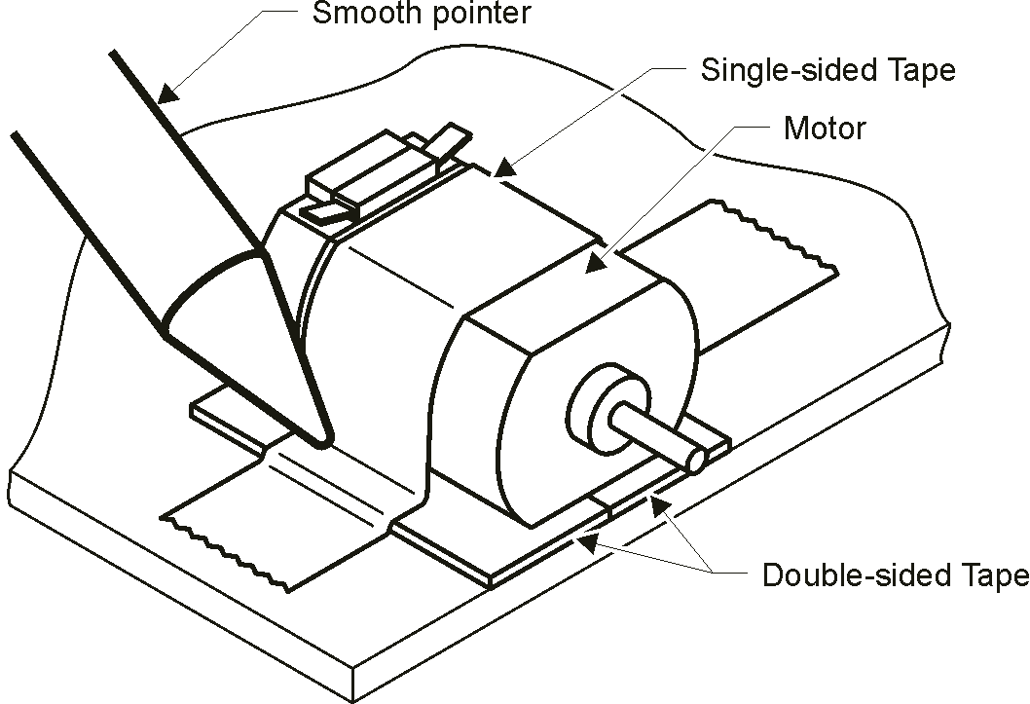

Glue the slide switch in position at the rear of the platform.

Warning: take care not to get any glue into the ends of the switch, as this will prevent it from operating.

4.1.3. Attaching the battery compartment

Glue the battery compartment onto the platform (the surface of the battery compartment may need to be roughened with sandpaper to allow the glue to stick to it).

4.2 Wiring the electrics

Cut about 100mm of fine electric wire.

Strip 10 mm of plastic insulation from both ends of the wire.

Solder one end of the wire to the centre terminal of the switch

Solder the other end of the wire to either of the terminals on the motor

Diagram of circuit

Note: hold the wire still while the solder cools, or the solder may fracture, causing a dry joint. A dry joint may look ok, but it is a poor electrical connection. This could cause the vehicle, to perform poorly or not work at all

Note: if there are solder blobs between the terminals, hold the vehicle upside down. Heat the solder blob with the tip of the soldering iron until it melts. Then lower the soldering iron away from the switch (gravity should pull the solder away with the soldering iron).

Note: when soldering wires to the switch and motor, take care not to overheat the terminals (overheating could cause the plastic part to melt).

4.3 Testing

Insert batteries into the battery compartment. Turn the switch on and touch the red and black wires onto the motor and the switch terminals. If the wheels turn correctly (i.e. to drive dragster forward), carefully solder the wires in place.

Test the operation of the vehicle to confirm everything is operating correctly, then, use a couple of small dobs of glue to fix the wire to the base.

4.4 Hook (for the guide line)

The last task is to make the (copper) wire hooks that will guide the dragster along the guide line. As the rear of the vehicle sits higher than the front of the vehicle, the hook at the back must be longer.

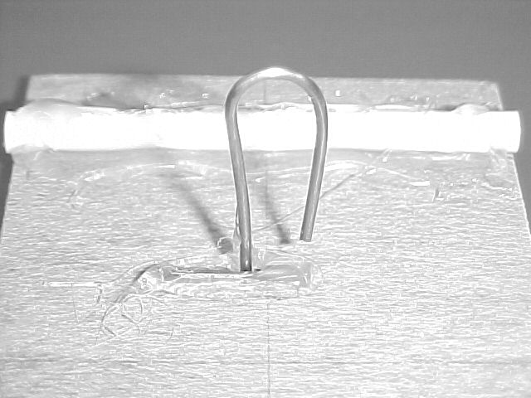

Bend the copper wire from the kit into the shape shown. Push it up through the two pre-drilled holes. Bend the short section over to hold the wire in place. Use some glue to hold the wire firmly in place. Cut off the excess.

Bend the remaining wire into a hook shape and construct the second hook.

Note: the bottom of the hooks should be about 5 mm above the ground (the line is 10mm above the surface). The hook should be long enough to prevent the guide line from coming out of the hook when racing.

Section 5. Investigation

The following section can be used as a basis for ideas on related topics that would enhance student learning. These can be used as both group projects and individual topics to produce detailed information for student instruction.

5.1 Mathematics

Students are to work out speed in Km/h (using the distance travelled and the time taken for the vehicle)

Calculate:

* Average (mean) speed, final speed (top speed), final drive ratio
* RPM of wheels from data on motor and gears used.
* How many times the wheels turn over the race (front and back)

Graphing data:

* Weigh all the vehicles and draw a graph in relation to their performance.
* Draw a chart or table showing the gear ratios of each vehicle, to show how this relates to performance.

5.2 Electrical

* What are: voltage, current and resistance?
* Describe the type of circuit used to control the dragster (series, parallel).
* What is Ohms law?
* Measure the voltage and current of the motor. Calculate the resistance of the motor.
* Find the formula used to work out power in an electric circuit. Calculate the power generated by the motor.
* How does a battery produce electricity?
* What electrical symbols are used to represent the motor, switch and batteries?

5.3 Design

* Identify the factors that affect how fast the dragster will travel.
* Write up the design brief for the construction of the vehicle.
* Draw up a design of the vehicle, using a top view and side view. Include all necessary measurements.

5.4 Investigate

* Explain what friction is.
* Explain how the following surfaces would affect the operation of the vehicle, and give examples of each: high friction, medium friction, low friction.
* Investigate the best surface within the school to run the race. Why is this so?
* Produce a (PowerPoint) presentation that demonstrates how an electric motor works.
* What is a gear system?
* Explain the dragster’s input, control, process, and output
* Investigate how gears work and explain gear ratios.
* Explain the motion of gears in a gear train.
* Give examples of different types of gear systems and where they are used.
* Present a demonstration about gears and gear ratios
* Set up a chart of the different gear ratios available using the various gear combinations. Record varying acceleration rates and top speeds for each combination. What do the graphs of these look like?

5.5 Environment

* Investigate the advantages and disadvantages of electric vehicles.
* Investigate the current developments in the production of electric vehicles around the world.

5.6 Evaluate

Using the finished dragster:

* Complete an evaluation on the dragster. Devise a series of questions to see if the design meets the requirements of the design brief. For example:
  + How well does the design function.
  + How well did it perform? Did it achieve the anticipated results?
  + Is the design pleasing in appearance?
  + Can the design be improved? How?
  + What are the best features of the design?

5.7 Student learning

Have students complete a mind map using Inspiration or drawing by hand to organise their ideas before beginning construction work. Give them some starting points.

Examples: electricity, batteries, electric motor, gears, wheels, voltage current, resistance, power, friction, weight, wheels etc.

Complete a second mind map after construction is complete. Compare the structure and composition of both maps.

Section 6 - suggested racing rules

The race is over a 20 metre distance.

Each dragster is guided along a (fishing) line 10mm above the racing surface.

The guide line must be tight.

Vehicles may only use 2 x AA batteries.

Competitors have a maximum of 1 minute to attach their vehicle to the guide line and be ready to start.

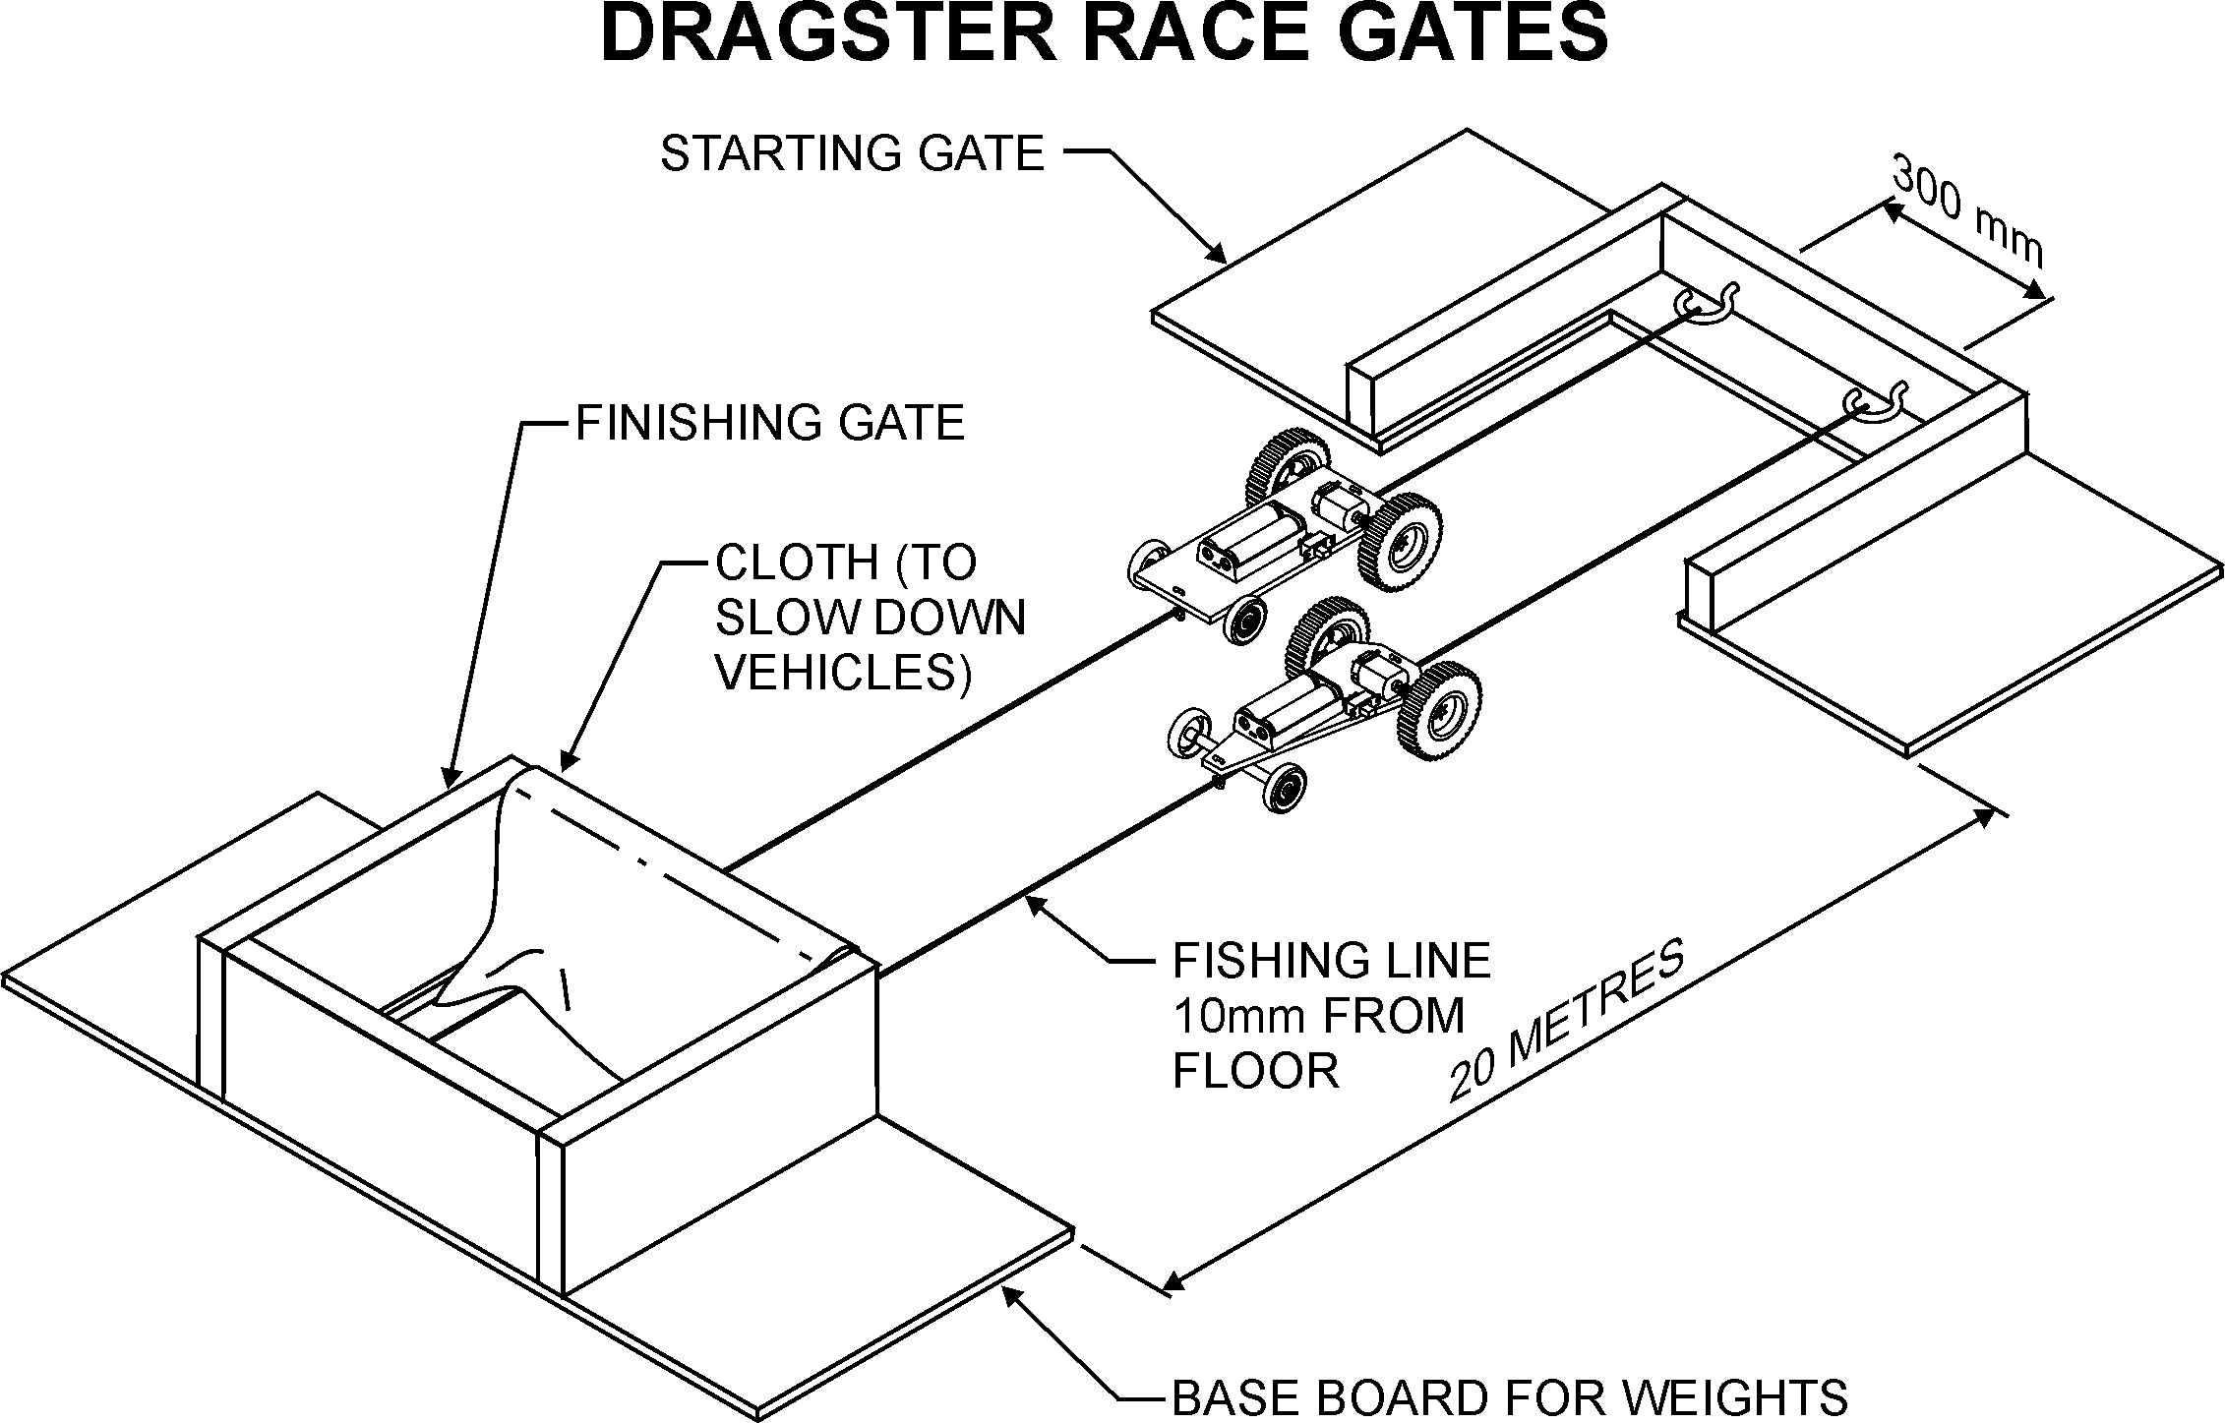

The vehicle is only to be turned on when the starting signal is given.

No pushing the vehicle at the start is allowed.

Vehicles that do not start or stop during the race are disqualified.

If a vehicle leaves the guide line it is disqualified.

A separate stopwatch will be used for each dragster competing

Section 7 - theory

Listed below explain the theory behind the Dragster.

7.1 Speed and acceleration

7.1.1. Average speed

Calculate the average (mean) speed of the vehicle during the race?

Know the distance over which the vehicle will race. Time the duration it takes from start to finish with a stopwatch. Use the following method to calculate how many kilometres per hour (km/h) the vehicle averages e.g. if the vehicle is racing over 20 metres and it takes 5 seconds to cover the distance:

Divide 1000 metres (the length of one kilometre) by the length of the racetrack (in this example 20 metres).

1000/20 = 50

Multiply the time taken by the vehicle to complete the race (in this example 5 seconds), by the result from the previous calculation.

5 x 50 = 250 seconds

This is the time it would take to travel one kilometre

Work out how many seconds there are in an hour.

60 x 60 =3600 seconds

To calculate the average speed in kilometres per hour, divide the seconds in an hour (3600 seconds) by the time it takes to travel one kilometre (in this example 250 seconds).

3600/250 = 14.4 kilometres per hour

This is the average speed obtained over the race. Remember the vehicle is not moving at all at the start. This means it must be going much faster (than the average speed) by the end of the race. How fast is the vehicle going at the end of the race? Hard to tell? No, not really thanks to something called physics.

7.1.2. Acceleration

First find the acceleration of the vehicle. Acceleration is a measure of how fast the vehicle’s speed is increasing. Acceleration is measured in metres per second squared (m/s²). Another term that will also be used in the calculation is velocity. Velocity is a measurement of speed. Velocity is measured in metres per second (m/s).

To find this, a formula is used, and it assumes that the acceleration is constant (ie. the acceleration is the same throughout the race).

Distance travelled = (starting speed of the vehicle x time taken) + (½ x acceleration x time taken ²)

To find the acceleration for our example:

20 metres = 0 + ½ x acceleration x 5²  
20 = ½ x acceleration x 25  
20/25 = ½ acceleration  
0.8 = ½ acceleration  
0.8 x 2 = acceleration  
Therefore acceleration = 1.6 metres per second squared (1.6m/s²)

7.1.3. End velocity

To find the velocity of the vehicle at the end of the race another formula is used.

Velocity = the starting speed of the vehicle + acceleration x time taken  
Velocity = 0 + 1.6 x 5  
Velocity = 8 metres per second (8 m/s)

To calculate the final speed, multiply the velocity by the number of seconds in an hour.

8 x 3600 = 28,800 metres or 28.8 Km per hour.

Challenge: Identify the relationship between the average speed and the maximum speed of a vehicle that starts from a stationary position? What is it, how can this be explained?

7.1 Gears

Gear Generator (online) OR using Crocodile technology

The following investigations are provided for all students with access to the internet using online Gear generator to enable students to investigate gears ratios.

Alternately experimentation can be done using Lego gears.

Schools that have access to crocodile technology (a commercially available software product) will enable students to investigate gears ratios and the effect of vehicle weight.

Experimenting with [Gear Generator](http://geargenerator.com/)

Experiment 1:

1. Change the gear properties of the parent gear to have 8 teeth. This could be a pinion gear attached to the motor. (the Driver).
2. Add another gear and give it 8 teeth
3. This will be the spur gear attached to the axle (the Driven) that will drive the back wheels.
4. Set the RPMs to 60 and watch the white dots.
5. What is the Gear ratio?
6. Record the results in the table below
7. Describe what is happening to the driver and driven gears.

Experiment 2:

1. Keep the Parent Gear (Driver) at 8 teeth and make the Driven gear 40 teeth.
2. Count the number of times the smaller pinion gear revolves for each *one* turn of the large gear. (Hint: watch the white dots).
3. What is the Gear ratio?
4. Record the results in the table below
5. Describe what is happening to the driver and driven gears.

Experiment 3:

1. Reset the Gears and make the Parent (Driver) Gear with 40 teeth and the Driven gear with 8 teeth.
2. What is the Gear ratio?
3. Record the results in the table below
4. Describe what is happening to the driver and driven gears.

| **Parent rpm**  Driver | **Parent (teeth)**  Driver | **Gear (teeth)**  Driven | **Gear rpm**  Driven | **Gear ratio** |
| --- | --- | --- | --- | --- |
| 60 | 8 | 8 |  |  |
| 60 | 8 | 40 |  |  |
| 60 | 40 | 8 |  |  |

Gear up means touse gear ratios like3:1 when increases velocity and reductions to torque are made.

Gear down means touses gear ratios like1:3to reduce velocity and increase torque.

Gearing down will occur many more times than gearing up, as electric motors that have a relatively high velocity but quite low torque.

(The dragster motor produces 6500 revolutions per minute!)

Change the gear properties of the parent gear to have 10 teeth. This will be the pinion gear attached to the motor.

Add another gear and give it 50 teeth. This will be the spur gear attached to the axle that will drive the back wheels.

Set the RPMs to 65 and count the number of times the smaller pinion gear revolves for each *one* turn of the large gear. (hint: watch the white dots).

Record the results in the table below and complete the experiments with other combinations of pinion and spur gears by pressing reset and changing the teeth numbers in properties.

|  | Spur Gear 50 | Spur Gear 60 | Gear ratio |
| --- | --- | --- | --- |
| Pinion 8 teeth |  |  |  |
| Pinion 10 teeth | 5 Revolutions of Pinion =1 Revolution of Spur |  |  |
| Pinion 12 teeth |  |  |  |

7.2 Calculations and conclusions and activities

**Note any observations about the results of the experiments.**

* What is the Gear Ratio?
* Which combination will produce the fastest speed?
* Which combination will produce the most pulling strength (torque)?
* What Is Torque?

Cloze passage

Complete the passage below using this word bank:

**axle, distance, force, fulcrum, increasing, less, levers, measurement, resistance, torque.**

When you turn a nut on a bolt using a spanner, you are producing .

When the nut is tight and offers some , you’ve probably discovered that the more the distance from the nut you hold the spanner, the the force you need to apply.

Torque is the product of two components: and .

You can increase torque by either increasing the applied force, or the distance from the centre of rotation.

The units of for torque are also a unit for the force, and a unit for the distance. The International System of Units (SI) defines the newton-meter (Nm) and the newton-centimetre (Ncm).

**Sitting on a see saw?**

Your weight provides a downward force.

If you want to balance with someone heavier you’ll need to move away from the fulcrum at a further distance, if they are lighter you’ll need to move closer.

F X d = f X D.

(A big Force times a little distance = a little force multiplied (times) a big Distance)

See saws are levers.

If you have some familiarity with the properties of , you will recognize the similarities.

In a lever, the resulting force depends on the distance between the application point and the . The longer the distance, the higher the force.

You can think of gears as levers whose fulcrum is their and whose application points are their teeth.

Thus, applying the same force to a larger gear (that is to a longer lever) results in an increase in torque.

**Crocodile Technology**

Draw up the following gear arrangements using crocodile technology

Select gears with the same number of teeth as shown and change the motor speeds to 1000 rpm

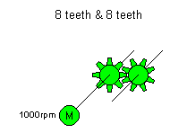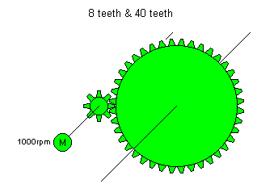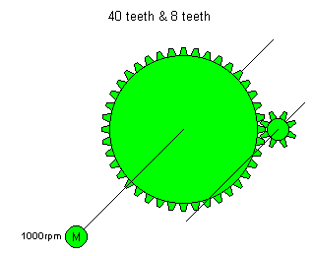

The gear connected to the motor is called the driver gear. The other gear that moves when in contact with the driver gear is called the driven gear.

Use the mouse (by placing it on the motor or gear) to measure the speed in rpm of the driven gears (ignore the degrees reading) and record the speed of each in the table below.

| **Motor RPM** | **DRIVER rpm** | **DRIVER (teeth)** | **DRIVEN (teeth)** | **DRIVEN rpm** |
| --- | --- | --- | --- | --- |
| 1000 |  | 8 | 8 |  |
| 1000 |  | 8 | 40 |  |
| 1000 |  | 40 | 8 |  |

From the readings try and work out the speed of the driven gear, for the gears shown in the table below.

| **DRIVER rpm** | **DRIVER (teeth)** | **DRIVEN (teeth)** | **DRIVEN rpm** |
| --- | --- | --- | --- |
| 1000 | 16 | 16 |  |
| 1000 | 8 | 24 |  |
| 1000 | 16 | 8 |  |

Explain how this was done for each problem in the space below.

16 to 16

8 to 24

16 to 8

7.2.2. Circuit of the racing vehicle

The circuit used is a simple series circuit, which contains a battery, switch and motor and is shown below.

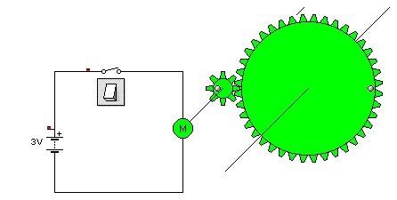

Draw up the circuit in crocodile technology (8 to 40 teeth) and confirm its operation by turning on the switch. Measure the speed of the driven gear in rpm. Record the speed.

Draw up another circuit with the battery reversed so that positive (+) is at the bottom of the screen. Operate the switch and observe the difference in operation between the circuits. Record the observation.

7.2.3. The effect of weight on the operation of the motor

Attach a flywheel to the large gear as shown. Set the inertia to 0.1 gm². This simulates the weight of the vehicle.

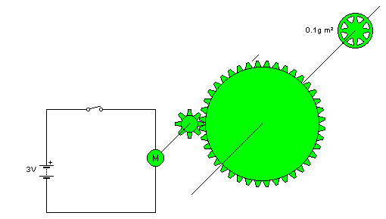

Turn on the switch and measure the speed of the driven gear. Record the maximum speed and how long it takes to reach that speed. Record it in the following table.

Turn off the switch and change the inertia to the values shown in the table and record the time it takes to reach maximum speed.

| **Flywheel Inertia** | **Max Speed** | **Time to reach max. speed** |
| --- | --- | --- |
| 0.1 gm² |  |  |
| 0.2 gm² |  |  |
| 0.5 gm² |  |  |
| 1 gm² |  |  |
| 4 gm² |  |  |

From the times recorded, what conclusion can be drawn about the effect that extra weight will have on the speed that the vehicle will reach?

Note: the time and race distance used in this example are made up values, to show how these calculations work. Different vehicle designs may achieve better speeds than given in the example.

Section 8 Glossary

Many of the following words will gather more meaning as students work through the stages in this booklet.

Students should complete the following table with definitions as they arise.

| **Word** | **Definition** |
| --- | --- |
| acceleration |  |
| battery |  |
| circuit |  |
| current |  |
| DC motor |  |
| effort |  |
| electricity |  |
| electromagnetism |  |
| energy |  |
| engineered systems |  |
| force |  |
| friction |  |
| fulcrum |  |
| gears |  |
| lever |  |
| motion |  |
| motor |  |
| newton |  |
| power |  |
| potential energy |  |
| resistance |  |
| strength to weight ratio |  |
| torque |  |
| velocity |  |
| voltage |  |
| wheels |  |
| woomera |  |

All outcomes referred to in this unit come from [Technology Mandatory Years 7-8 Syllabus 2017](http://educationstandards.nsw.edu.au/wps/portal/nesa/k-10/learning-areas/technologies/technology-mandatory-7-8-new-syllabus)   
© NSW Education Standards Authority (NESA) for and on behalf of the Crown in right of the State of New South Wales, 2017

© [Scorpio Technology](http://www.scorpiotechnology.com.au/) 2018. This teaching unit has been adapted to comply with the Department’s accessibility and style guidelines with the kind permission of [Scorpio Technology](https://www.scorpiotechnology.com.au/). (HPRM MAIL18/282230).

This resource was developed by:

* Bernie Livermore, Birrong Boys High School

The following people and organisations contributed to the consultation and development of the materials.

* Scorpio Technology Vic. Pty. Ltd
* Peter Davis, Normanhurst Boys High School
* Marlene Wakefield, East Hills Girls Technology high School
* Dan Rytmeister, Learning and teaching Directorate