Online learning courses:
Data summary

January 2017

Contents
Online learning courses: data summary 3
1. Participation since 2009 (at January 2017) 3
Table 1 - Total course participants by course - January 2009
to January 2017 4
Course participation distribution 4
2. Feedback and evaluation data 4
Table 2 - Participant self-rated knowledge and understanding of the
specific disorders/disability 5
Table 3 - Participant self-rated skills in assessing student needs 6
Table 4 - Participant self-rated skills in planning and implementing
interventions for students 7
Table 5 - Participant self-rated confidence in meeting student’s needs 8
Table 6 - Impact of Online learning courses through pre and post
course evaluations: participants selected their level of knowledge, understanding, skills and confidence 9
90 day follow up 9
Recommendation of the courses to others 10
3. Qualitative data from participants course contributions 10
Understanding Personalised Learning and Support 10
Understanding Autism Spectrum disorder 11
Understanding and Supporting Behaviour 11
Understanding Dyslexia and Significant Reading Difficulties 11
Inclusion of learners with Speech, Language and Communication
Needs 12
Understanding Hearing Loss 12
Understanding Motor Coordination Difficulties 12

Online learning courses: data summary

1. Participation since 2009 (at January 2017)
Participation | Numbers of participants
Course registrations  Total across the 7 available courses | 31,202
Individual participants  Some staff have taken several courses including classroom teachers, specialist teachers, school principals and other executive staff and school learning support officers | 20,442
Participants in Understanding Autism Spectrum Disorders Since 2009 | 9,866
Participants in Understanding and Supporting Behaviour Since 2010 | 7,431
Participants in Motor Coordination Difficulties Since 2011 | 1,562
Participants in Inclusion for learners with Speech, Language and Communication Needs Since 2011 | 4,075
Participants in Understanding Dyslexia and Significant Reading Difficulties Since 2012 | 5,585
Participants in Understanding Hearing Loss Since 2013 | 861
Participants in Personalised Learning & Support Since 2015 | 1,813

Table 1 - Total course participants by course - January 2009 to January 2017

Course participation distribution
Online learning course participation has continued to grow over the second half of 2016 with 1,364 new course registrations. Courses with particularly high take up include Understanding Autism Spectrum Disorder (9,866 registrations since 2009) and Understanding Personalised Learning and Support (1,813 registrations since 2015). During 2016, the Understanding Autism Spectrum Disorder course was updated. The revised course includes updated content, resources, forums and quizzes and was made available from January 2017.

2. Feedback and evaluation data
The department collects and analyses a range of data about the online learning courses to inform planning and support for their implementation. This data includes:
- pre and post course surveys of participants about their confidence, knowledge and skills in the topic area
- a voluntary follow up survey 90 days after completion
- post course evaluation of participants’ willingness to recommend the course to others
- qualitative data from participants’ final forum contributions.
The data continues to be highly positive in terms of the relevance of course content, the satisfaction felt by course participants and their ongoing use of course materials following course completion. A high completion rate has been sustained across all courses since 2009. Participants are asked, before and after their course, to rate their knowledge and understanding, assessment skills, planning skills and confidence in meeting the needs of students with the particular disability or need on which the course is focused. The data represented below reflects all course evaluations since August 2014.

Table 2 - Participant self-rated knowledge and understanding of the specific disorders/disability
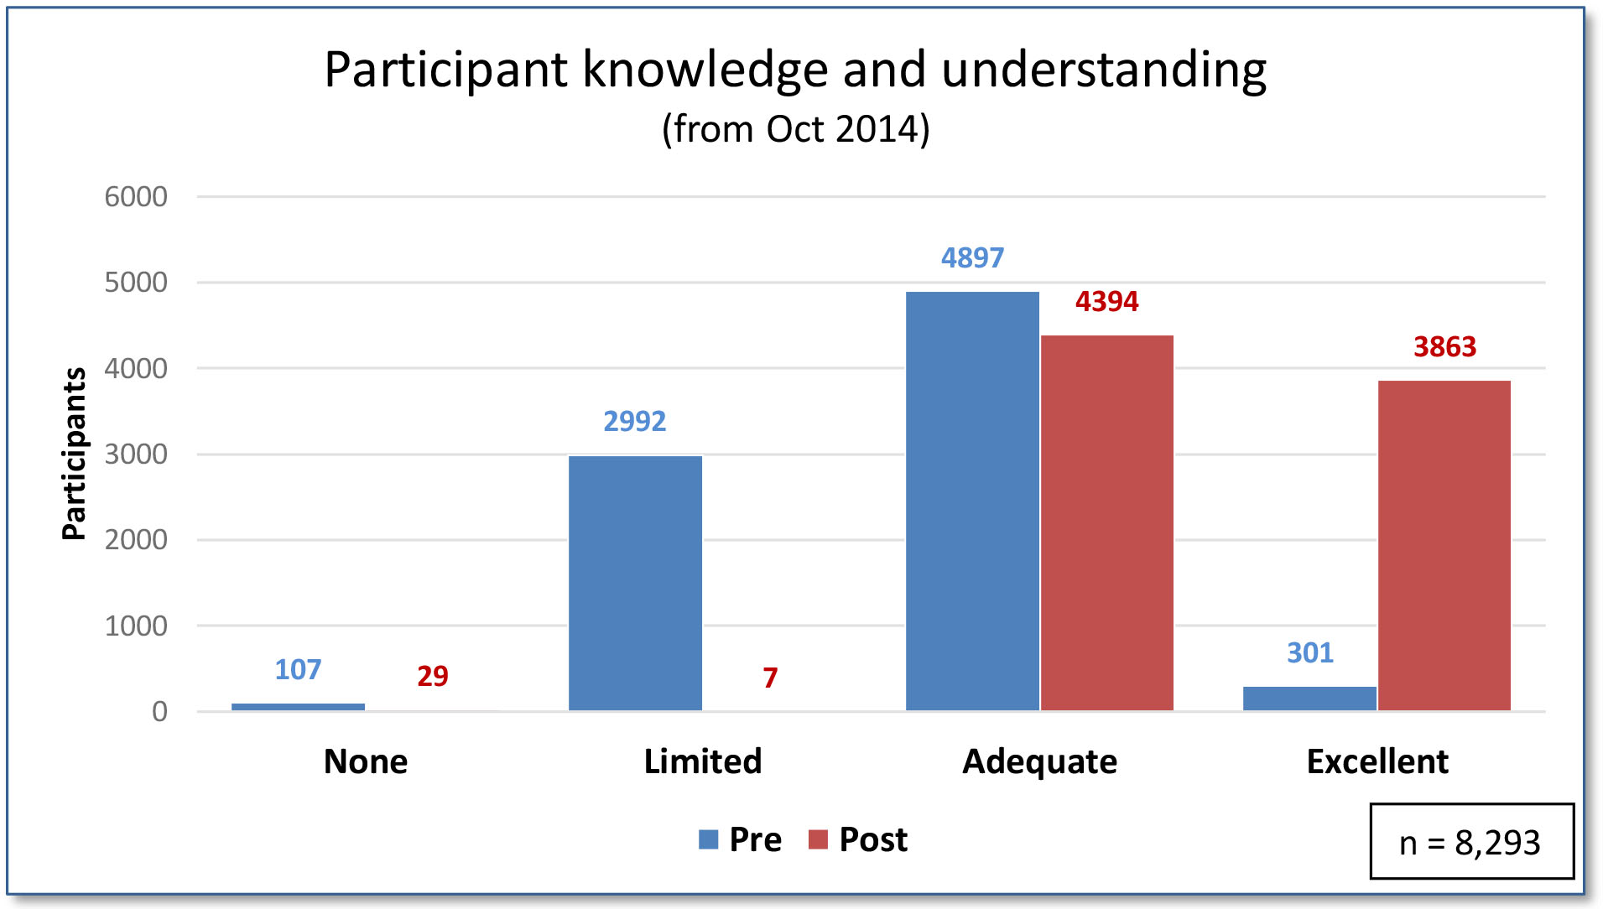
% of participants with no or limited knowledge & understanding reduced from 37.4% to 0.4%
% of participants with excellent or adequate knowledge & understanding increased from 62.6% to 99.6%

Table 3 - Participant self-rated skills in assessing student needs
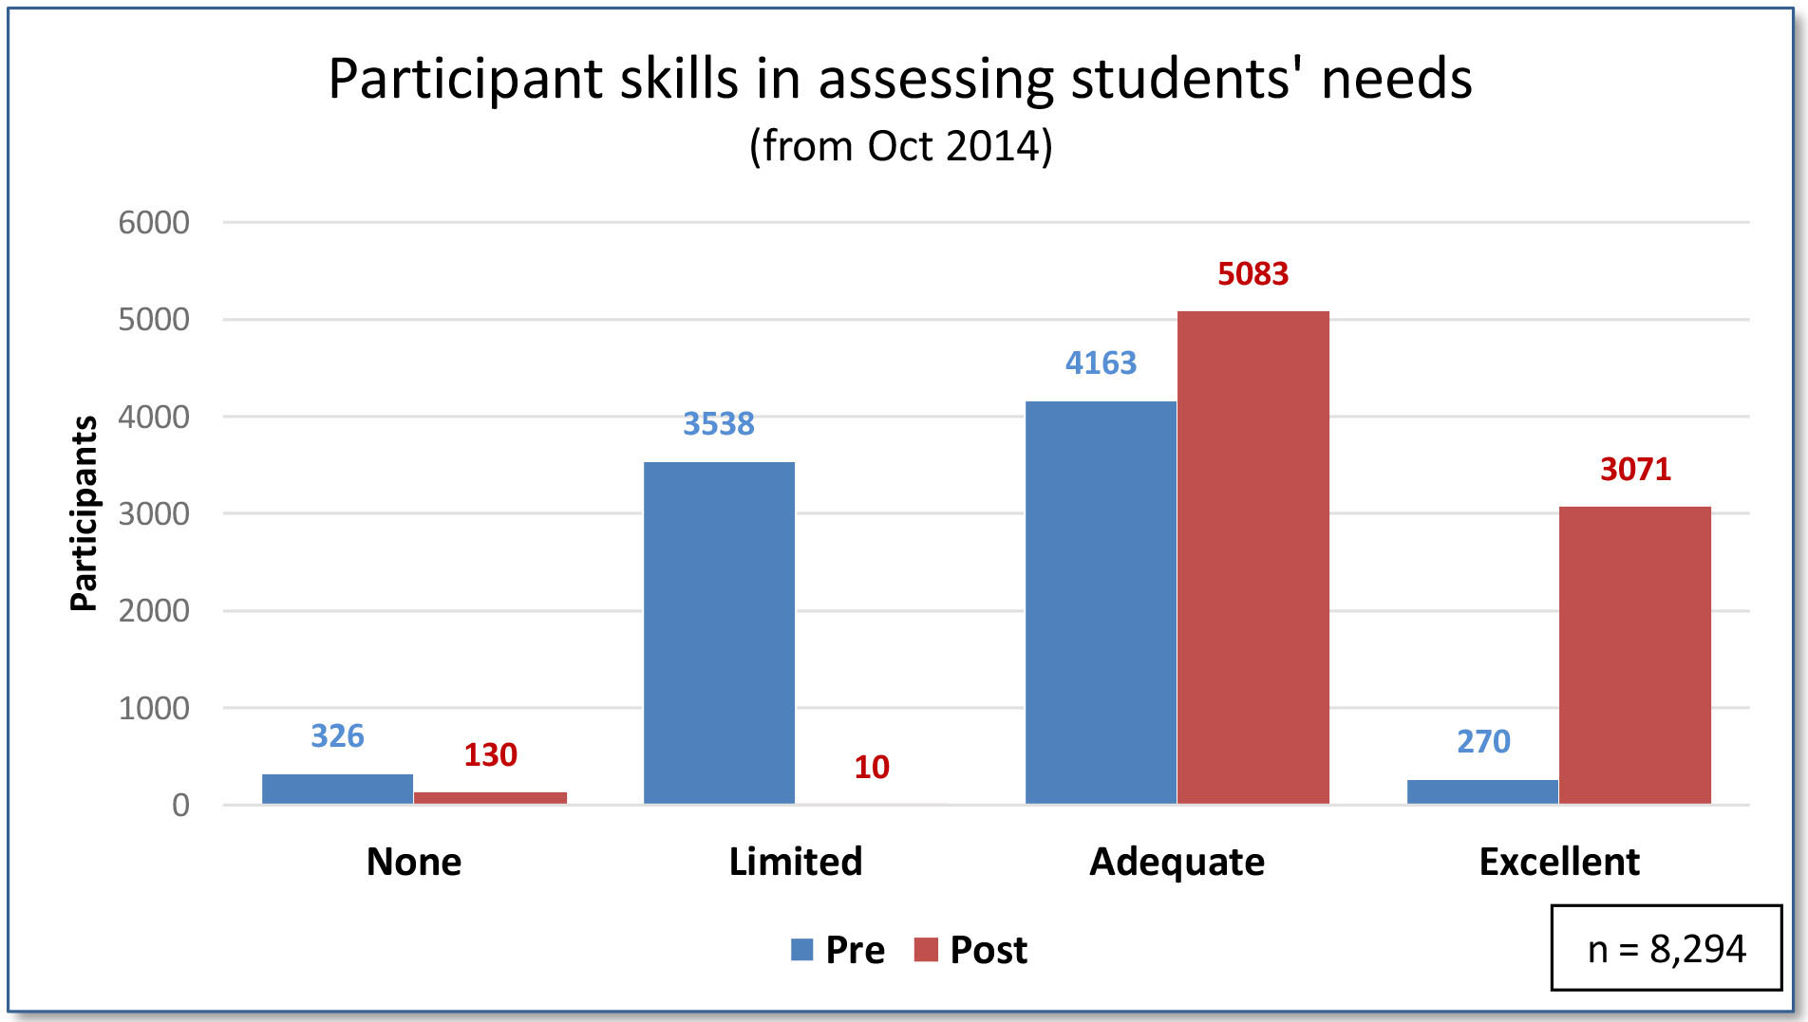
% of participants with no or limited skills in assessing students' needs reduced from 46.6% to 1.7%
% of participants with excellent or adequate skills in assessing students' needs increased from 53.4% to 98.3%

Table 4 - Participant self-rated skills in planning and implementing interventions for students
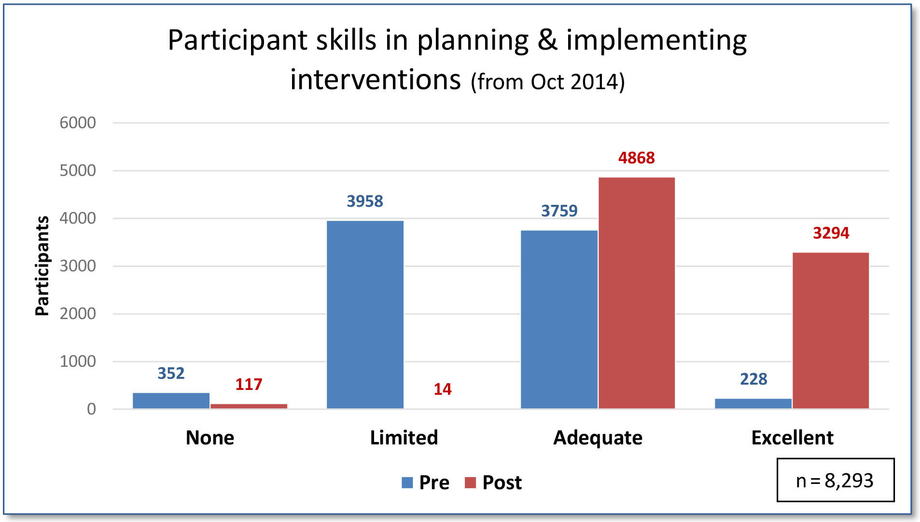
% of participants with no or limited skills in planning & implementing interventions reduced from 51.9% to 1.6%
% of participants with excellent or adequate skills in planning & implementing interventions increased from 48.1% to 98.4%

Table 5 - Participant self-rated confidence in meeting student’s needs
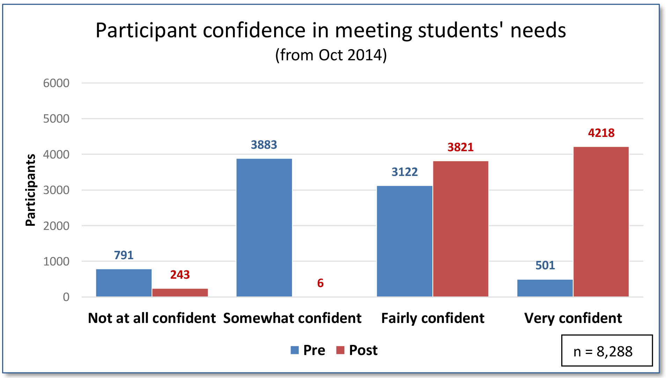
% of participants who are not or are somewhat confident in meeting students' needs reduced from 56.3% to 3.0%
% of participants who are very or fairly confident in meeting students' needs increased from 43.7% to 97.0%
These results are consistent with the results of the previous reporting period.

Table 6 - Impact of Online learning courses through pre and post course evaluations: participants selected their level of knowledge, understanding, skills and confidence
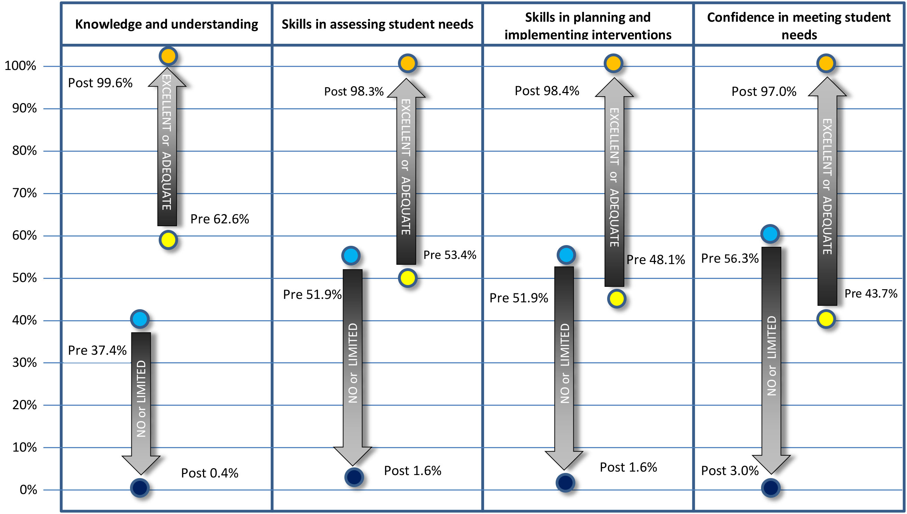
Ratings for each of the 7 courses are based on 8,682 completed post course online surveys since August 2014.

90 day follow up
Course participants receive an email survey 90 days after completion asking if they are still referring back to and/or using the course materials. Their response is voluntary. Feedback data shows that 90% of the 10,255 participants who have responded are still either referring back to the course content or using the course material 90 days after completing a course. This feedback has been collected since 2009 and represents approximately one third of all registrations.
Participants also comment on the extent to which the SMART goals (specific, measurable, agreed, realistic and time-related) they set for their focus student have or have not been achieved or exceeded and outline their future plans.

Recommendation of the courses to others
The willingness of participants to recommend the course they completed to others has remained consistently high with between 97%-99% of respondents indicating that they would recommend the course.

3. Qualitative data from participants course contributions
Each course participant is asked to reflect on their personal learning as they complete the course in their final online forum. A sample of participants’ final forum contributions is provided below. The sample has been selected to illustrate comments from a range of people in teaching roles across the department.

Understanding Personalised Learning and Support
“Fantastic to have so many resources at my fingertips to refer to when I need them. It has helped me feel a lot more confident in my ability to support my students, colleagues and parents.”
“The availability of the wonderful resources offered in this course will really assist me in supporting students, families, teachers and schools. I think the course has made me even more determined to support whole school communities in the needs of students in order that they in turn are empowered to better support the students in their school.”
“This course consolidated so many things for me. It brought everything together that we need to do in order to personalise student learning and improve student outcomes.”
“The tutor led sessions were great as they provided an overview then informed on the details for each section of the course for the online learning that we were about to undertake. The sessions offered a mix of learning methods which assisted uptake of the course and the general understanding s for each section. I appreciated the organisation, on-going support and knowledge of the tutors.”

Understanding Autism Spectrum disorder
“It has provided me with a deeper understanding of the social difficulties faced by students with ASD and a practical tool to set goals and assist students to cope in a mainstream setting.”
“This course has given me so many ideas to implement at the classroom level and for specific individual students. I was able to pass on the resources to our LST team which has impacted at a school level.”
“The course has provided a thorough bank of ideas and strategies to support students. It also highlights the value of conversations with other teachers, aides and parents to share information and ideas.”

Understanding and Supporting Behaviour
“Provided opportunities for professional dialogue in the sharing and clarification of understandings and best practice.”
“I love the smart goals and the interventions. Also assessing the behaviour ideas are very useful. I also like the fact that the resources can be accessed when the course is finished.”
“This course was extremely useful in providing me with knowledge and understanding of particular behaviours, as well as effective strategies that I could use in my everyday classroom. This course provided me with an insight to why some of the behaviours I witness may be present in my students' lives, and how as an educator, I can cater for their individual strengths and needs within my classroom and school context.”

Understanding Dyslexia and Significant Reading Difficulties
“It’s a great course and I would recommend it to any teacher.”
“This course has given me tools and resources to aid students who have difficulty with literacy. It has reinforced the need for adjustments and highlights how students' self-esteem and self-worth can be severely affected due to learning difficulties. Also it emphasises the importance of a learning community to provide advice and assistance that involves not only the teacher and the student but the parents/ carers, counsellor, principal, SLSOs etc. Success is possible for all students.”

Inclusion of learners with Speech, Language and Communication Needs
“It has prompted me to ensure that when I'm planning I consider the needs of students with speech and language difficulties as part of my normal planning process, regardless of whether there is a formal diagnosis for a student. Strategies taught within this course are often beneficial for all students.”
“A very worthwhile course which I would recommend to other teachers. It has given me a wealth of information on SLCN and how I can cater for students needs.”

Understanding Hearing Loss
“It has given me more in depth knowledge and avenues for accessing support to help with students if I am unsure.”
“Fantastic input from the tutor to support the content provided through the online learning.”

Understanding Motor Coordination Difficulties
“My understanding of the setting of SMART goals and interventions has improved to better address and support the student's individual needs. The realisation of the importance of motor co-ordination and its impact on a child's learning and self-esteem.”
“The course answered many questions I had about motor coordination issues my students have.”
“Contributed positively toward my knowledge, understanding, attitude and teaching practice around motor coordination difficulties.”

