Stage 4 Japanese

Activity – Japanese homes, how do they measure up?

Numeracy activity name
Japanese homes, how do they measure up?

Numeracy Skills Framework Focus Area
4: Measurement and time calculations

Aspect/s
Understanding and applying area concepts

Developed by
W. Mac (Sydney Technical School)

Stage
4

Year level
8

Language
Japanese

Unit of work
Japanese homes

How will the numeracy skills be supported by this activity?
Students are required to:
- read the blog about Japanese homes and examine the provided Japanese house plan stimulus
- investigate and determine the different standard measurements used in the floorplan, for example tatami measure versus metres/centimetres
- make conversions between the types of measurements for the rooms
- create a floor plan of their own home/dream home using tatami measurements.

Language structures incorporated
- What is a ? ( は 何ですか)
- How many metres is it? How many tatami is it? (何メートルですか。 / 何畳ですか。)
- It is metres. It is tatami. ( メートルです。 / 畳です。)

Homes and rooms – how do they measure up?
Read through the blog guide about Japanese homes – https://resources.realestate.co.jp/buy/guide-to-japanese-apartments-floor-plans-photos-and-kanji-keywords/
Review the floor plan below and then answer the following questions.
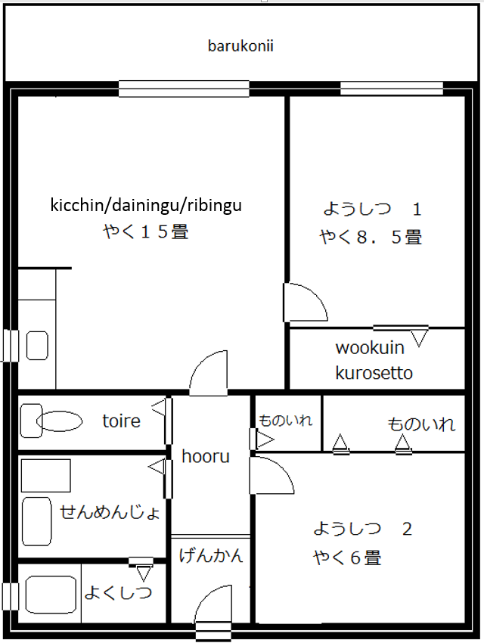
Standard tatami measurement: 1.8 × 0.9 metres

Questions
Answer the following questions in the language specified.
- In English, describe what you noticed about the way the size of the rooms is measured.

- 畳は何メートルですか。Answer in English.
- What are these called in Japanese? Answer in Japanese.
- [entrance] は 何 ですか。
- [balcony] は 何 ですか。
- [toilet] は 何 ですか。
- [bathroom] は 何 ですか。
- What are these called in English? Answer in English.
  - ようしつ は 何 ですか。
  - げんかん は 何 ですか。
  - wookuin kurosetto は 何 ですか。
  - kicchin/dainingu/ribingu は 何 ですか。
- Answer the following questions using the standard tatami measurement. Show calculations.
  - ようしつ（１） は 何メートル ですか。
  - ようしつ（２） は 何メートル ですか。
  - kicchin/dainingu/ribungu は 何メート ルですか。
- Create a floor plan of your own home/dream home using tatami （畳）as the measurement. Each room is to be labelled in Japanese (hiragana/romaji).

