Stage 5 Mathematics – The Sydney Metro rail project
Bankstown Girls High School is a comprehensive high school comprising of approximately 540 girls from diverse backgrounds located in south-west Sydney. A total of 61% of students come from the bottom 25% in the index of community socio-educational advantage and 98% come from non-English speaking backgrounds. Thus, many of our students begin their schooling lives at considerable disadvantage to their peers across Australia. The school is committed to the preparation of students for the 21st century and promotion of global citizenship and in particular, under the Future Focus Learning portfolio, on inquiry-based learning.
Substrands: S4 Data Collection and Representation (partial review), S4 Single Variable Data Analysis (partial review), S5.1 Single Variable Data Analysis, S5.2 Single Variable Data Analysis (partial review)

Inquiry-based learning unit – the ‘Sydney Metro rail project
Stage 5 – 10–12 lessons

Unit context
This unit was written by Clare Rounis (Numeracy Coordinator) and Vicky Saisanas (Head Teacher, Mathematics) of Bankstown Girls High School. The aim was to provide engaging, authentic learning opportunities for students studying ‘Data and representation’ as a part of their Stage 5 Mathematics course. The unit has been designed to model how to question and analyse real world data through structured inquiry. Students submitted an expression of interest to participate and this was the first opportunity offered to this group of students to engage in a real world project. The project commenced with 23 students initially, with 20 students completing it. Students who had poor attendance prior to the commencement of the program demonstrated improvement in attendance and a high degree of motivation and engagement.
This unit was created, trialled and peer reviewed as part of a professional development program in inquiry-based learning for primary and secondary school teachers. The professional development courses were part of a pilot partnership between the NSW Government’s Sydney Metro transport agency and Western Sydney University. Facilitated by Western Sydney University’s Education Knowledge Network, the professional development program aimed to develop teacher expertise in inquiry-based learning using a real-life example of a major infrastructure project in delivery stage.
Sydney Metro is Australia’s biggest public transport project.
The unit is aligned to © NSW Education Standards Authority (NESA) syllabuses, specifically the NSW Mathematics K-10 (2012) syllabus
for and on behalf of the Crown in right of the State of New South Wales, 2019

Contents
Outcomes 5
New South Wales Syllabus 5
Australian Curriculum 5
Key considerations 5
Key inquiry question 5
Literacy 5
Overview 6
Stimulating interest and discussion 6
Class organisation and preparation 6
Teaching and learning sequence 7
Assessment 12
Marking rubric I for the Sydney Metro Inquiry-based learning activity 13
Marking rubric II for the Sydney Metro inquiry-based learning activity 14
Unit evaluation 15
What impact did this project have on student learning? 15
How did the teachers feel? 15
Self-evaluation – Type of learner form 16
Student survey – Sydney Metro rail project 17
Student planning guide – Designing the survey 18
Conducting a survey – Student script Sydney Metro rail project 20
Sydney Metro rail project – Student report checklist 21
Peer evaluation form for group work 22
Feedback on team dynamics/collaboration 23
Post-project student survey – Sydney Metro rail project 24
Student work sample – Survey 26
Student work sample – Presentation 27
Student work sample: Speaking notes Group 2 28
Copyright 29
Links to third-party websites 29

Outcomes

New South Wales Syllabus
- MA4-1WM communicates and connects mathematical ideas using appropriate terminology, diagrams and symbols.
- MA4-2WM applies appropriate mathematical techniques to solve problems.
- MA4-3WM recognises and explains mathematical relationships using reasoning.
- MA4-19SP collects, represents and interprets single sets of data, using appropriate statistical displays.
- MA4-20SP analyses single sets of data using measures of location, and range.
- MA5.1-1WM uses appropriate terminology, diagrams and symbols in mathematical contexts.
- MA5.1-2WM selects and uses appropriate strategies to solve problems.
- MA5.1-3WM provides reasoning to support conclusions that are appropriate to the context.
- MA5.1-12SP uses statistical displays to compare sets of data, and evaluates statistical claims made in the media.
- MA5.2-3WM constructs arguments to prove and justify results.

Australian Curriculum
- Identify everyday questions and issues involving at least one numerical and at least one categorical variable, and collect data directly from secondary sources (ACMSP228)
- Construct back-to-back stem-and-leaf plots and histograms and describe data, using terms including 'skewed', 'symmetric' and 'bi-modal' (ACMSP282)
- Compare data displays using mean, median and range to describe and interpret numerical data sets in terms of location (centre) and spread (ACMSP283)
- Evaluate statistical reports in the media and other places by linking claims to displays, statistics and representative data (ACMSP253)

Key considerations

Key inquiry question
What impact do you think the Sydney Metro rail project will have on the people you know (yourself, your family and the community)?
- Calculate mean, median, mode and range for sets of data, and interpret these statistics in the context of data.
- Investigate the effect of individual data values, including outliers, on the mean and median.
- Investigate reports of surveys in digital media and elsewhere for information on how data was obtained to estimate population means and medians.
- Identify everyday questions and issues involving at least one numerical and at least one categorical variable, and collect data directly from secondary sources.
- Construct back-to-back stem-and-leaf plots and histograms and describe data using terms, using terms including ‘skewed’, ‘symmetric’ and ‘bi-modal’.
- Compare data displays using mean, median and range to describe and interpret numerical data sets in terms of location (centre) and spread.
- Investigate techniques for collecting data, including census, sampling and observation.

Literacy
- This topic contains statistical jargon, so a student-created glossary may be useful.
- ‘Median’ = middle, for example, median strip on a highway, or sounds like ‘medium’; ‘mode’ (French) = fashionable, popular.
- ‘n’ may refer to a collection of items as well as people.
- Teacher will need to spend considerable time explaining the difference between ‘discrete data’ and ‘continuous data’.
- The term ‘average’, when used in everyday language, generally refers to the mean and describes a ‘typical value’ within a set of data.
- Students need to be provided with opportunities to discuss what information can be drawn from the data presented. They need to think about the meaning of the information and to put it into their own words.
- Report writing: The literacy teacher will be consulted to provide the students with a lesson on report writing.

Overview
Students require relevant knowledge, skills and understanding from:
- S4 Data Collection and Representation
- S4 Single Variable Data Analysis (part)

Stimulating interest and discussion
A video called ‘Sydney Metro − Australia’s biggest public transport project’, will be presented in the first lesson to stimulate interest and discussion. This will also allow students to familiarise themselves with the website sydneymetro.info.

Class organisation and preparation
Student participation in the project will be determined by a verbal expression of interest. The offer will be made to a mixed ability group, namely 9M2 and 9M3.
Divide the interested students into teams of 3, maximum of 24 students.
Adjustments
- Assign teams carefully to accommodate students’ capabilities and social interaction skills. These teams may be determined by the students.
- Some students may require a teacher’s assistant or buddy.
- Some students may require a script to assist them in collecting data from the sources available to them. This script will be determined during discussions.
- Negotiation with the teacher teaching the other mainstream class to minimise disruption to their lessons (as required).
- Meeting times and amount of work submitted may be negotiated (as required).
- Students to be provided with the opportunity to ‘opt out’ of the project (case by case).
- Scaffolding of content (as required).

Teaching and learning sequence
NSW Syllabus | Teaching, learning and assessment | Resources
 | The content knowledge required by students to complete this unit of work, particularly the inquiry process, was studied in the Stage 4 Data and Representation topic. This was delivered in conjunction with the ‘Improving Numeracy Outcomes’ project focussing on statistical inquiry. Students are expected to apply the knowledge, skills and understanding they have gained through the study of this content and process to successfully complete this project.
Learning experience 1: Sydney Royal Easter Show excursion
Students will attend the Sydney Metro exhibit at the Sydney Royal Easter Show and inspect the new train.
Students will be expected to write an expression of interest to participate in the project.
 | Learning experience 2: What type of learner are you?  Students will be taken through an activity to help them identify what type of learner they are using the self-evaluation – Type of learner worksheet.  Student survey  Distribute the Sydney Metro rail project student survey to gain an understanding of each student’s prior knowledge of inquiry-based learning and the Sydney Metro project. | Self-evaluation − Type of learner worksheet on page 15 of this document  Sydney Metro rail project survey on page 17 of this document
- MA4-1WM communicates and connects mathematical ideas using appropriate terminology, diagrams and symbols.  - MA4-3WM recognises and explains mathematical relationships using reasoning.  - MA5.1-1WM uses appropriate terminology, diagrams and symbols in mathematical contexts.  - MA5.1-12SP uses statistical displays to compare sets of data, and evaluates statistical claims made in the media. | Learning experience 3: Subject matter familiarisation  Students will be asked to view the video called ‘Sydney Metro − Australia’s biggest public transport project’ from the official Sydney Metro website. This will be done as a whole class, without discussion.  Question: What did you learn from watching the video?  Students will view the video individually and note down 5-10 points of interest, ensuring numerical data has been included. This process may need to be repeated by the students to gain a thorough understanding of the key ideas of the video.  Students will share their points with their team members. As a team they will report back to the class. Similarities and differences will be discussed.  To familiarise themselves with the website and brochures, each student will:  - explore the official website and brochures  - investigate the numeracy content presented in these resources  - write a 200-word report about the ‘Sydney Metro rail project’ which includes numerical and categorical data  - present a 3-5 minute speech to the class, based on their findings/report. | Website  sydneymetro.info  Information book  Link to Sydney Metro Transforming Sydney Program Overview, https://www.sydneymetro.info/documents
- MA4-19SP collects, represents and interprets single sets of data, using appropriate statistical displays.  - MA4-20SP analyses single sets of data using measures of location, and range.  - MA5.1-1WM uses appropriate terminology, diagrams and symbols in mathematical contexts.  - MA4-2WM applies appropriate mathematical techniques to solve problems. | Learning experience 4: Statistical inquiry process  Students will be introduced to the statistical inquiry process and how to plan for their investigation, that is:  - Pose the question.  - Collect the data.  - Organise the data.  - Summarise and display the data.  - Analyse the data and draw conclusions.  Planning your investigation  Plan: What is the question you want answers to? Is there a problem you want to find out some information about? How can statistics help you to find out the answer? Do you already have an idea of what it is you may discover? What do you expect the outcome and conclusions to be?  Collect: Exactly what data do you need to help you answer your question? Where will you go to find it? What variables will you use – are there useful extras that might be interesting to investigate? Consider gender, age, height. How much data will you need? Does it need to be a random sample?  Process: How are you going to organise your data? What kinds of tables and graphs will best present your data? How can you ensure you are concentrating on things that are important for your investigation?  Discuss: What does your data tell you? Does it answer your question? Does it answer other questions? How are you going to present your conclusions? Does your data present other questions to you? Can you use your results to make predictions? Does it raise any concerns? Where should the investigation go next?  Evaluate: Were there weaknesses in your methods? Did these affect the quality of the results and conclusions? What would you do differently next time?
- MA4-19SP collects, represents and interprets single sets of data, using appropriate statistical displays. | Learning experience 5: Introduce the inquiry question  What impact do you think Sydney Metro will have on the people you know (yourself, your family and the community)?  Prompts:  - How will this affect me and what impact will it have?  - How will this affect my family and what impact will it have?  - How will this affect my community and what impact will it have?  What/who/how/where/when/why  Once the students have decided on the information they require remind them of the need to collect evidence (the information that will enable them to answer the question).  In teams students discuss:  - What evidence do we need to collect to provide the information?  - How can we collect the evidence?  - How will we record the evidence which we have collected?  - From who do we need to collect the evidence?  Each team will give a brief report (maximum 5 minutes) to the class. Other teams should be encouraged to provide feedback. | Review of statistical terms and concepts − worksheet and PowerPoint presentations
- MA4-1WM communicates and connects mathematical ideas using appropriate terminology, diagrams and symbols.  - MA4-19SP collects, represents and interprets single sets of data, using appropriate statistical displays. | Learning experience 6: Designing the survey  Teacher will lead discussion on the aspects of designing a survey.  A questionnaire or survey is a series of questions to gather specific information.  To design a questionnaire students:  - Use simple language  - Make questions unambiguous  - Respect the privacy of the interviewee  - Ensure the questionnaire is free from bias.  Further discuss the type of survey questions using Student planning guide – Designing the survey worksheet  Students will work in their groups to design their survey.  Students will present their surveys to the class to promote discussion with their peers.  Surveys will be adjusted as required and the published.  Students will complete the student planning guide –Designing the worksheet, prior to conducting the survey. | Student planning guide - Designing the survey worksheet on page 17 of this document  See student work sample of the survey on page 25 of this document.
MA4-19SP collects, represents and interprets single sets of data, using appropriate statistical displays. | Learning experience 7: Conducting the survey  Students will attend Bankstown railway station to conduct their survey.  Students will also be required to survey school students, family members and members of the local community during their own time.  This will allow for personal data to be collected.  A script will be provided to the students to assist them in conducting the survey. | Student script on page 19 of this document
 | Learning experience 8: Scaffolding students presentations and reports  Before compiling their presentation and reports students will be provided with a marking rubric to guide them through the process. | An inquiry-based learning activity marking rubric I on page 12 of this document
- MA5.1-1WM uses appropriate terminology, diagrams and symbols in mathematical contexts.  - MA5.1-3WM provides reasoning to support conclusions that are appropriate to the context.  - MA5.1-12SP uses statistical displays to compare sets of data, and evaluates statistical claims made in the media.  - MA5.2-3WM constructs arguments to prove and justify results. | Learning experience 9: Organising and displaying  Activities on displaying and organising numerical and categorical data.  Students will need to organise and display the data collected from their survey.
- MA4-20SP analyses single sets of data using measures of location, and range.  - MA5.1-3WM provides reasoning to support conclusions that are appropriate to the context.  - MA4-2WM applies appropriate mathematical techniques to solve problems. | Learning experience 10: Analysing, drawing conclusions and evaluating  Students will complete a series of activities which will assist them with analysing and drawing conclusions from data.  The evaluation component of this section may lead students to take alternate directions.
- MA4-20SP analyses single sets of data using measures of location, and range.  - MA5.2-3WM constructs arguments to prove and justify results. | Learning experience 11: Interpretation of data and writing the report  Students will need to write a report based on the data collected, making predictions and drawing generalisations. They will be guided using the Sydney Metro Student report checklist scaffold | Sydney Metro rail project – Student report checklist on page 20 of this document
- MA5.2-3WM constructs arguments to prove and justify results  - MA5.1-2WM selects and uses appropriate strategies to solve problems.  - MA5.1-3WM provides reasoning to support conclusions that are appropriate to the context. | Learning experience 12: Presentation  Students will be required to present their findings in the form of a PowerPoint presentation, video, letter to Sydney Metro, poster, cultural dance interpretation, song, poem or any other form. | See student work sample on page 26 of this document.
 | Learning experience 13: Peer evaluation  Students will complete the Peer evaluation form for group work. | Peer evaluation form for group work on page 21 of this document
 | Learning experience 14: Learning reflection  To promote a deeper understanding of the content and to allow students to refine their final product and encourage critical and creative thinking, a new rubric will be issued to the students. A day will be organised for students to present their findings, explore the new rubric, An inquiry-based learning activity marking rubric II, and to polish their final product. | An inquiry-based learning activity marking rubric II on page 13 of this document

Assessment
Students will be required to complete a range of formal and informal assessment tasks and surveys, including:
- Pre-project student survey: This will provide data to inform explicit teaching and learning activities.
- Report writing: Students will be required to write a short report on their findings from viewing the DVD ‘World’s best metro’
- Questionnaire design: Students will design a series of survey questions and will be provided with verbal feedback to improve their questionnaire, where necessary.
- Methodology: Students will be assessed on the way in which they collected their data and how the data is organised and presented.
- Accuracy: Students will be assessed on their ability to interpret the data and make predictions/generalisations.
- Presentation: Students will be required to submit a final product and will be assessed on its effectiveness to engage the audience.
- Peer evaluation: Students will be required to evaluate the work of their team members.
- Post-project student survey: Students will be required to complete a survey after submitting their final project.

Marking rubric I for the Sydney Metro Inquiry-based learning activity
Criteria | 3 | 2 | 1 | 0
Introduction  (Background report) | Provides a thorough/detailed description of the project.  and  Provides a thorough/detailed reason for why the project was chosen. | Provides a thorough/detailed description of the project.  or  Provides a thorough/detailed reason for why the topic was chosen. | Provides a limited description of the project.  or  Provides a limited reason for why the topic was chosen. | Does not provide a description of the topic or the reason for the project.
Knowledge and understanding of mathematical content (Survey/questionnaire design) | Provides a minimum of six survey questions with no bias and appropriate sample size. | Provides a maximum of four survey questions with no bias and appropriate sample size. | Provides a maximum of four survey questions with some bias with or without appropriate sample size. | Provides a maximum of three survey questions with some bias with or without appropriate sample size.
Knowledge and understanding of mathematical content  (Methodology) | Provides a thorough/detailed description of how the data was collected including the source. | Provides a reasonable description of how the data was collected including the source. | Provides a limited description of how the data was collected including the source. | Does not provide a description of the method used to collect the data.
Communication  (Expression and organisation of ideas and information in written and visual form)  (Display/presentation of data) | Organises ideas and information in presenting results of inquiry with a high degree of effectiveness. | Organises ideas and information in presenting results of inquiry with some degree of effectiveness. | Organises ideas and information in presenting results of inquiry with a limited degree of effectiveness. | Ideas are not presented with any degree of effectiveness.
Use of creative/critical thinking processes  (Reasoning/conclusions)  (Interpretation of data) | The report reflects the key findings/conclusions of the inquiry with a high degree of accuracy. | The report reflects the key findings/conclusions of the inquiry with some degree of accuracy. | The report reflects the key findings/conclusions of the inquiry with a limited degree of accuracy. | The report does not reflect the key findings/conclusions of the inquiry.
Communication  (Presentation of the inquiry to an audience) | Findings of inquiry are presented to an audience with a high degree of effectiveness. | Findings of inquiry are presented to an audience with some degree of effectiveness. | Findings of inquiry are presented to an audience with a limited degree of effectiveness. | Findings of inquiry are not presented to an audience with any degree of effectiveness.
Evaluation |  | Peer evaluation conducted for all team members. | Peer evaluation conducted for some team members. | Peer evaluation not conducted.
Total marks |  |  |  | /20

Marking rubric II for the Sydney Metro inquiry-based learning activity
Criteria | 3 | 2 | 1 | 0
Introduction  (Background report) | Provides a thorough, detailed description of the project  and  justifies reasons for why the project was chosen. | Provides a thorough, detailed description of the project  or  discusses reasons for why the topic was chosen. | Provides a limited description of the project  or  identifies the reason for why the topic was chosen. | Does not provide a description or justification for why the project was chosen.
Knowledge and understanding of mathematical content (Survey/questionnaire design) | Provides a minimum of six relevant survey questions with no bias and appropriate sample size. | Provides a maximum of four relevant survey questions with no bias and appropriate sample size. | Provides 1-3 relevant survey questions with bias evident, with or without appropriate sample size. | Inappropriate sample size or bias is evident in all questions.
Knowledge and understanding of mathematical content (Methodology) | Justifies data collection methods including the source. | Discusses how the data was collected including the source. | Outlines how the data was collected including the source. | Does not provide a description of the method used to collect the data.
Communication (Expression and organisation of ideas and information in written and visual form)  (Display/presentation of data) | Data visualisation is appropriate to the data collected and accurate. | Data visualisation is appropriate to the data collected but inaccurate. | Data is visualised inappropriately and inaccurate. | No data visualisation.
Use of creative/critical thinking processes  (Reasoning/conclusions)  (Interpretation of data) | Synthesises the data to draw conclusions and prove findings of inquiry. | Analyses the data to draw conclusions and make findings. | Organises the data to draw conclusions and make findings. | The report does not reflect the key findings/conclusions of the inquiry.
Communication  (Presentation of the inquiry to an audience) | Analyses and presents the findings in an effective format that is relevant to the audience. | Discusses and presents the findings in a format that is relevant to the audience. | Outlines the findings in a format that may be relevant to the audience. | Presentation is irrelevant to the audience or presents no findings.
Evaluation |  | Peer evaluation conducted for all team members. | Peer evaluation conducted for some team members. | Peer evaluation not conducted.
Total marks |  |  |  | /20

Unit evaluation

What impact did this project have on student learning?
- High student engagement was evident.
- Students gained confidence working collaboratively in teams that were determined by them.
- Individual students and teams demonstrated initiative in leadership roles.
- Improved attendance.
- Some enjoyed the project without realising that they were ‘doing’ maths.
- Felt pride and ownership of the product that they were developing.
- Promoted independent learning.
- This project was real and relevant to them and their families.
- This led to increased focus and synthesis of information.
- Data that was collected had relevance.
- Improved their communication skills.
- Increased and improved work ethic.
- Felt important, in terms of being given this opportunity.
- Students had the opportunity to ‘opt out’, without prejudice. When a team folded, team members were given the choice of joining another team or continuing on their own.

How did the teachers feel?
- Teachers faced many obstacles in terms of whole school activities – loss of face-to-face class time (NAPLAN, school carnivals, extra-curricular activities).
- Team members were not from the same class – the other Year 9 teacher was inconvenienced when the project had to make up for lost time.
- The statistical inquiry process was well executed. The scaffolding developed had impact on student learning and their ability to collect data.
- The transformation of the learning of these students made it all worth it.
- The students felt a sense of belonging and never once treated the opportunity as a way to ‘get out of’ lessons.
- The students who did not have access to computers at home, ‘Face-timed’ one another.
- Extremely proud of the students.
- The presentation day and investigation of the second rubric was well received and is scheduled for week 10.
- The resources and scaffolds developed, implemented and evaluated may be used in any inquiry process.

Self-evaluation – Type of learner form
Your name:
Indicate the extent to which you agree with the statement on the left, using a scale of 1-4 (1=strongly disagree; 2=disagree; 3=agree; 4=strongly agree).
Learner profile
Caring: I show empathy, compassion and respect. I try to make a difference in the world around me.
Principled: I act with integrity and fairness. I take responsibility for my actions and respect others.
Inquirer: I am curious and develop my skills for inquiry and research. I can learn independently and with others.
Thinker: I can use critical and creative thinking skills to analyse and solve problems and make decisions.
Open minded: I appreciate my own culture and the differences in other cultures too. I am open to others’ ideas.
Communicator: I can express my ideas confidently and creatively. I can listen and work cooperatively.
Reflective: I understand my strengths and challenges. I can set goals for myself.
Risk-taker: I am willing to try new things knowing that I will grow from it. Challenge and change helps me to evolve.
Knowledgeable: Through inquiry, I am developing an understanding of the world around me, locally and globally.
TOTALS

Student survey – Sydney Metro rail project
- a) What is your understanding of ‘inquiry-based learning’?
b) Can inquiry-based learning be used in Mathematics? Explain.

- What type of learner are you? How do you learn best?

- How does working collaboratively in groups make you feel?

- How do you feel about being involved in the Sydney Metro rail project?

- a) What do you already know about the Sydney Metro rail project?
b) What impact do you think the Sydney Metro will have on you, your family and your community?

Student planning guide – Designing the survey
Investigation/title:
Starting thoughts/ideas:
- Plan
What question am I going to investigate?

What do I expect the answers/findings to be and why?

- Data
The population
The sample size
  - What data and variables will I need?

  - How will I collect it?

- Process
What calculations will I do?

What information will this tell me?

What graphs/diagrams will I use?

What will these tell me?

- Discuss
What have I discovered?

How do my results help with my question?

Can I use my results to make any predictions?

Are there any other questions that have arisen?

- Evaluation
Were there weaknesses in the methods I used?
Did this affect the quality/validity of the results and conclusions?
What would I do differently next time?

Conducting a survey – Student script Sydney Metro rail project
Introduce yourself and your partner; and provide a brief description of why you are there.
Hi / good morning / hello / good afternoon my name is __________________________________________ and this is ___________________________________________________.
We are here from Bankstown Girls High School and we are trying to discover what impact the Sydney Metro rail project will have on our local community. Would it be okay for us to ask you some questions?
Show them the survey and let them fill it themselves, if they prefer.
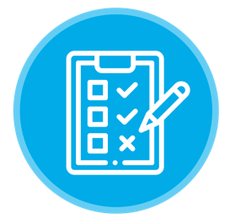

Sydney Metro rail project – Student report checklist
Names of team members:
Use the following checklist as a guide to write your report.
Team members | How were the roles and responsibilities of the team members allocated?
Background report | Why did you decide to investigate this topic?  What are you hoping to learn?
Survey/questionnaire design | A minimum of six questions have been developed  Questions have no bias  Sample size is appropriate
Methodology | Describe the population that is to be surveyed (identification of population)  Describe your sampling procedure and your attempt to make it representative of the population  Plan your sampling procedure  Decide how the survey will be conducted  Explain how, when and where you administered the survey  Collect your data
Display/presentation of data | Organise and summarise your data (Use as many tools that were studied in class as are appropriate).  Appropriate graphs have been used to give a clear picture of the findings. Why did you decide to investigate this topic?
Interpretation of data | Discuss what the data tells you about the inquiry you chose. What did you learn?  What generalisations/predictions might you draw about the population from which the sample was drawn?  Your sentences in this paragraph could start with these types of prompts:  ‘Some generalisations that we can make are ...’  ‘The data suggests that ...’  ‘We saw the following trend ...’
Presentation | How did you decide on the final presentation mode?  Your presentation must engage the audience
Evaluation of process | Share any difficulties you experienced during the inquiry.  What might you do differently if you were to repeat the survey?  How might you have administered the survey differently if you had more time and resources?  You should address known sources of bias.  Are there any possible extensions of this inquiry project that might prove interesting?

Peer evaluation form for group work
Your name:
Write the name of each of your group members in a separate column. For each person, indicate the extent to which you agree with the statement on the left,
using a scale of 1-4 (1=strongly disagree; 2=disagree; 3=agree; 4=strongly agree).
Total the numbers in each column.
Evaluation criteria | Group member name: | Group member name: | Group member name: | Group member name:
Contributes meaningfully to group discussions.
Participation in developing ideas and planning project.
Staying on task and meeting deadlines.
Interest and enthusiasm in the project.
Demonstrates a cooperative and supportive attitude. Respecting others.
Contributes significantly to the success of the project.
TOTAL

Feedback on team dynamics/collaboration
- How effectively did your group work?

- Were the behaviours of any of your team members particularly valuable or detrimental to the team? Explain.

- Did you encounter any obstacles in completing this inquiry?

- What did you learn about working in a group from this project that you will carry into your next group experience?

Post-project student survey – Sydney Metro rail project
- Has your understanding of inquiry-based learning improved? Explain.

- Can inquiry-based learning be used in Mathematics? Explain

- What type of learner are you? How did you learn during this project?

- How did working collaboratively in groups make you feel?

- How did you feel about being involved in the Sydney Metro rail project?

- Are you better informed about the Sydney Metro rail project? Explain.

- What impact will the Sydney Metro rail project have on you, your family and your community?

- Did you enjoy the project? Explain.

Student work sample – Survey
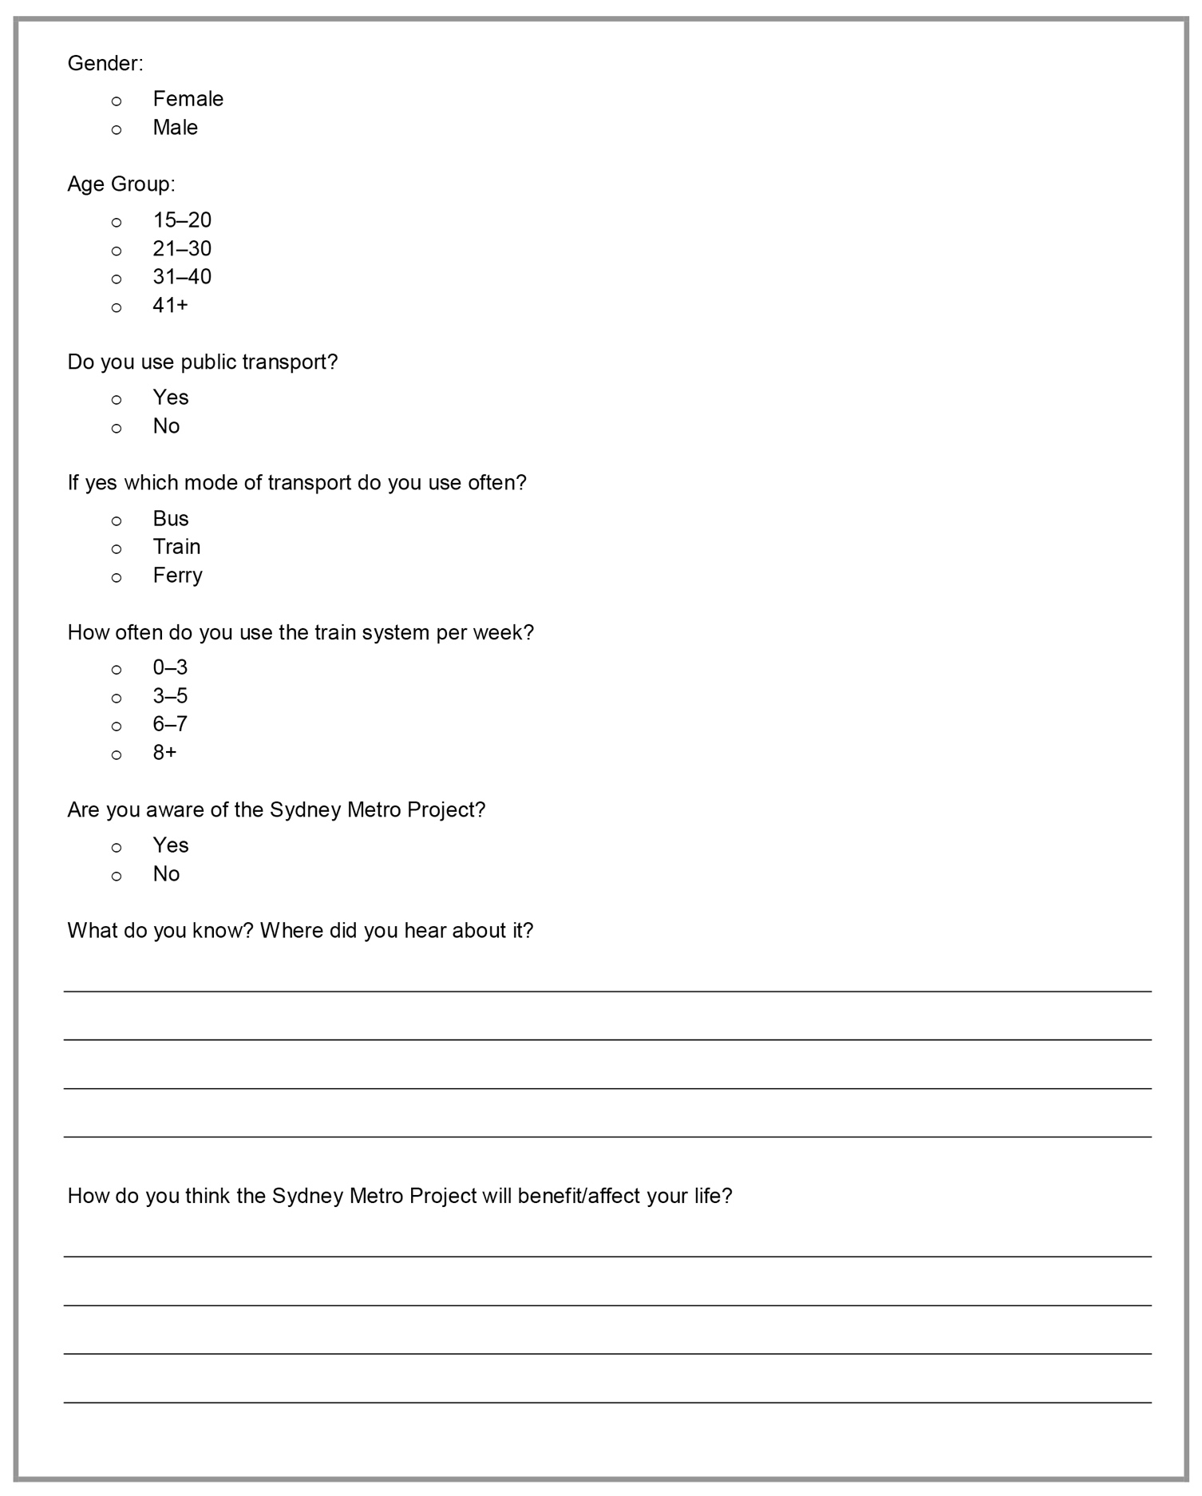

Student work sample – Presentation
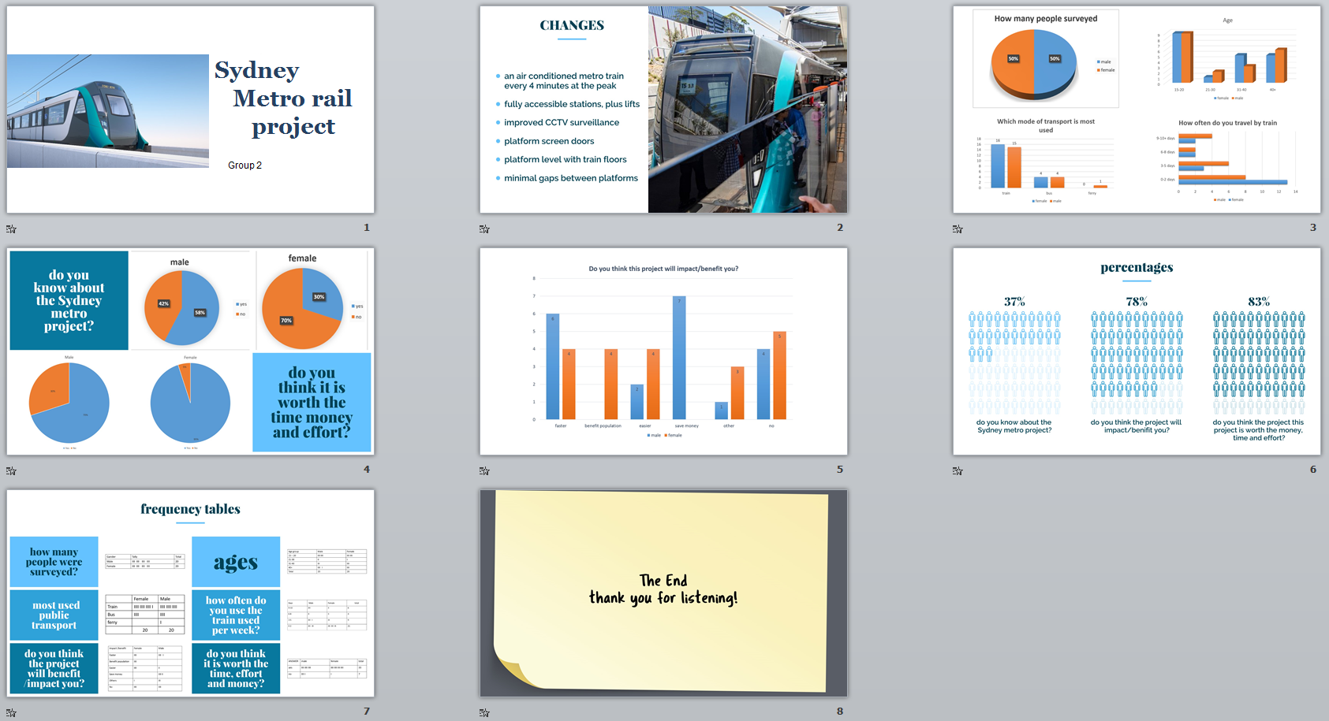

Student work sample: Speaking notes Group 2
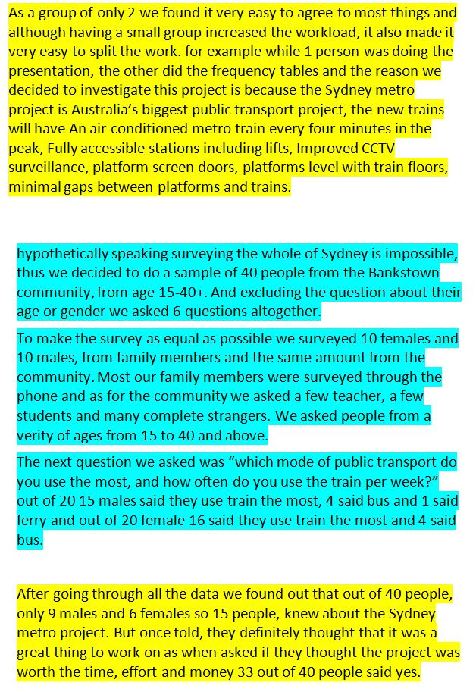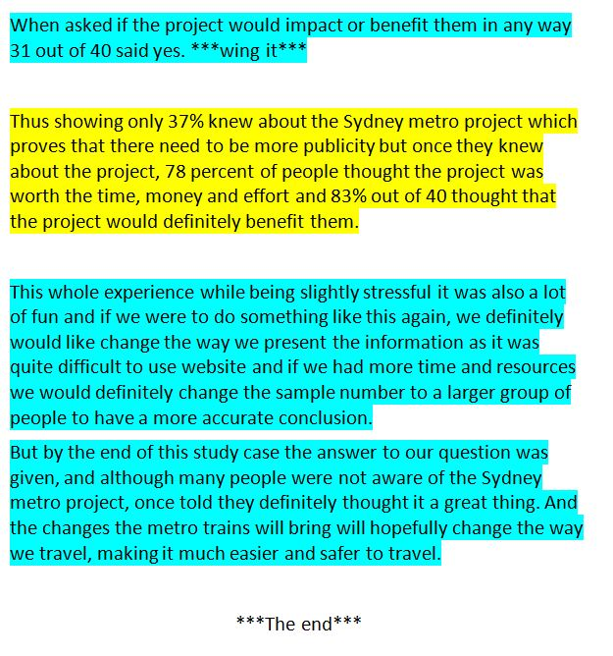

Copyright
© State of New South Wales (Department of Education), 2019
The copyright material in this publication is subject to the Copyright Act 1968 (Cth), and is owned by the NSW Department of Education or, where indicated, by a party other than the NSW Department of Education. Copyright material which is owned by the NSW Department of Education is licensed under a Creative Commons Attribution 4.0 International (CC BY 4.0) licence.
This licence allows you to:
- share – copy and redistribute the material in any medium or format
- adapt – remix, transform and build upon the material for any purpose, even commercially.
Attribution should be given to:
© State of New South Wales (Department of Education), 2019.
Material in this publication not available under a Creative Commons licence includes:
- the Department of Education logo, other logos and trademark-protected material
- material owned by a third party that has been reproduced with permission. Permission will need to be obtained from the third party to re-use this material.
If this publication contains your work and you have an objection to such content, please contact legal@det.nsw.edu.au.

Links to third-party websites
If you use the links provided in this publication to access a third party’s website, you acknowledge that the terms of use, including licence terms set out on the third party’s website apply to the use which may be made of the materials on that third party’s website or where permitted by the Copyright Act 1968 (Cth).
The department accepts no responsibility for content on third-party websites.

