

INVICTUS GAMES SYDNEY 2018 EDUCATION PROJECT

EDUCATIONAL EXCURSION EXPERIENCE – BULLETIN 3

Monday 22 – Friday 26 October 2018

Dear Colleagues,

The Invictus Games Sydney 2018, are now only a week away. Your numbers have been finalised. The food is prepared. The presenters are excited.

Please ensure you are familiar with your individual school program.

This bulletin is to clarify final details.

Arrival by bus/coach:

* Pease have the A4 sized parking permit displayed on the front window of the bus.(see attachment)
* Bus drop off and parking in pod ‘C’. (see map attached)
* Leave any school bags, glass, metal bottles larger than 600ml, flags, sporting equipment, sun creams in bottles larger than 250m on the bus. There is no storage facility at any venue.
* When you disembark, follow the directions of the Education Project staff (blue polo shirts) to ANZ Stadium.
* Please use external ANZ toilets before entering the stadium.

map is enlarged on page 6 of bulletin

Arrival by train:

* When you exit train station, head to ANZ Stadium.
* Education Project staff (blue polo shirts) and volunteers (red polo shirts) will be on site to assist you.
* Please use toilets in Cathy Freeman Park or the external ANZ toilets before entering the stadium.

At ANZ Stadium:

* Enter the ANZ Stadium via gate ‘C’.
* ONE staff member with two student helpers (if you have a large group please have extra helpers nearby) report to the ticketing area inside gate ‘C’ to resister and collect your tickets, bags and caps.
* The other staff member/s and students follow the Education Project staff and volunteers to their seats in the stadium for the welcome and orientation.
* Education Project volunteers will be in red polo’s and Education Project staff will be in blue polo’s.

If you are running late on the day:

* Don’t panic.
* One staff member and two student helpers (depending on the size of your group) walk to ANZ Stadium gate “C” to register, and collect tickets, caps and bags.
* The remaining staff and students move to their timetabled event and venue to wait for their tickets.

Who to look for, if you need help:

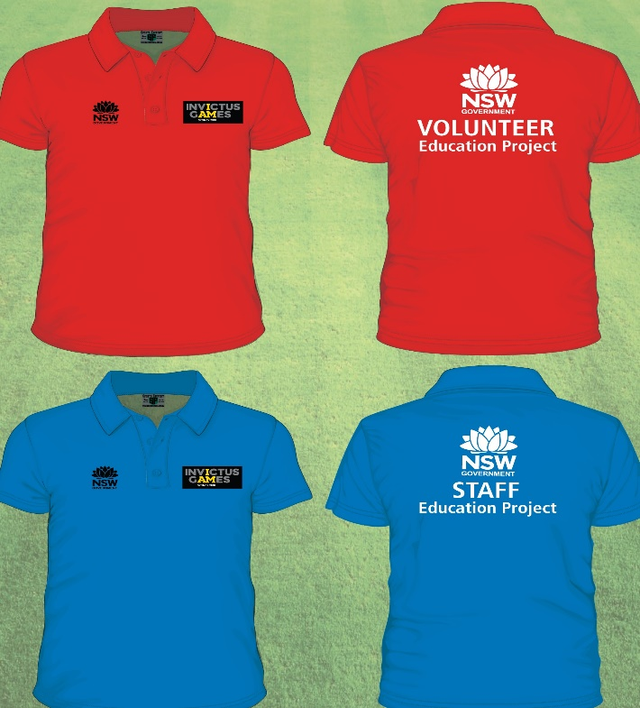

Risk Management:

There is a medical officer available at ANZ stadium, near Gate C.

Please ensure that you have Epipens, Asthma treatments and any specific medication required for students.

Supervision:

Students will be under the active supervision of their accompanying teachers and staff at all times.

Media Information:

Supervising teachers must ensure students who do not have permission for publication are not interviewed or have their individual image taken by any media.

School Uniform:

Students should be dressed in their “physical education” uniform. Many of the workshops require physical participation. Please wear suitable enclosed shoes for walking around the venues. Please remember we will be supplying students and staff with a cap and bag.

Back packs and school bags:

Staff members who are required to carry medical equipment: your bag will be checked and tagged appropriately.

Please note one of the conditions of entry is that bags must be no more than 40cm X 40cm if you are carrying larger medical equipment you may leave it in the private feeding room at ANZ Stadium near gate ‘C’.

Please note the following; Conditions of Entry for Invictus Games Sydney 2018 Competition Venues: <https://www.invictusgames2018.org/invictus-games-2018/venue-entry-conditions/>

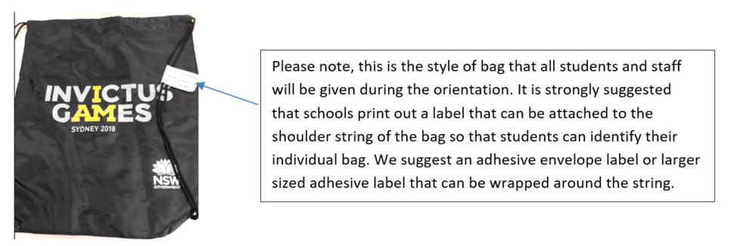

General admission seating within the venue:

All Invictus Games Sydney 2018 competition venues are general admission seating. Please follow the instructions of the Invictus Games Sydney 2018 Education Project volunteer to ensure you are seated in the correct area within venue.

You may be instructed by venue staff and volunteers to move into seats to ensure all spectators can be seated during the competition.

Please note that athletics General Admission seating includes areas seated on the grassed hill area, please be prepared.

All spectators are encouraged to enter and exit the venue at the allocated session times, however there will be no restrictions if you arrive late or need to leave early. **Please note that there are no pass outs**, so you may only exit the venue once. Please also be considerate of competitors by leaving quietly and in breaks where possible.

Morning tea:

Students will be able to bring snacks into venues. Snacks should be carried in ‘ziplock bags’ until the drawstring regulation bags are issued. (Soft drinks, metal water bottles or opened water bottles are NOT allowed to be taken into any venue.)

Commercial food items, including coffee, are NOT allowed to be taken into venues.

Lunch:

A sandwich, piece of fruit and bottle of water will be provided for each student. You will need to collect it from the front of the RAS Amphitheatre. A staff member will need to sign for the lunches and collect the trays with the aid of student helpers. Please distribute the lunches to your students and return the trays to the RAS Amphitheatre.

Cathy Freeman Park is available to use as an open lunch area, weather permitting. There are toilets at the park.

If the weather is not suitable for eating lunch in the park, the Hordern Sprung Pavilion will be made available.

Students with Special Needs:

Suitable toileting and feeding areas are available at ANZ Stadium adjacent to gate ‘C’.

Payment of accounts:

The student ticket numbers will be used to generate a direct debit to your school account via a Sundry Tax Invoice/RCTI Statement which we will upload to EDConnect Accounts Receivable.

The invoice will be based on the student ticket number as of Friday, 28 September.

This upload is scheduled for October.

The contractual commitments with the venues, caterers, workshop presenters and speakers mean that we will not be able to vary ticketing now. We will not be able to provide refunds on tickets. It was your responsibility to advise, in writing, any changes to ticket numbers by close of business on **Friday, 28 September as per bulletin 2**.

School requirements template:

Schools are also reminded to complete the school requirements template if they have not already done so, so that the caterers can meet your needs. This should be returned to **Sheena Walker**, Email: [sheena.walker@det.nsw.edu.au](mailto:sheena.walker@det.nsw.edu.au) by **no later than Monday 15 October 2018**.

Weather advice:

Please note that the weather is unpredictable in October. While most sporting venues and workshops are undercover, there can be up to a 15 minute walk between venues. There is very little shelter available while walking to venues.

The Athletics Centre on Thursday and Friday will not be under cover. Students and staff are advised to bring a raincoat/poncho as umbrellas cannot be brought on site.

FURTHER INFORMATION

Useful Links

Curriculum materials and resources produced by the Department <https://education.nsw.gov.au/teaching-and-learning/curriculum/invictus-games>

Description of the events that are being held at the 2018 Invictus Games please go to the following website: <https://en.wikipedia.org/wiki/Invictus_Games>

Motivational speaker Lorin Nicholson, “The greatest mountain we climb in life, is the mountain inside ourselves”

Lorin is a blind musician, author and cyclist. <http://lorin.com.au/education>

Prohibited list page 6

Maps pages 7 and 8

Required bus sign for parking and drop off at Pod C page 9

Please check the previous bulletins saved on the Curriculum website as your questions will probably be answered there. It may take a day to answer your emails. Contact Sheena Walker Email: [sheena.walker@det.nsw.edu.au](mailto:sheena.walker@det.nsw.edu.au) if any further information or clarification is required.

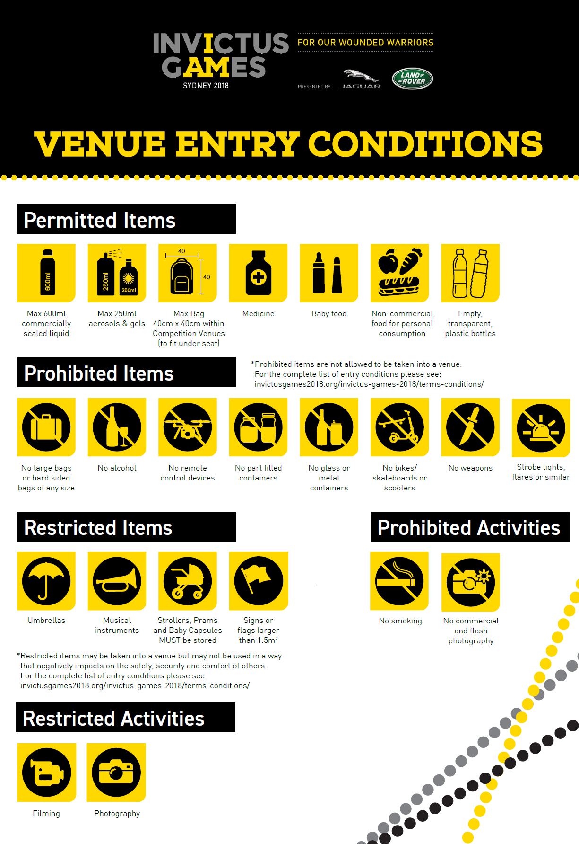



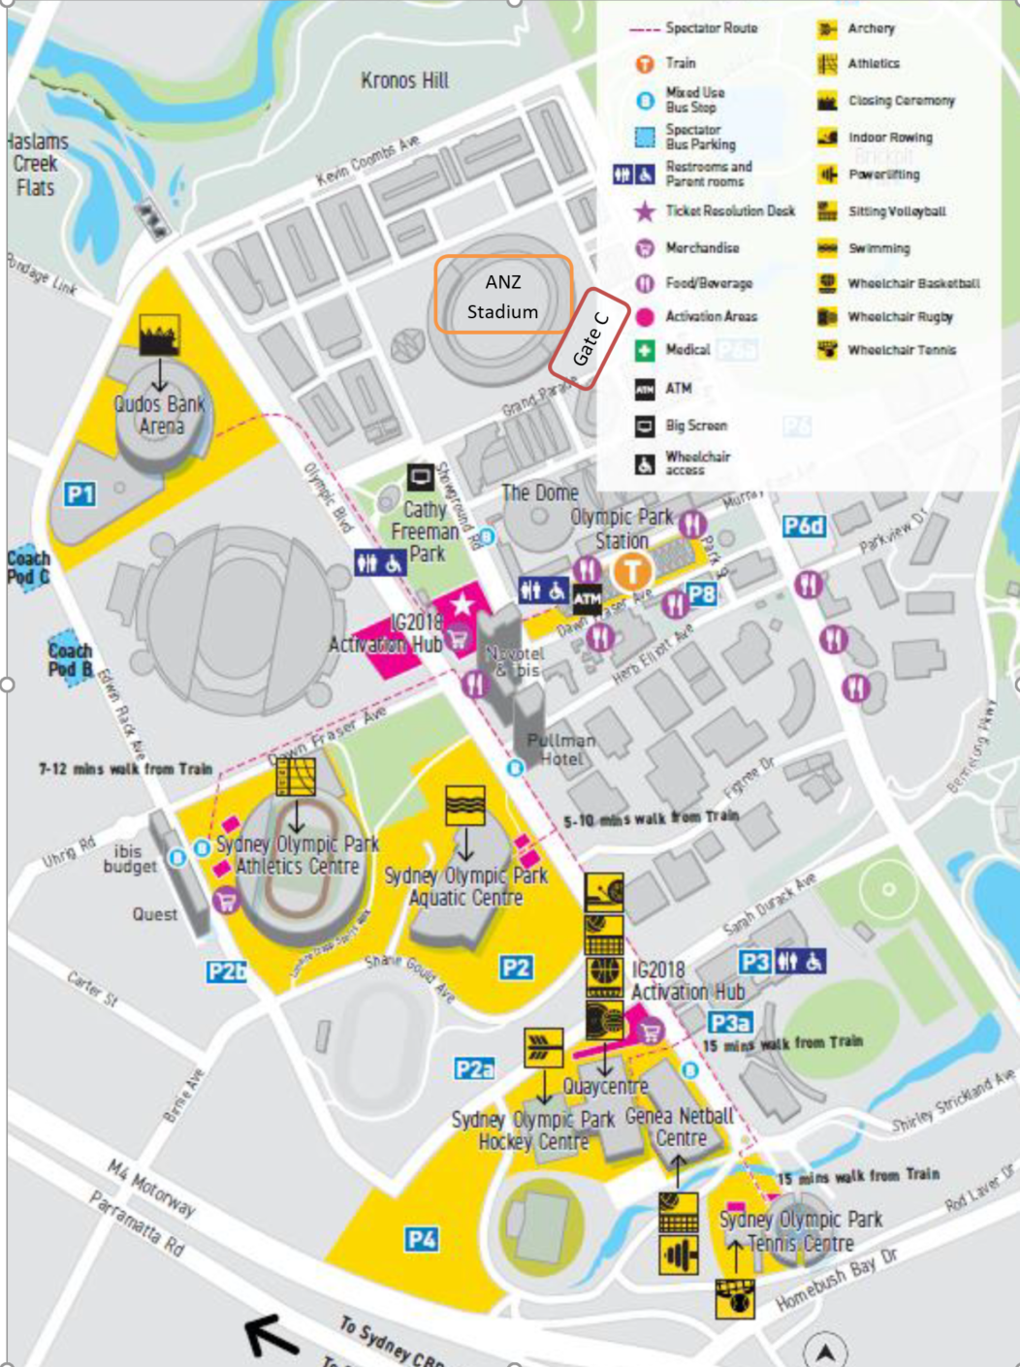



Coach and Bus Parking Permit