  - INVICTUS GAMES SYDNEY 2018 EDUCATION PROJECT
  - EDUCATIONAL EXCURSION EXPERIENCE - BULLETIN 1
  - Monday 22 – Friday 26 October 2018
Dear Principal and Teacher Ambassador,
The Invictus Games Sydney 2018 event is fast approaching. The planning for your school’s involvement and participation is progressing and over the next two months we will be in touch with your school via two more bulletins. In these bulletins we will provide more precise information relating specifically to your attendance.
The purpose of this bulletin is to firstly thank you and congratulate you for supporting this initiative. We are confident that your students and staff will have a positive experience. We would also like to advise you of a number of organisational aspects with regard to your attendance.
  - DATES
The Invictus Games Sydney 2018 will commence on Saturday 20 October and conclude on Saturday 27 October 2018. From Monday 22 October until Friday 26 October 2018 the Department of Education is providing the opportunity for schools to be involved as spectators at a number of adaptive sports events, as well as the opportunity to participate in a number of educational workshops and/or seminars.
  - VENUES
The Invictus Games Sydney 2018 has attracted approximately 500 competitors from 18 different nations. Events are being conducted throughout Sydney, using venues that include Sydney Harbour and the Sydney Olympic Park precinct. At Sydney Olympic Park, the venues include ANZ Stadium, Quay Stadium (formerly Sports Centre), Sydney Olympic Park Aquatic Centre, Sydney Olympic Park Athletic Centre and the Royal Agricultural Society amphitheatre (adjacent to the Cathy Freeman Park). The Armory will also be used as part of the educational excursion experience.
Students and staff will be able to walk between most venues. For students visiting the Armory, transportation will be provided. For students with special needs transportation arrangements will be advised.
A map of the Sydney Olympic Park precinct may be viewed by using the following link: Map link

  - RISK MANAGEMENT
A draft risk management assessment is attached for your information. Please refer to the separate attachment “NSW Risk Assessment and Risk Management Plan – IG2018 Education Project 2018 – Updated 17.8.2018”

  - PROGRAM
Students will have the opportunity to be involved as spectators at the adaptive sports event(s) and will participate in various workshops/presentations and/or tours of selected venues. When the schedule is finalised your school will be forwarded a “Daily Program” which will relate specifically to your attendance.
In the interim, a sample daily program is attached at the end of this bulletin.

  - SCHOOL RESPONSIBILITIES
Supervision:
Students will be under the active supervision of accompanying teachers. Schools should have strategies in place in case students become lost (e.g. mobile phone contact number). Each day will start with a registration of schools and a welcome and orientation meeting at ANZ Stadium, entering via Gate C. Gate C will be the entry and exit point in use throughout the day. Gate C is also the “Help Point” location, close to security and medical resources. Schools should prepare students for the day so that they know to return to Gate C if they become lost or separated from their group.
Arrival:
All schools are asked to arrive at ANZ Stadium Gate C by 7.30am to receive tickets, student handouts (bags & caps) prior to the welcome and orientation. The only exception to this is for some schools attending on Friday 26 October. These schools will be notified about their specific welcome and orientation meeting time.
At the completion of the welcome and orientation session, school groups will be dispersed to their respective events or workshops for the day.
Accommodation:
Please be aware that it is the responsibility of each school to book and arrange their own overnight accommodation if required.

ANZ Stadium, Gate C is located adjacent to the corner of Olympic Boulevarde and Dawn Fraser Avenue.
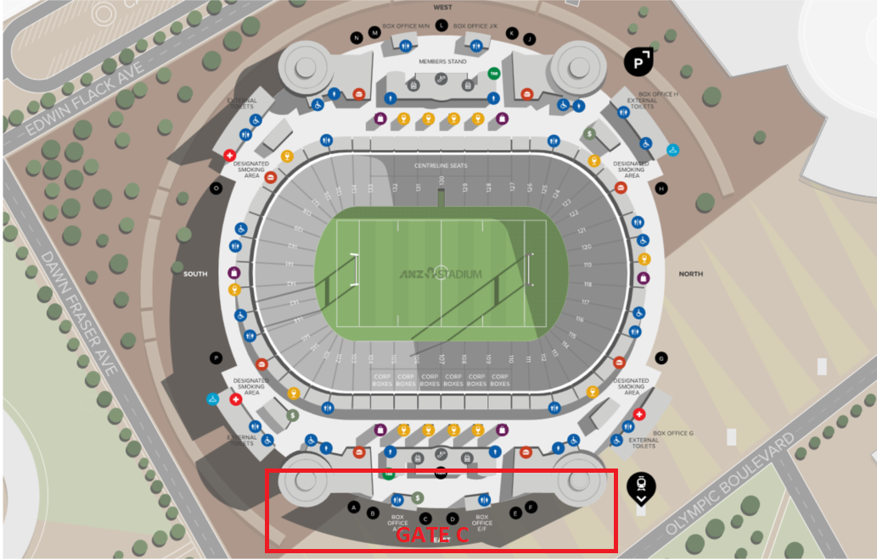
Transport:
It is each school’s responsibility to make all transport arrangements for their travel to and from Sydney Olympic Park. Currently we are attempting to negotiate bus parking allocations within the precinct for schools whose bus will not be returning to base during the day.
We ask that schools with their own buses for students with special needs (or country schools) and/or if you would like to enquire about a parking allocation please contact Sheena Walker (sheena.walker@det.nsw.edu.au) no later than Thursday, 6 September 2018. Please email your response using the attached pro forma.
It is anticipated a shuttle bus will transport students between Sydney Olympic Park and the Armory.

School Uniform:
All students are to be dressed in their correct school uniform or school sports uniform.
Due to the security requirements and limited space in the venues students will not be able to carry bags. Students will be provided with a drawstring bag and cap at the welcome and orientation at ANZ Stadium, starting at 7.30am.
All bags will be searched and screened before entering a sporting venue.

Consent Forms/Permission to Publish:
All schools are responsible for providing the relevant information to parents/caregivers pertaining to the visit. As the Department of Education will be livestreaming the event to a broader audience all schools must distribute and collect a “Permission to Publish” form. A complete list of all students who have not given “Permission to Publish” needs to be forwarded to Sheena Walker (sheena.walker@det.nsw.edu.au) by no later than Thursday, 6 September 2018. Please email your response using the attached pro forma.

Lunches:
Students and staff will be provided with lunch (sandwich and a bottle of water). Where students or staff have specific dietary requirements, please contact Sheena Walker (sheena.walker@det.nsw.edu.au) no later than Thursday, 6 September 2018. Please email your response using the attached pro forma.

Students with Special Needs:
We are currently in negotiation with the Invictus Games Sydney 2018 organisers to ensure that transport around the precinct is available and suitable toileting and feeding areas are available at the venues. Specific information will be advised in a later bulletin. If your students have any other special needs or requirements we should be aware of please contact Sheena Walker (sheena.walker@det.nsw.edu.au) no later than Thursday, 6 September 2018. Please email your response using the attached pro forma.

Additional tickets to events:
The organising committee has received some additional tickets that are available to schools who have already registered for the games. If your school would like additional tickets please complete another ticket application to place an order. It is requested that this information is received by no later than Thursday, 6 September 2018. Please note that we are unable to guarantee additional tickets will necessarily match a school’s current ticket allocation. Contact the organising committee for more information.

  - WHAT DO I NEED TO DO NOW?
Where applicable complete the table below, paste a copy into an email to Sheena Walker (sheena.walker@det.nsw.edu.au) no later than Thursday, 6 September 2018.
Please use the subject title of “Invictus Event school information” on your email.
If you do not return this form it will be taken as a nil return. It will be assumed that students have returned their “Permission to Publish” forms and there are no dietary requirements or special needs.
  - Required information about school and student requirements.
School:
Date of visit:
Contact person:
Where bus parking is requested
Number of bus(es): | Sizes of bus(es) (e.g. 21 seat mini bus):
Estimated arrival time: | Estimated departure time:
The following student(s) do not have “Permission to Publish”
Name (please print):
Insert more rows as required
Dietary Requirements
Type of issue (e.g.no dairy) | Number of students
Insert more rows as required
Special requirements for students (for venue information)
Wheelchair/ mobility requirements | e.g. Ramps and companion seating for 5 wheelchair students
Private feeding space
Toileting – change table / hoist.
Insert more rows as required

  - INVICTUS GAMES SYDNEY 2018 EDUCATIONAL EXCURSION
Monday 22 – Friday 26 October
  - Sample timeline for the day (General)
Final arrangements for each school will be advised in later bulletins
Time | Task | Venue | Information
7.30am-8.00am | School groups arrive  Registration | ANZ Stadium (entry via Gate C) | Invictus Games Sydney 2018 briefing and orientation for the day
8.00am-8.30am | Bags, caps and tickets distributed | ANZ Stadium
8.30am-8.45am | Students assembled for movement to venue(s) | ANZ Stadium | Schools will be advised what events they will be viewing and will be moved to the venues by event officials
8.45am-9.00am | Students escorted to respective venue(s) | ANZ Stadium | Event officials to take schools to venues
9.00am– 10.45am  SAMPLE TIMELINE ONLY | Arrival at venue.  Event officials to hand groups over to venue supervisor | As per schedule | Invictus Games Sydney 2018 events and workshop activities/tours
 | Students escorted between venues |  | Lunches will be distributed between 11.00am and 12.30pm
10.45am– 12.30pm | Arrival at venue.  Event officials to hand groups over to venue supervisor | As per schedule | Invictus Games Sydney 2018 events and workshop activities/tours
 | Students escorted between venues |  | Lunches will be distributed between 11.00am and 12.30pm
12.30pm– 2.00pm | Arrival at venue.  Event officials to hand groups over to venue supervisor | As per schedule | Invictus Games Sydney 2018 events and workshop activities/tours
2.00pm | Finish viewing | As per schedule | Move to buses
After 2.00pm | Return to school

Breaks for toilet visits and lunch vary for different programs. Schools will be advised individually.

  - FURTHER INFORMATION
Please feel free to call the organising committee if any further information or clarification is required.
Sheena Walker Ph: (02) 9244 5194 | Email: sheena.walker@det.nsw.edu.au
Grant Parker Ph: (02) 9707 6957 | Email: grant.parker@det.nsw.edu.au

