Integration
Content/applications/implications and considerations | Teaching strategies | Resources
4.1 Integration  The student is able to:  Use a table of standard integrals  Some of the results listed in the standard integrals table will need to be established as an appropriate method is developed.  Change an integrand into an appropriate form by use of algebra  Some integrals may be changed into a form which can be integrated through use of some simple algebra, eg . $\int{} {(\frac{x+1}{x})}^{2} dx$, $∫\frac{x^{2}}{x^{2}+1}dx$  Evaluate integrals using algebraic substitutions  Only simple substitutions are needed, e..g $u = 1 + x^{2}$, $v^{2} = 1 – x$ in $∫x{(1+x^{2})}^{4}dx$, $\int{}\frac{x}{\sqrt{1-x}}dx$. The effect on limits of integration is required, and definite integrals are to be treated.  Evaluate simple trigonometric integrals  Include squares of all trigonometric functions, as well as those which can be found by a simple substitution, eg $\int_{0}^{\frac{π}{4}}{}\sin^{2} 2x dx$, $\int_{0}^{\frac{π}{4}}{}\sin^{2} x cos x dx$, $\int_{0}^{\frac{π}{4}}{}\sin^{2} x \cos^{3} x dx$  Evaluate integrals using trigonometric substitutions  Typical substitutions would be $x = a tan θ$ and $t = tan\frac{θ}{2}$ in integrals such as  $∫(\frac{dx}{a^{2}+x^{2}})$, $\int{}\frac{sinθ}{2+sin θ }dθ$  Evaluate integrals using integration by parts  The work on integration by parts should include the integrands $\sin^{–1} x$, $e^{ax} cos bx$, $ln x$, $x^{n} ln x$ (n an integer).  Derive and use recurrence relations  Integration by parts should be extended to particular types of recurrence relations, eg $\int{}x^{n}e^{x}dx$, $\int_{0}^{\frac{π}{2}}{}\cos^{n} x dx$.  Recurrence relations such as $\int_{0}^{1}{}x^{m}{(1-x)}^{n}dx$, which involve more than one integer parameter, are excluded.)  Integrate rational functions by completing the square in a quadratic denominator  Examples should include cases to be integrated using a sum or difference of two squares,  Eg $\int{}\frac{dx}{x^{2}-4x-1},$ $\int{}\frac{dx}{3x^{2}+6x+10},$ $\int{}\frac{(3x+2)}{x^{2}-4x+1}dx$  Integrate rational functions whose denominators have simple linear or quadratic factors.  Cases where the degree of the numerator is not less than the degree of the denominator are to be considered.  Only rational functions, whose denominators can be broken into a product of distinct linear factors, or of a distinct quadratic factor and a linear factor, or of two distinct quadratic factors, need to be considered. | - Introduce Integration as a process that is really well done by computers – e.g. Wolfram Alpha – they do this by manipulating expressions and matching to standard results  - Show students other tables of standard integrals to demonstrate the usefulness of these results  - Algebraic manipulation most often involves splitting the numerator  - Start by reviewing Integration by Substitution as covered in Ext 1 Mathematics – focus on the correct setting out - must follow correct mathematical processes particularly with regards putting = signs for expression that are NOT equal ☺ major difference is in Ext 2 the substitutions are not given – may help to review Ext 1 type questions without giving the substitution  - Students should be able to integrate squares of trigonometric functions by inspection  - If Polynomials has not yet been covered the algebraic techniques for breaking into partial fractions must be covered / reviewed.  - Students must be able to identify expressions where breaking into partial fractions – include denominator containing: 1: Distinct Linear Factors; 2:Unfactorisable Quadratic Factors; 3: Repeated Linear Factors; 4: Distinct Quadratic factors  - Review t formulae from Ext 1 – students need to be fluent with these before attempting substitution – also review double angle formulae  - Integration by parts formula should be derived from the product rule  - Include examples with integration by parts needs to occur more than once  - Quadratic expressions 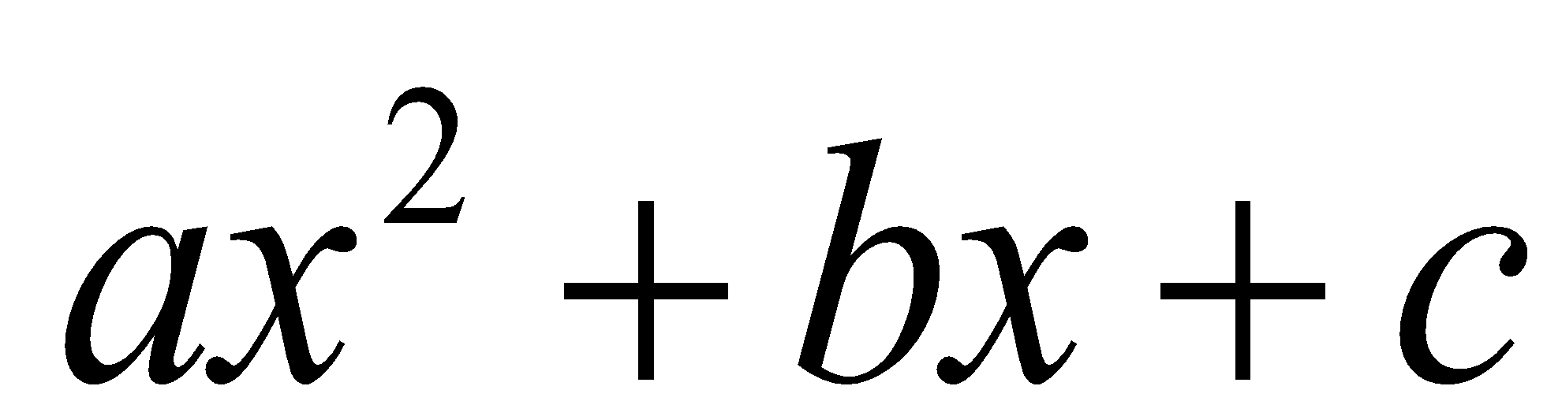 can be expressed as a sum or difference of two squares – which then with an appropriate substitution have an inverse trigonometric function as a primitive | Table of Standard Integrals – HSC  Wolfram Alpha  Using Standard Integrals + Substitution [Keynote | Powerpoint | pdf ]  Ext 2 Integration - Eddie Woo (Youtube Playlist)  Khan Academy Integration by Parts  Coroneous 100 Integrals  Solutions to Coroneous 100 Integrals (YouTube Playlist)  Williams Curriculum Model – Ext 2 Integration  Numerous other YouTube Videos

