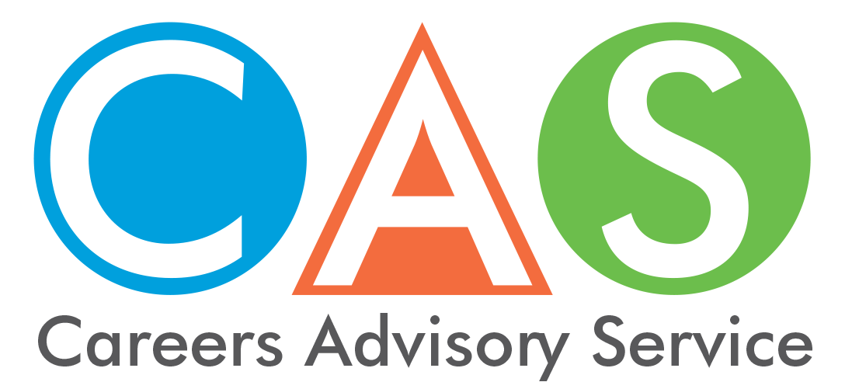

6. Vocational Education and Training (VET)
Vocational Education and Training (VET) can help you gain the skills and qualifications you need to meet the employment demands of the future. VET provides multiple pathways for you to open up career opportunities.

Registered Training Organisations (RTOs)
Registered training organisations (RTOs) are training providers registered by the Australian Skills Quality Authority (ASQA) to deliver nationally recognised vocational education and training (VET) services and qualifications.
You can use the Smart and Skilled website Course Finder to check your eligibility, find the right Smart and Skilled course and approved training provider, and estimate the student fee.

TAFE NSW
TAFE NSW offers a range of courses with a choice of qualifications, industry areas, learning styles and durations. TAFE NSW offers nationally recognised vocational qualifications across all these levels:
- Certificates I–IV
- Diplomas and Advanced Diplomas
- Graduate Certificates and Diplomas
- Associate and Bachelor Degrees
- Short courses
Check out the website for entry requirements and fees.
TAFE NSW Credit Transfer and Recognition of Prior Learning
Your Unique Student Identifier (USI) will transfer to TAFE NSW and you may get recognition for courses already attained.

Smart and Skilled
Smart and Skilled is government subsidised training and provides eligible students with:
- an entitlement to government-subsidised training up to and including certificate III level qualifications, and select traineeships and apprenticeships.
- training in higher-level courses (certificate IV and above) in targeted priority areas.
Check the website to see if you are eligible.

Fee-free pre-apprenticeships and pre-traineeships
If you are thinking about taking an apprenticeship or traineeship but not sure if it is right for you, then enrol in a fee-free pre-apprenticeship or pre-traineeship course and see if it suits.
To be eligible for a pre-apprenticeship or pre-traineeship, you need to:
- be 15 years old or over
- have completed Year 10 (or its equivalent) and be eligible to leave school under NSW Education Amendment (school leaving age) Regulation 2009
- be living or working in NSW
- be an Australian citizen, Australian permanent resident, Australian humanitarian visa holder or New Zealand citizen.

© 2018 NSW Department of Education

