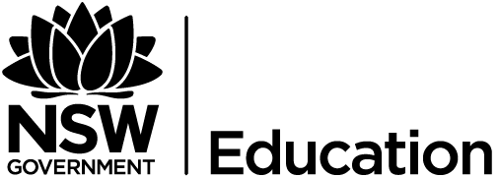
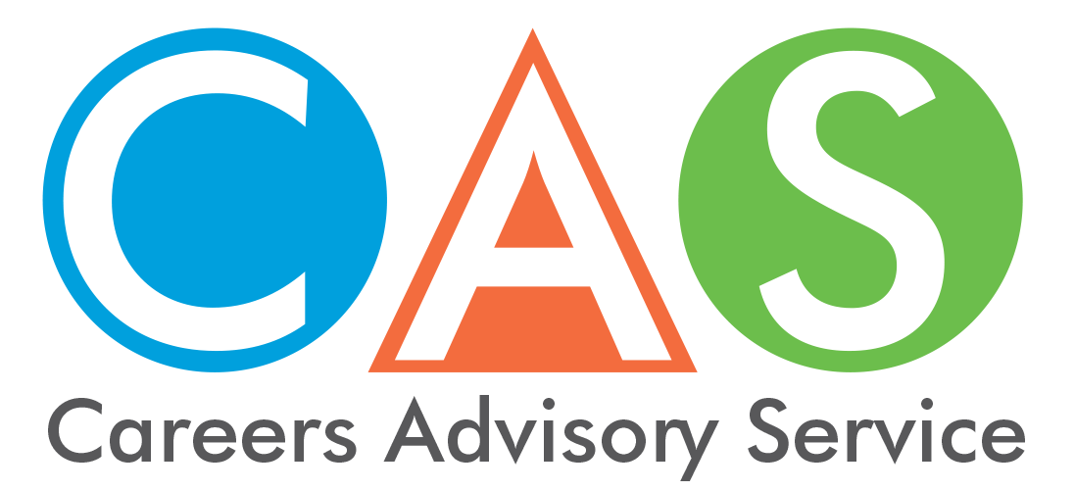

10. Smart and Skilled, Fee-free pre-apprenticeships and scholarships

Smart and Skilled
Through Smart and Skilled you can access government-subsidised training. You pay a portion of the full course fee to your preferred training provider and the government will pay the balance. However, you must meet certain eligibility criteria for this to apply.
Courses are marked as ‘Smart and Skilled’ if they appear on the NSW Skills List. Courses on this list are linked to industries that have been determined as a high priority for the state and will be in demand in the future.
Eligible students may receive:
- an entitlement to government-subsidised training up to and including certificate III level qualifications, and select traineeships and apprenticeships.
- training in higher-level courses (certificate IV and above) in targeted priority areas.
The student eligibility criteria:
- 15 years old or over
- no longer at school
- living or working in NSW
- an Australian citizen, Australian permanent resident, humanitarian visa holder or New Zealand citizen.

Asylum seekers and refugees
If you're an asylum seeker or refugee, you are eligible for Smart and Skilled training from Certificate I to Advanced Diploma level if you meet the criteria listed on the Smart and Skilled website.
If you are eligible you will have access to fee-free training for qualifications up to Certificate IV level on the NSW Skills List

Fee-free pre-apprenticeships & pre-traineeships
If you are thinking about taking an apprenticeship or traineeship but unsure if it is right for you, then enrol in a fee-free pre-apprenticeship or pre-traineeship course and see if it suits.
To be eligible for a pre-apprenticeship or pre-traineeship, you need to:
- be 15 years old or over
- have completed Year 10 (or its equivalent) and be eligible to leave school under NSW Education Amendment (school leaving age) Regulation 2009
- be living or working in NSW
- be an Australian citizen, Australian permanent resident, Australian humanitarian visa holder or New Zealand citizen.

Jobs for Tomorrow Scholarships
People with skills in science, technology, engineering or mathematics (STEM) are in high demand. If you are interested in training in these skills, you may be eligible for a $1,000 Jobs of Tomorrow scholarship under the NSW Government's Smart and Skilled Program. You can apply for a Jobs of Tomorrow Scholarship worth $1,000.

© 2018 NSW Department of Education

