# Creating timelines

Timelines are visual representations of the passing of time and offer opportunities for students to develop the vocabulary of time and chronological order. Using images and events placed in sequence in a timeline can provide a scaffold for students to retell a personal or family narrative about the past.

## Creating timelines online with Teach-nology

On the Teach-nology website you can generate a [horizontal timeline](http://www.teach-nology.com/web_tools/materials/timeline/) with six dates and events.

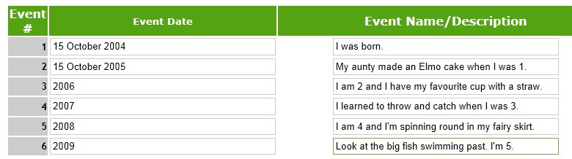

Edit and generate the timeline:

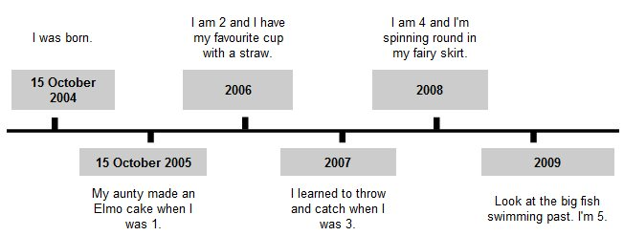

You could save each student’s timeline as 'htm' and open it in a web browser such as Internet Explorer or Firefox. You could take a screenshot with tools such as SnagIt or WinSnap for PC and SnapNDrag or Capture Me for Mac. Save the image to enlarge and print A3 size, or display on an interactive whiteboard.

Drag and drop digital photos into the spaces above and below the timeline on an IWB or use PowerPoint. Insert the timeline then students could insert digital photos above and below the timeline.

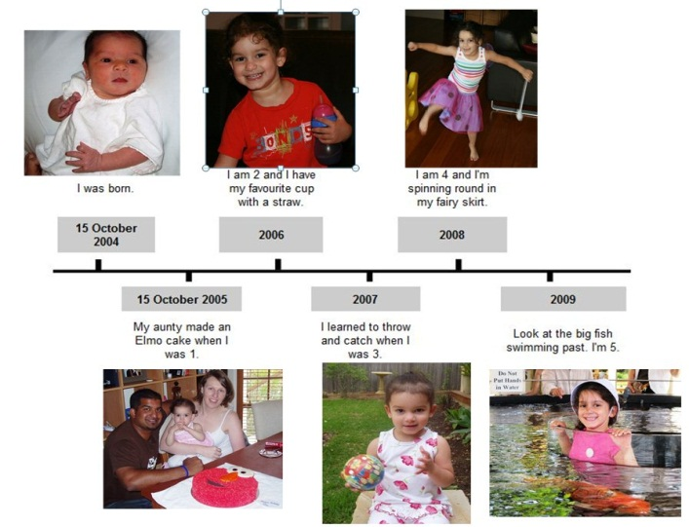

In Teach-nology you can also generate a [vertical timeline](http://www.teach-nology.com/web_tools/materials/bigtimeline/) with up to eight events.

The [Work sample portfolio](http://www.acara.edu.au/curriculum/worksamples/AC_Worksample_History_1.pdf) Sample 1 for Year 1 shows a student timeline.

## Creating timelines online with Timetoast

[Timetoast](http://www.timetoast.com) is an online tool you could use to construct an interactive timeline.

This [Vimeo tutorial](http://vimeo.com/8459331) or [TeacherTube](http://teachertube.com/viewVideo.php?video_id=264965&title=Timetoast) video will help you get started. You can register and make personal timelines to edit and view. You can share them with others if you provide your login details. However, if you ‘publish’ the timelines they become public on the internet. Look at a screen capture of a completed timeline. As you rollover the black dots (event markers) on your timeline the bubbles appear in groups of three.

**How I’ve changed**

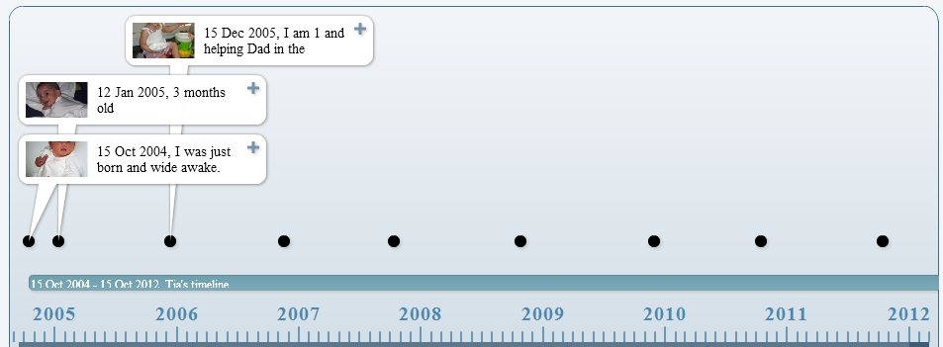

Click on a bubble to view that event full screen:

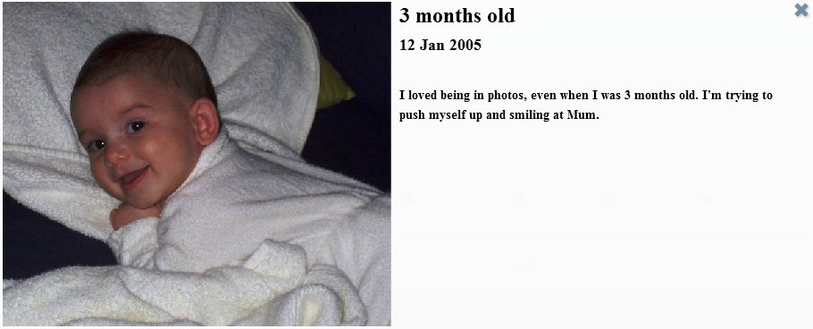

The description font, though quite small for Year 1, can be used with teacher prompts and guidance, and can be enlarged when viewed on an IWB.

Other timelines you could try are:

* the four seasons, beginning with the current season
* a class timeline with events for a month, a term or a year
* a [text-only vertical timeline](http://teacher.scholastic.com/lessonplans/graphicorg/pdfs/timeline.pdf) where you type in text on the PDF, then enlarge and print on A3 paper and add photographs.

**A screenshot of the Text view in Timetoast**

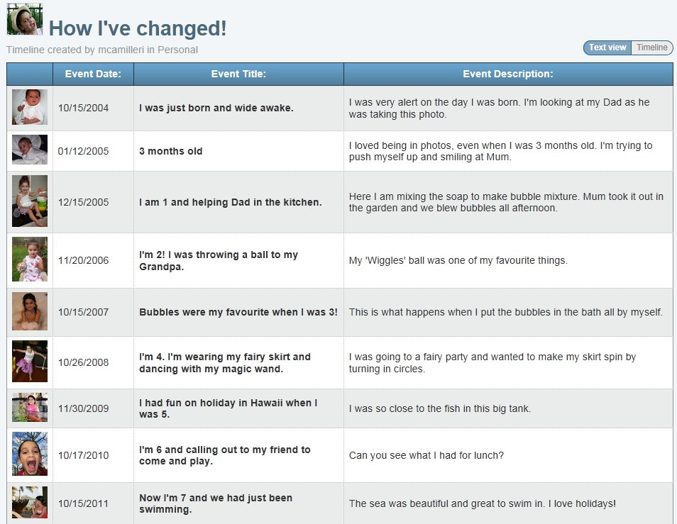

## Creating a calendar online

Use a Microsoft PowerPoint template to construct a class calendar or students could make one for their family.

Go to File, New and select Calendars in Available Templates and Themes. Options include Family and Academic calendar templates which include a schoolhouse design.

Another option is the [Localendar](http://www.localendar.com/elsie) website. You will have to register and sign in but it is free.

[History: Time and chronology](http://ppds.ie/index.php?option=com_content&task=view&id=303&Itemid=469)