# Oral history questions

## Toys and games

Remember to:

* make your guest comfortable
* give the questions to your guest and allow time for your guest to think about the answers
* speak clearly and keep eye contact with your guest
* be a good listener
* thank your guest for their time.

1. What toys do you remember having as a child?
2. Tell me about a favourite toy you had when you were my age. Why was it your favourite toy?
3. Today a lot of toys are made from plastic. What types of materials were toys made from in your day?
4. What games did you play?
5. 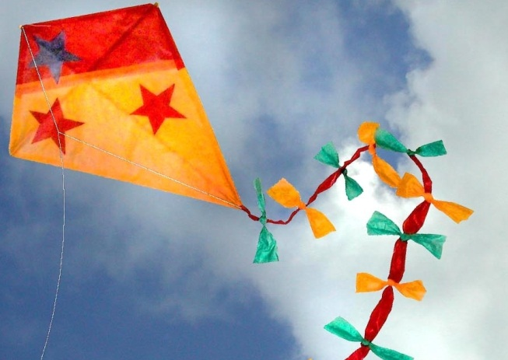People like to keep old objects from the past. What game or toy from the past would you still like to have today? Why?
6. How have toys changed since you were my age?
7. What do you think is the biggest difference between where we play today compared with where you played in your childhood?
8. What do you think is the biggest difference between what we play with today and what you played with in your childhood?
9. What do you think children miss out on today that you had?
10. Do you think the toys you played with when you were my age were better than the toys today? Why?