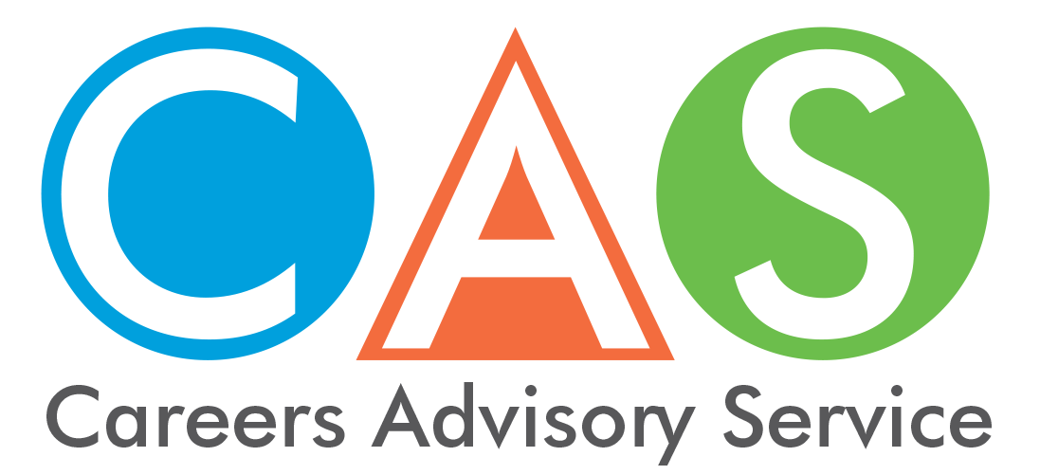

14. Youth assistance
All young Australians deserve a safe, stable home. Young people require employment and further education guidance to assist them with the best possible start for a fulfilling career.
For links to help with health issues, safety issues, legal rights visit the NSW Family and Community Services website.

Homeless Youth
- Youth off the Street Phone: 1800 062 288
- YFoundation Phone: (02) 8306 7900
- Salvation Army Phone: 13 72 58
- Barnardos Australia Phone: 1800 066 757
- Youth Solutions Phone: (02) 4628 2319

Youth Wellbeing
If you need to talk to someone
- Lifeline - 13 11 14
- beyondblue - 1300 22 4636
- Kids Helpline - 1800 55 1800
- headspace - 1800 650 890
- Blackdog - (02) 9382 2991
- MensLine - 1300 78 99 78
- SISTER2sister - (02) 9211 9129
- Suicide Call Back Service - 1300 659 467

Australian Government Department of Employment - Support for Youth
The Australian Government through the Department of Employment is delivering a range of initiatives to give young job seekers the employability skills and real work experience they need to get a job. The initiatives include:
- Youth Jobs PaTH which is a flexible program designed to prepare young people for work. It also encourages employers to trial a young person for a job by offering interns and financial incentives to reduce the cost of recruitment. Youth Jobs PaTH has three elements: Prepare - Trial - Hire.
- The Encouraging Entrepreneurship and Self-Employment initiative to support young Australians who wish to start their own business.
- The Youth Transition to Work Program assists young people to get intensive pre-employment support to help them set and achieve their employment and education goals.
- Empowering YOUth Initiatives support new, innovative approaches to help long-term unemployed young people aged 15 to 24 years to improve their skills and move toward sustainable employment.
- Engaging Early School Leavers has been designed to strengthen the chances of early school leavers finding and keeping a job.
- ParentsNext helps eligible parents to plan and prepare for employment by the time their children are at school.
- Job Jumpstart has tips and ideas about jobs and careers in the one spot.

Income support for students and trainees
The Australian Government provides financial support to assist with costs while you finish school, undertake tertiary education, or undertake an Australian Apprenticeship or traineeship.
- ABSTUDY provides help with costs for Aboriginal and Torres Strait Islander Australians who are studying or undertaking an Australian Apprenticeship.
- ABSTUDY Fares Allowance helps cover the cost of travel between your permanent home and place of study if you need to live away from home to study and receive ABSTUDY.
- Assistance for Isolated Children Scheme helps parents and carers who mainly live in rural and remote areas with the extra costs of educating their children.
- Austudy provides financial help to full time students and Australian Apprentices 25 years or older.
- Education Entry Payment helps students or trainees who get specific income support payments to assist with the cost of study.
- Fares Allowance helps with travel costs between your permanent home and your place of tertiary study in Australia.
- Jobs, Education and Training Child Care Fee Assistance provides extra help with the cost of approved child care for eligible parents who are looking for work, studying, training or undertaking rehabilitation to enter or re-enter the workforce.
- ParentsNext connects you to local support services to help you plan for your future. It’s important to think about your study and work goals for when your children are at school.
- Pensioner Education Supplement helps with the cost of study in an approved course if you get certain payments.
- Relocation Scholarship is a yearly payment to help students move to or from a regional or remote area to study. You must get ABSTUDY or Youth Allowance and be in full time higher education.
- Rent Assistance gives extra financial help to people who pay rent and receive an income support payment.
- Student Start-up Loan
Available for eligible new recipients of Youth Allowance, Austudy or ABSTUDY studying a Student Start-up Loan approved course.
The loans are paid in two half-yearly instalments.
Repayment arrangements are the same as for HELP.
- Youth Allowance provides financial help for people 16 to 24 years of age who are studying full time, undertaking a full time Australian Apprenticeship, training, looking for work or sick.
- Youth Disability Supplement provides additional financial support to young people with a physical, intellectual or psychiatric disability who receive certain income support payments.
- Australian Apprenticeships information about resources and the support available.
- Concession and health care cards can get you cheaper health services and medicines.
- Managing your money is information about budgeting, borrowing and credit, and managing debt, to help manage your money.
- Young people becoming independent provides information, payments and services if you are between 15 and 24 years of age and becoming independent.
- Leaving school is information to help you choose your next adventure if you’re about to or have just finished school.

© 2018 NSW Department of Education

