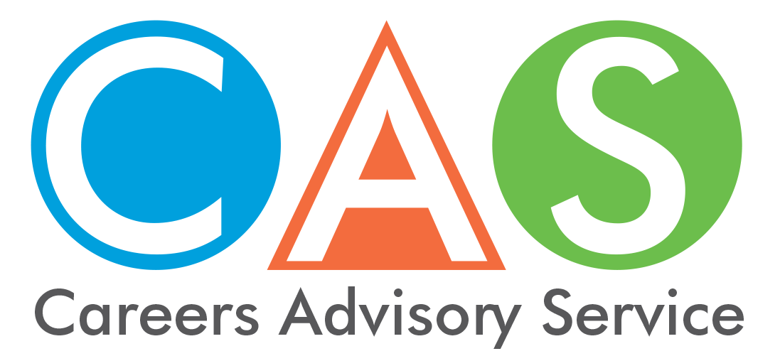

12. Students and job seekers with disability

Tertiary Disability Advisers
Students with disability, including mental health issues, medical conditions and learning disabilities are advised to contact disability advisers at the institute of your choice to discuss your condition and any special needs. Even if you are unsure, it is a good idea to make contact and learn how the system works in case you do need help or adjustments.
Disability Officers are available at each of the Universities in NSW for you to discuss your education needs.
For tips, hints and links to help high school students with disability thinking about going to university see the Get Ready for Uni guide.
P: (02) 9678 7371
E: ndco@westernsydney.edu.au
University Admissions Centre (UAC) staff can also provide help with the application process.
Phone 1300 275 822
from mobile or overseas (02) 9752 0200
TAFE NSW also has information on how to access support for students with disability.

Australian Disabilities Clearinghouse on Education and Training (ADCET)
The student resources section of the ADCET website has a range of resources to assist university students to become independent learners and job seekers. Areas covered include:
- planning for post-secondary education
- understanding university entry pathways
- knowing your rights
- linking with appropriate supports
- managing your studies
- planning for graduate employment.

Disability Employment Services
JobAccess is a free Australian Government information and advice service for people with disability to access information on topics such as financial assistance, help with finding and changing jobs, creating flexible work environments, career advice and training courses.
Phone a JobAccess Adviser on 1800 464 800 or visit the website.
The Australian Government delivers employment assistance for job seekers with disability, injury or health condition through Disability Employment Services. These services are able to provide assistance to prepare for, find and keep a job. They are divided into two parts:
- Disability Management Service – for job seekers with disability, injury or health condition who need assistance to find a job and occasional support to keep a job.
- Employment Support Services – provides assistance to people with permanent disability and who need regular, ongoing support to keep a job.
National Disability Coordination Officer Program
The Australian Government’s National Disability Coordination Officer (NDCO) program works strategically to assist people with disability access and participate in tertiary education and subsequent employment, through a national network of regionally based NDCOs. The NDCOs work with stakeholders at the local level to reduce systemic barriers, facilitate smooth transitions, build links and coordinate services between the education, training and employment sectors.

The National Disability Insurance Scheme (NDIS)
The NDIS supports people with a permanent and significant disability that affects their ability to take part in everyday activities. If you are not already a participant of the NDIS and you have a disability, you may wish to find out if you are eligible. Check your eligibility with the NDIS online access checklist or contact the National Disability Insurance Agency on 1800 800 110.

Registering with an Employment Services Provider
Centrelink can refer you to an Employment Services Provider in your area. They can help you access:
- job search help and training
- job availability in your area
- resources such as computers, telephones and stationery
For advice phone Centrelink 13 28 50 or visit the Human Services website - Disability Employment Services
© 2018 NSW Department of Education

