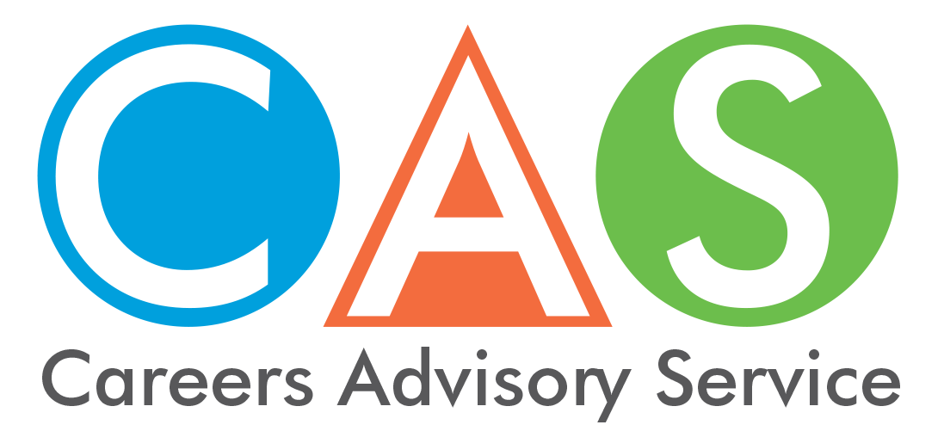

1. Leaving school before the HSC
Students must complete Year 10 (or its equivalent), then remain in approved education or training or a combination of education or training and paid work until the age of 17. See NSW Department of Education information on attendance.

NSW Record of School Achievement (RoSA)
If you leave school before completing your Higher School Certificate (HSC) you may be eligible for the Record of School Achievement (RoSA). Once your school has informed the NSW Education Standards Authority (NESA) that you are eligible for a RoSA, you will be able to download it as a free PDF from Results Services on NSW Students Online in My Details. For more information go to the NESA website.

Literacy and numeracy test results
You can also choose to sit voluntary literacy and numeracy tests. Your literacy and numeracy test and diagnostic report will be delivered to My Messages in your NSW Students Online account shortly after completing your test.

Links to Learning
Support for students at risk of disengaging from learning and/or at risk of leaving school early (Links to Learning). The department funds NSW based not for profit, non-government organisations and community based organisation to deliver targeted projects to students at risk (Year 6- Year 11) of disengaging from learning and/or at risk of leaving school early.
Not all schools in NSW are involved in Links to Learning, and the target group for projects also varies, for example some schools may be involved in a project targeting Year 7 and 8 students, other schools may be involved in a project targeting Year 9 and 10 students.
The learning support team is the referral point for students seeking involvement in a project. The list of schools currently involved in links to learning projects is available at the Links to Learning website.

Distance education
Distance education is an equity program for NSW students who are geographically isolated or whose individual circumstances prevent them from regularly attending school.

Complete your studies in Vocational Education and Training
Registered training organisations (RTOs) are training providers registered by the Australian Skills Quality Authority (ASQA) to deliver nationally recognised vocational education and training (VET) services and qualifications.
The NSW Department of Industry has a find a course function and lists which RTO delivers it. See also TAFE NSW.

Fee-free pre-apprenticeships and pre-traineeships
If you are thinking about taking an apprenticeship or traineeship but not sure if it is right for you, then enrol in a fee-free pre-apprenticeship or pre-traineeship course.

Smart and Skilled
Smart and Skilled provides eligible students with:
- an entitlement to government-subsidised training up to and including certificate III level qualifications, and select traineeships and apprenticeships
- training in higher-level courses (certificate IV and above) in targeted priority areas.
For more information phone 1300 772 104 or visit the websites.
Training NSW
Smart and Skilled NSW

Australian Government Department of Employment - Support for Youth
The Australian Government through the Department of Employment is delivering a range of initiatives to give young job seekers the employability skills and real work experience they need to get a job. The initiatives include:
- Youth Jobs PaTH which is a flexible program designed to prepare young people for work. It also encourages employers to trial a young person for a job by offering interns and financial incentives to reduce the cost of recruitment. Youth Jobs PaTH has three elements: Prepare - Trial - Hire.
- The Encouraging Entrepreneurship and Self-Employment initiative to support young Australians who wish to start their own business.
- The Youth Transition to Work Program assists young people to get intensive pre-employment support to help them set and achieve their employment and education goals.
- Empowering YOUth Initiatives support new, innovative approaches to help long-term unemployed young people aged 15 to 24 years to improve their skills and move toward sustainable employment.
- Engaging Early School Leavers has been designed to strengthen the chances of early school leavers finding and keeping a job.
- ParentsNext helps eligible parents to plan and prepare for employment by the time their children are at school.
- Job Jumpstart has tips and ideas about jobs and careers. Also get tips on workplace rights and responsibilities and safety, networking and personal presentation.

Income support for students and trainees
- ABSTUDY helps with costs for Aboriginal or Torres Strait Islander Australians who are studying or undertaking an Australian Apprenticeship.
- Education Entry Payment helps people on income support to study.
- Fares Allowance helps with travel costs between your permanent home and your place of tertiary study in Australia.
- Low Income Health Care Card gives you cheaper health care and some concessions if you’re on a low income.
- Child Care Fee assistance helps with the cost of approved child care for eligible parents doing an approved activity.
For more income support options see the CAS home page - Get the facts - fact sheet 14 - Youth Assistance and for all the latest information and rates see the Centrelink website.

Youth assistance
For links to help with health issues, safety issues, legal rights visit youth.nsw.gov.au

Homeless Youth
- Youth off the streets phone: 1800 062 288
- Yfoundations phone: (02) 8306 7900
- Salvation Army phone: 13 72 58
- Youth Solutions phone: (02) 4628 2319

© 2018 NSW Department of Education

