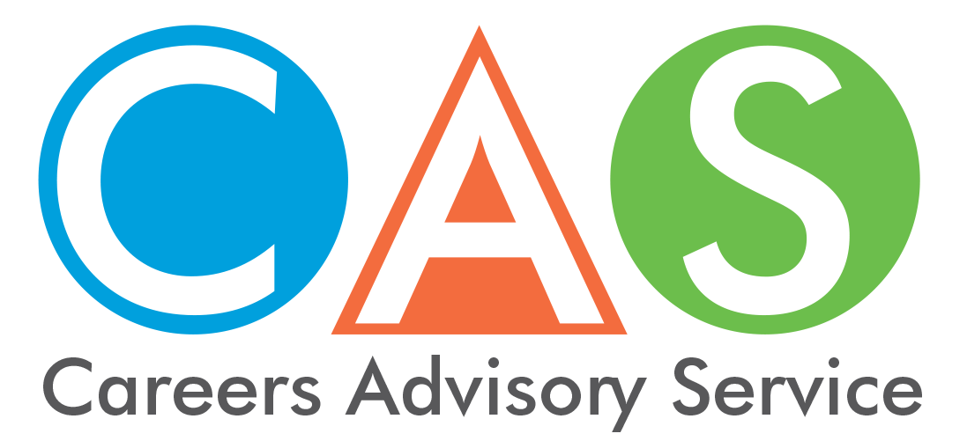

8. Alternative university entry schemes
Alternative Entry information from the Universities Admission Centre (UAC) website for each institution may assist school leavers who are seeking entry but do not meet the usual criteria.
Note: Information for international students, students without the HSC and mature age students is not included here. Check UAC and separate university information for details.

Disadvantaged students
The Educational Access Scheme (EAS) for students who have experienced long-term educational disadvantage is detailed on the UAC website as well as in information that has been sent to schools.
Participating institutions (except University of Technology Sydney, which allocates places for eligible applicants) use EAS assessments to apply equity adjustments that increase an applicant's selection rank.
Equity adjustments do not change your ATAR, instead they change your selection rank for a particular course. The application of equity adjustments does not guarantee you entry to a course, as you still need to meet the published lowest selection rank.
Some universities consider late applications to the scheme up to early January. Contact individual universities for late closing dates.

Aboriginal students, elite athletes and performers
Each university has a special entry scheme for indigenous students. Many have schemes for elite athletes and performers. Check UAC and separate university information for details. Indigenous Centres at Australian Universities are detailed on the CAS home page - Get the facts - fact sheet 13 - Aboriginal Youth.

Schools Recommendation Schemes (SRS)
Schools Recommendation Schemes (SRS) are one way institutions make early offers to current Australian Year 12 students who have applied for undergraduate admission through UAC.
SRS offers are made before ATARs are released. Students may receive one or more conditional offers and then decide which offer to convert to unconditional.
SRS aim to assist access to higher education for current Australian Year 12 students using a wide range of selection criteria, including school recommendations, Year 11 Studies, your Educational Access Schemes (EAS) application, (If applicable) and intuition specific documents (if applicable).
Institutions have their own policies on determining SRS eligibility and making offers. These approaches may include:
- making offers based solely on SRS criteria
- making offers based on both SRS criteria and ATAR/selection rank
- making offers based on SRS criteria and ATAR and equity criteria
There are two types of offers available under SRS. Successful applicants may receive:
- a conditional offer (where there are additional criteria you must meet, such as a minimum ATAR, course prerequisites, submitting a personal statement or portfolio, attending an audition or interview, or completing a test.)
Conditional SRS offers dates can be found on UAC Schools Recommendation Schemes and can be made to any of your university preference.
To convert your conditional offer to an unconditional offer, you must: meet the criteria stipulated in the offer and meet all other institution requirements. You should place the course that you would most like to convert into an unconditional offer at the top of your list of preferences.
- an unconditional SRS offer is where there are no further requirements for you to meet.
- Unconditional SRS offers release dates can be found at UAC Schools Recommendation Schemes website.

Early Offer Schemes
Some universities have early offer schemes for Year 12 students. Through these schemes, Year 12 applicants may be offered courses independently of their final Year 12 results and on the basis of a range of criteria, including recommendations provided by schools.
The Schools Recommendation Schemes is an early offer scheme that you apply for through UAC. All other early offer schemes must be applied for directly through each institution.
For more information, check UAC - Undergraduate Fact Sheet - Early Offer Schemes
© 2019 NSW Department of Education

