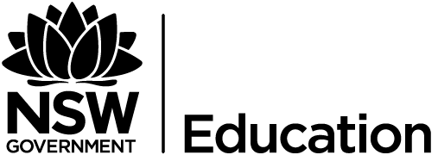
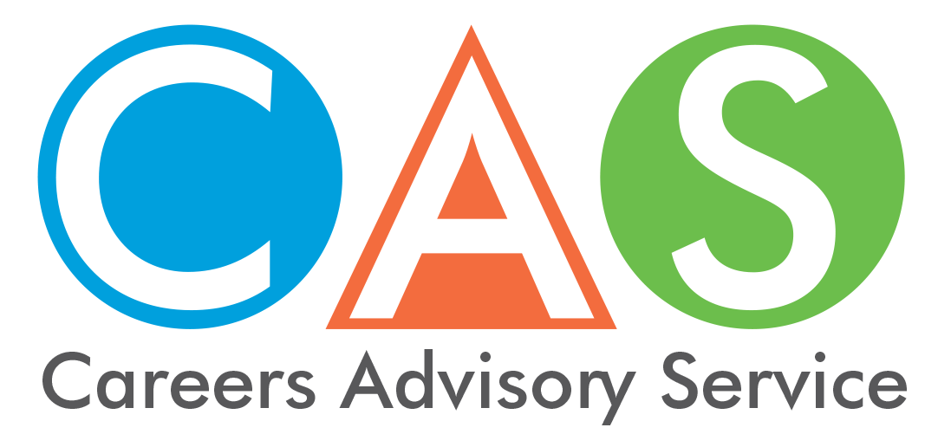

13. Aboriginal Youth

Smart and Skilled
Eligible Aboriginal students are entitled to fee-free government subsidised training in priority skill areas, up to and including certificate III, with approved training providers. Subsidised training is also available for higher qualification levels. Visit the Smart and Skilled website for details.

Scholarship, work and study opportunities
Indigenous Scholarship Portal. Here you will find a list of scholarships available for Aboriginal and/ or Torres Strait Islander students currently studying at, universities, TAFEs or registered training organisations (RTO’s).
The Aurora Education Foundation supports high achieving Aboriginal and Torres Strait Islander students to attain academic excellence at some of the most prestigious universities in the world.
The Charlie Perkins Scholarship Trust for students to study at the University of Oxford or the University of Cambridge.
IYLP – Indigenous Youth Leadership Program supports Aboriginal and Torres Strait Islander students living in remote or very remote areas of Australia to attend a high performing secondary school (government and non-government, day and boarding) and/or university to complete Year 12 and/or an undergraduate degree.
GO Foundation Metropolitan Sydney region. Scholarships include financial assistance of $2,500 per year for educational needs for Years 11 and 12, and access to the GO Ecosystem where students receive access to mentoring, homework support, internships, work experience and other opportunities.

Indigenous Youth Mobility Program (IYMP)
IYMP offers young Indigenous people from rural and remote communities the opportunity to move to a host location and participate in further education, training or Australian apprenticeships. IYMP addresses the barriers to training, employment and education and provides holistic support to young Indigenous people whilst engaged in the project.

The National Aboriginal Sporting Chance Academy (NASCA)
NASCA utilises the power of structured sporting and culture programs to harness the educational, employment and health aspirations of Aboriginal and Torres Strait Islander young people.

Aboriginal Employment Strategy (AES)
Matching the right career seekers to the right opportunities, AES supports a broad range of activities that are responsive to the needs of employers, Indigenous Australians and their communities.

Rural and Regional Enterprise Scholarships
These Rural and Regional Enterprise Scholarships will support regional and remote students to undertake STEM (Science, Technology, Engineering and Mathematics) studies. The scholarships will be for vocational education, undergraduate and postgraduate students (certificate IV to PhD).

Educational Access Schemes (EAS)
Australian Aboriginal young people may apply for special consideration under the specific schemes at each university, and/or under the Educational Access Scheme (EAS) scheme. Check your preferred university website for their scheme.

Supporting Aboriginal students at TAFE and University
TAFE NSW, Registered Training Organisations (RTO) and universities have programs and policies to facilitate access by Aboriginal students and to cater for their needs once they have enrolled.
Other useful websites:

Australian government policies and programs www.indigenous.gov.au
Indigenous Centres at Australian Universities (Copyright 2012)
Information supplied by the NSW Department of Education, Aboriginal Education and Communities Directorate in 2017.
Aboriginal centres in NSW Universities
Indigenous Teaching at Australian Universities.
University of Notre Dame
Nulunga Research Institute
University of Southern Queensland
College of Indigenous Studies, Education and Research
University of Newcastle
The Wollotuka Institute
Southern Cross University
Gnibi College of Indigenous Australian Peoples
Central Queensland University
Indigenous Engagement
Australian Catholic University
First Peoples and Equity Pathways Directorate
Australian National University
Tjabal Indigenous Higher Education Centre
Batchelor Institute Batchelor Institute of Indigenous Tertiary Education
Bond University
Nyombil Indigenous Support Centre
Charles Darwin University
Australian Centre for Indigenous Knowledges and Education
Charles Sturt University
Centre for Indigenous Studies
Curtin University of Technology
Centre for Aboriginal Studies
Deakin University
Institute of Koorie Education
Edith Cowan University
Kurongkurl Katitjin Centre for Indigenous Australian Education and Research
Federation University
Aboriginal Education Centre
Flinders University
Yunggorendi First Nations Centre for Higher Education and Research
Griffith University
Gumurrii Student Support Unit
James Cook University
School of Indigenous Australian Studies
La Trobe University
Office of Indigenous Strategy and Education
Macquarie University
Warawara, Department of Indigenous Studies
Monash University
Monash Indigenous Studies Centre
Murdoch University
Kulbardi Aboriginal Centre
Queensland University of Technology
Oodgeroo Unit
RMIT University
Ngarara Willim Centre
The University of Adelaide
Wirltu Yarla Aboriginal Education
University of Canberra
Ngunnawal Indigenous Higher Education Centre
University of Melbourne
Murrup Barak- Melbourne Institute for Indigenous Development
University of New England
Oorala Aboriginal Centre
University of New South Wales
Nura Gili
University of Queensland
Aboriginal and Torres Strait Islander Studies Unit
University of South Australia
Aboriginal Pathway Program (APP)
University of Sydney
Buduwa
University of Tasmania
Riawunna
University of Technology Sydney
Jumbunna Indigenous House of Learning
The University of Western Australia
School of Indigenous Studies
Western Sydney University
Badanami Centre for Indigenous Education
University of Wollongong
Woolyungah Indigenous Centre
Victoria University
Moondani Balluk Academic Unit

© 2018 NSW Department of Education

