FM5 – Annuities and loan repayments

Outcomes

MG2H-1 uses mathematics and statistics to evaluate and construct arguments in a range of familiar and unfamiliar contexts
MG2H-3 makes predictions about situations based on mathematical models, including those involving cubic, hyperbolic or exponential functions
MG2H-6 makes informed decisions about financial situations, including annuities and loan repayments
MG2H-9 chooses and uses appropriate technology to locate and organise information from a range of contexts
MG2H-10 uses mathematical argument and reasoning to evaluate conclusions drawn from other sources, communicating a position clearly to others, and justifies a response
New South Wales Board of Studies (2012), Mathematics General Stage 6 Syllabus, pp13-14.
Content | Teaching strategies and activities | Resources
Recognise that an annuity is a financial plan involving periodical, equal contributions to an account, with interest compounding at the conclusion of each period | Students conduct a research activity to investigate the word annuity and its relationship to financial planning and investment. Teacher sets parameters for the research such as each student must use 3 to 5 different websites (preferably Australian and reputable investment institutions e.g. Commonwealth Bank etc.) and write down keywords or ideas they find from their research. Students then combine their keywords and ideas to create a wordle (see Resource 1) or other tool.  Teacher provides a formal mathematical definition of an annuity in the form of a closed passage (see Resource 2), students use the results from their research to complete the closed passage and work through an example investment. | http://www.wordle.net/  Word Doc – What is an annuity?
Recognise that the values in a table of future value interest factors can be obtained using the formula for the future value of an annuity  Calculate (i) the future value of an annuity (FVA) and (ii) the contribution per period, using a table of future value interest factors for calculating a single future value of an annuity stream | Revisit the terms future value and contributions as discussed in FM4 to ensure students are familiar with the concepts and understand what they are calculating.  Introduce a table of future value interest factors created using a spreadsheet to demonstrate how the future value formula has been used to find the interest factors in the table. Change the basic values e.g. contribution amount, interest rate etc. to show students how these affect the interest factors (see Resource 1).  Provide examples of how to calculate the future value and contribution amount using the interest factors from a table.  For example, using the table, the future value of an annuity of $1200 per year for three years at 5% pa is 3.1525 × $1200 = $3783.  Students solve a variety of problems involving future value of an annuity (see Resource 1, Resource 2 and Resource 3). | Spreadsheet – Annuity Tables of Interest Factors  Commercial textbooks, worksheets and study guides  Past HSC papers
Recognise that the values in a table of present value interest factors can be obtained using the formula for the present value of an annuity  Calculate (i) the present value of an annuity (PVA) and (ii) the contribution per period, using a table of present value interest factors for calculating a single present value of an annuity stream  Use a table of interest factors for the present value of an annuity to calculate loan instalments, and hence the total amount paid over the term of a loan  Calculate the monthly repayment for a home loan from a table, given the principal, rate and term | Revisit the terms present value and contributions as discussed in FM4 to ensure students are familiar with the concepts and understand what they are calculating. Ensure students understand that the contributions towards and annuity investment are the same as a loan repayments for a reducible loan where the present value is the amount borrowed.  Introduce a table of present value interest factors created using a spreadsheet to demonstrate how the present value formula has been used to find the interest factors in the table. Change the basic values e.g. contribution amount, interest rate etc. to show students how these affect the interest factors (see Resource 1)  Provide examples of how to calculate the present value and contribution amount (loan repayments) using the interest factors from a table e.g. to determine the monthly repayment in the case of a reducing-balance car loan.  For example, the monthly repayment a for a car loan of $8000 at 9% pa for four years is calculated as follows:  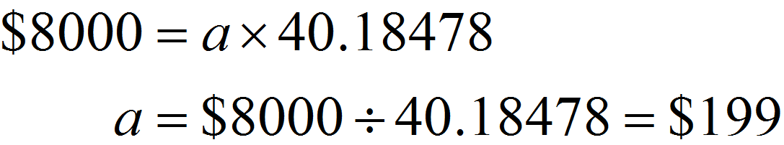to the nearest dollar. | Spreadsheet – Annuity tables of interest factors  Commercial textbooks, worksheets and study guides  Past HSC papers
Investigate the various processes for repayment of loans  Calculate the fees and charges that apply to different options for borrowing money in order to make a purchase | Students conduct an investigation of the processes, fees and charges associated with repayment of loans using real world financial institutions. Teacher sets the parameters of the investigation to ensure students find out about the following:  - Loan accounts  - Loan insurance  - Income protection  - Application fees  - Establishment fees  - Account service fees  - Valuation fees  - Legal fees  Discuss the findings of the investigation and establish a list of definitions for the various processes, fees and charges (see Resource 1)  Provide examples of how to calculate the fees and charges associated with a loan. Students solve a variety of problems involving the addition of fees and charges to a loan and the affect these have on the overall amount paid (see Resource 2 and Resource 3). | Websites for financial institutions in Australia such as:  - http://learn.nab.com.au  - http://www.anz.com.au  - http://www.citibank.com.au  - https://www.commbank.com.au  Commercial textbooks, worksheets and study guides  Past HSC papers
Interpret graphs that compare two or more repayment options for home loans. | Use a loan repayments calculator or table to graph an equivalent reducible loan with varying repayment options (see Resource 1). Ask students questions to check understanding and develop knowledge of repayments and the affect they can have on the repayment period of a loan. E.g. How much faster can a loan be paid off if you pay an extra $100 a month?  Students solve problems requiring the interpretation of repayment comparison graphs (see Resource 2 and 3). | Spreadsheet - Loans  Commercial textbooks, worksheets and study guides  Past HSC papers

