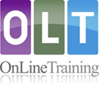

Blended online learning courses for teachers and schools
Visit the homepage at www.oltaustralia.net to view introductory information and watch video clips about the courses and their use in Department of Education schools. Courses are accessed by joining a cohort led by a trained tutor in your local area.
Courses available through the Department  - Understanding Personalised Learning and Support  - Understanding Autism Spectrum Disorder  - Understanding and Supporting Behaviour  - Understanding Motor Co-ordination Difficulties  - Inclusion for Learners with Speech, Language and  Communication Needs  - Understanding Dyslexia and Significant Reading Difficulties  - Understanding Hearing Loss  Each course has four sections  - Understanding or Introduction  - Assessment for learning  - Interventions or Planning and Programming  - Case studies or Classroom Practice | 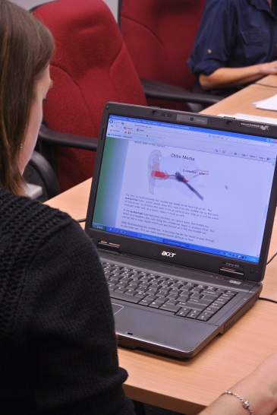

Multimedia content
A web-based format with content presented in dynamic ways that accommodate adult learning, including interactive elements to support and encourage the learning process.
* Animations *Self assessment exercises * Online quizzes * Video clips * Online forums
* Printable practical resources * Links to related websites *Further readings/research
The courses include Australian case studies and other video content featuring students, families and education personnel in a range of school settings.

Course delivery
Blended Online Learning provides a flexible approach to course delivery. Participants study the course online at their own pace and attend 3 or more tutor led sessions, depending on the course, supported by a trained tutor. Professional knowledge and experience is shared between participants and their tutor.

To find available courses
School based cohorts can be negotiated or participants can join open cohorts.
Courses can be found by searching MyPL@Edu using the phrase ‘Online Training Australia’, by browsing recent Schoolbiz editions or by contacting local educational services teams.

Accreditation
The courses carry a Certificate of Online Completion and are registered with the Board of Studies, Teaching and Educational Standards (BOSTES) against the Australian Professional Standards for Teachers.
For information about online learning courses go to www.oltaustralia.net/OLT home page
or email Disabilitylearning@det.nsw.edu.au

