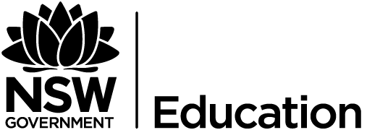
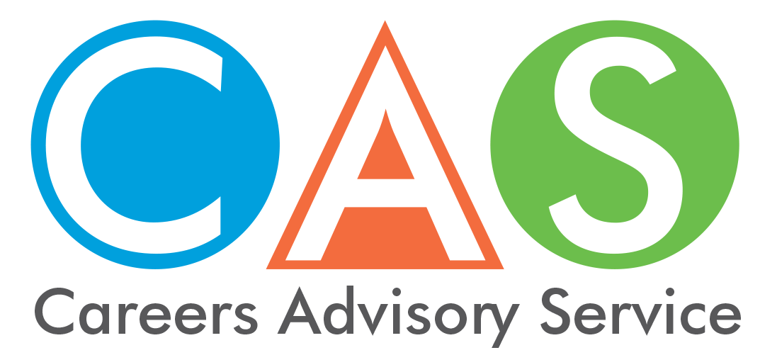

2. HSC dates and information

NSW Education Standards Authority (NESA)

Thursday 13 December 2018
- 6 am: HSC results will be delivered to students via email and text.
- 8 am: HSC Inquiry Centre is open Phone: 1300 138 323
- Enter student number and PIN and follow the prompts.
Remember your NESA number and Students Online PIN are different from your University Admissions Centre (UAC) number and PIN.
If you wish to opt out of receiving your results by email or SMS, go to NSW Students Online, My Details. You will also be able to access your results that day via NSW Students Online, My Details.

December 2018
Download your NESA credentials as a free PDF from NSW Students Online, My Details. Your HSC credentials will include a HSC Testamur, Record of Achievement detailing your Year 12, 11 and 10 results, and personalised course reports for relevant HSC courses. After downloading, remember to save or print your credentials as your NSW Students Online account will only remain open until 30 June, 2019.

January 2019
Your formal HSC Testamur will be posted from NESA. You can print the documents from NSW Students Online or pay for another copy.

HSC results inquiries
The HSC Inquiry Centre, phone 1300 13 83 23, will be available from 8am on Thursday 13 December 2018, followed shortly after by other HSC results services.

Need help logging in?
If this is your first time logging in to your personal account, you need to activate your account and create your NSW Students Online PIN. If you have forgotten your PIN see Help.

Privacy Information
NESA will provide the personal details and results of all NSW students to UAC for the calculation of the Australian Tertiary Admission Rank (ATAR) and to TAFE NSW. In addition, your principal and some approved officials from the school system to which your school may belong - the Department of Education, Catholic Schools NSW, or the Association of Independent Schools of NSW - will also have access to your results.
NESA publishes HSC merit lists on its website and provides these lists to select media outlets. HSC merit lists include the name, school and course/s of all students who, for example, achieve a HSC mark in the top band in any course. NESA does not provide the media with the names or the results of any other students. If you choose not to have your name published on the NESA website and provided to the media, you will not be eligible to receive associated awards.
Please read NESA's privacy policy. If you require further information on privacy issues or wish to be removed from a published merit list, please contact NESA.

Literacy and numeracy test results
Your literacy and numeracy test and diagnostic report will be delivered to My Messages in your NSW Students Online account shortly after completing your test. Read more about the literacy and numeracy tests.

© 2018 NSW Department of Education

