Where the creatures roam (S2-S3)
Vocal Ease More

Accompaniment and song – how does music help us to imagine?
- Watch a short video overview by the composer (0:39)
- Watch a short video overview of the teaching points (0:41)
- Listen and follow the score (3:11)
- Listen to the full performance (3:15)
- Listen to the backing track with spoken text (3:11)
- Listen to the backing track without spoken text (3:11)
- Access the lyric sheet

Background to where the creatures roam
This song is about mythical creatures such as the Ninki Nanka, Yumbo and Tikoleshe that are native to different parts of Africa, just like the Bunyip is to Australia and the Loch Ness Monster is to Scotland.
A Ninki Nanka is a legendary creature in West African folklore. Descriptions of the creature vary, but most contend that the animal is reptilian and possibly dragon-like. According to tradition, the Ninki Nanka lives in the swamps of West Africa. The animal is said to be extremely large and very dangerous.
Yumboes are a kind of fairy in the mythology of the Wolof people on Goree Island in Senegal, West Africa. They are two feet in height, a pearly white colour and have silver hair. The Yumboes live beneath the Paps Hills and come out to dance in the Moonlight.
In Zulu mythology, Tikoloshe, Tokoloshe or Hili is a dwarf-like water sprite. It is considered a mischievous and evil spirit that can become invisible by drinking water. Tokoloshes are called upon by people to cause trouble for others. At its least harmful, a tokoloshe can be used to scare children, but its power extends to causing illness and even death upon the victim.
This song also uses instruments from Africa such as the caxixi, mbira and kwela.

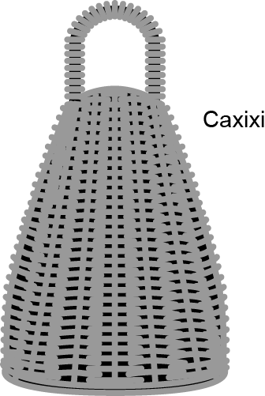
Caxixi sample (0:20)
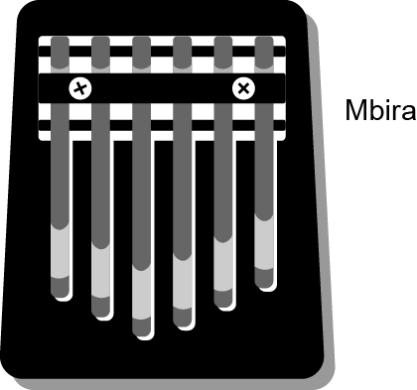
Mbira sample (0:27)
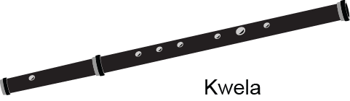
Kwela sample (0:16)

Quick start menu
- Listen to the Where the Creatures Roam and keep the beat. Add movement to help identify the different sections of the music. Build up to the full version of the song. Perform if you wish.
- Add instruments to represent the different sections.
- Improvise different rhythms and explore communication using drumming.
- Complete some extra activities exploring organising sound.

Key to icons

Concepts of music
Duration
Pitch
Dynamics
Tone colour
Structure

Learning experiences
Performing
Organising sound/composition
Listen
Outcomes and other elements of the syllabus used in this document are copyright Creative Arts K-6 Syllabus (NESA)

Learning across the curriculum
Cross-curriculum priorities | General capabilities | Other learning across the curriculum areas
Asia and Australia’s engagement with Asia | Critical and creative thinking  Ethical understanding  Information and communication technology capability  Intercultural understanding  Literacy  Numeracy  Personal and social capability | Civics and citizenship  Difference and diversity

Get familiar

Outcomes and purpose

MUS2.1
MUS2.2
MUS3.1
MUS3.2
Become familiar with the song.
Identify the instruments used in the song.
Keep the beat
Use movement to identify the different sections of the music.
Play some of the instrumental parts to accompany the music

Learning experiences | Activities S2-S3 | Concepts of music
Context – with the words displayed, listen to the song. Reflect upon where the song could be from and how we know. Discuss and explore the instruments used including the kwela, caxixi, mbira and the maracas.
Focus on the lyrics and discuss the mythical animals mentioned on the song: the Ninki Nanka, the Yumboe, the Tikoleshe. What do these songs tell us about Africa? Where is Africa? What do we traditionally know about African ‘creatures’? Discuss mythical animals from around the world such as the bunyip in Australia.
Reflect upon the descriptions of the African mythical animals provided within the lyrics. What do these creatures look like? Use these descriptions for the students create their own artwork representations of one of these mythical creatures using whichever techniques or forms are most appropriate.
How does the music help us to imagine the creatures? Explore this idea with other pieces of music such as Night on Bald Mountain or Pictures at an Exhibition by Mussorgsky. What do you imagine when you listen to these?
 | Keep the beat – with words displayed, keep the beat whilst listening to the recording of the full song. Try this a few times with a variety of methods for beat keeping including movement (such as stepping), clapping or other body percussion (such as clicking or patsching).
Investigate the music – listen to the song and discuss the changes in the way the music sounds. The initial verses are in a minor key which is often described as sounding scared or sad. This is the tonality of the music (4:40). The tonality then changes to a major key for the instrumental break. Major tonality is usually considered as being happy or bright. You can also see the differences in the written notation or play them using this score. Listen to an example of a major key (0:14) then a minor key (0:14) in these scales. Access the score of these scales.
Why would the composer have used a minor key for the verses and a major key for the other sections?
Identify these differences whilst listening to the song. Then listen to a song in a major key (such as Yellow Submarine by The Beatles or Shake It Off by Taylor Swift), then a minor key (such as Mad World by Gary Jules or Stairway to Heaven by Led Zeppelin). Discuss the differences and when each type of tonality would be appropriate.
Practice singing the song through using the words and dramatising the words.
 | Move – listen to the song again, and investigate the changes in the structure. There are clear sections where the music changes from being sung to spoken. Create a signal for the students to demonstrate these changes through movement. For example, the students could step from side to side keeping the beat during the sung section then stand still during the spoken section. During the instrumental break they could dance freely
Perform – learn to play the instrumental glockenspiel part on available melodic instruments such as xylophones, recorders, boomwhackers. Have some students play this whilst others move. You will also note that the tin whistle part has been included and can be played on treble recorder or melodic percussion.
Sing with the complete recording of the song (3:15). Add movement as appropriate. Once confident, use the backing track only (3:11) to perform either with the spoken words or with a student performing the spoken words.

Spice it up

Outcomes and purpose

MUS2.1
MUS2.2
MUS3.1
MUS3.2
Maintain the beat.
Explore the structure through movement.

Learning experiences | Activities S2-S3 | Concepts of music | Watch the lesson
 | Keep the beat – revise the song by singing and keeping the beat using some form of body percussion or movement. Repeat one of the activities previously completed.  Follow the pitch contour of the melody by moving hands according to the direction of the melody. For example, starting at the beginning of the first verse, heads, shoulders, waists, shoulders, heads and so on. |  | 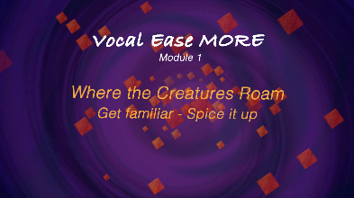  (1:12)
Accompaniment – allocate the students to three different groups to match each of the three sung verses. Either determine a movement for the group or have them devise one themselves to represent the animal and mythical creature discussed in their verse.
Construct a movement sequence to match the instrumental section (bar 22) that you all perform as a class. Explore examples of Gumboot dancing for possible inspiration.
Allocate the students instruments such as maracas (or make your own) to play when they are not performing their verse or to play whilst dancing during the instrumental section.
Experiment – during the spoken sections, the students could explore drumming. If drums are unavailable, use buckets or boxes. Initially the students should keep the beat. They may then wish to copy some of the rhythms played by the drummer in the recording of the spoken sections. Alternatively create your own words for this section using the backing track version without the spoken words.
The students could then explore different rhythmic ostinatos to play on their drums. These could accompany the sung sections during the verses. For example, repeatedly saying and playing the words and rhythm of 'Af-ric-a' on drums as an ostinato accompaniment during the singing of each verse. Experiment with different dynamics to enhance the arrangement.
 | Perform – use your ostinato accompaniment with the complete recording of the song.

Make it up

Outcomes and purpose

MUS2.1
MUS2.2
MUS2.3
MUS2.4
MUS3.1
MUS3.2
MUS3.3
MUS3.4
Explore call and response as a way to organise sound.
Improvise rhythms and melodies through call and response.

Learning experiences | Activities S2-S3 | Concepts of music | Watch the lesson
 | Call and response – using the drums or equivalent, create a call and response. For example, start the call yourself by saying and/or playing 'Africa where the great creatures roam'. The students could as a group then respond with the rhythm of ‘We know about the lion and the big hippo’.
 | Improvise the rhythm – as a class, sing the call and then altogether give different improvised response rhythms that last 8 beats. It may be beneficial to call out the beat numbers in this response. It is a way for the students to get used to hearing what 8 beats sound like as their response. This will also get the students used to experimenting with rhythm without the pressure of being on their own.  Use the instrumental section backing track (4:42) to allow students to improvise. This should allow approximately 16 rounds of improvisation of 8 beats. |  | 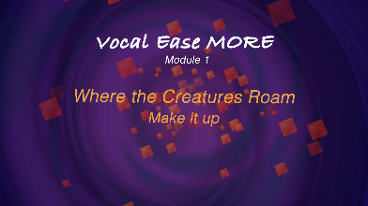  (2:09)
 | Improvise in pairs – with a partner, the students can think, pair, share a rhythmic response to the call. Sit in a circle. As a whole class, play a call for each pair and have them give their rhythmic response. This may take several turns until the students are able to do this without missing a beat after the call.
Improvise a melody- repeat the above steps 2-4 using melodic instruments or iPads. Start with only 1 note (an E and then a D). When the students are more confident, expand to an E and a D.
Use the backing track throughout to help.
If the students are struggling with using all these rhythms, start with just one or two rhythms and builds up. Alternatively, write rhythms on cards that the students can arrange in different orders.
For example,
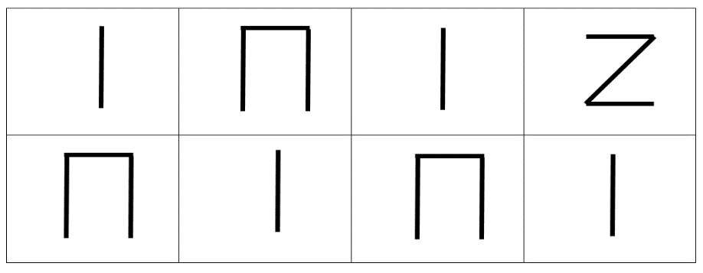
 | Extend it – point out to the students that drumming was and sometimes still is traditionally a form of communication amongst some African peoples. The students could then in pairs have their own conversations with each other using only their drums or using classroom items such as boxes. Boxes make good drums and are excellent for demonstrating communication through rhythm. |  | 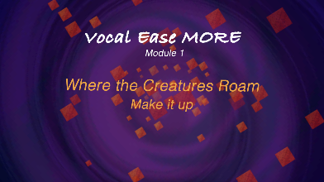  (3:11)
 | Improvise the melody – as a class, play the glockenspiel or instrumental part (bar 22) on available melodic instruments. This section features notes of the C major scale that is C D E F G A B. Discuss how this instrumental section is an ostinato with each pattern being 8 beats in length.  Repeat the process for rhythmic improvisation starting as a class, then pairs, then move to individual responses. This time use the notes of the C pentatonic scale from within the C major scale for the improvisation. These notes are C D E G A. Listen to the C pentatonic scale (0:12).  Provide an 8-beat melodic pattern as a call. The call might consist of the first 2 bars of the glockenspiel part or may be improvised.  The students then altogether give different improvised response melodies that last 8 beats. Using only the notes of the C pentatonic scale. Use the extended instrumental track to assist in this. This should achieve approximately 16 students improvising.  Depending upon student confidence, limit the number of notes initially such as just using C, D, E then gradually build up to more notes as the students' confidence increases. Alternatively, write the names of the notes on cards (C, D, E, G, A) that the students can arrange in different orders and then improvise rhythms with the notes.  With a partner the students can think, pair, share a melodic response to a call using only the C pentatonic scale. Sit in a circle. As a whole class, play a call for each pair and have them give their melodic response. This may take several turns until the students are able to do this without missing a beat after the call.  Repeat the above steps by offering a call, but this time the students individually provide their response. Depending upon student experience and confidence, repeat this activity improvising using the full C major scale. |  | (2:44)

Take it away

Outcomes and purpose

MUS2.1
MUS2.2
MUS2.3
MUS2.4
MUS3.1
MUS3.2
MUS3.3
MUS3.4
To create a soundscape using all the musical concepts.
Learn about rondo form as a way of arranging the musical compositions.
Create a rhythmic ostinato section for repetition by layering rhythms over each other.

Learning experiences | Activities S2-S3 | Concepts of music | Watch the lesson
 | Create a soundscape – students can create their own monster or creature images. Select a few for different groups to use as inspiration for creating a soundscape. When creating a soundscape, the students are best placed in small groups and provided with a range of instrumental options. Also consider environmental percussion such as rulers, chairs, as well as body percussion and vocal sounds.  Discuss musical concepts:  - Duration – will there be ostinatos, what will the tempo be, will the rhythms change?  - Pitch – will there be a melody?  - Dynamics – will the volume change and why?  - Timbre – what instruments will you choose and why, what is the effect of that choice?  - Structure – how will the parts be put together, how will it start and finish, will each part enter at the same time? |  | 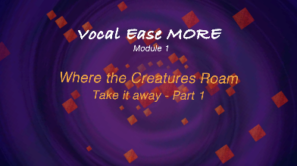  (1:53)  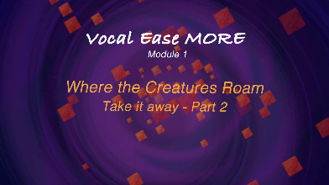  (1:43)
Change it – during the spoken sections change the words to be ostinato patterns that can be layered in. Use the recording of the separate parts being layered in to support this (0:23).
There are four lines of text. Create four groups that enter one line apart from each other and repeat their line as an ostinato for this section.
In this example allocate these lines to groups as follows:
Group 1 – drumming the beat or saying Ni-nki Nan-ka
Group 2 – speech ostinato of Af-ri-ca ostinato previously learnt
Group 3 – speech ostinato of Ti-ko-le-she
Group 4 – speech only once through of Yum-boe. Then repeat the whole section
Take these rhythms and transfer the spoken words to body percussion or percussion instruments.
Make up your own rhythms or lyric patterns if you would prefer.
 | Arrange it – arrange the soundscapes and the rhythms as class composition. For example as part of rondo form composition. Start with the combined spoken rhythm section (as above) then each group performs their soundscape in the place of a verse.  The class theme (the rhythmic speech section) forms Part A. The soundscapes per group will end up being the alternative sections B, C, D and so on. This will end up being something like the hamburger diagram below  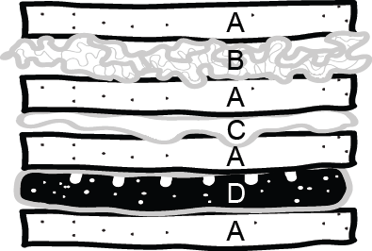 |  | 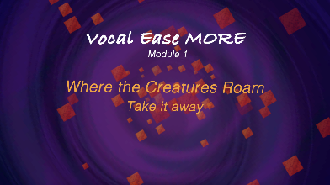  (5:48)
 | Perform – record and/or perform each student composed section for each other. Comment on the use of musical concepts in each group. Students can take on the role of a critic to discuss and analyse each group.  The next step could then be for the students to graphically notate their group's compositions. This will enable them to record their composition and also to compare with their peers. Rich discussion can then follow about the positives and negatives of graphic notation. |  | 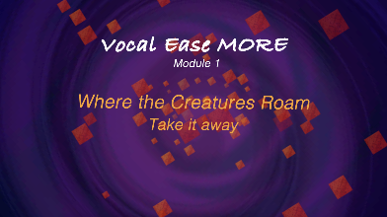  (4:18)  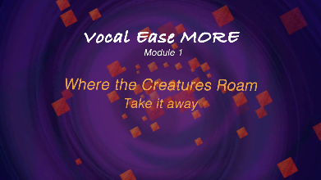  (1:29)

Where to from here?

Purpose
- Using imagination to create music that reflects an idea.
- Exploring musical concepts through movement.
- Understanding why composers use specific musical concepts and their effects of their choices.

Activities S2-S3
- Use dance to show differences in sections of the structure in this piece or in a variety of pieces.
- Identify the tonality of a song and why this tonality may have been chosen. This is particularly interesting with film music.
- Explore instrumental timbre to demonstrate different animals or characters within a text that you might read as a class or through listening to pieces such as Carnival of the Animal by Saint Saens.
- Use drumming to keep the beat and to improvise using call and response techniques.
- Explore rhythm through stick notation and drumming to introduce rhythmic sequences.
- Create a soundscape to reinforce a text, character or story.
- Create music or dances about mythical creatures.

- What is a pentatonic scale? What does pent mean? How is this pattern formed and how is it replicated in different keys? Tune bottles either to the pentatonic scale or by using bottles tuned to C major scale.
- What is the pattern that makes up a major then a minor scale? How are they different? What is the influence of mathematics here with reference to patterns and formulas? How does this translate to musical composition?
- Make tin whistles, kwelas, caxixi, mbira or maracas. Explore how they are made, the measurements required (or not) and how sound is produced. These African instruments were originally made usually locally sourced materials, including drums and the choses of materials used. What could we use in our local environment to create instruments? Research previously local-made instruments such as gum leaves and tea chest string basses.
- How do you make a monster? What is a monster, what is their purpose, why were they ever created and what would you need to create your own? Create your own monster complete with as many functions as possible/appropriate.
- Creative Arts – Visual arts: recreate the monsters/creatures referred to in the song or create own. Use either drawing, painting, collage or sculpture. Dance: Create dances about mythical creatures. Drama: through role play explore the ways these animals may behave. Dramatise the song. Use drama games such as conscience alley to explore the way mythical creatures may teach us a life lesson or solve an ethical question.
- English – explore legends, myths and folk stories from around the world. Look at translation and the meanings they share. Use the creatures within this song as the basis of a descriptive text. Replicate this for researching, discussing and writing about African animals.
- HSIE: History – examine stories and shared histories, including recalling and retelling stories of local histories. Explore the concept of fact versus fiction in personal and social traditions. Look at change and continuity such as can be seen in folk tales from other countries. Could these be used in a song? Geography – explore diversity of the world's people, places and environments. Investigate the interconnection between people and places and how cultural identities are shaped, such as in Africa. Explore the concept of migration, including how the environment influences settlement patterns. Examine the interconnection of the world's peoples by looking at diversity and different cultures around the world.

