Issunboshi (S2-S3)
Vocal Ease More

Movement, storytelling and song – what does folk music tell us about a country?
- Watch a short video overview by the composer (0:38)
- Watch a short video overview of the teaching points (1:02)
- Listen and follow the score (4:20)
- Listen to the full performance (4:17)
- Listen to the backing track (4:17)
- Access the lyric sheet (PDF)

Background to the Issunboshi
This song is based upon a folk tale from Japan called the One Inch Fellow. It was rewritten into a children’s book called The Inch Boy by Japanese visual artist and author Junko Morimoto (10:46). As a survivor of the atomic bomb drop on Hiroshima, she also wrote My Hiroshima and The Two Bullies.
In summary, the story of The Inch Boy is about an old couple who wanted a child. They made a wish and stated that they didn’t care if he was one-inch tall. Eventually they did get a child and he only grew to be one inch. They named him Issunboshi which meant One Inch Boy.
After some time Issunboshi decided he wanted to see the world. His parents gave him a bowl, chopsticks and a needle that he could use as a sword to protect himself. Issunboshi went to the city and was taken in by a nobleman to be a servant for a princess.
One day they went out and were stopped by a large green demon called an Oni. Issunboshi acted quickly. He climbed the Oni and poked it in the tongue with his sword and the princess was saved. To thank Issunboshi, the princess made a wish for him to grow. Gradually he grew to be a full-sized man. The pair were married and they lived together happily ever after.
The instruments featured include
- The koto is a traditional Japanese stringed musical instrument derived from the Chinese Zheng. The koto is the national instrument of Japan.
- The shamisen literally means three strings. It is a three-stringed traditional Japanese musical instrument derived from the Chinese instrument sanxian. It is played with a plectrum or pick called a bachi.
- The shakuhachi is a Japanese end-blown bamboo flute. It was originally introduced from China into Japan in the 6th or 7th centuries. The instrument is tuned to the minor pentatonic scale (0:15). This is a 5-note scale such as E G A B D:
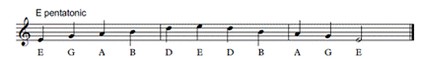

Koto sample (0:28)
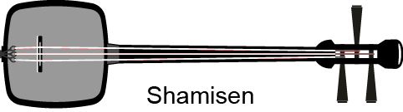
Shamisen sample (0:22)
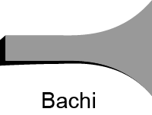
Bachi sample (0:16)
Shakuhachi sample (0:29)

Quick start menu
- Listen to the Issunboshi and keep the beat. Learn to sing the call (Little Issunboshi followed by the instrumental response on the koto) and listen to the response sections. Build up to the full version of the song. Perform if you wish.
- Explore pentatonic scales by making your own instruments or playing the suggested notes on melodic instruments.
- Complete some or all the suggested activities including some of the suggestions for integrating into other key learning areas.
- Learn other folk songs or make your own.

Key to icons

Concepts of music
Duration
Pitch
Dynamics
Tone colour
Structure

Learning experiences
Performing
Organising sound/composition
Listen

Learning across the curriculum
Cross-curriculum priorities | General capabilities | Other learning across the curriculum areas
Asia and Australia’s engagement with Asia | Critical and creative thinking  Ethical understanding  Information and communication technology capability  Intercultural understanding  Literacy  Numeracy  Personal and social capability | Civics and citizenship  Difference and diversity

Get familiar

Outcomes and purpose

MUS2.1
MUS2.2
MUS2.3
MUS2.4
MUS3.1
MUS3.2
MUS3.3
MUS3.4
Become familiar with the song.
Explore the structure of the song.
Keep the beat.

Learning experiences | Activities S2-S3 | Concepts of music | Watch the lesson
Context – with the words displayed, listen to the song. Reflect upon where the song could be from and how we know? Discuss and explore the Japanese instruments used. Focus on other Japanese folk music such as Sakura. What do these songs tell us about Japan? Practise Japanese counting with the recording.
Read and reflect upon the story of The Inch Boy by Junko Morimoto. Reflect upon the text and the meaning of the words. Dramatise the story or use this as the basis of an exploration of Japan and Japanese culture (see Integrates HSIE link).
 | Keep the beat – with words displayed, keep the beat whilst listening to the recording of the full song. Try this a few times with a variety of methods for beat keeping including movement (such as stepping), clapping or other body percussion (such as clicking or patsching).  Pass an object around a circle on the beat like a stone passing game. Add more objects. Example may include a ball, chopsticks or sandbags. Don’t miss a beat!  Use objects to individually or in pairs keep the beat such as fans, chopsticks, rice paper balls. Movement and objects are great ways to reinforce the beat.  If the students are confident with keeping the beat use fans, fabric or rice paper balls to reinforce the phrasing. You will generally reach the end of the phrase when you feel the need to breathe, much like when you come to a comma or full stop when reading a text. |  | 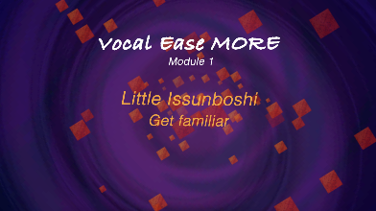  (2:05)
Investigate the music – either by clapping or tapping with chopsticks or drumsticks, play the rhythm (the words) rather than the beat. Focus on the first three main sections of the piece – letters A, B and C. Highlight the difference between the short notes and rests of A and C, by comparison to the long notes of letter B.
In pairs, students create clapping game patterns using this rhythmic difference. Emphasise the need for repetition and patterns to assist in memorisation. Ensure the patterns are the same for sections A and C. Discuss this musical structure.
Repeat the focus on rhythm rather than beat at letter G. Use the fabric, scarves, fans, or paper balls again to explore duration focusing on the long versus short sounds.
 | Move – listen out for the words ‘Little Issunboshi’. Make a signal (such as hands in the air) for every time you hear them. Does the melody change? The melody changes notes or pitches but the words stay the same. This keeps it interesting.  To guide the listening, find the section of the music with the call of ‘Little Issunboshi’ where there is an instrumental response. Devise some body percussion to match this section. Particularly try to follow the pitches of the notes in the koto response by moving higher or lower depending on the pitch. For example,  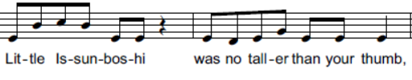  Explore the pitch using a parachute, large class elastic (6-10 metres), ribbon sticks or scarves. Move these objects up and down according to the pitch. This is following the melodic contour. |  | 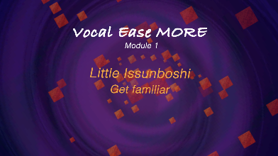  (2:33)
Parts – sing with the complete recording of the song. When the song changes to two parts singing together (letter E), sing the top part (the melody) along with the recording.
Repeat with the lower part using the recording. Play the lower part on melodic instruments.
Play and sing together. Add the upper part and sing or play both parts together with the recording.
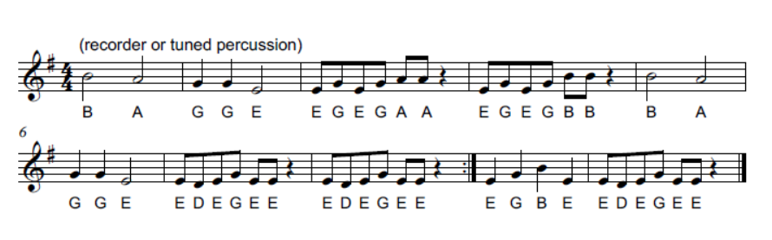
 | Play it – learn to play the instrumental section at letter G on either melodic percussion or recorders.
 | Perform – sing the complete song with both parts at letter E and again at H. Add movement as appropriate.

Spice it up

Outcomes and purpose

MUS2.1
MUS2.2
MUS2.3
MUS2.4
MUS3.1
MUS3.2
MUS3.3
MUS3.4
Explore ways of accompanying and arranging the song.
Discovering call and response as a musical structure.
Learning about E minor pentatonic scale.

Learning experiences | Activities S2-S3 | Concepts of music | Watch the lesson
 | Keep the beat – revise the song by singing and keeping the beat using some form of body percussion or movement. Repeat one of the activities previously completed.
 | Ostinato accompaniment – is the song always sung or is whispering used? Use speech either whispered or in a normal speaking voice as a simple ostinato accompaniment to the song. This will help reinforce the learning of the song. Describe the dynamics. Choose a phrase of words to say repeatedly to accompany the melody. For example, ‘Little Issunboshi’, then count 1, 2, 3, 4 (a full bar) before repeating again. |  | 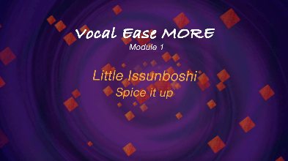  (3:51)
Instrumental accompaniment – extend upon the previous ostinato accompaniment by adding instruments. The instruments can be traditional percussion instruments or self-created (see STEAM link). For example, finger cymbals, cymbals, triangles or drums. This is a good time to revise the Japanese instruments used. These may sound best played only at the beginning of each bar (every 4 beats).
Add a melodic instrument playing a drone throughout (0:28). Playing an E at the start of each bar (every 4 beats will complement the melody). You may notice a clash on the 3rd bar sung. The E should be changed to a D for those two bars.
You will notice the notes of the drone written below each bar.
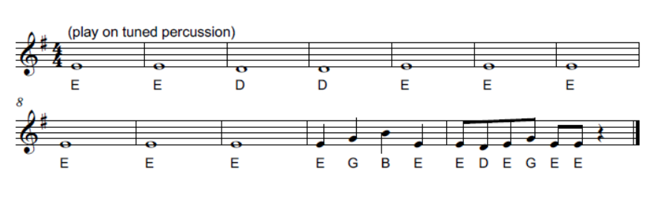
 | Experiment – use either a drone or an ostinato to explore accompaniments for the song. This might include changing the instruments or changing the rhythms or the words of the ostinatos for example, using only long notes of up to 8 beats in duration on melodic or non-melodic instruments experimenting with rhythms that are commonly featured in the song such as two sounds on a beat then a rest (ti-ti sa). One part along with the recording.  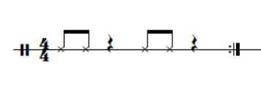 |  | 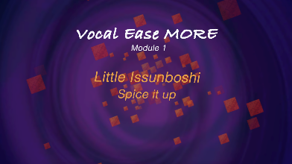  (1:44)
 | Perform – use your ostinato accompaniment with the complete recording of the song. This could be done with one half of the class (or a group) performing the ostinato and the remainder singing the song. When the song changes to having two parts singing together (letter E), continue with the ostinato or alternatively change to singing one part along with the recording.

Make it up

Outcomes and purpose

MUS2.1
MUS2.2
MUS2.3
MUS2.4
MUS3.1
MUS3.2
MUS3.3
MUS3.4
Play and improvise using the rhythmic and melodic material in the song.
Discovering call and response as a musical structure.

Learning experiences | Activities S2-S3 | Concepts of music | Watch the lesson
Call and response – practice singing the call of the call and response section (bar 19). These notes are part of the minor pentatonic scale:
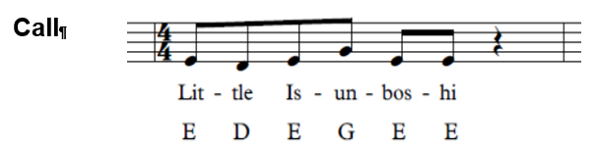
Once secure, add the response by clapping the 8 beat rhythm first, then humming the 8 beat melody (bars 20-21) along with the recording:
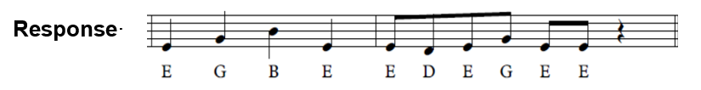
 | Improvise together – as a class, sing the call and then altogether give different improvised response rhythms that last 8 beats. Call out the beat numbers in this response as a way for the students to get used to what 8 beats sound like as their response. This will also get the students used to experimenting with rhythm without the pressure of being on their own.
 | Improvise in pairs – with a partner the students can think, pair, share a rhythmic response to the call. Sit in a circle. As a whole class, sing the call for each pair and have them give their rhythmic response. This may take several turns until the students are able to do this without missing a beat after the call
 | Improvise alone – repeat the above steps by offering the call but this time the students individually provide their response.
 | Improvise a melody – repeat the above steps 2-4 using melodic instruments or iPads. Start with only 1 note (an E and then a D). When the students are more confident, expand to an E and a D. Use the backing track throughout to help.
 | Extend it – the next step is for the students to learn to play the melody of the call and response. Once this is secure, play the call then follow the improvisation process for a melodic response using any of the notes already played i.e. E D G or B. These are all notes of the minor pentatonic scale. Use the backing track to help. |  | 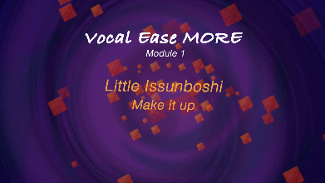  (1:29)
 | Final Performance – learn to play the full glockenspiel part using the score provided. Arrange your final performance using a combination of the different activities explored.

Where to from here?

Outcomes and purpose
Using speech and song in combination to reinforce musical concepts.

Activities S2-3
- Use movement to reinforce musical concepts. For example, parachutes, scarves or elastics to show pitch changes, phrasing or melodic contour.
- Create an ostinato to accompany a song.
- Accompany songs using chord notes, chords, a drone or a rhythmic ostinato.
- Use the minor pentatonic scale to explore further improvisation with or without the backing track. Use this to compose a new song.
- Create your own folk song using the backing track or using a method of accompaniment above. Reflect on the needs of a country and how they relate to song.
- How can a song tell us about a country? What components are required to let us know about that country?
- How can we tell the story of our country through song?
- What is a pentatonic scale? How is the formula created for this and how do we use this pattern? Where does it fit into mathematics? Explore or create other pentatonic songs. How does music take mathematics further in this pursuit?
- What is an inch? Compare standard units of measure. Use measurement to explore tuning bottles either to the pentatonic scale or using bottles tuned to E to perform a drone. Why is this term used to describe a repeated note?
- Extend this further by using measurement principles to make bamboo flutes.
- Japanese culture explores many mathematical principals through art such as origami and tangrams. Explore and reinforce mathematical thinking and principles through these methods.
- Creative Arts – visual arts: explore the Japanese artform of anime drawing. What is its purpose, where do we see it, and can we replicate it? Examine famous traditional artworks such as The Great Wave off Kanagawa (Hokusai) and Japanese art techniques such as ink painting (sumi-e) or block printmaking (ukiyo-e). Discuss wabi sabi (stark beauty and aging) and yugen (subtlety).
- Creative Arts – music and dance: how and why do folk or cultural stories become folk songs? Explore some other international folk songs such as:
  - Polynesia – Tongo
  - Jamaica – Shake the Papaya, Calypso
  - UK – London's Burning, My Bonnie Lies Over the Ocean, Here We Go 'Round the Mulberry Bush, Skye Boat Song
  - Australia – Click Go the Shears, Waltzing Matilda, Bound for Botany Bay
  - International Handclapping Games – A Sailor Went to Sea, Miss Mary Mack, Down Down Baby
- Can you find any other folk tales from other countries that you could use in a song?
- English – explore texts relevant to the folk story of Issunboshi such as The One Inch Boy, Little Tom Thumb. What role do these types of stories with a moral teach us? What other types of texts are like this? Could this text be transformed into a reader's theatre?
- English – there are many texts to explore that teach us about Japanese life and history. For example, The Sound of Silence (Katrina Goldsaito), Origami Heart (Binni), Sadako and the Thousand Paper Cranes (Eleanor Coerr) or Lots (Marc Martin). The author of The One Inch Boy Juno Morimoto has also written other texts worth reading including The Two Bullies and My Hiroshima.
- HSIE – geography: location of places, why people live where they live, geographical information, seasonal patterns and climate, connections and comparisons to countries and lifestyles across the world including trade and migration, vegetation and natural resources and stereotypes. History – families, cultures, celebrations, commemorations, trade and Asia.

