Nationally Consistent Collection of Data on students with disability (NCCD)
Data Entry Tips for using the Online Data Collection Website/ ERN – For the Census Stage (5 to 16 August)
This important stage produces the school’s official record for the NCCD. Refer to the Online Data Collection Website for detailed instructions on completing the NCCD census stage. Below are quick tips for this stage.

What do I do in the census stage?
Between 5 – 16 August 2019, schools will need to:
- review their NCCD data in the Online Data Collection Website (datacollections.det.nsw.edu.au);
- make any required changes to student records in the Online Data Collection Website. At this stage you can only update records of students already appearing on the website (i.e. students cannot be added). Once satisfied that the data is correct, schools should then update ERN to reflect any changes made in the Online Data Collection website; and
- sign-off the final data for submission in the Online Data Collection Website by 5pm on 16 August 2019.

What do I need to look for?
In the Online Data Collection website, under “Step 2: Review Census Data”, NCCD data will be displayed in two tables (see screenshot below), showing students included in the NCCD and students excluded from the NCCD. Schools with large numbers may need to scroll down the page to reveal the students excluded table.
Additional students cannot be added to the list at this stage, however, students can be moved from the excluded table to the included table, and vice versa, by selecting the drop down menu arrows embedded in the table to amend the school’s judgements. Once the judgements satisfy the NCCD criteria and the information is saved the student will automatically move into the desired table.
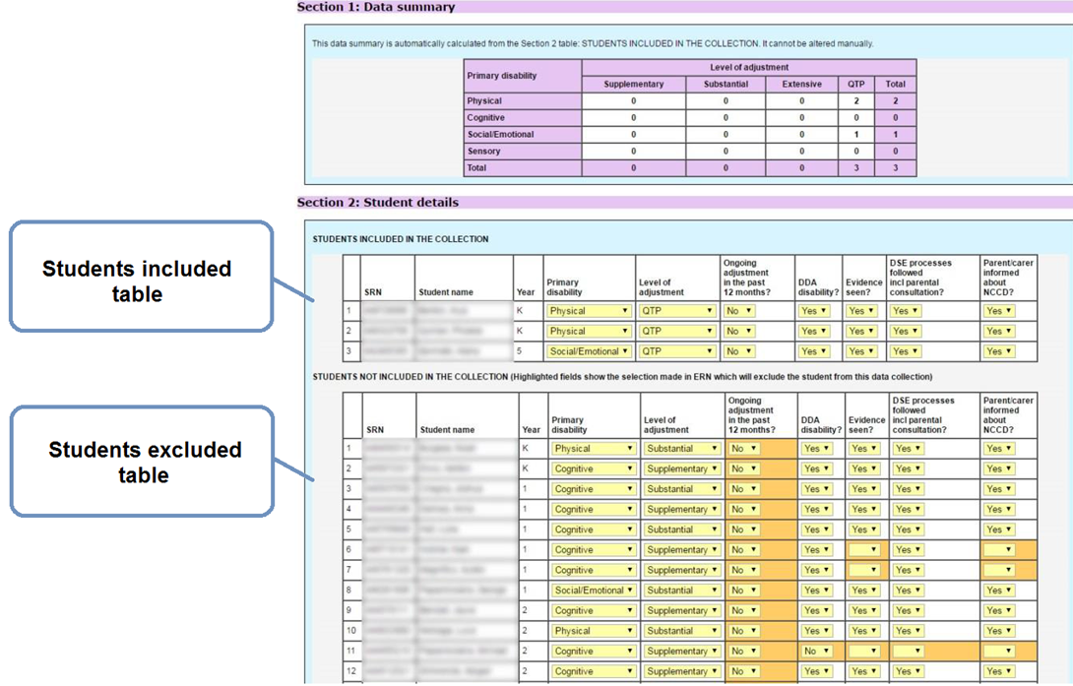
Figure 1 Screenshot from Online Data Collection Website

Why aren’t my ERN changes updating the Online Data Collection Website?
There is no link between ERN and the Online Data Collection Website. Changes made in ERN are not automatically updated on the website and vice versa.
Data on the Online Data Collection Website is only updated twice each year – prior to the Validation Stage and on census date.

Do I need to sign off?
When the data is accurate, select “Step 3: Sign off Census”. The principal signs off on the data to produce the official NCCD record prior to 16 August 2019 at 5pm. A copy of the data and the sign off should be made for school records.
What happens next?
The NSW Department of Education Statistics Unit will extract and submit the final data to the Australian Government Department of Education.
Schools can print their census return for their own records. Historical data is also available for all schools on the Online Data Collection Website.

For more information contact
NCCD Helpdesk
9244 5178 or 9244 5587
nccd@det.nsw.edu.au
education.nsw.gov.au/teaching-and-learning/disability-learning-and-support/personalised-support-for-learning/national-disability-data-collection

